Study on the interaction between volatile oil components and skin lipids based on molecular docking techniques
REN Weishuo¹, WULAN Tuya^{1, †}, DAI Xingxing^{1, 2}, ZHANG Yingying³, JIA Mingyue³, FENG Minfang¹, SHI Xinyuan^{1, 2, *}

1. School of Chinese Materia Medica, Beijing University of Chinese Medicine, Beijing 102488, China
2. Key Laboratory for Production Process Control and Quality Evaluation of Traditional Chinese Medicine, Beijing Municipal Science&Technology Commission, Beijing 102488, China
3. School of Life Sciences, Beijing University of Chinese Medicine, Beijing 100029, China

*Corresponding author: E-mail: xys_2019@126.com
Manuscript received 2024-3-3; accepted 2024-6-5;
available online 2024-6-25.

†The authors contributed equally.

[Abstract] [Objective] To analyze the interactions between different structural types of volatile oil components (VOCs) and skin lipid molecules, and investigate the mechanism of volatile oil in Chinese materia medica (VOCMM) as penetration enhancers. [Methods] In this study, 210 different structural types of VOCs were selected from the VOCMM penetration enhancer database, and the molecular docking experiments were conducted with three main lipid molecules of skin: ceramide 2 (CER2), cholesterol (CHL), and free fatty acid (FFA). Each VOC was docked individually with each lipid molecule. Cluster analysis was used to explore the relationship between the binding energy of VOCs and their molecular structures. Nine specific pathogen-free (SPF) Sprague Dawley (SD) rats were randomly divided into Control, Nootkatone, and 3-Butylidenephthalide groups for in vitro percutaneous experiments, with three rats in each group. The donor pool solutions were 3% gastrodin, 3% gastrodin + 3% nootkatone, and 3% gastrodin + 3% 3-butylidenephthalide, respectively. The penetration enhancing effects of VOCs with higher binding energy were evaluated by comparing the 12-hour cumulative percutaneous absorption of gastrodin (Q₁₂, µg/cm²). [Results] (i) Most of the VOCs were non-hydrogen bonded to the hydrophobic parts of CHL and FFA, and hydrogen bonded to the head group of CER2. Among them, sesquiterpene oxides showed the most pronounced binding affinity to CER2. The VOCs with 2 − 4 rings (including carbon rings, benzene rings, and heterocycles) demonstrated stronger binding affinity for three skin lipid molecules compared with the VOCs without intramolecular rings (P < 0.01). (ii) According to the cluster analysis, most of the VOCs that bond well to CER2 had 2 − 3 intramolecular rings. The non-oxygenated VOCs were bonded to CER2 in a hydrophobic manner. The oxygenated VOCs were mostly bonded to CER2 by hydrogen bonding. (iii) The results of Franz diffusion cell experiment showed that the Q₁₂ of Control group was 260.60 ± 25.09 µg/cm², and the transdermal absorption of gastrodin was significantly increased in Nootkatone group (Q₁₂ = <styled-content style-type="number">5503.00</styled-content> ± <styled-content style-type="number">1080.00</styled-content> µg/cm², P < 0.01). The transdermal absorption of gastrodin was also increased in 3-Butylidenephthalide group (Q₁₂ = 495.40 ± 56.98 µg/cm², P > 0.05). (iv) The type of oxygen-containing functional groups in VOCs was also an influencing factor of binding affinity to CER2. [Conclusion] The interactions between different types of VOCs with different structures in the VOCMM and three skin lipid molecules in the stratum corneum were investigated at the molecular level in this paper. This research provided theoretical guidance and data support for the screening of volatile oil-based penetration enhancers, and a simple and rapid method for studying the penetration-enhancing mechanism of volatile oils.

[Key words] Chinese materia medica; Volatile oil; Stratum corneum lipids; Transdermal penetration-enhancing effects; Molecular docking; Ceramide 2 (CER2); Penetration enhancers
[DOI] 10.1016/j.dcmed.2024.09.006

1 Introduction
Volatile oil in Chinese materia medica (VOCMM) is a lipophilic mixture widely found in aromatic plants, with the main components being monoterpenes, sesquiterpenes, and their derivatives, aromatic and aliphatic compounds. As a characteristic manifestation of aromatic Chinese materia medica (CMM), VOCMM has demonstrated the efficacy of releasing the exterior, transforming dampness, moving Qi, and opening orifice ^{[1]}. Meanwhile, many VOCMMs have shown good penetration-enhancing effects, as reported by studies related to penetration enhancers for transdermal drug delivery systems. Volatile oils are found in more than 500 species of plants from 60 families in China, and good transdermal penetration-enhancing effects have been noted in 34 types of VOCMM, among which 21 types of VOCMM can enhance the penetration of over two chemical components ^{[2, 3]}. More importantly, as penetration enhancers, VOCMMs have less skin irritation and fewer side effects than the traditional chemical penetration enhancers such as nitrone and dimethyl sulfoxide, and also has demonstrated the effects of combining medicine and adjuvant ^{[4]}. For example, borneol not only has a certain penetration enhancement effect on various kinds of medicines, but also has anti-inflammatory and bacteriostatic properties ^{[5-7]}. Another study investigated the penetration enhancement effects of Zanthoxylum bungeanum Maxim (Z. bungeanum) oil and its main components (terpinen-4-ol, 1,8-cineole and limonene), in which Z. bungeanum oil and limonene had penetration-enhancing effects for both esterophilic and hydrophilic drugs, while terpinen-4-ol and 1,8-cineole appeared to provide significant enhancement in the fluxes or cumulative amounts of various lipophilic model drugs ^{[8]}. In addition, the compound volatile oils can also enhance the penetration of hydrophilic and lipophilic drugs by altering the structure of the stratum corneum ^{[9]}. Therefore, VOCMMs and their constituents, as well as compound VOCMMs have good prospects as penetration enhancers in application ^{[10]}.
Currently, the main method for evaluating the penetration-enhancing effect of volatile oils is the in vitro transdermal test. Due to the large difference in the barrier function between the isolated rat skin and human skin, the results of penetration amounts differ significantly from actual human skin and exhibit poor reproducibility ^{[11]}. Furthermore, there are discrepancies in the absorption function between isolated skin and intact epidermis ^{[12]}. Therefore, it is necessary to consider the in vitro penetration test and in vivo microdialysis technology together to provide a reasonable evaluation of the impact of penetration enhancers. However, the necessity of specialized microdialysis equipment results in increased experimental costs. The application of computer simulation technology in the study of VOCMMs offers the possibility to efficiently and easily evaluate its penetration-enhancing effect and explore its penetration-enhancing principles. Considering volatile oil components (VOCs) and lipid molecules as ligands and receptors, the molecular docking technique enables the calculation of binding affinity based on geometric and energy matching ^{[13]}. Notably, CHU et al. ^{[14]} used molecular docking technology to analyze the binding affinity and binding target of constituents of five VOCMMs with ceramide 2 (CER2), thus indicating the possible mechanism of the penetration-enhancing effect of VOCMMs. Besides, NAN et al. ^{[15]} applied molecular docking and molecular modeling techniques to investigate the mechanism for promoting penetration and to calculate the solubility parameters of the volatile oil of Ledum palustre L. var. angustum N.. Thus, the mechanism of VOCMMs as penetration enhancers can be better evaluated at the level of molecular interaction ^{[16]}.
In summary, this paper has adopted the molecular docking method to investigate the interactions between the VOCs of CMM and the three skin lipid molecules in the stratum corneum at the molecular level. The structural characteristics of VOCs with strong CER2 binding affinity in combination have been analyzed using the clustering method. This study is considered to provide theoretical guidance for the screening of volatile oil-based penetration enhancers and to propose a simple and rapid method for investigating volatile oil penetration enhancers.
2 Materials and methods
2.1 Drugs and reagents
The drugs and reagents were purchased from the following companies: acetonitrile (Thermo Fisher Scientific, China), propylene glycol (Yuanye Bio-Technology, China), phosphate-buffered saline (PBS) (Ranbold Biologicals, China), gastrodin (Macklin, China), nootkatone (Jiangsu Aikon, China), and 3-butylidenephthalide (Beijing InnoChem, China).
2.2 Instruments
The instruments included in this study were as follows: intelligent transdermal diffusometer (Tianjin Xintianguang Analytical Instrument Technology Co., Ltd., TP-6); high-performance liquid chromatograph (HPLC) (Waters, Alliance e2695), and analytical balance (Sartorius AG, BP211D)
2.3 Databases and softwares
PubChem database (https://pubchem.ncbi.nlm.nih.gov/), AutoDock 4.2, OpenBabel 3.0.1, PyMOL 2.5, Bioinfo Intelligent Cloud (https://www.bic.ac.cn/BIC/#/), and LigPlot 2.2.7 were employed in this study.
2.4 Selection and pre-treatment of ligand VOCs
In this study, 210 VOCs were selected for docking with three stratum corneum skin lipid molecules. These selected VOCs are all from the VOCMM penetration enhancer database established by our group in the previous stage of the study. There were 134 terpenes (27 monoterpenes, 40 monoterpene oxides, 34 sesquiterpenes, and 33 sesquiterpene oxides), 38 aromatics, 33 aliphatics, and 5 others in terms of types (Figure 1A). Regarding intramolecular ring formation, there were 44 linear VOCs, 77 single-ring VOCs, 57 double-ring VOCs, 29 three-ring VOCs, and 3 four-ring VOCs (Figure 1B). Concerning the intramolecular oxygen-containing functional groups, there were 78 unoxygenated substances and 132 oxygen-containing substances (Figure 1C). According to the oxygen-containing functional groups, they were classified as 38 alcohol hydroxyls, 21 cyclic ketones, 12 ester bonds, 10 aldehydes, 9 phenol ethers, 9 cycloesters, 7 carboxylic acid groups, 6 ether bonds, 6 cycloethers, 5 phenol hydroxyls, 3 carbonyls, 3 alkenyl ethers, 1 containing both ether and alcohol hydroxyls, and 2 others. The .sdf structure files of the above VOCs were downloaded from the PubChem database ^{[17]}, and the OpenBabel 3.0.1 software was used to convert the .sdf format files into the .pdb format, which is required for docking.
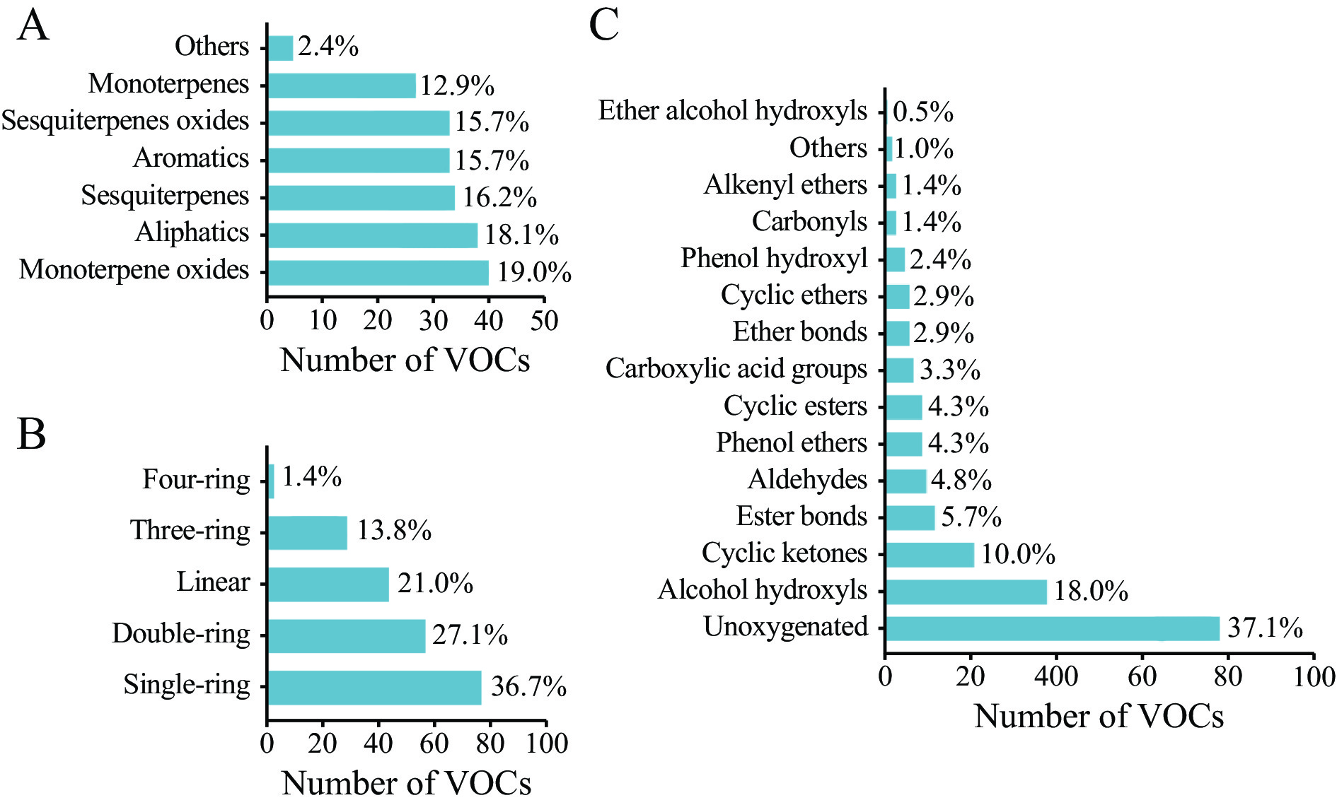
Fig. 1 Distribution of types, intramolecular rings, and oxygen-containing functional groups of VOCs
A, structure types of VOCs. B, intramolecular ring of VOCs. C, oxygen-containing functional groups of VOCs.
2.5 Selection and pre-treatment of receptor skin lipid molecules
As shown in Figure 2, by reviewing the relevant literature on transdermal absorption of drugs, the three main skin lipid molecules including CER2, cholesterol (CHL), and C24 free fatty acid (FFA) make up 90% of the interstitial space of the skin stratum corneum and play an important role in skin barrier function were selected ^{[18]}. The structure files of the skin lipid molecules were handled in the same way as the VOCs.
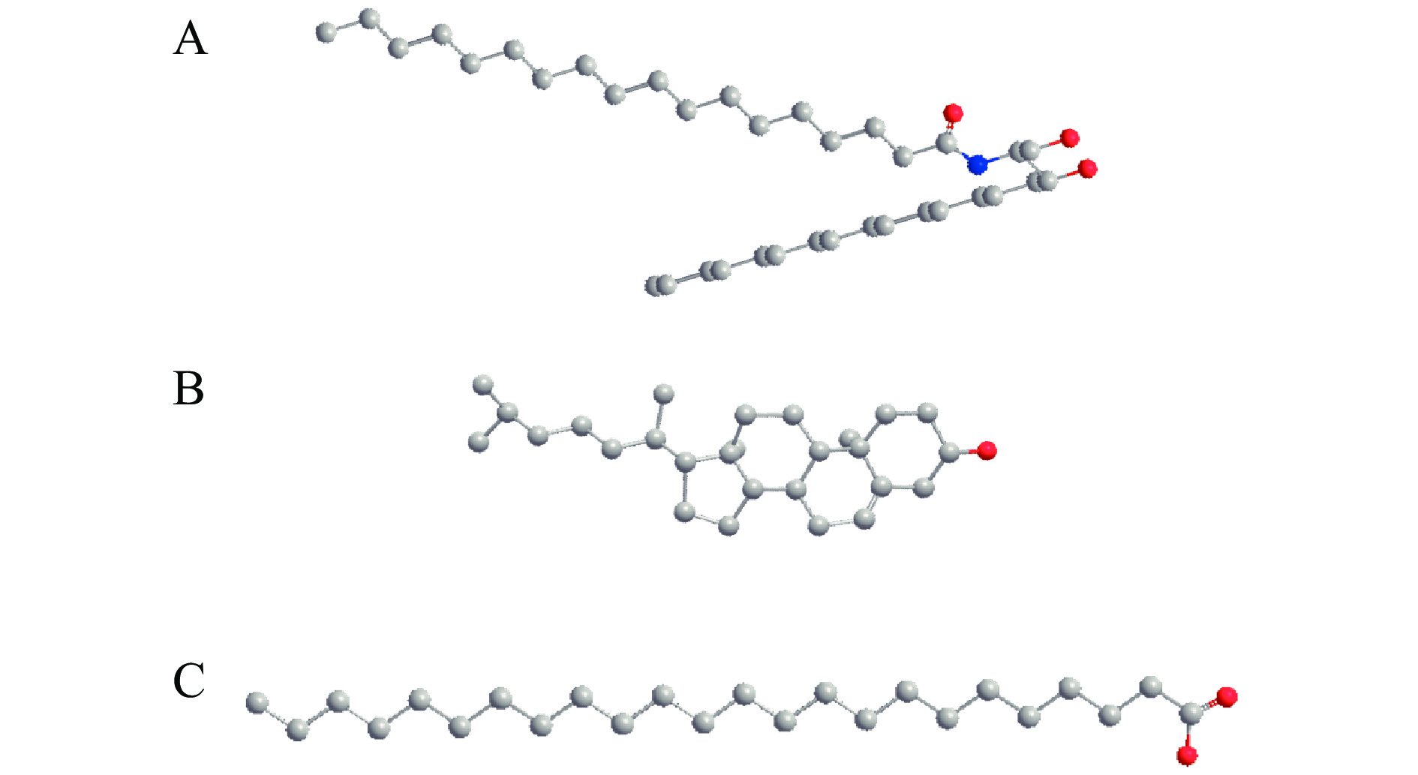
Fig. 2 Three major skin lipid molecules of the stratum corneum interstitium
A, CER2. B, CHL. C, FFA. Gray, carbon atoms. Red, oxygen atoms. Blue, nitrogen atoms.
2.6 Molecular docking methods and evaluation of results
2.6.1 Molecular docking methods
The structure files of the skin lipid molecules in .pdb format were imported into AutoDock 4.2. Hydrogenation and charge calculations were performed on skin lipid molecules. The obtained results were saved in the .pdbqt format. Structure files of VOCs in .pdb format were imported into AutoDock 4.2. Hydrogenation was performed and rotatable bonds on VOCs were viewed. The obtained results in the .pdbqt format were saved.
The coordinates were first used to determine whether the receptor is below the ligand molecule as the initial position for docking. Next, the entire docking box was selected and the parameters were established so that the ligand could dock to all sites of the entire receptor molecule. Finally, the calculation was conducted to obtain the result file in .glg format.
The receptor and ligand molecules were selected and the algorithm was set to “Local Search”. Then the calculation was carried out and the result file in .dlg format was obtained. The docking results can be visualized by opening the result file obtained above using PyMOL 2.5 software.
2.6.2 Methodology for assessing docking results
It is generally believed that the binding affinity of ligand small molecules and receptor macromolecules is mainly determined by the binding energy. The lower the binding energy, the greater the possibility of interaction. A binding energy less than 0 means that the ligand and receptor can achieve spontaneous binding, and a value below – 5.0 kcal/mol (1 cal ≈ 4.186 J) indicates a strong binding capacity ^{[19]}.
2.7 Cluster analysis
Given the insufficient number of VOCs with a binding energy below – 5 kcal/mol to CER2 for analysis, the optimal number of VOCs was evaluated for clustering using a binding energy below – 3.5 kcal/mol as the criterion. Before cluster analysis, VOCs that met the criterion were selected and their number of intramolecular rings, the number of oxygens, and hydrogen bonds (HB) formed with CER2 were counted to further analyze the structural characteristics of VOCs. After normalization, the data were imported into the Bioinfo Intelligent Cloud (https://www.bic.ac.cn/BIC/#/). The “Ward” method was selected and the distance metric as “Euclidean” was set to draw the clustered heat map. The .pdb file was imported into LigPlot 2.2.7 software to observe the non-HB interactions between skin lipid molecules and VOCs.
2.8 Franz diffusion cell method for in vitro penetration experiments
2.8.1 Animals
A total of nine specific pathogen-free (SPF) grade male Sprague Dawley (SD) rats, 5 − 6 weeks old, weighing 190 − 210 g, were supplied by SPF Biotechnology Co., Ltd. (Beijing, China), and the license number is SCXK (Beijing) 2024-0001. Rats were housed under standard environmental conditions (25 ± 2 °C) with a 12 h light/dark cycle and air filtration. The rats had free access to water and food. All experiments were conducted in accordance with the Ethical Principles in Animal Research adopted by Beijing University of Chinese Medicine and were approved by the Ethics Committee for Animal Research (BUCM-4-2024050601-3018).
2.8.2 VOCs selection and animal grouping
Nootkatone (No. 96 VOC, binding energy = – 4.14 kcal/mol, 3%) and 3-butylidenephthalide (No. 101 VOC, binding energy = – 4.16 kcal/mol, 3%) were selected from the VOCs for clustering with strong binding affinity to CER2 to perform in vitro transdermal experiments to verify the transdermal-promoting ability. Based on preliminary experiments by the group, 3% gastrodin was selected as the drug being promoted for permeation.
After 7 d of acclimatization, the rats were randomly divided into Control, Nootkatone, and 3-Butylidenephthalide groups (n = 3 per group). The grouping and test solutions in the donor cells were as follows: Control group received 3% gastrodin; Nootkatone group received a mixture of 3% gastrodin and 3% nootkatone; 3-Butylidenephthalide group received a mixture of 3% gastrodin and 3% 3-butylidenephthalide.
2.8.3 Preparation of the skin samples
SD rats were anesthetized by intravenous injection of 50 mg/kg of sodium pentobarbital, euthanized by cervical dislocation, and placed in a dissecting tray. The limbs were immobilized to fully expose the abdominal skin. The abdominal hair was shaved with a razor, and the skin was excised from the middle part of the abdomen. Excess subcutaneous tissue was removed by repeated wiping with a cotton ball, immersed in saline and washed repeatedly to obtain a milky white skin with a smooth translucent surface. The skin was wrapped in aluminum foil and stored at − 20 °C with a recommended shelf life of one month. The skin was thawed naturally before use, checked for integrity, cut to a size that could completely cover the diffusion hole (area of 1.23 cm²), and washed with saline until it was free of turbidity.
2.8.4 Preparation of reserve solution
An analytical balance was employed to accurately weigh 750 mg of gastrodin, which was then transferred to a 25 mL volumetric flask. The appropriate amount of 80% propylene glycol solution was then added, and the mixture was ultrasonicated for 20 min until the drug was completely dissolved. Then, the solution was diluted with 80% propylene glycol solution to the final volume to prepare a 3% gastrodin reserve solution.
2.8.5 Preparation of test solution
A total of 150 mg each of nootkatone and 3-butylidenephthalide standards were weighed using the method described in section 2.8.4 and transferred to a 5 mL volumetric flask. An appropriate amount of 3% gastrodin reserve solution was added to the flask, and the mixture was sonicated for 20 min. Then, the solution was diluted with 3% gastrodin reserve solution to 5 mL. This yielded test solutions of 3% nootkatone and 3% 3-butylidenephthalide in 3% gastrodin, respectively.
2.8.6 Assembly of the experimental device
A modified Franz diffusion cell was employed to secure the skin between the donor cell and the receptor cell. The receptor cell contained 15 mL of PBS, while the donor cell was filled with 2 mL of the test solution. The effective contact area of the skin was 1.23 cm², the temperature of the water bath was maintained at 32 °C, and the magnetic stirrer speed was set at 300 rpm.
2.8.7 The setting of the sampling method
The commencement of the experiment was designated as time zero. 0.8 mL PBS solution from the receptor cell was collected at 1, 2, 4, 6, 9, and 12 h intervals, filtered through a 0.45 μm micron membrane, and stored in HPLC vial for subsequent analysis. Subsequently, an equal volume of PBS was added to the receiptor cell for each sample.
2.8.8 Determination of gastrodin content
HPLC was performed using a Waters XBridge C18 column (250 mm × 4.6 mm, 5 μm) with a mobile phase of acetonitrile and water in a 1 : 9 ratio. Chromatographic separation was accomplished at a flow rate of 1 mL/min, with a column temperature at 25 °C and an injection volume of 10 μL. Ultraviolet (UV) detection was performed at 220 nm.
2.8.9 Development of standard curve of gastrodin
The gastrodin standard was weighed to 10.87 mg and transferred to a 25 mL volumetric flask. It was then dissolved in PBS and the volume was made up to the mark to obtain a solution with a concentration of 432 µg/mL. This solution served as the control for the experiment. According to the chromatographic conditions, the gastrodin control solution was precisely pipetted and diluted with PBS to obtain several concentrations of the control solution (86.96, 43.48, 21.74, 8.696, 4.348, 2.174, and 1.087 μg/mL). The injection volume was 2.5 µL, and the peak area (Y) of the mass concentration (X) was determined by linear regression.
2.8.10 Calculation of relevant parameters
The cumulative penetration of drug per unit area (Q_{n}, μg/cm²) was calculated using Equation (1).
$Q_{n}=\frac{(C_{n}×V_{0}+\sum_{i=1}^{n−1}{}C_{i}×V_{i})}{A}$ (1)
C_{n} represents the concentration of gastrodin in the sample solution from the receiving cell measured at the nth hour. C_{i} represents the concentration of gastrodin in the sample solution from the receptor cell measured at the ith hour. V₀ denotes the volume of the diffusion cell receptor chamber, which is 15 mL. V_{i} denotes the volume of each sample, which is 0.8 mL. A represents the effective area of the skin, which is set at 1.23 cm². A linear regression of Q_{n} versus time (t) was performed, and the rate of penetration was calculated based on the slope [J_{s}, μg/(cm²·h)].
The enhancement ratio (ER) was calculated using Equation (2).
$ER=\frac{Q_{e}}{Q_{0}}$ (2)
Q_{e} represents the Q_{n} of the penetration enhancer group, and Q₀ represents the Q_{n} of the control group.
2.9 Statistical analysis
GraphPad Prism 9.0 was used for statistical analysis. The results of in vitro penetration experiments were presented as mean ± standard deviation (SD). Data were tested by the one-sample Kolmogorov-Smirnov test for conformity to a normal distribution before analysis. Multiple group comparisons were performed using one-way analysis of variance (ANOVA). Under the condition of equal variances assumed, the least signiﬁcant difference (LSD) test was selected for analysis. P < 0.05 was considered statistically significant.
3 Results
3.1 Docking results of VOCs with CER2
3.1.1 Binding energy results
The binding energy of all types of VOCs with CER2 was less than 0, indicating that they can spontaneously bind with CER2 molecules (Figure 3A). The distribution of binding energy among VOCs of the same type was relatively concentrated. The binding affinity of sesquiterpenes and their oxides with CER2 was significantly stronger than aromatics (P < 0.05), aliphatics, monoterpenes, and their oxides (P < 0.01). Additionally, the binding affinity of oxygenated terpenes was stronger than that of general terpene VOCs.
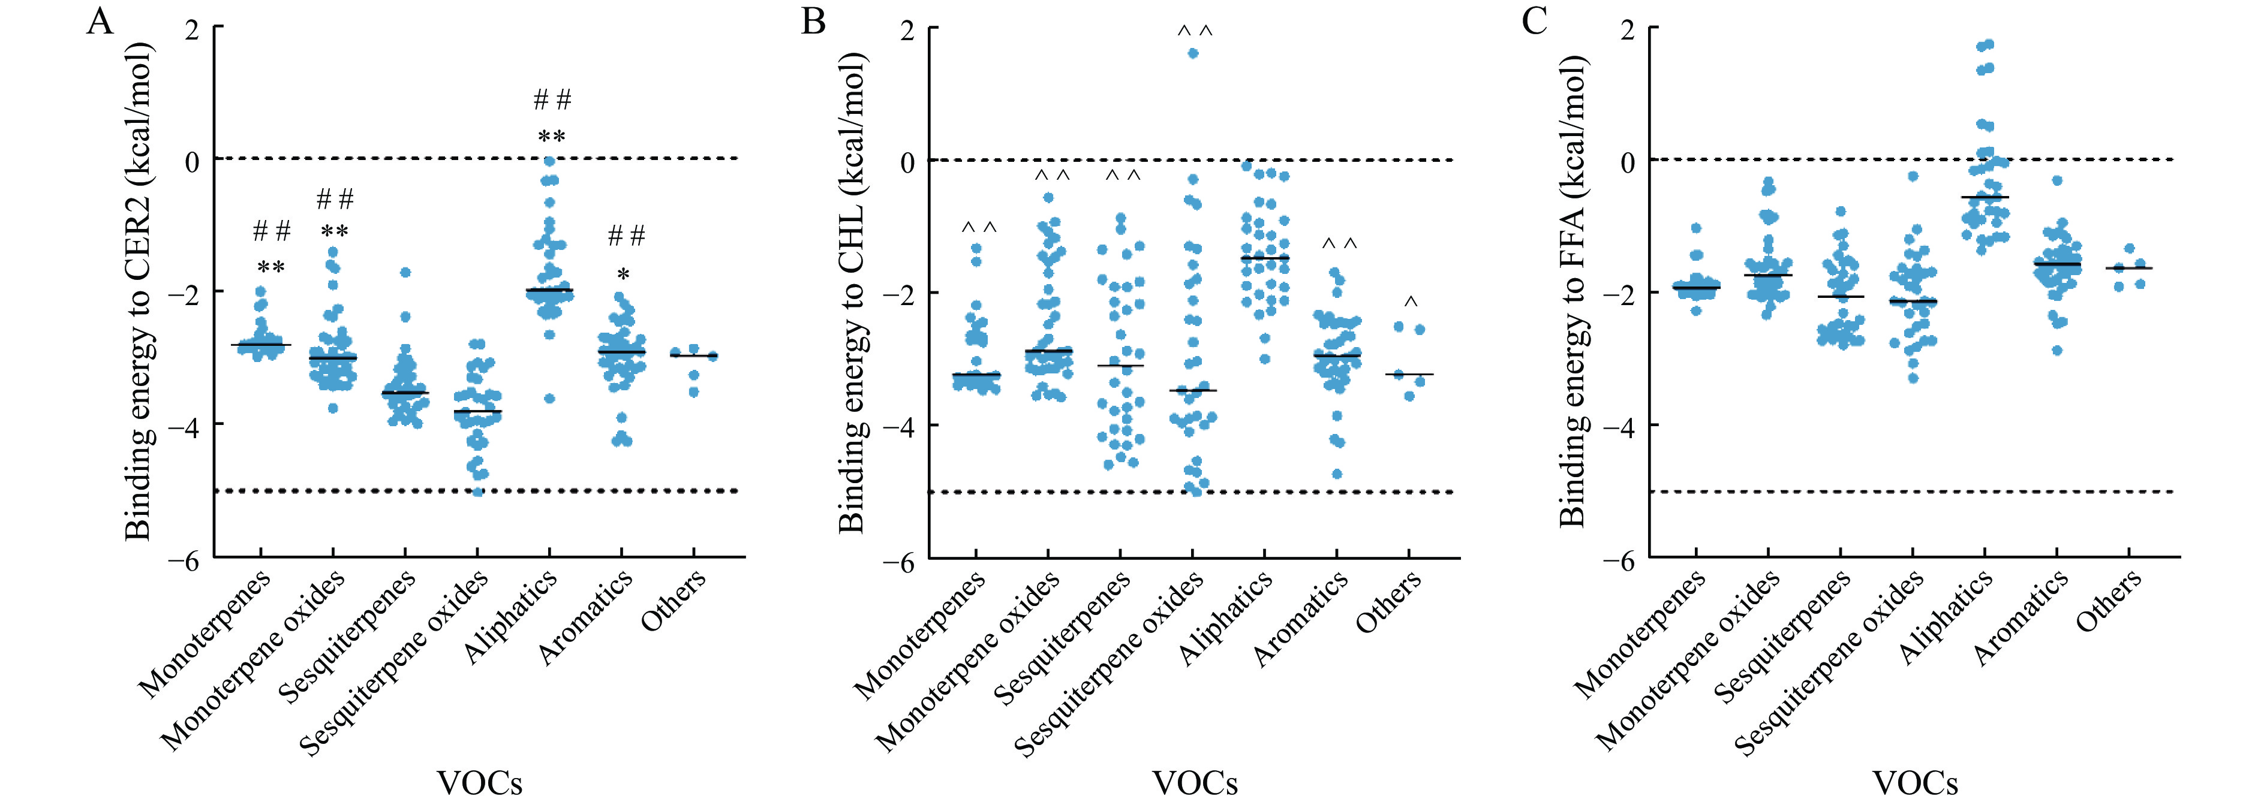
Fig. 3 Binding energy of various VOCs to three skin lipid molecules
A, CER2. B, CHL. C, FFA. *P < 0.05 and **P < 0.01, compared with sesquiterpenes. ##P < 0.01, compared with sesquiterpenes oxides. ^ < 0.05 and ^^P < 0.01, compared with aliphatic.
3.1.2 The docking sites and HB generation of VOCs and CER2
Previous research showed that the HB between VOCs and CER2 was stable when the bond length was less than 2 Å ^{[20]}. Accordingly, the frequency and ratio of docking sites and HB generation between each type of VOC and CER2 were analyzed.
Overall, 75.2% of the VOCs could bind to the head group of CER2, primarily including monoterpene oxides, sesquiterpene oxides, aromatics, aliphatics, and other VOCs (Table 1). Only 15.2% of the VOCs bonded to the head group of CER2 and were unable to form HB, indicating that HB plays a major role during the VOCs’ binding with the head group of CER2. In addition, 24.8% of the VOCs, mainly monoterpenes and sesquiterpenes, bonded to the tail chain of CER2 in a non-HB form, suggesting that there is no HB force between these VOCs and less than CER2.

Table 1 Molecular docking sites and HB types between various VOCs and CER2
Docking site | HB type | Monoterpene | Monoterpene oxide | Sesquiterpene | Sesquiterpene oxide | Aromatic | Aliphatic | Other | Subtotal | Total
Head group | No HB | 10 | 0 | 15 | 1 | 1 | 4 | 1 | 32 (15.2%) | 75.2%
Head group | Stable HB | 0 | 11 | 0 | 15 | 15 | 15 | 1 | 57 (27.1%) | 75.2%
 | Unstable HB | 0 | 27 | 0 | 14 | 17 | 9 | 2 | 69 (32.9%)
Tail chain | No HB | 17 | 2 | 19 | 3 | 5 | 5 | 1 | 52 (24.8%) | 24.8%
 | Stable HB | 0 | 0 | 0 | 0 | 0 | 0 | 0 | 0
 | Unstable HB | 0 | 0 | 0 | 0 | 0 | 0 | 0 | 0

3.2 Molecular docking results of VOCs with CHL
3.2.1 Binding energy results
The binding energy of the 209 VOCs with CHL were all less than 0, indicating that, they can spontaneously bind to CHL molecules (Figure 3B). Except for curcumol, the sesquiterpene oxide VOCs had a binding energy greater than 0, which was 1.61 kcal/mol. The distribution of binding energy among VOCs of the same types was relatively dispersed, and the discrepancy of the binding energy between VOCs remained small. However, the aliphatic VOCs were significantly weaker in binding affinity to CHL compared with all types of VOCs (P < 0.05).
3.2.2 The docking sites and HB generation of VOCs and CHL
A total of 88.6% of the VOCs bonded to the hydrophobic part of CHL, without HB between them (Table 2). It is speculated that the VOCs may bind to the hydrophobic part of CHL molecules by van der Waals forces. In addition, 11.4% of the VOCs bonded to the head group of CHL, and none of them could form stable HB, indicating that van der Waals forces are still dominant in the binding of VOCs to the head group of CHL.

Table 2 Molecular docking sites and HB types between various VOCs and CHL
Dockingsite | HB type | Monoterpene | Monoterpeneoxide | Sesquiterpene | Sesquiterpeneoxide | Aromatic | Aliphatic | Other | Subtotal | Total
Head group | No HB | 0 | 2 | 7 | 4 | 0 | 4 | 0 | 17 (8.1%) | 11.4%
Head group | Stable HB | 0 | 1 | 0 | 1 | 2 | 2 | 1 | 7 (3.3%) | 11.4%
 | Unstable HB | 0 | 0 | 0 | 0 | 0 | 0 | 0 | 0
Tail chain | No HB | 27 | 37 | 27 | 28 | 36 | 27 | 4 | 186 (88.6%) | 88.6%
 | Stable HB | 0 | 0 | 0 | 0 | 0 | 0 | 0 | 0
 | Unstable HB | 0 | 0 | 0 | 0 | 0 | 0 | 0 | 0

3.3 Molecular docking results of VOCs with FFA
3.3.1 Binding energy results
The binding energy of most VOCs docked with FFA was less than 0 (Figure 3C). However, eight aliphatic VOCs (linoleic acid, methyl palmitate, palmitic acid, oleic acid, stearic acid, octyl formate, lauric acid, and ethyl dodecanoate), had binding energy with FFA greater than 0. The distribution of binding energy among VOCs of the same type was relatively concentrated, and the binding affinity of various types of VOCs with FFA varied, but they were generally poor.
3.3.2 The docking sites and HB generation of VOCs and FFA
Overall, 93.8% of the VOCs bonded to the hydrophobic part of FFA, and there was no HB, indicating that most VOCs can bond in the hydrophobic part of FFA in the form of non-hydrogen (Table 3). In addition, 6.2% of VOCs could bind to the head group of FFA by HB in a relatively stable manner.

Table 3 Molecular docking sites and HB types between various VOCs and FFA
Dockingsite | HB type | Monoterpene | Monoterpeneoxide | Sesquiterpene | Sesquiterpeneoxide | Aromatic | Aliphatic | Other | Subtotal | Total
Head group | No HB | 0 | 0 | 0 | 0 | 0 | 0 | 0 | 0 | 6.2%
Head group | Stable HB | 0 | 3 | 0 | 0 | 1 | 2 | 0 | 6 (2.9%) | 6.2%
 | Unstable HB | 0 | 1 | 0 | 0 | 4 | 2 | 0 | 7 (3.3%)
Tail chain | No HB | 27 | 36 | 34 | 33 | 33 | 29 | 5 | 197 (93.8%) | 93.8%
 | Stable HB | 0 | 0 | 0 | 0 | 0 | 0 | 0 | 0
 | Unstable HB | 0 | 0 | 0 | 0 | 0 | 0 | 0 | 0

The binding affinity of VOCs to CER2 was significantly correlated with the type of VOCs. Moreover, the sesquiterpene oxide VOCs showed more prominent binding affinity to CER2. Meanwhile, some of the sesquiterpene oxide VOCs also showed outstanding binding affinity to CHL. Among the other VOCs bonded to CHL, no significant discrepancy was observed between different types except for the aliphatic VOCs, which indicated significantly poor binding affinity (P < 0.01). Besides, the binding affinity of VOCs to FFA was generally poor.
3.4 Analysis of binding affinity for VOCs with different numbers of intramolecular rings to lipids
Rings are important scaffolding elements of molecular structure. Recent studies have shown that different rings in the structure of drug molecules have a certain correlation with their biological activities and lipophilicity ^{[21, 22]}. Therefore, this study analyzed the discrepancy in the binding energy of VOCs with different numbers of intramolecular rings to three skin lipid molecules to explore the relationship between the structure of VOCs and their binding affinity to lipids. The results are as follows.
3.4.1 Analysis of binding affinity for VOCs with different numbers of intramolecular rings to CER2
The average binding energy of VOCs can be ranked from low to high as four-ring, three-ring, double-ring, single-ring, and ringless (Figure 4A). The binding energy of ringless VOCs to CER2 was distributed near 0, demonstrating weak binding affinity. The VOCs with intramolecular rings exhibited significantly stronger binding affinity compared with ringless VOCs (P < 0.01).
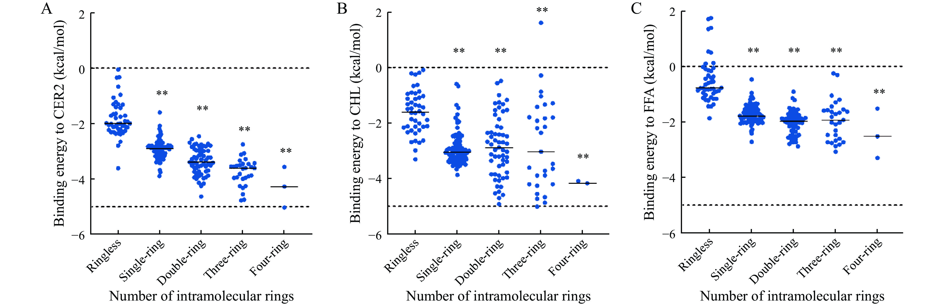
Fig. 4 Binding energy of VOCs with different numbers of intramolecular rings to three skin lipid molecules
A, CER2. B, CHL. C, FFA. **P < 0.01, compared with ringless.
3.4.2 Analysis of binding affinity for VOCs with different numbers of intramolecular rings to CHL
The average binding energy of VOCs can be ranked from low to high as four-ring, three-ring, double-ring, single-ring, and ringless (Figure 4B). The VOCs without intramolecular rings showed poor binding affinity to CHL while most of the single-ring VOCs had strong binding affinity to CHL (P < 0.01). The distribution of the binding energy among double-ring and three-ring VOCs was relatively dispersed, with marked differences in the binding energy compared with ringless VOCs (P < 0.01). The four-ring VOCs demonstrated a stronger binding affinity to CHL compared with other VOCs (P < 0.05).
3.4.3 Analysis of binding affinity for VOCs with different numbers of intramolecular rings to FFA
The binding affinity of VOCs to FFA remained weak, but the binding affinity of VOCs with intramolecular rings to FFA was still stronger than that of ringless VOCs (P < 0.01, Figure 4C).
In summary, the discrepancy in binding affinity of VOCs with different numbers of intramolecular rings to CER2 was the most obvious, and it gradually increased with the increasing number of intramolecular rings. Regarding the binding affinity of VOCs with CHL and FFA, it can be summarized as follows. (i) The ringed VOCs showed significantly stronger binding affinity than the ringless VOCs. (ii) The four-ring VOCs exhibited stronger binding affinity than the other VOCs. (iii) The differences among the other VOCs were not significant.
CHEN et al. ^{[23]} found that the enhancement ratio of oxygenated terpenoids, determined by skin resistance kinetics, was proportional to the stability of oxygenated terpenoid-CER2 complexes in molecular docking. We hypothesized that the higher the number of rings in VOCs, the stronger their affinity to interference with the lipids of the skin stratum corneum, and thus the better the penetration-enhancing effect. Meanwhile, it has also been suggested that the binding of cyclic terpenoids to CER2 can facilitate the penetration of hydrophilic drugs through the stratum corneum ^{[24]}.
3.5 Cluster analysis
CER2, which accounts over 50% of stratum corneum lipids, is a key component in the composition of stratum corneum lipids and in the formation of the epidermal penetration barrier of the skin ^{[25, 26]}. Therefore, in this section, the number of HB formed with CER2 and structural characteristics of VOCs with strong binding affinity to CER2 are investigated using clustering methods. Furthermore, the penetration-enhancing mechanisms of VOCs can be explored at the level of molecular interactions.
The VOCs that bonded well to CER2 were mainly classified into two categories: VOCs I and VOCs II (Figure 5). The VOCs in both categories mainly have 2 – 3 intramolecular rings. Most of the VOCs contained no oxygen atoms and did not bind to CER2 in the form of HB, with a binding energy range from – 3.5 to – 4.25 kcal/mol. A majority of VOCs II had one or two oxygen atoms and mainly bonded to CER2 through HB, with a binding energy range from – 3.51 to – 5.03 kcal/mol.
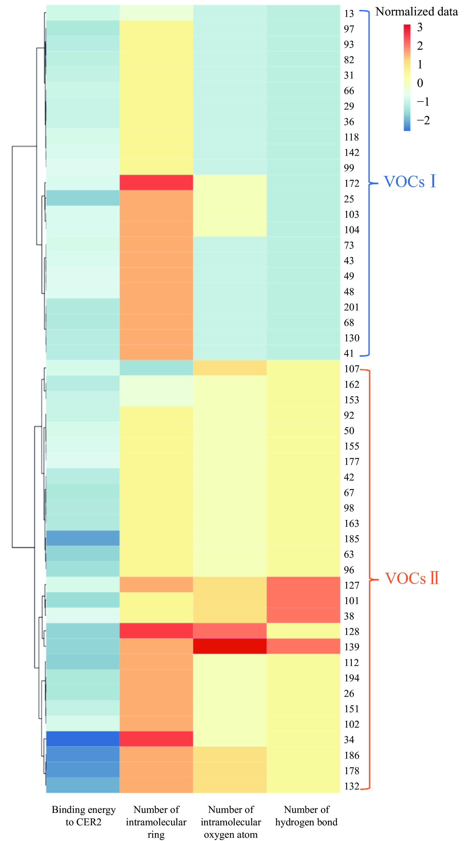
Fig. 5 Heatmap of VOCs with the binding energy to CER2 under – 3.5 kcal/mol
To further clarify the specific binding conformations of the two types of VOCs with CER2, the interactions within VOC-CER2 complexes were analyzed in this study. VOCs I bonded to the hydrophobic carbon atoms of CER2 by hydrophobic interaction (Figure 6A and 6B). VOCs II were bonded to CER2 by one HB, while having hydrophobic interaction with a portion of the carbon atoms of the hydrophilic head of CER2 (Figure 6C and 6D).
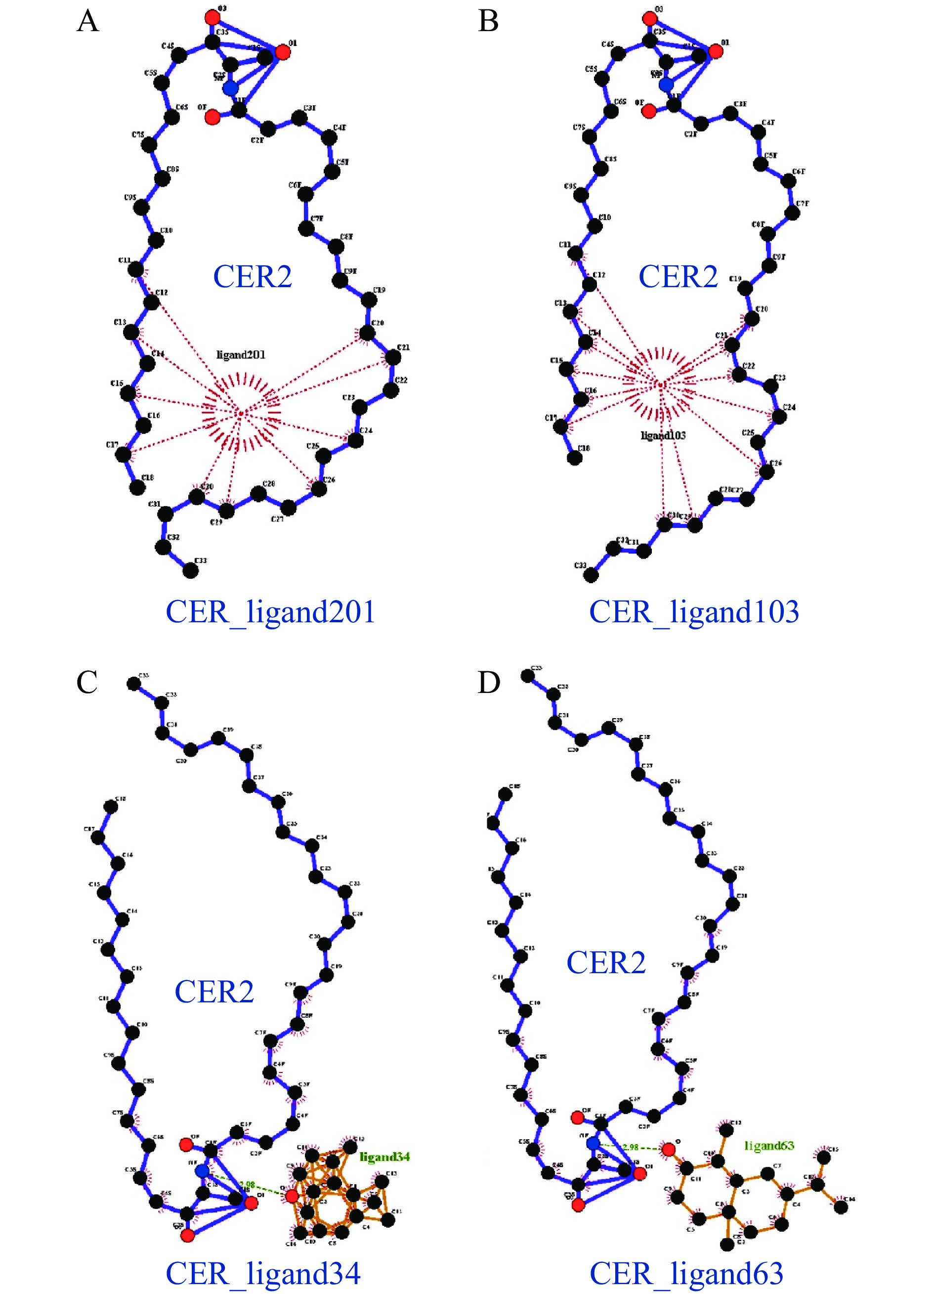
Fig. 6 Hydrophobic interactions between VOCs and CER2
A and B, hydrophobic interaction of No. 201 and No. 103 molecule with CER2 in VOCs I, respectively. C and D, hydrophobic interaction and hydrogen bond of No. 34 and No. 63 molecule with CER2 in VOCs II, respectively.
3.6 Analysis of oxygen-containing functional groups in VOCs II
The clustering analysis results indicate that VOCs II can form HB with CER2 due to the presence of oxygen atoms, but there are some differences in the binding energy with CER2 among VOCs II. Therefore, in this section, the different oxygen-containing functional groups of VOCs II are further analyzed.
Among VOCs II, the hydroxyl group had the highest proportion, followed by cyclic ketones, cyclic esters, and cyclic ethers (Figure 7). In the binding energy distribution, the average binding energy of cyclic esters was the lowest, while the average binding energy of the alcohol hydroxyl group was relatively high and more concentrated. The binding energy of VOCs containing phenolic hydroxyl groups, alkenyl ethers, and ether bonds were all less than – 4 kcal/mol, and the average binding energy of cyclic ketones and cyclic ethers was close to – 4 kcal/mol. In summary, VOCs containing the structures of cyclic esters, cyclic ketones, and cyclic ethers may be prioritized when selecting volatile oil penetration enhancers with oxygen-containing structures.
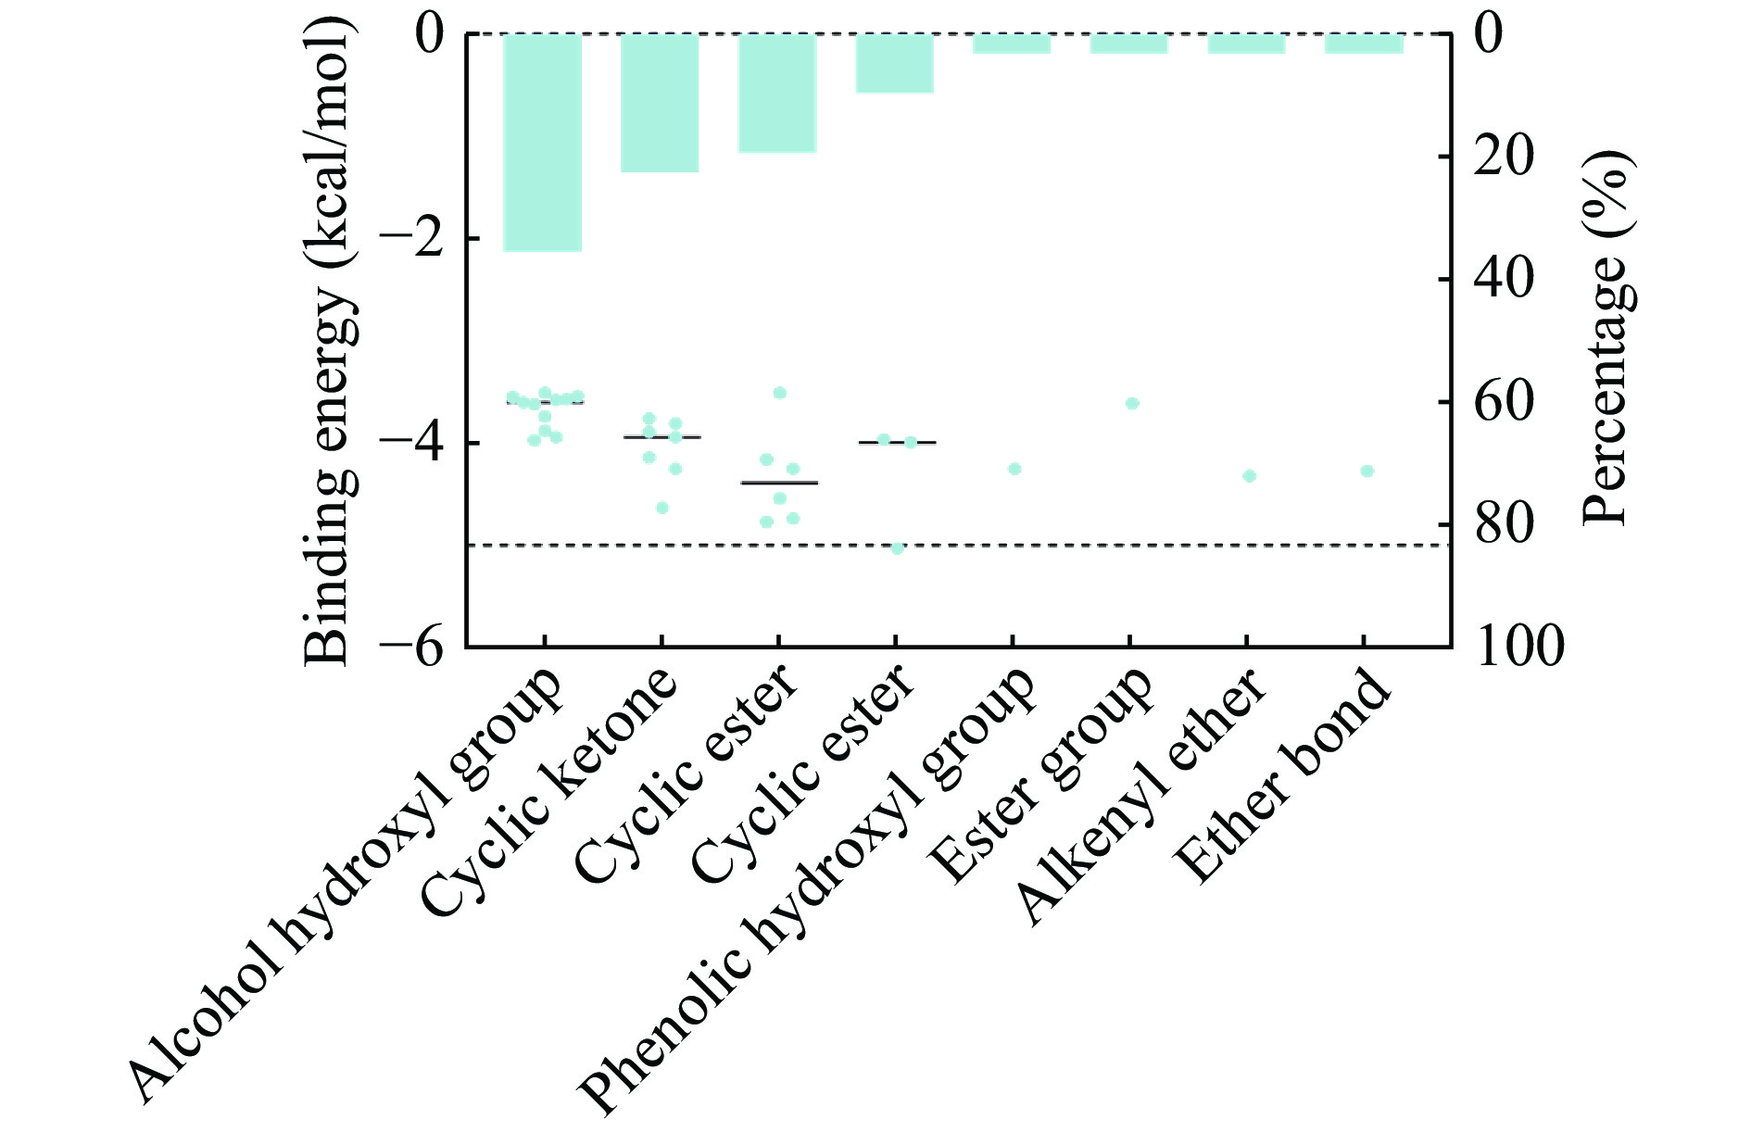
Fig. 7 Percentage of oxygenated functional groups in VOCs II and their binding energy distributions
The blue dots are the distribution of binding energy of VOCs II to CER2, corresponding to the left Y axis. The blue column is the percentage of oxygen-containing functional groups in VOCs, corresponding to the right Y axis.
For example, the volatile oil of Angelica sinensis contains α-aromatone, No. 63 VOC, which has a cyclic ketone structure in its molecule. It has a certain penetration-enhancing effect on acetaminophen and indomethacin in rat skin. Besides, the volatile oil of Angelica sinensis contains (Z)-ligustilide and No. 38 VOC, which have a cyclic ester structure in its molecule. It has a penetration-enhancing effect on Pueraria lobata, tanshinone II A, and ginsenoside Rg1 in mouse skin ^{[27, 28]}.
3.7 Results of in vitro penetration experiments by the Franz diffusion cell method
3.7.1 The standard curve of gastrodin
The resulting linear regression model was found to be statistically significant, with an r² value of 0.999 7. The equation for this model is as follows: Y = 11.109 X + 10.614.
3.7.2 Results of in vitro permeation enhancement
Both nootkatone and 3-butylidenephthalide showed pro-penetration effects on gastrodin. Among them, nootkatone increased the Q₁₂ of gastrodin by 21-fold and is expected to be an efficient penetration enhancer (P < 0.01). It is proposed that VOCs that have strong binding affinity to CER2 are likely to have a penetration-enhancing effect (Figure 8 and Table 4).
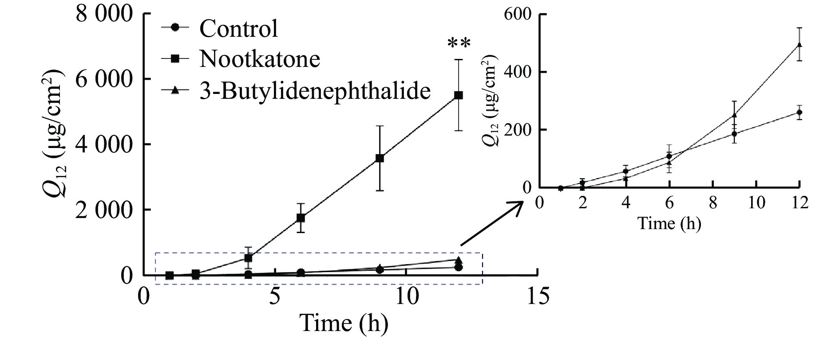
Fig. 8 The penetration-enhancing effects of 3-butylidenephthalide and nootkatone for gastrodin
**P < 0.01, compared with Control group.

Table 4 The penetration-enhancing effects of 3-butylidenephthalide and nootkatone for gastrodin
Group | Q₁₂ (μg/cm²) | J_{s} [μg/(cm²·h)] | ER
Control | 260.60 ± 25.09 | 24.01 | 1.00
Nootkatone | 5 503.00 ± 1 080.00** | 517.00 | 21.12
3-Butylidenephthalide | 495.40 ± 56.98 | 44.24 | 1.90

4 Discussion
As the main barrier for transdermal absorption of drugs, stratum corneum consists of keratinocytes and intercellular lipids where VOCMM plays the role of penetration enhancers to help the drugs pass through the stratum corneum ^{[11, 29]}. The intercellular lipids are composed of approximately 50% CER2, 25% CHL, 15% FFA, and a very small amount of phospholipids and other lipids ^{[30]}. Changes in the composition of the three lipid components can affect the skin barrier function in the following ways: (i) increased levels of short-chain CER2 would reduce skin barrier effects; (ii) decrease in CER2 and changes in some subclasses of CER2 would lead to abnormal skin function; (iii) a blockage in the synthesis or a decrease in the content of CHL can also lead to changes in skin function; (iv) an increase in the content of short-chain FFA and an elevation in the degree of unsaturation of FFA also affect the skin barrier function ^{[30, 31]}. In addition, changes in the ratio of the three lipid components would also cause abnormalities in skin barrier function.
Based on the above results, relevant studies have found the following possible mechanisms for the penetration-promoting effect of volatile oils: (i) volatile oils can affect the order of stratum corneum lipids to change the lipid mobility and destroy the integrity of the stratum corneum; (ii) alter the protein conformation of stratum corneum; (iii) decrease the interaction between the drug and stratum corneum lipids to promote the distribution of the drug in the stratum corneum; (iv) form hydrogen bonds with the hydrophilic groups of CER2, thus destroying the hydrogen-bonding network of stratum corneum and promoting the penetration of hydrophilic drugs ^{[32-35]}.
In this study, the molecular docking technique was adopted to investigate the differences in the binding affinity of various species and structural types of VOCs to the three skin lipid molecules. Among the VOCs, some sesquiterpene oxides showed strong binding affinity to the three skin lipid molecules. VOCs with intramolecular rings have significantly stronger binding affinity to the three lipid components than VOCs without intramolecular rings, and four-ring VOCs have significantly stronger binding affinity than other VOCs. Therefore, we hypothesize that the ring-forming VOCs in the structure are more readily bonded to the tail chain of CER2, altering the lipid arrangement order of the stratum corneum and strengthening the stratum corneum lipid mobility. Therefore, the ring-forming VOCs could have a better penetration-enhancing effect.
Further, we found that the VOCs with strong binding affinity to CER2 were broadly divided into two groups of VOCs I: with 2 − 3 rings in their structures and without oxygen atoms, which mainly bind to CER2 through hydrophobic interactions in the tail region of CER2. They might become trapped in stratum corneum lipids and alter the fluidity of lipids to promote penetration. VOCs II, with 2 − 3 rings in their structures but containing oxygen atoms, mainly bind to the nitrogen atoms in the head group of CER2 through an HB and have hydrophobic interactions with some carbon atoms near the head group. We hypothesized that VOCs II may reduce the skin barrier by destroying the hydrogen-bonding network (with different -OH and -NH groups) between the head of the CER2 molecules and the other skin lipid molecules in the hydrophilic region of the bilayer ^{[36]}. In the present validation experiment, the log P of gastrodin was − 1.99, indicating it is a hydrophilic drug ^{[37]}. Nootkatone may be efficiently penetration-enhancing through the above mechanism. Therefore, we assumed that VOCs II could facilitate the transdermal penetration of hydrophilic drugs. Finally, the analysis of VOCs II containing oxygen atoms demonstrated that the VOCs with cyclic esters, cyclic ketones, and cyclic ethers have a stronger affinity to bind with CER2. The study only elucidated the differences in the binding affinity of VOCs with different oxygen-containing functional groups to CER2 and did not provide an adequate explanation in terms of the mechanism. Therefore, future research is warranted to explore the interactions between different oxygen-containing functional groups and stratum corneum lipids through molecular dynamics simulations.
Study has shown that VOCMM and their constituents are promising and safe natural penetration enhancers ^{[38]}. However, VOCMM as mixtures usually exhibit a stronger and broader range of penetration-enhancing abilities than the individual components ^{[33, 39]}. Therefore, it is also of research interest to explore the synergistic effects among VOCs. SCHMITT et al. ^{[40]} revealed that limonene showed an enhancing effect on the penetration of citronellol and eugenol. These findings indicate that VOCs have transdermal penetration-enhancing effects on each other. Next, based on the results of this study, further investigations may be conducted to ascertain whether the simultaneous use of multiple VOCs with transdermal-enhancing effects results in a synergistic effect and to elucidate the underlying mechanisms of this effect.
5 Conclusion
VOCMMs can enhance the transdermal absorption of other drugs and hold promise for wide application in transdermal drug delivery for penetration enhancement. The results provide theoretical guidance and data support for screening volatile oil penetration enhancers. Meanwhile, this study also proposes a simple and rapid method for investigating the mechanism of volatile oils as penetration enhancers , which is of great significance for future studies on volatile oil penetration enhancers.

Competing Interests
The authors declare no conflict of interest.

References
- WANG YQ, YANG YZ, WU ZF, et al. Traditional function and modern research progress on volatile oil in Chinese materia medica. Chinese Traditional and Herbal Drugs, 2018, 49（2）: 455–461.
- LI Y, CHEN JS, GUO XJ, et al. Status Quo and analysis of volatile oil in Chinese medicine based on “unification of medicine and adjuvant”. Modern Chinese Medicine, 2022, 24（4）: 564–569.
- ZHANG JL, TAO L, GUAN YM, et al. Promoting effect of transdermal absorption of essential oils from Chinese materia medica and problem analysis in the study of topical preparations. Chinese Traditional and Herbal Drugs, 2017, 48（24）: 5263–5269.
- LAN Y, WU Q, MAO YQ, et al. Cytotoxicity and enhancement activity of essential oil from Zanthoxylum bungeanum Maxim. as a natural transdermal penetration enhancer. Journal of Zhejiang University Science B, 2014, 15（2）: 153–164.
- LIAO YY, GUO SJ, ZHOU Q, et al. Study on the difference of permeation effects of three sourced borneol on drugs with different molecular weights. Global Traditional Chinese Medicine, 2022, 15（7）: 1121–1125.
- ZHAO SN, ZHANG JL, LIU X, et al. External application of dandelion combined with borneol effectively reduced pain and facial swelling after jaw surgery. Medicine, 2023, 102（38）: e35258.
- RUAN SF, WANG ZX, XIANG SJ, et al. Mechanisms of white mustard seed （Sinapis alba L.） volatile oils as transdermal penetration enhancers. Fitoterapia, 2019, 138: 104195.
- LAN Y, LI H, CHEN YY, et al. Essential oil from Zanthoxylum bungeanum Maxim. and its main components used as transdermal penetration enhancers: a comparative study. Journal of Zhejiang University Science B, 2014, 15（11）: 940–952.
- YANG N, AI XY, CHENG K, et al. A compound essential oil alters stratum corneum structure, potentially promoting the transdermal permeation of hydrophobic and hydrophilic ingredients. Current Drug Delivery, 2024, 21（5）: 744–752.
- HERMAN A, HERMAN AP. Essential oils and their constituents as skin penetration enhancer for transdermal drug delivery: a review. The Journal of Pharmacy and Pharmacology, 2015, 67（4）: 473–485.
- CHEN J, LIU P, JIANG Q, et al. Current situation and future outlook on essential oils from Chinese materia medica as penetration enhancers. Chinese Traditional and Herbal Drugs, 2014, 45（24）: 3651–3655.
- LIANG LP. Percutaneous permeability enhancement of essential oil fructus viticis and volatile oil from cinnamom. Guangzhou: Guangdong Pharmaceutical University, 2018.
- REN J, WEI J. Application of molecular docking technology in Chinese materia medica research. Chinese Journal of Information on Traditional Chinese Medicine, 2014, 21（1）: 123–125.
- CHU TZ, XU H, YAN HL, et al. Enhancing effect and mechanism of volatile oil of 7 common Qi regulating medicine on penetration of ligustrazine. China Journal of Traditional Chinese Medicine and Pharmacy, 2023, 38（6）: 2878–2882.
- NAN LY, LIU C, LI QY, et al. Investigation of the enhancement effect of the natural transdermal permeation enhancers from Ledum palustre L. var. angustum N. Busch: mechanistic insight based on interaction among drug, enhancers and skin. European Journal of Pharmaceutical Sciences, 2018, 124: 105–113.
- CHEN Y, WANG J, CUN DM, et al. Effect of unsaturated menthol analogues on the in vitro penetration of 5-fluorouracil through rat skin. International Journal of Pharmaceutics, 2013, 443（1/2）: 120–127.
- KIM S, SHOEMAKER BA, BOLTON EE, et al. Finding potential multitarget ligands using PubChem. Methods in Molecular Biology, 2018, 1825: 63–91.
- SALA M, DIAB R, ELAISSARI A, et al. Lipid nanocarriers as skin drug delivery systems: properties, mechanisms of skin interactions and medical applications. International Journal of Pharmaceutics, 2018, 535（1/2）: 1–17.
- CHEN K, JIN C, CHENG YY, et al. Molecular mechanism of Spatholobi Caulis in treatment of lung cancer based on network pharmacology and molecular docking. China Journal of Chinese Materia Medica, 2021, 46（4）: 837–844.
- NARISHETTY STK, PANCHAGNULA R. Transdermal delivery of zidovudine: effect of terpenes and their mechanism of action. Official Journal of the Controlled Release Society, 2004, 95（3）: 367–379.
- HARITHA M, SURESH CH. Hydration patterns of rings in drugs and relationship to lipophilicity: a DFT study. Journal of Computational Chemistry, 2022, 43（7）: 477–490.
- ERTL P, ALTMANN E, RACINE S, et al. Ring replacement recommender: ring modifications for improving biological activity. European Journal of Medicinal Chemistry, 2022, 238: 114483.
- ZHU XM, LI Y, XU F, et al. Skin electrical resistance measurement of oxygen-containing terpenes as penetration enhancers: role of stratum corneum lipids. Molecules, 2019, 24（3）: 523.
- SCHAFER N, BALWIERZ R, BIERNAT P, et al. Natural ingredients of transdermal drug delivery systems as permeation enhancers of active substances through the stratum corneum. Molecular Pharmaceutics, 2023, 20（7）: 3278–3297.
- JIA Y, GAN Y, HE CF, et al. The mechanism of skin lipids influencing skin status. Journal of Dermatological Science, 2018, 89（2）: 112–119.
- UCHIDA Y, PARK K. Ceramides in skin health and disease: an update. American Journal of Clinical Dermatology, 2021, 22（6）: 853–866.
- ZHAO TT, ZHANG T, XIANG LY, et al. Percutaneous permeability enhancement of volatile oils from Angelica sinensis and Eugenia caryophyllata. Chinese Traditional Patent Medicine, 2016, 38（9）: 1923–1929.
- WANG FX, QIAN Q, LI BL, et al. Research progress on chemical constituents and pharmacological effects of CyperiRhizoma and predictive analysis on its quality marker （Q-Marker）. Chinese Traditional and Herbal Drugs, 2022, 53（16）: 5225–5234.
- KUMAR S, ZAKREWSKY M, CHEN M, et al. Peptides as skin penetration enhancers: mechanisms of action. Journal of Controlled Release, 2015, 199: 168–178.
- JIA L, JIA Y, CHENG ZW, et al. Advancement in maintaining skin barrier—secretion and composition of lipid. The Chinese Journal of Dermatovenereology, 2016, 30（6）: 640–643.
- CHEN XQ, LIANG BH, LI HP, et al. The research progress in the stratum corneum structure and function. Journal of Diagnosis and Therapy on Dermato-Venereology, 2020, 27（1）: 53–56.
- GAO XC, TONG Y. Effect of wintergreen oil on in vitro transdermal permeation of osthole and geniposide. China Journal of Chinese Materia Medica, 2017, 42（7）: 1338–1343.
- LIU XY, XU LY, WANG YJ, et al. Effect and mechanism of essential oil from Zanthoxylum bungeanum in microemulsion gel preparation on percutaneous delivery of complex components. China Journal of Chinese Materia Medica, 2019, 44（21）: 4627–4633.
- GU Q, ZHU XM, WEI XC, et al. Effect of hot or warm property on skin toxicity of essential oil as penetration enhancer and its mechanism. China Journal of Chinese Materia Medica, 2021, 46（2）: 359–365.
- CHU TZ, WANG CY, WANG J, et al. Chiral 4-O-acylterpineol as transdermal permeation enhancers: insights of the enhancement mechanisms of a transdermal enantioselective delivery system for flurbiprofen. Drug Delivery, 2020, 27（1）: 723–735.
- GARCÍA-ARRIBAS AB, ALONSO A, GONI FM. Cholesterol interactions with ceramide and sphingomyelin. Chemistry and Physics of Lipids, 2016, 199: 26–34.
- GUO KK, WANG X, HUANG BL, et al. Comparative study on the intestinal absorption of three gastrodin analogues via the glucose transport pathway. European Journal of Pharmaceutical Sciences, 2021, 163: 105839.
- CARREÑO H, STASHENKO EE, ESCOBAR P. Essential oils distilled from colombian aromatic plants and their constituents as penetration enhancers for transdermal drug delivery. Molecules, 2023, 28（6）: 2872.
- LI Y, YAO JH, SHU YT, et al. Comparative study of penetration-enhancing effect in vitro of cinnamon oil and cinnamaldehyde on ibuprofen. China Journal of Chinese Materia Medica, 2018, 43（17）: 3493–3497.
- SCHMITT S, SCHAEFER UF, DOEBLER L, et al. Cooperative interaction of monoterpenes and phenylpropanoids on the in vitro human skin permeation of complex composed essential oils. Planta Medica, 2009, 75（13）: 1381–1385.

