Screening influencing factors of blood stasis constitution in traditional Chinese medicine
ZHOU Xiaoying¹, YANG Shengwen², OU Jintao³, WANG Zhuo⁴, WANG Guangrong³, LUO Yue^{1, *}

1. School of Medical Information Engineering, Chengdu University of Traditional Chinese Medicine, Chengdu, Sichuan 611137, China
2. Department of Traditional Chinese Medicine, The Fourth People's Hospital of Jinniu District, Chengdu, Sichuan 610081, China
3. Chinese Internal Medicine, Yilong Hospital of Traditional Chinese Medicine, Chengdu, Sichuan 637600, China
4. Department of Traditional Chinese Medicine, Xi'an Road Community Health Service Center of Jinniu District, Chengdu, Sichuan 610011, China

*Corresponding author: Associate Professor, E-mail: luoyue@cdutcm.edu.cn.
Manuscript received 2022-2-1; accepted 2022-3-14;
available online 2022-6-25.

[Abstract] Objective To study the influencing factors of blood stasis constitution and provide a basis for treating blood stasis-related diseases by traditional Chinese medicine (TCM) constitution identification. Methods Data were collected using the self-developed TCM constitution identification platform based on B/S model by the project team. The obtained data were divided into blood stasis constitution and normal constitution groups. The differences of the categorical type influencing factors (gender, birth mode, feeding mode within four months of birth, family history, marital status, eating habits, sleeping habits, exercise habits, emotional state, stress situation, and living environment) and the quantitative type influencing factors (sleep time, age, and mother's age at birth) on the constitution of the two groups were analyzed. In the single-factor analysis, the Pearson's chi-square test was selected for the categorical variable, and the independent sample t test and Mann-Whitney U nonparametric test were selected for the quantitative variables according to whether they conformed to the positive-terrestrial distribution; the binary logistic stepwise regression method was selected for the multi-factor analysis. Results The data of 318 cases were collected from the TCM composition identification platform, and 159 cases of blood stasis constitution were used as the experimental group and 159 cases of normal constitution were used as the control group. The Pearson's chi-square test yielded significant differences (P < 0.05) in the effects of gender, pressure situation, family history, living environment, emotional state, exercise habits, and dietary habits on blood stasis constitution. The independent samples t test yielded differences in sleep duration between the blood stasis constitution and normal constitution populations (P < 0.05), which meant sleep duration of the blood stasis constitution population was less than that of the normal constitution population. The Mann-Whitney U nonparametric test results accepted the original hypothesis that there was no difference in the distribution of age and mother’s age at birth across constitution types (P > 0.05). Binary logistic regression analysis showed that gender, family history, marital status, living environment, exercise habits, and emotional state were risk factors for blood stasis constitution (P < 0.05). Conclusion Gender, family history, living environment, emotional state, and exercise habits were significant influencing factors of blood stasis constitution. Blood stasis constitution populations can pay more attention to these influencing factors in their daily life for the prevention and reconciliation of blood stasis constitution.

[Key words] Blood stasis constitution; Screening influencing factors; Pearson’s chi-square test; Nonparametric test; Binary logistic stepwise regression
[DOI] 10.1016/j.dcmed.2022.06.006

1 Introduction
Blood stasis constitution is one of the nine divisions of the Chinese medicine constitution proposed by WANG Qi ^{[1]}, the founder of China's constitution theory. Adjustments to diet structures and changes in living habits have led to an increase in blood viscosity, and the phenomenon of blood stasis has become increasingly apparent ^{[2]}. Many studies have shown that blood stasis constitution is related to coronary heart disease, ischemic stroke, dysmenorrhea, polycystic ovary syndrome, malignant tumors, and other diseases, which seriously threaten people's physical health and safety ^{[3-5]}. In addition, a study has shown that blood stasis impacts mental health and is one of the main factors of reducing the quality of life in the psychological field ^{[6]}. The above studies have fully demonstrated the degree of danger of blood stasis constitution. However, most of the experimental studies are based on a particular disease ^{[7]}, and the scope of influence is limited. There are few studies on the analysis of more comprehensive influencing factors of blood stasis constitution. To obtain more reliable analysis results, pure blood stasis constitution data were selected, and the research methods were chosen according to the types of influencing factors. The research model with the best prediction effect was selected after evaluating the comprehensive utility of the method through multiple simulation experiments. Our study is to provide theoretical support for treating blood stasis by traditional Chinese medicine (TCM) through reliable data analysis, and to provide clinical guidance for people with blood stasis constitution to “prevent diseases before they occur, prevent degeneration due to diseases”.
2 Data and methods
2.1 General information
Data were collected through the project team self-developed TCM constitution identification platform based on B/S model from September 9, 2020 to February 18, 2021, and identification was conducted according to the standard of Classification and Determination of Physical Constitutions in TCM ^{[8]} issued by the National Administration of Traditional Chinese Medicine. The obtained data were divided into blood stasis constitution group and normal constitution group. This study was approved by the Ethics Committee of Hospital of Chengdu University of Traditional Chinese Medicine (2022KL-024).
2.2 Inclusion and exclusion criteria
2.2.1 Inclusion criteria
(i) Aged between 18 and 65 years; (ii) healthy and sub healthy populations; and (iii) informed consent of those whose data were collected and who were willing to contribute information.
2.2.2 Exclusion criteria
(i) Suffering from diseases, such as hypertension and diabetes mellitus; and (ii) pregnant and lactating women.
2.3 Observed indicators
The selected observations were divided into two groups based on their types: (i) categorical variables (gender, birth mode, feeding mode within four months of birth, family history, marital status, eating habits, sleeping habits, exercise habits, emotional state, stress situation, and living environment); (ii) quantitative variables (sleep time, age, and mother's age at birth). All the samples were from Chengdu distriction, thus regional factors were not considered.
2.4 Statistical methods
2.4.1 Pre-processing
Statistical software SPSS 21.0 was used for data quantification and preprocessing. Missing values and outliers were excluded, and count data were expressed as rates or composition ratios.
2.4.2 Single-factor analysis
In the univariate analysis, according to the classification of the study factors, 2 × 2 chi-square analysis and C×R chi-square analysis were applied to the definite class data according to their factor terms. The categorical frequencies of each influential factor were first weighted in the processing, and then the Pearson's chi-square test was performed sequentially. According to the interpretation guidelines of the Pearson's chi-square test results, the total number of samples was 318, which satisfied n was greater than 40 and the minimum sample size was greater than or equal to 5, and the results of the Pearson's chi-square test were selected. For continuous variables, the independent sample t test and Mann-Whitney U nonparametric test were used according to whether they conformed to the positive-terrestrial distribution.
2.4.3 Multifactor analysis
Multifactor analysis was performed by using a binary logistic regression model with the forward stepwise (likelihood ratio test) method with an entry criterion of 0.05 and an exclusion criterion of 0.1. The test level α was equal to 0.05. P < 0.05 was considered statistically significant.
3 Results
Data of 318 cases screened by inclusion and exclusion criteria from the TCM composition identification platform were used as the final study subjects, including 159 cases of blood stasis constitution as experimental group and 159 cases of normal constitution as control group. The single-factor analysis and multi-factor analysis were selected according to the type of observed indicators.
3.1 Pearson's chi-square test of classified variables
First, a single-group chi-square analysis was performed on the study of the participants’ gender, mode of birth, feeding pattern within four months of birth, family history, marital status, dietary habits, sleep habits, exercise habits, emotional state, stress situation, and living environment in relation to whether they had blood stasis constitution. The results are shown in Table 1 (only P < 0.05). The P value of Pearson's chi-square test showed significant differences in the effects of gender, stress situation, family history, living environment, emotional state, exercise habits, and dietary habits on blood stasis constitution (P < 0.05). The Cramer's V symmetric measures were 0.294, 0.276, 0.231, 0.160, 0.274, 0.232, and 0.226, respectively, all of which were weakly correlated. The correlations were ranked as gender > stress situation > emotional state > exercise habits > family history > dietary habits > residential environment.

Table 1 The percentage analysis and Pearson's chi-square test of the classification variables
Influencing factor | Classification item | Proportion of normal constitution（n = 159, %） | Proportion of blood stasis constitution（n = 159, %） | Chi-square test | Symmetric metric (Cramer's V)
Gender | Male | 56.00 | 27.00 | 0.000 | 0.294
Female | 44.00 | 73.00 |  |  | 0.294
Stress situation | Great stress | 4.40 | 5.70 | 0.000 | 0.276
High stress | 10.10 | 29.50 |  |  | 0.276
High stress | 52.20 | 47.80 |  |  | 0.276
High stress | 33.30 | 17.00 |  |  | 0.276
Family history of disease | Hypertension, diabetes | 3.20 | 14.50 | 0.000 | 0.231
Hypertension | 6.90 | 12.50 |  |  | 0.231
Hypertension | 89.90 | 73.00 |  |  | 0.231
Living environment | Dark and damp | 3.80 | 10.70 | 0.017 | 0.160
Dry | 4.40 | 8.20 |  |  | 0.160
Dry | 91.80 | 81.10 |  |  | 0.160
Emotional state | Sadness mostly | 3.10 | 10.10 | 0.000 | 0.274
Anger mostly | 3.10 | 6.90 |  |  | 0.274
Anger mostly | 6.30 | 13.80 |  |  | 0.274
Anger mostly | 25.20 | 9.40 |  |  | 0.274
Anger mostly | 62.30 | 59.80 |  |  | 0.274
Exercise habits | Exercise often | 30.80 | 17.60 | 0.000 | 0.232
Sometimes exercise | 40.30 | 31.40 |  |  | 0.232
Sometimes exercise | 28.90 | 51.00 |  |  | 0.232
Eating habits | Not special | 35.80 | 20.80 | 0.006 | 0.226
Prefer light | 23.30 | 16.40 |  |  | 0.226
Prefer light | 12.60 | 17.60 |  |  | 0.226
Prefer light | 4.40 | 8.70 |  |  | 0.226
Prefer light | 5.00 | 8.20 |  |  | 0.226
Prefer light | 18.90 | 28.30 |  |  | 0.226

Next，the proportion of the classification items of the influencing factors using Pearson's chi-square test was analyzed. The proportion of blood stasis constitution occurrence in women was 73.0%, while 27.0% in men, indicating that women are prone to blood stasis constitution than men. In the case of stress, those who experienced high and great stress accounted for 35.2% of blood stasis constitution cases, while 14.5% of the normal constitution cases, indicating that people with high stress levels are prone to blood stasis constitution. Those with a family history of hypertension and hypertension combined with diabetes mellitus accounted for 27.0% of blood stasis constitution cases, and 10.1% of the normal constitution cases, indicating that people with a family history of hypertension and diabetes mellitus are prone to blood stasis constitution. Those who live in dark, damp, and dry environments made up 18.9% of blood stasis constitution cases and 8.2% of the normal constitution cases, indicating that people who live in dark, damp, or dry environments for a long time are prone to blood stasis constitution. The percentage of people who were chronically sad, angry, and anxious accounted for 30.8% of blood stasis constitution cases and 12.5% of the normal constitution cases, indicating that people who are chronically sad, angry, and anxious are prone to blood stasis constitution. The percentage of people who exercise less accounted for 51.0% of blood stasis contitution cases and 28.9% of the normal constitution cases, indicating that people who exercise less are more prone to blood stasis constitution. Finally, the percentage of people who prefer spicy foods accounted for 28.3% of blood stasis constitution cases, and 18.9% of the normal constitution cases, indicating that people who prefer spicy food are prone to blood stasis constitution (Table 1).
3.2 Independent sample t test of sleep duration
The Q-Q plots of the sleep duration of participants with blood stasis constitution and those with normal constitution showed that the data points overlapped with the theoretical straight line, and the data followed normal distribution (Figure 1). An independent sample t test was used to determine whether there was a difference in the sleep duration of participants with blood stasis constitution and those with normal constitution, P < 0.05 indicated a significantly difference in sleep duration. Further comparison of the mean values revealed that the sleep duration of participants with normal constitution was greater than those with blood stasis constitution. Further details are provided in Table 2.
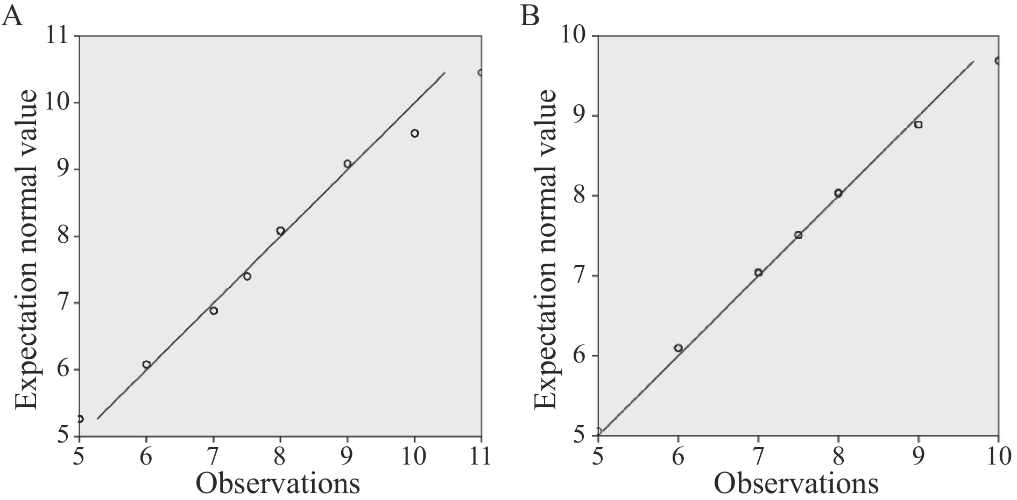
Fig. 1 Q-Q plot for normal distribution of sleep duration
A, Q-Q plot for normal distribution of sleep durationin in blood stasis constitution. B, Q-Q plot for normal distribution of sleep duration in normal constitution.

Table 2 Independent sample t test of sleep duration in people with blood stasis constitution and normal constitution
Constitution | Average value | t value | P value
Blood stasis constitution | 7.360 | 3.110 | 0.002
Normal constitution | 7.760 |  | 0.002

3.3 Nonparametric tests of age and mother's age at birth
The Q-Q plots of age and mother's age at birth data points did not overlap with the theoretical straight line, and the data did not conform to a positive distribution (Figure 2). Therefore, the Mann-Whitney U nonparametric test was used, yielding P (0.909) for age and P (0.946) for mother's age at birth (P > 0.05), accepting the original hypothesis that there were no differences in the distribution of age and mother's age at birth across constitution (Table 3).
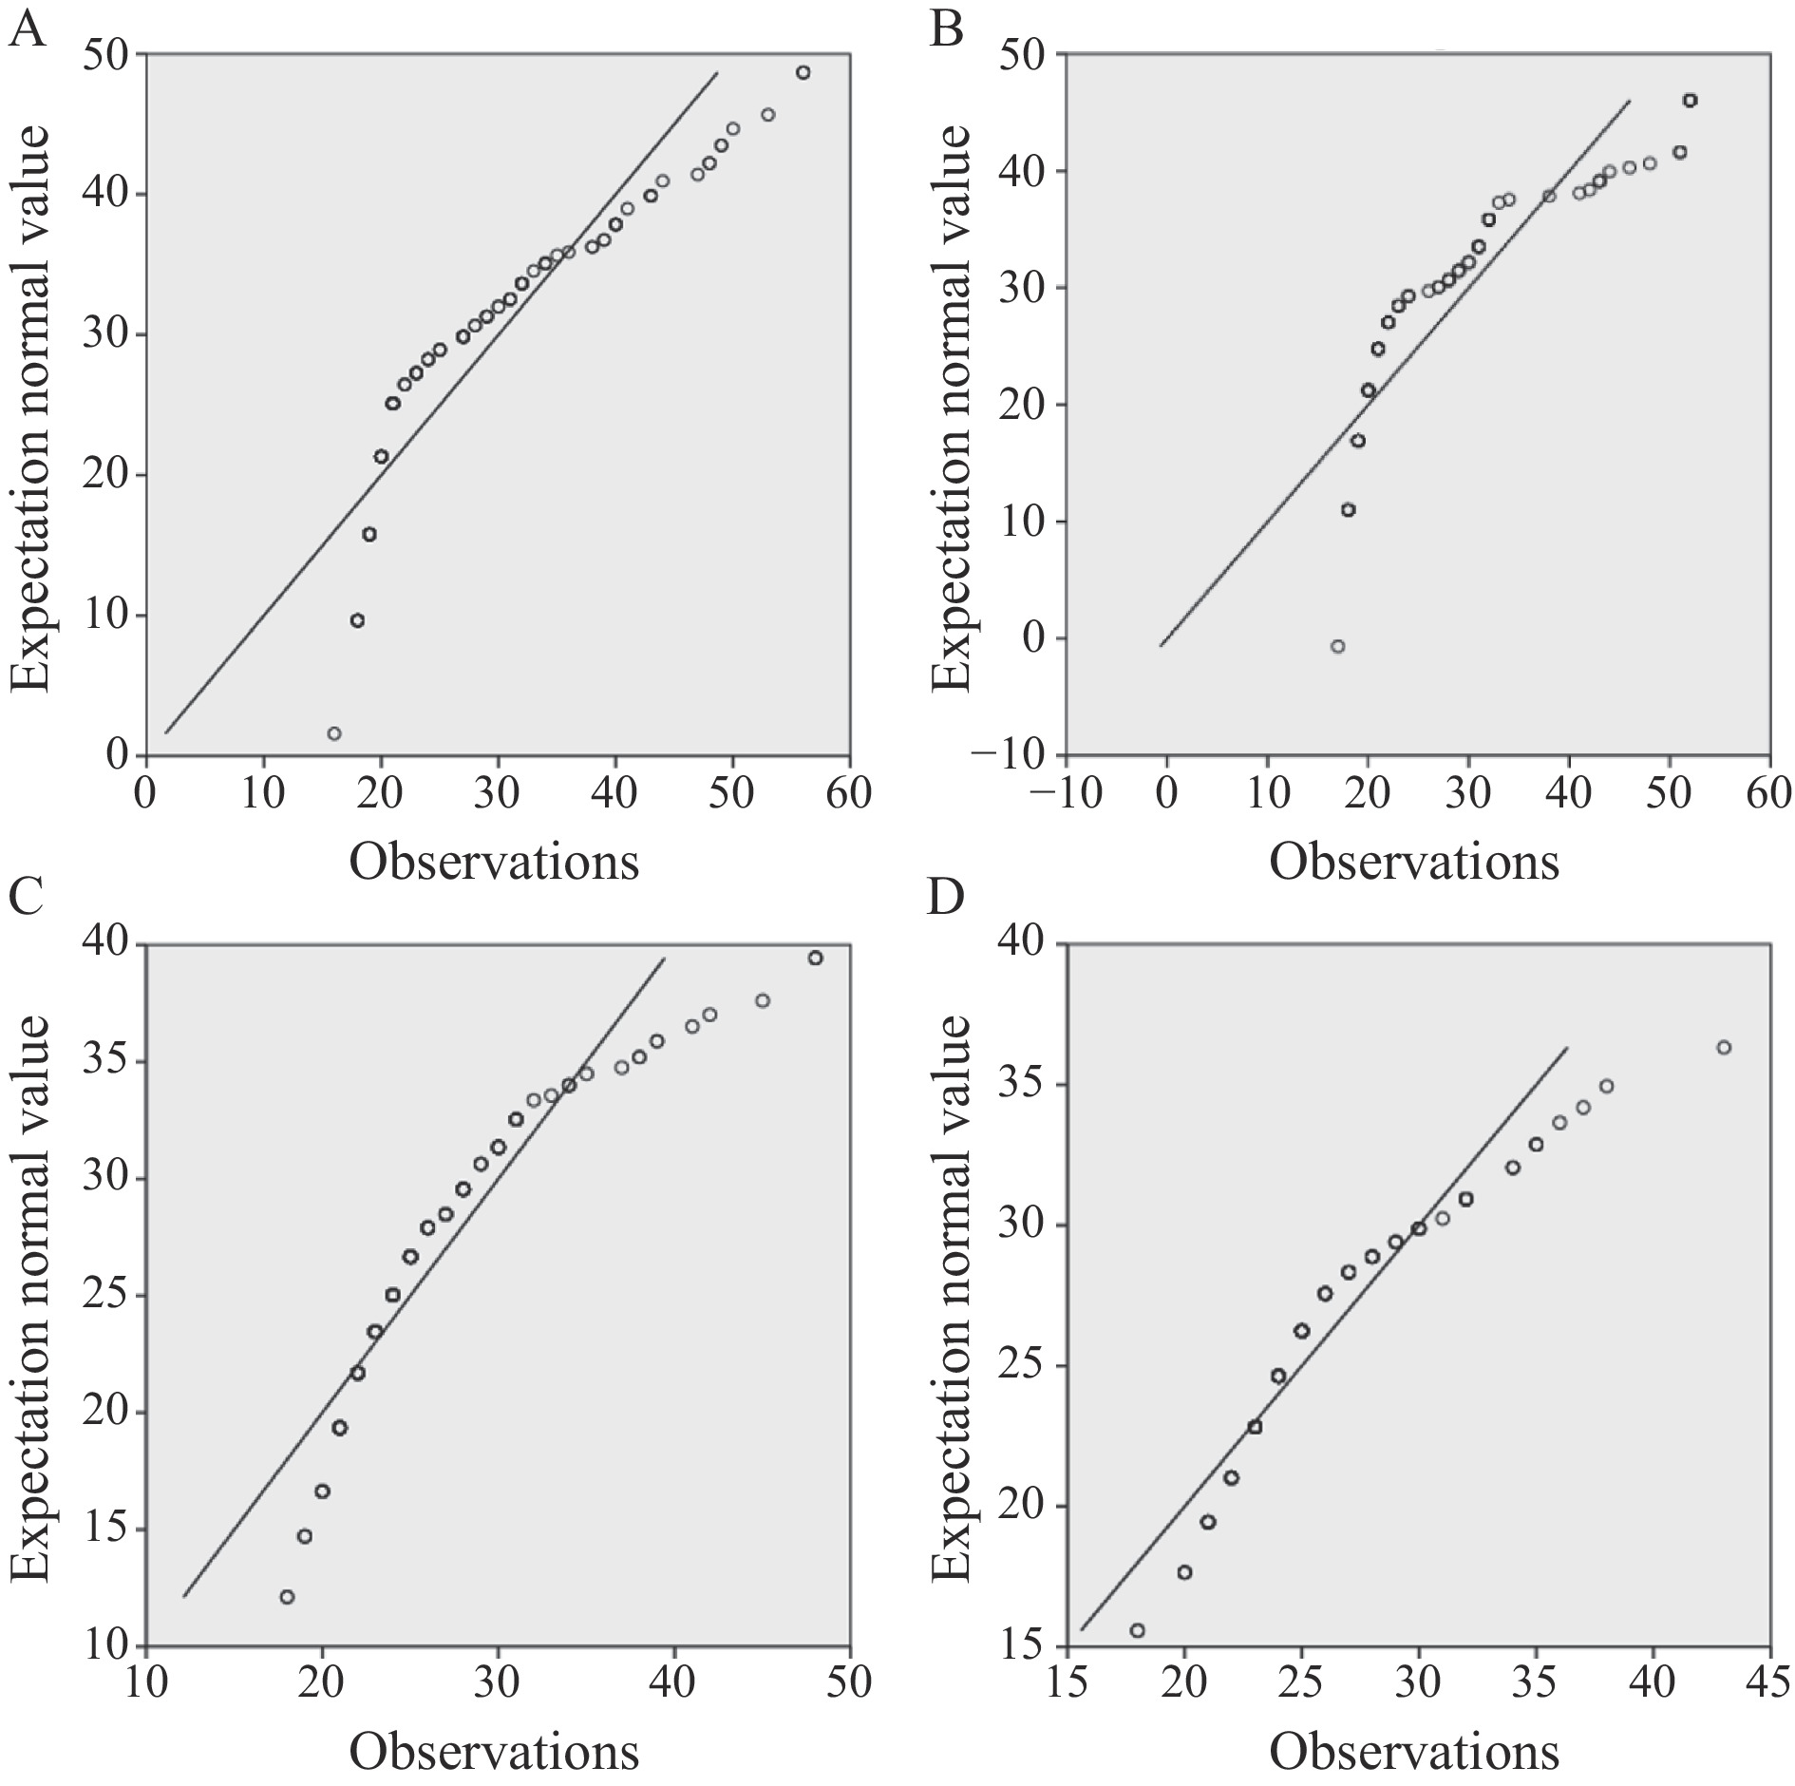
Fig. 2 Q-Q plot for non-normal distribution of age and mother's age at birth
A, Q-Q plot for non-normal distribution of age in normal constitution. B, Q-Q plot for non-normal distribution of age in blood stasis constitution. C, Q-Q plot for non-normal distribution of mother's age at birth in normal constitution. D, Q-Q plot for non-normal distribution of mother's age at birth in blood stasis constitution

Table 3 Nonparametric test results of age and mother's age at birth
Null hypothesis | P value
Age distribution is the same across different constitutions | 0.909
The same distribution of mother's age at birth across different constitutions | 0.946

3.4 Multifactor logistic analysis
3.4.1 Covariance diagnosis
Covariance diagnosis was performed before all impact factors of blood stasis constitution and normal constitution in the study model were included, and the results of the covariance statistics yielded tolerance (Tol)greater than 0.7 and variance inflation factor (VIF) less than 2 for all studied factors, which were far from the covariance reference value Tol less than 0.1, or variance inflation factor (VIF) greater than 10 (Table 4). It can be concluded that no covariance exists among the studied impact factors covariance, and the impact factors can be included in the binary logistic regression model.

Table 4 Analysis of covariance for all observations
Influencing factor | Tolerance (Tol) | Variance inflation factor (VIF）
Gender | 0.728 | 1.374
Sleep duration | 0.772 | 1.296
Age | 0.232 | 4.307
Mother’s age at birth | 0.899 | 1.112
Way of birth | 0.900 | 1.112
Feeding during the first four months of life | 0.941 | 1.063
Family history | 0.643 | 1.555
Marital status | 0.288 | 3.472
Eating habits | 0.812 | 1.232
Sleeping habits | 0.835 | 1.198
Exercise habits | 0.737 | 1.356
Emotional state | 0.758 | 1.318
Stressful situation | 0.719 | 1.391
Living environment | 0.752 | 1.330

3.4.2 Comparison of prediction models
Two prediction models were developed based on differences in the number of included influences, which were listed in section 2.3 (categorical variables: gender, birth mode, feeding mode within four months of birth, family history, marital status, eating habits, sleeping habits, exercise habits, emotional state, stress situation, and living environment; quantitative variables: sleep time, age, and mother's age at birth). They were included in the maximum likelihood ratio stepwise regression analysis research model, and the influencing factors (gender, stress situation, family history, living environment, emotional state, exercise habits, and eating habits) screened by section 3.1. Pearson's chi-square analysis were included in the maximum likelihood ratio stepwise regression analysis research model. The analysis was followed by an receiver operating characteristic (ROC) curve to compare the superiority of the two models. The area of the resulting ROC curves was greater than 0.5, where the area of the ROC curve was greater for the research model that included all the observations listed in section 2.3 in the maximum likelihood ratio stepwise regression analysis, indicating better prediction (Figure 3).
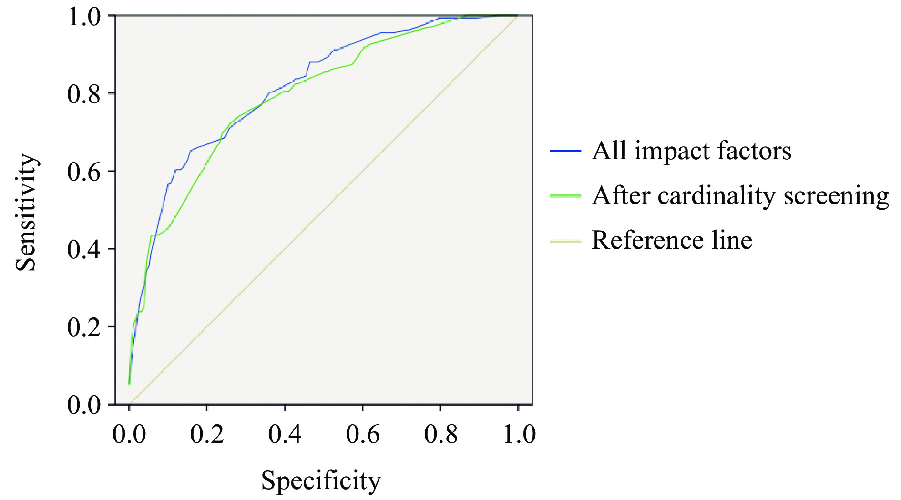
Fig. 3 ROC curve of the prediction model
3.4.3 Variable assignment
All the observations listed in section 2.3 were assigned values before analysis using the maximum likelihood estimation stepwise elimination method of binary logistic regression. The dependent variable was set to “0” for normal constitution and “1” for blood stasis constitution, and the remaining influencing factors, except for gender, were assigned values (0, 1, 2, 3, 4, 5, and 6) in degree of health-unhealthiness (Table 5). During the binary logistic regression analysis, the categorical variables such as gender, birth mode, feeding mode within four months of birth, family history, marital status, dietary habits, sleep habits, exercise habits, emotional state, stress situation, and living environment were treated as dummy variables, and the first option was uniformly selected as the reference.

Table 5 Variable assignment for all observations
Influencing factor | Classification item | Variable assignment
Gender | Female | 1
Gender | 0
Mode of birth | Caesarean section | 1
Mode of birth | 0
Feeding mode within four months of birth | Artificial feeding | 2
Feeding mode within four months of birth | 1
Feeding mode within four months of birth | 0
Family history of disease | Hypertension, diabetes | 2
Family history of disease | 1
Family history of disease | 0
Marital status | Married | 1
Marital status | 0
Eating habits | Prefer spicy | 6
Eating habits | 5
Eating habits | 4
Eating habits | 3
Eating habits | 2
Eating habits | 1
Eating habits | 0
Sleeping habits | Irregular | 4
Sleeping habits | 3
Sleeping habits | 2
Sleeping habits | 1
Sleeping habits | 0
Exercise habits | Exercise often | 1
Exercise habits | 2
Exercise habits | 3
Emotional state | Sadness mostly | 4
Emotional state | 3
Emotional state | 2
Emotional state | 1
Emotional state | 0
Stress situation | Great stress | 3
Stress situation | 2
Stress situation | 1
Stress situation | 0
Living environment | Dark and damp | 2
Living environment | 1
Living environment | 0
TCM constitution types | Blood stasis constitution | 1
TCM constitution types | 0

3.4.4 Multivariate logistic regression analysis
In the results, the statistical value in the “Hosmer-Lemeshaw test” table was 0.727 (P> 0.05), accepting the original hypothesis that the model in this case could fit the observed data well; the “classification” table yielded a prediction accuracy of 72.3%. In the final step of the “variables in the equation” table, the P values for gender, family history, marital status, exercise habits, emotional state, and living environment were significant (P < 0.05), implying that the above independent variables were risk factors for the development of hemoptysis. Other factors (age, mother's age at birth, sleep duration, sleep habits, birth mode, feeding mode in the four months of birth, stress situation, and dietary habits) did not show significant correlations (P > 0.05). Detailed parameters are shown in Figure 4. Table 6 lists only the specific risk factors for the development of blood stasis constitution.
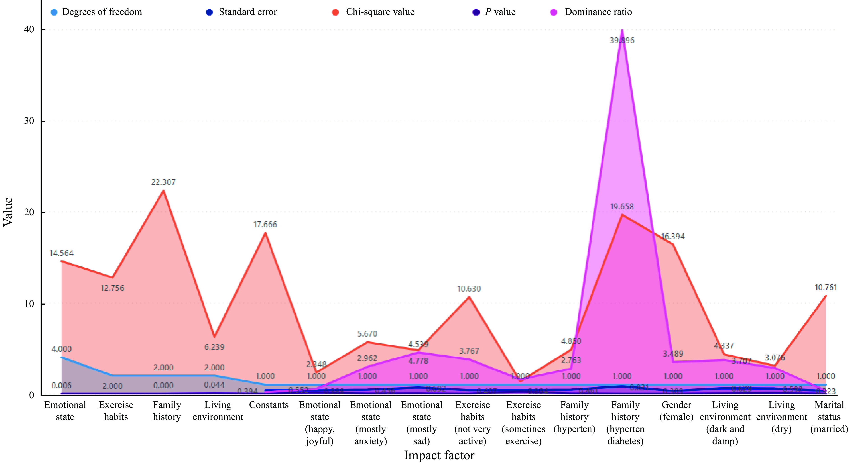
Fig. 4 Multifactor logistic regression analysis of factors influencing blood stasis constitution

Table 6 Specific risk factors for the occurrence of blood stasis constitution
Impact factor | Regression coefficient | Standard error | Chi-square test | Degrees of freedom | P value | Odds ratio | Odds ratio (95% CI)
Gender (female) | 1.250 | 0.309 | 16.394 | 1 | 0.000 | 3.489 | 1.905 – 6.389
Family history (hypertension) | 1.016 | 0.461 | 4.850 | 1 | 0.028 | 2.763 | 1.118 – 6.826
Family history (hypertension, diabetes) | 3.686 | 0.831 | 19.658 | 1 | 0.000 | 39.896 | 7.820 – 203.534
Marital status (married) | 1.060 | 0.323 | 10.761 | 1 | 0.001 | 0.346 | 0.184 – 0.653
Exercise habits (not very active) | 1.326 | 0.407 | 10.630 | 1 | 0.001 | 3.767 | 1.697 – 8.362
Emotional state (mostly anxiety) | 1.086 | 0.456 | 5.670 | 1 | 0.017 | 2.962 | 1.212 – 7.239
Emotional state (mostly sad) | 1.513 | 0.692 | 4.778 | 1 | 0.029 | 4.539 | 1.169 – 17.62
Living environment (dark and damp) | 1.310 | 0.629 | 4.337 | 1 | 0.037 | 3.707 | 1.080 – 12.722
Constant | − 1.861 | 0.385 | 23.334 | 1 | 0.000 | 0.156 | None

4 Discussion
In this study, cardinality analysis showed significant differences in the effects of gender, stress situation, family history, living environment, emotional state, exercise habits, and dietary habits on blood stasis constitution. The order of relevance was gender, stress situation, emotional state, exercise habits, family history, eating habits, and living environment. An independent sample t test showed differences in sleep duration between people with blood stasis constitution and those with normal constitution. The average sleep time of people with blood stasis constitution was less than those with normal constitution. The binary logistic regression analysis results showed that the P value for women, with a family history of hypertension and diabetes, who were married or living in dark and humid environments or exercise less or chronically sad were predominantly suggested to be significant, implying that the above independent variables would affect blood stasis constitution. The results obtained in the univariate analysis and the multifactor logistic regression analysis differed slightly. However, the commonality of both showed that female, family history of hypertension and diabetes, dark and humid environment, less exercise, and anxiety and sadness were the significant influencing factors of blood stasis constitution, which was consistent with the analysis of the influencing factors of blood stasis constitution by previous studies ^{[6-9]} and proved that the results obtained in this paper had high reliability.
4.1 Women and blood stasis constitution
Women have blood as the basis and the liver as the precursor, and they have physiological characteristics such as menstruation, belts, fetuses, childbirth, and breastfeeding, thus they are prone to deficiency and inability to transport blood or stagnation that affects blood flow, resulting in blood stasis constitution ^{[9-12]}. Most gynecological diseases are closely related to blood stasis constitution. A study on the relationship between blood stasis constitution and coronary heart disease and gynecological diseases shows that gynecological diseases accounted for 25.7% of the susceptible diseases in people with blood stasis constitution ^{[2]}. Endometriosis is when the active endometrium bleeds periodically in the body along the menstrual cycle, the blood that leaves the menstrual cycle and stasis of blood. Dysmenorrhea is mainly caused by the internal obstruction of blood stasis, which is also closely associated with chronic pelvic inflammatory disease development. Polycystic ovary syndrome (PCOS) is one of the most common gynecological diseases, and blood stasis constitution is its main clinical constitution type ^{[13]}. Women with blood stasis constitution are more prone to suffer from diseases related to blood stasis, such as tumors, menstrual disorders, uterine diseases, and gynecological inflammation. These diseases have a long course and are prone to recurrence, and long-term failure to heal can easily lead to the formation of blood stasis constitution, which further confirms the saying that “prolonged illness causes stasis” ^{[10]}. Women are Yin in nature, and they like to be quiet and tend to be thoughtful and worried, which makes them prone to blood stasis constitution, and the gynecological diseases to which they are prone to a serious threat to their health. Therefore, in the clinical treatment of blood stasis in TCM, the primary consideration should be gender, and women should pay more attention to their lifestyles to prevent diseases before they occur, and to prevent degeneration due to diseases.
4.2 Suitable living environment contributing to physical health
According to Chinese medicine, the human body is a harmonious and unified whole with nature, and changes in nature also have an important impact on the physiology and pathology of the human body, such as spring strings, summer hooks, autumn hair, and winter stones which are manifestations of the changes in human Qi with the changes in the four seasons of nature ^{[11]}. Modern medicine also believes that the most suitable living environment for the human body is 20 – 23 °C，in such an environment, the human body’s skin temperature basically does not change, and the body can maintain a good thermal balance inside and outside; if the external temperature is too high or too low, it will have an impact on the body's thermal balance, leading to various diseases ^{[14]}. LI et al. ^{[11]} found that the temperature of either the living or working environment would affect both TCM constitution types. The association between the biased constitution population and the working environment of air conditioning temperature above 25 °C was stronger, which is probably related to the fact that the biased constitution population is weaker and less adaptable to the external environment and cannot tolerate cold. This study concluded that living in a dark, humid, or dry environment for a long time is more likely to lead to blood stasis constitution. Therefore, people should pay attention to the influence of the living environment on the constitution, avoid living in dry or humid places for a long time, and use humidifiers and dehumidifiers when changing the environment to create a buffer process for the body to adapt to the environment.
4.3 Stress management and emotional regulation
In the Yellow Emperor’s Inner Classics ( Huang Di Nei Jing , 《黄帝内经》) , it says “If that the will and spirit are concentrated, the soul is not scattered, regret and anger are not suspended, and the five organs are not subject to evil” ^{[15]}. Conversely, chronic mental stress and emotional turmoil make it difficult for the spirit to be concentrated and thus depleting its essence. When evil energy is too strong and righteous energy is insufficient, people are naturally prone to pathological states. LI et al. ^{[10]} correlated female blood stasis constitution with emotional conditions such as tension, anxiety, and depression, and concluded that the correlation coefficients were 0.457 (P < 0. 01) and 0.416 (P < 0. 01), indicating a significant correlation between female blood stasis constitution and emotional conditions (tension, anxiety, and depression).
This is consistent with the cardinality analysis of the present study that people who are chronically anxious and angry are prone to blood stasis constitution. Therefore, controlling stress within the normal range and having a relaxed mood can effectively prevent blood stasis constitution. Meanwhile, mental and physical health should be treated at the same way in daily life.
4.4 Family history of hypertension and diabetes
ZHAO et al. ^{[16]} studied 70 patients with hypertension (with a family history) to analyze the distribution of constitution, of which 11.43% were blood stasis constitution. In a meta-analysis of several body types that may be associated with the development of hypertension, ZENG et al. ^{[17]} concluded that blood stasis constitution (OR = 1.24, 95% CI: 1.06 − 1.46, P = 0.007) is one of the constitution types which is more likely to be found in hypertensive people. ZHU et al. ^{[18]} suggested that hypertension is controlled by genes, that is, families have specific genes that can cause hypertension. Modern western medicine also believes that hypertension has a family aggregation phenomenon ^{[19]} , and from the perspective of Chinese medicine, it is believed that the poor functioning of the flow, which produces blood stasis and slows down the blood flow, will cause hypertension ^{[20]}. This is also the same as the characteristics of people with blood stasis constitution, which explains the correlation between the two. Diabetes mellitus is also a well-known disease that has been considered to be hereditary ^{[21]}. In a study on the relationship between blood stasis constitution and coronary heart disease, XING et al. ^{[2]} showed that 25.6% of people with blood stasis constitution were susceptible to type 2 diabetes mellitus by bibliometric analysis. Blood stasis constitution is the most common type of Chinese medical condition in type 2 diabetes, and because diabetes is inherited, people with a family history of diabetes are more likely to develop blood stasis constitution ^{[22]}. In the present study, both Pearson's chi-square univariate test and binary logistic regression multivariate analysis concluded that hypertension and a family history of diabetes mellitus were risk factors for blood stasis constitution, and the results were reliable. Therefore, a family history of hypertension and diabetes mellitus should be considered in the treatment of blood stasis-related diseases in TCM.
4.5 Maintaining proper exercise
The blood stasis constitution is characterized by the potential tendency for poor blood operation or blood stasis internal resistance. Long-term sitting, lying for a long time, less exercise, poor operation of Qi and blood, subtle movement of water and valley, resulting in dampness, turbidity, and stagnation, form a vicious circle. In analyzing the factors influencing blood stasis constitution, LI et al. ^{[10]} used logistic regression analysis by using a stepwise elimination method to conclude that exercise pattern was a significant predictor of the formation of blood stasis constitution. The chi-square analysis and binary logistic regression in this study also yielded significant influencing factors for blood stasis constitution when there is not much exercising. Different study samples yielded common influencing factors, further indicating that proper exercise helps Qi and blood flow and can effectively prevent the formation of blood stasis constitution.
5 Conclusion
In summary, blood stasis constitution is a kind of dangerous biased constitutions, and the discussion of its influencing factors can further provide a basis for the health guidance of people with blood stasis constitution. In daily life, people should choose a suitable living environment, pay attention to regulating the emotional state, and avoid being in a state of excessive stress, especially for women, who should pay attention to keeping warm during menstruation. People with family history of hypertension and diabetes should regulate and improve their lifestyle habits in order to avoid blood stasis constitution.
Fundings
The Youth Fund of National Natural Science Foundation of China (81904324), and Xinglin Talent Plan of Chengdu University of Traditional Chinese Medicine (QNXZ2020015).

Competing Interests
The authors declare no conflict of interest.

References
- WANG Q. Classification and diaganosis basis of nine basic constitutions in Chinese medicine. Journal of Beijing University of Traditional Chinese Medicine, 2005, 28, (4): 1–8.
- XING TY, LIN H, SHANG XL, et al. Relevancy of the blood stasis constitution between coronary artery heart disease and gynecological diseases. Jilin Journal of Chinese Medicine, 2020, 40(6): 735–737.
- WANG CS. Physique Characteristic of elderly in modern society. Jiangsu Journal of Traditional Chinese Medicine, 2004, 25, (10): 16–19.
- YANG YT, HOU LH, LI Y. Correlation of TCM constitution distribution and clinical indicators in patients with polycystic ovary syndrome complicated with hyperandrogenism. Modern Chinese Clinical Medicine, 2020, 27(1): 30–34.
- LIU J. A study on the Chinese medical constitution and its relationship with recurrence after radical surgery in middle-aged and elderly people susceptible to common malignant tumors. Science Regimen, 2021, 24(19): 17–18.
- WANG Q, ZHU YB, WU CY, et al. Correlation between constitution in Chinese medicine and health-related quality of life. Chinese Journal of Tissue Engineering Research, 2007, 49(11): 9946–9950.
- WANG F, WANG WJ, ZHANG Y, et al. Research progress on stagnant blood constitution in recent 10 years. Chinese Medicine Modern Distance Education of China, 2018, 16(13): 148–150.
- ZHU YB, WANG Q, ZHELI XH. Evaluation on reliability and validity of the constitution in Chinese medicine questionnaire (CCMQ). Chinese Journal of Behavioral Medicine and Brain Science, 2007, 16(7): 651–654.
- TIAN QL, WANG Q. Problems related to study for constitution of blood stasis. Jilin Journal of Traditional Chinese Medicine, 2009, 29(2): 93–95.
- LI MX HAN JZ, OUYANG B. Analysis on influencing factors of blood stasis constitution in females. Journal of Traditional Chinese Medicine, 2015, 56(15): 1290–1293.
- LI H, LIN ZZ, YANG ZM, et al. A logistic regression analysis of influences of living and work environments on types of TCM constitution. Henan Traditional Chinese Medicine, 2016, 36(1): 123–125.
- ZHANG R, LIU M, YAN GL, et al. Logistic regression analysis to influential factors of TCM constitution of 1627 freshmen. Journal of Traditional Chinese Medicine, 2015, 56(21): 1858–1861.
- DING CL, HOU LH, HAO SL, et al. Correlation analysis between Chinese medicine constitution and sex hormone and lipid metabolism in patients with polycystic ovary syndrome. Journal of Traditional Chinese Medicine, 2016, 57(15): 1303–1307.
- JIN ZP. Adjusting room temperature for health. Medicine & People, 2000, 13(2): 92.
- ZHAO XJ, LU WM. On the influencing factors of TCM constitution. Jilin Journal of Traditional Chinese Medicine, 2011, 31(4): 293–294.
- ZHAO M. Study on constitution distribution of 70 cases of yypertension (with family history). World Latest Medicine Information, 2019, 19(85): 233–234.
- ZENG YD, LIANG H, JIAN WX, et al. Meta-analysis of correlation between hypertension and TCM constitution. Modernization of Traditional Chinese Medicine and Materia Medica-World Science and Technology, 2019, 21(8): 1731-1737.
- ZHU XM. On the causes of hypertension. Biology Teaching, 2004, 29(4): 54–56.
- DAI MZ, LI JH. Analysis of different understandings of the causes of hypertension in several major medical schools. China Health Care & Nutrition, 2013, 23(2): 572–573.
- LIANG HD. Etiological mechanisms and common treatments for hypertension-analysis based on Chinese medicine perspective. Medical Information, 2011, 24(8): 4126–4127.
- GAN FX, GAO WJ, LV Y, et al. Analysis on the heritability of diabetes, based on data from the Chinese adult twins. Chinese Journal of Epidemiology, 2019, 40(4): 389–393.
- YAN HG, YAB GB, HOU JT, et al. Study on the correlation between blood stasis evidence of type 2 diabetes mellitus and Chinese medicine constitution. Journal of Yunnan University of Traditional Chinese Medicine, 2017, 40(2): 48–51.

