Study on the compatibility principle of Wutou Decoction based on network pharmacology
WANG Weijie^{1, 2, 3}, YANG Xiaonan¹, WANG Yilin^{1, 4}, PAN Hudan^{1, 5, *}, LIU Liang^{1, 5, *}

1. Dr. Neher’s Biophysics Laboratory for Innovative Drug Discovery/State Key Laboratory of Quality Research in Chinese Medicine, Macau University of Science and Technology, Macao 999078, China
2. Rheumatology Department, The Second Affiliated Hospital of Zhejiang Chinese Medical University, Hangzhou, Zhejiang 310005, China
3. Institue of Basic Theory for Chinese Medicine, China Academy of Chinese Medical Sciences, Beijing 100700, China
4. Famous Doctor Studio, Zhuhai Integrated Traditional Chinese and Western Medicine Hospital, Zhuhai, Guangdong 519000, China
5. Guangdong-Hong Kong-Macau Joint Lab on Chinese Medicine and Immune Disease Research, Guangzhou, Guangdong 510000, China

*Corresponding author: Assistant Professor, E-mail: panhudan1988@163.com. Academician, E-mail: lliu@must.edu.mo
Manuscript received 2021-11-18; accepted 2022-1-7;
available online 2022-3-25.

[Abstract] Objective To investigate the underlying drug enhancement mechanisms of the Chuanwu (Aconiti Radix) and Huangqi (Astragali Radix) combination and toxicity reduction of Chuanwu combined with Gancao (Glycyrrhizae Radix et Rhizoma) in Wutou Decoction (乌头汤, WTD), and to elucidate the compatibility principle. Methods The active compounds and potential effective targets of the selected combinations were retrieved from the Traditional Chinese Medicine Systems Pharmacology Database and Analysis Platform (TCMSP) and Traditional Chinese Medicines Integrated Database (TCMID). The toxicity of Chuanwu (Aconiti Radix) was investigated by selecting all five toxic compounds from the literature and the TCMSP database, and obtaining their targets through SwissTargetPrediction. Targets related to rheumatoid arthritis (RA) were searched using DisGeNET, GenCards, and Online Mendelian Inheritance in Man (OMIM). Mutual targets between the drug pairs and RA were selected as potential RA therapy targets. The medicinally active compound-target network was constructed using Cytoscape 3.9.0. Gene ontology (GO) term enrichment and Kyoto Encyclopedia of Genes and Genomes (KEGG) pathway enrichment were performed using the Database for Annotation, Visualization, and Integrated Discovery (DAVID) platform. Results We obtained 191 active compound targets for Gancao (Glycyrrhizae Radix et Rhizoma), 171 for Huangqi (Astragali Radix), and 103 for Chuanwu (Radix Aconiti) (hypoaconitine’s target was obtained through literature and SwissTargetPrediction). A total of 5872 genes were obtained for RA. A drug-active compound-target network involving 13 effect-enhancing and nine toxicity reduction targets was constructed. PGR was the main effect enhancement target, and KCNH2 was the main toxicity reduction target. The effect-enhancing targets were related to 23 GO terms (such as positive regulation of transcription from RNA polymerase II promoter, steroid hormone-mediated signaling pathway, plasma membrane, and protein binding) (P < 0.01), and 13 KEGG pathways related to synergism [such as estrogen signaling pathway, cholinergic synapse, and phosphatidylinositol 3-kinase/protein kinase B (PI3K/Akt) signaling pathway]. The toxicity reduction targets were related to 28 GO terms (mainly involes G-protein coupled receptor signaling pathway, plasma membrane, and drug binding) (P < 0.01), and five KEGG pathways related to toxicity reduction (cholinergic synapse, calcium signaling pathway, regulation of actin cytoskeleton, neuroactive ligand-receptor interaction, and serotonergic synapse). Conclusion The combination of Chuanwu (Aconiti Radix) and Huangqi (Astragali Radix) plays an important effect-enhancing role in WTD and involves the estrogen and PI3K/Akt signaling pathways, with PGR as the core. The Chuanwu (Aconiti Radix) and Gancao (Glycyrrhizae Radix et Rhizoma) combination decreases toxicity in WTD and is associated with the cholinergic synapse and calcium signaling pathways, with KCNH2 as the core.

[Key words] Wutou Decoction (乌头汤); drug pair; Network pharmacology; effect enhancement; toxicity reduction; PGR; KCNH2
[DOI] 10.1016/j.dcmed.2022.03.001

1 Introduction
The duality of effect and toxicity is an innate drug characteristic. Chinese doctors often use combinations of Chinese herbal prescriptions following the principle of “sovereign-minister-assistant-envoy” (Jun-Chen-Zuo-Shi in Chinese) to enhance drug efficacy or reduce toxicity.
The Wutou Decoction (乌头汤, WTD) consists of Chuanwu (Aconiti Radix), Mahuang (Ephedrae Herba), Shaoyao (Paeonia lactiflora Pall.), Huangqi (Astragali Radix), and Gancao (Glycyrrhizae Radix et Rhizoma), which is a well-known traditional Chinese herbal formula often used to treat rheumatoid arthritis (RA) and other arthritic syndromes with a significantly positive response ^{[1]}. A meta-analysis of 11 randomized controlled clinical trials (RCTs) demonstrated that treatment with WTD significantly improved therapeutic efficacy by decreasing the Disease Activity Score in 28 Joints (DAS28), joint tenderness and swelling, the duration of morning stiffness, the erythrocyte sedimentation rate (ESR), serum C-reactive protein (CRP) levels, rheumatoid factor (RF) scores, and anticyclic citrullinated peptide (anti-CCP) antibody levels, compared to treatments without WTD ^{[2]}. Chuanwu (Aconiti Radix) is a toxic traditional Chinese medicine (TCM) that generally causes paroxysmal muscle spasms, convulsions, arrhythmia, shortness of breath, and nose flapping, however, no significant differences regarding the incidence of adverse reactions ^{[3, 4]} were noted in patients with or without WTD, indicating that other herbs in WTD may relieve the toxicity associated with Chuanwu (Aconiti Radix).
TCM states that drug combinations are a basic characteristic of the compatibility of Chinese herbal formulas. Based on clinical WTD experience, Chuanwu (Aconiti Radix) and Huangqi (Astragali Radix) combination enhances the therapeutic effect of RA treatments, and Chuanwu (Aconiti Radix) and Gancao (Glycyrrhizae Radix et Rhizoma) combination reduces the toxicity of Chuanwu (Aconiti Radix). However, the underlying compatibility mechanisms remain unclear. Our initial study demonstrated that Huangqi (Astragali Radix) intensified the anti-arthritic effects of Chuanwu (Aconiti Radix) by regulating the NF-κB-mediated inflammatory and the Nrf2-mediated anti-oxidation pathways, which are the major WTD pathways involved in alleviating RA symptoms ^{[5]}. Combination of Chuanwu (Aconiti Radix) and varying Gancao (Glycyrrhizae Radix et Rhizoma) proportions increased the low toxic (LD₅₀) and median toxic (TD₅₀) doses, inhibited the acceleration of myocardial beating rhythm caused by aconite, and reduced the lactate dehydrogenase content ^{[6]}. Researchers have also found that the 50 to 100 mg/kg total flavonoids in Gancao (Glycyrrhizae Radix et Rhizoma) could prolong the incubation period of aconitine-induced arrhythmia in mice and reduce the duration of aconitine-induced arrhythmia in rats ^{[7]}.
Network pharmacology can generate complicated interaction networks based on target molecules, biological functions, and bioactive compounds, which can systematically elucidate the mechanism of action of Chinese herbal formulas at the molecular level ^{[8]}. Thus, we aimed to elucidate using a network pharmacology to analysis the effect enhancement mechanisms of Chuanwu (Aconiti Radix) and Huangqi (Astragali Radix) combination, and the toxicity reduction mechanisms of Chuanwu (Aconiti Radix) and Gancao (Glycyrrhizae Radix et Rhizoma) combination.
2 Methods
2.1 Screening the active compounds and targets of Chuanwu (Aconiti Radix), Huangqi (Astragali Radix), and Gancao (Glycyrrhizae Radix et Rhizoma)
We screened the active compounds and targets of the three herbs using the Traditional Chinese Medicine Systems Pharmacology Database and Analysis Platform (TCMSP) (https://old.tcmsp-e.com/index.php), based on an oral bioavailability (OB) of ≥ 30% and a drug-likeness (DL) of ≥ 0.18. For compounds without target information in the TCMSP and Traditional Chinese Medicines Integrated Database (TCMID, http://www.tcmip.cn), data were obtained from the available literature. We also downloaded the structural formulas of these compounds from PubChem (https://pubchem.ncbi.nlm.nih.gov/), followed by the application of SwissTargetPrediction (http://www.sib.swiss/). The UniProt database (https://www.uniprot.org/) was used to convert the protein names to gene symbols.
2.2 Summary of RA-related targets
We used “Rheumatoid arthritis” as the key phrase to summarize disease-related targets through the DisGe-NET, GenCards, and Online Mendelian Inheritance in Man (OMIM) databases. Deduplication was performed, and RA-related disease genes were obtained for follow-up research.
2.3 Definition and analysis of “synergistic targets” and “attenuated targets”
We first intersected the Chuanwu (Aconiti Radix) and Huangqi (Astragali Radix) effective component targets with the RA targets. The two intersection targets were sorted, identified, and defined as synergistic targets. For attenuation targets, all active compounds of Chuanwu (Aconiti Radix) were screened from the databases (no OB and DL restrictions were set) to identify the toxic compounds, including aconitine, mesaconitine, benzoylmesaconine, talatisamine, and hypaconitine. Attenuated targets were then defined by screening available literature and applying SwissTargetPrediction (probability > 0.1), followed by deduplication.
2.4 Compound-target network construction
The drug compound-target interaction network was constructed using Cytoscape 3.9.0 software. We adjusted the size and transparency of each compound and target according to the different degree values to highlight the different components and target proportions more intuitively. We set the adjustment range and the target shape size from a minimum of 60 to a maximum of 130, and the transparency from a minimum of 150 to a maximum of 300. Compounds or targets with larger shapes and darker colors had larger degree values, indicating that they are more likely to play an important role in enhancing or decreasing toxicity.
2.5 Gene Ontology (GO) function enrichment and Kyoto Encyclopedia of Genes and Genomes (KEGG) pathway enrichment analysis
The Database for Annotation, Visualization, and Integrated Discovery (DAVID, https://david.ncifcrf.gov/home.jsp) was used for GO enrichment and KEGG analysis. For GO enrichment analysis, items with P < 0.01 were selected to make bar graphs. For KEGG enrichment analysis, we listed all enriched pathways.
3 Results
3.1 Active compounds of Chuanwu (Aconiti Radix), Huangqi (Astragali Radix), and Gancao (Glycyrrhizae Radix et Rhizoma)
In total, 87, 12, and 280 compounds were identified for Huangqi (Astragali Radix), Chuanwu (Aconiti Radix), and Gancao (Glycyrrhizae Radix et Rhizoma), respectively. Twenty active compounds for Huangqi (Astragali Radix), three for Chuanwu (Aconiti Radix), and 92 for Gancao (Glycyrrhizae Radix et Rhizoma) were identified through further screening based on the OB and DL values (Supplementary file).
3.2 Target protein prediction and cross-validation
We used the TCMSP and TCMID databases to obtain target records for the three herbal medicines. These were then compared with the active compounds selected using absorption, distribution, metabolism, and excretion (ADME) parameters. We subsequently obtained 191 effective targets for Gancao (Glycyrrhizae Radix et Rhizoma), 171 for Huangqi (Astragali Radix), and 103 for Chuanwu (Aconiti Radix) (hypoaconitine’s target was obtained using SwissTargetPrediction). We selected five toxic compounds (aconitine, mesaconitine, benzoylmesaconine, talatisamine, and hypaconitine) to study the toxicity of Chuanwu (Aconiti Radix) and obtained 48 targets through SwissTargetPrediction (probability > 0.1, listed in Supplementay file). Based on the DisGeNET, GenCards, and OMIM databases, 5 872 RA-correlated genes were predicted. The Venn diagram identified 13 intersection targets between Chuanwu (Aconiti Radix), Huangqi (Astragali Radix), and RA (Figure 1). We also identified nine overlapping targets from the toxic component targets of Chuanwu (Aconiti Radix) and Gancao (Glycyrrhizae Radix et Rhizoma) (Figure 2).
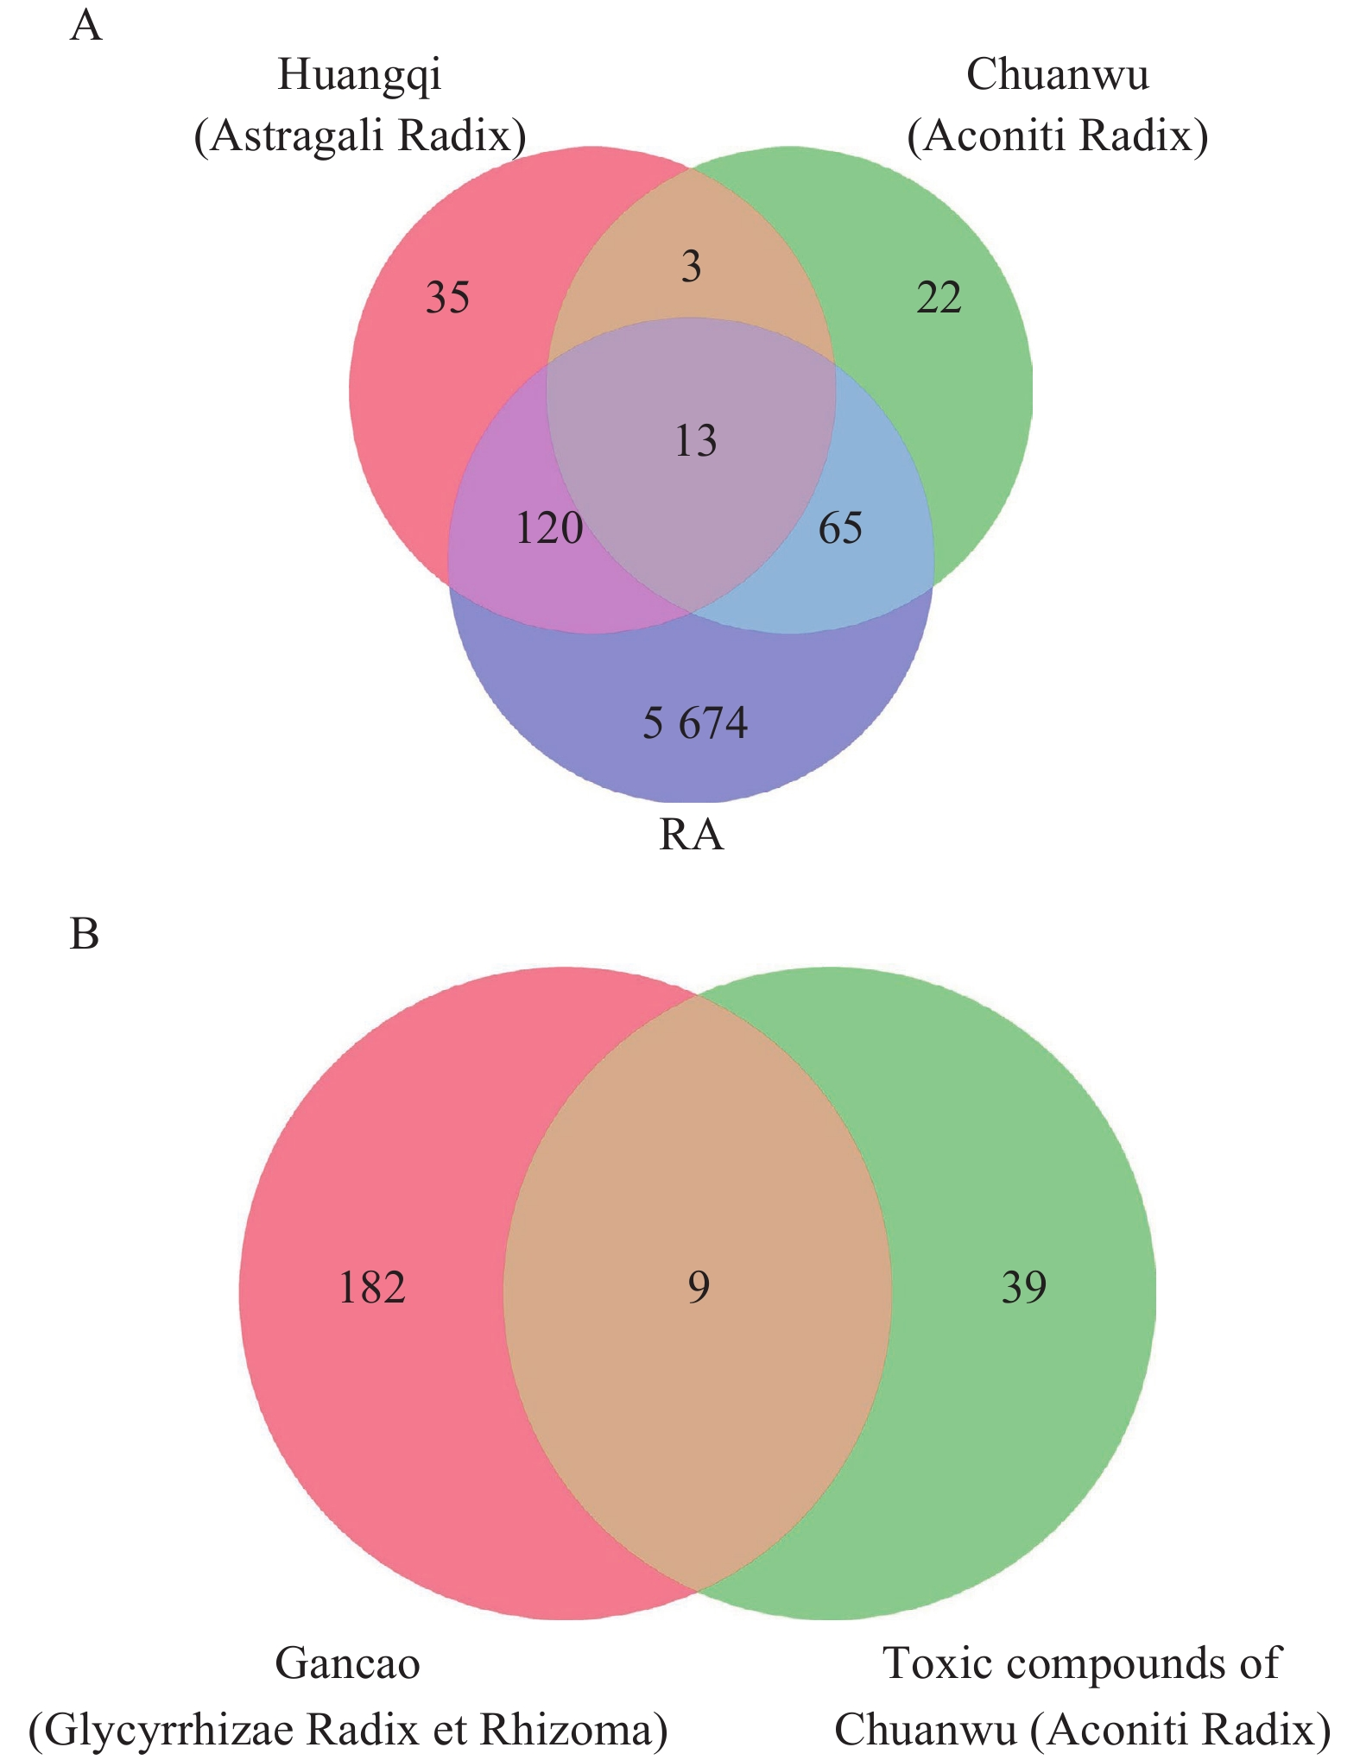
Fig. 1 Venn diagram of the herbs and RA cross-validation analysis on efficacy enhancement and toxicity reduction
A, cross-validation of Chuanwu (Aconiti Radix), Huangqi (Astragali Radix), and RA demonstrating enhanced effects. B, cross-validation of the toxic compounds in Chuanwu (Aconiti Radix) and Gancao (Glycyrrhizae Radix et Rhizoma).
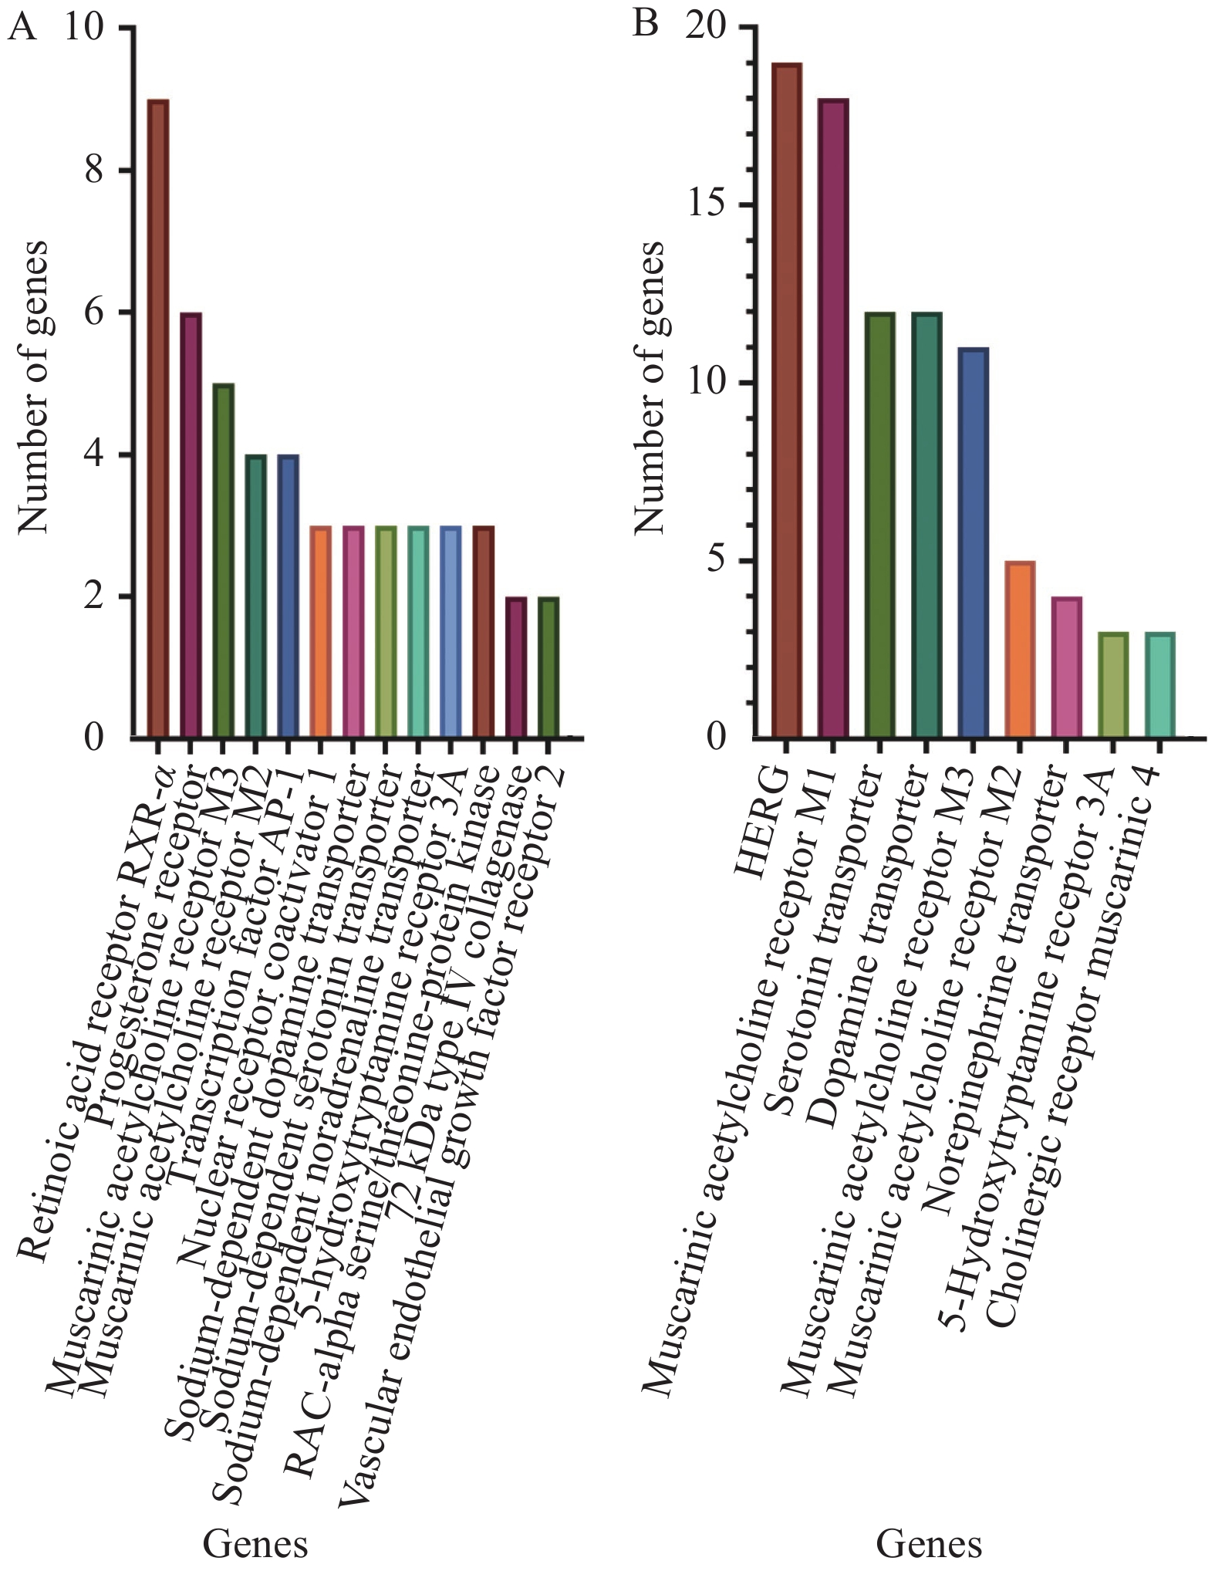
Fig. 2 Target gene frequency related to efficacy enhancement and toxicity reduction
A, frequencies of the 13 target genes associated with efficacy enhancement. B, frequencies of the nine target genes associated with toxicity reduction.
3.3 Drug-active compound-target network
Thirteen effect-enhancing and nine toxicity reduction targets were imported into Cytoscape to construct a drug-active component-target network model. The effect-enhancement network contained 39 nodes and 92 edges, with a maximum target point degree of 19 (PGR gene) (Figure 3A). The toxicity-reduction network contained 23 nodes and 35 edges, with a maximum target point degree of three (KCNH2 gene) (Figure 3B).
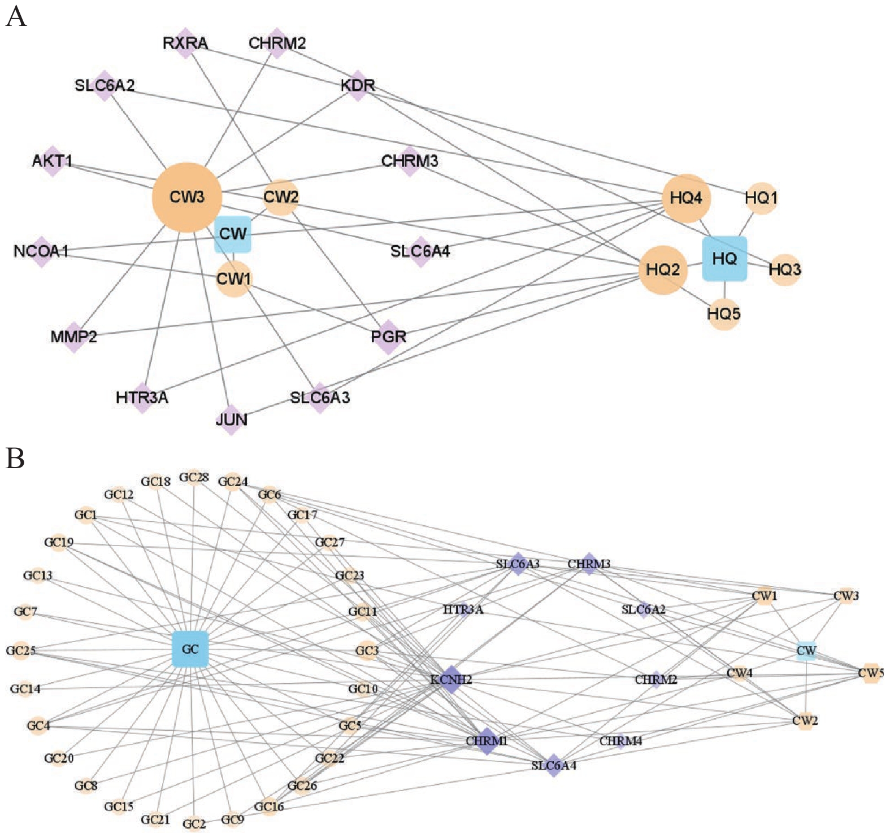
Fig. 3 Drug active compound-target networks associated with effect enhancement and toxicity reduction
A, the active compound-target network of Chuanwu (Aconiti Radix) and Huangqi (Astragali Radix). B, the active compound-target network of Chuanwu (Aconiti Radix) and Gancao (Glycyrrhizae Radix et Rhizoma). CW represents Chuanwu (Aconiti Radix); HQ represents Huangqi (Astragali Radix); and GC represents Gancao (Glycyrrhizae Radix and Rhizoma). Yellow represents the herb compounds; blue represents the herb name; and purple represents the target.
3.4 Functional terms and pathways involving the target proteins
Ten GO biological process functional terms, seven GO cellular component functional terms, and six GO molecular function terms were enriched for 13 targets associated with effect enhancement with an adjusted P < 0.01. GO enrichment analysis revealed that the biological processes mainly involved positive regulation of the RNA polymerase II promoter, the steroid hormone-mediated signaling pathway, the plasma membrane, and protein binding (Figure 4A). However, 12 GO biological process functional terms, 11 GO cellular component functional terms, and five GO molecular function terms were enriched for nine toxicity reduction targets with an adjusted P < 0.01. The main biological processes involved were the G protein-coupled receptor signaling pathway, the plasma membrane, and drug binding (Figure 4B). KEGG function enrichment analysis identified 13 enriched pathways associated with effect enhancement, in which the estrogen signaling, cholinergic synapse, and phosphatidylinositol 3-kinase/protein kinase B (PI3K/Akt) signaling pathways were the main pathways (Figure 5A). Conversely, five enriched pathways were associated with toxicity reduction, namely the cholinergic synapse, the calcium signaling pathway, actin cytoskeleton regulation, neuroactive ligand-receptor interaction, and serotonergic synapse (Figure 5B).
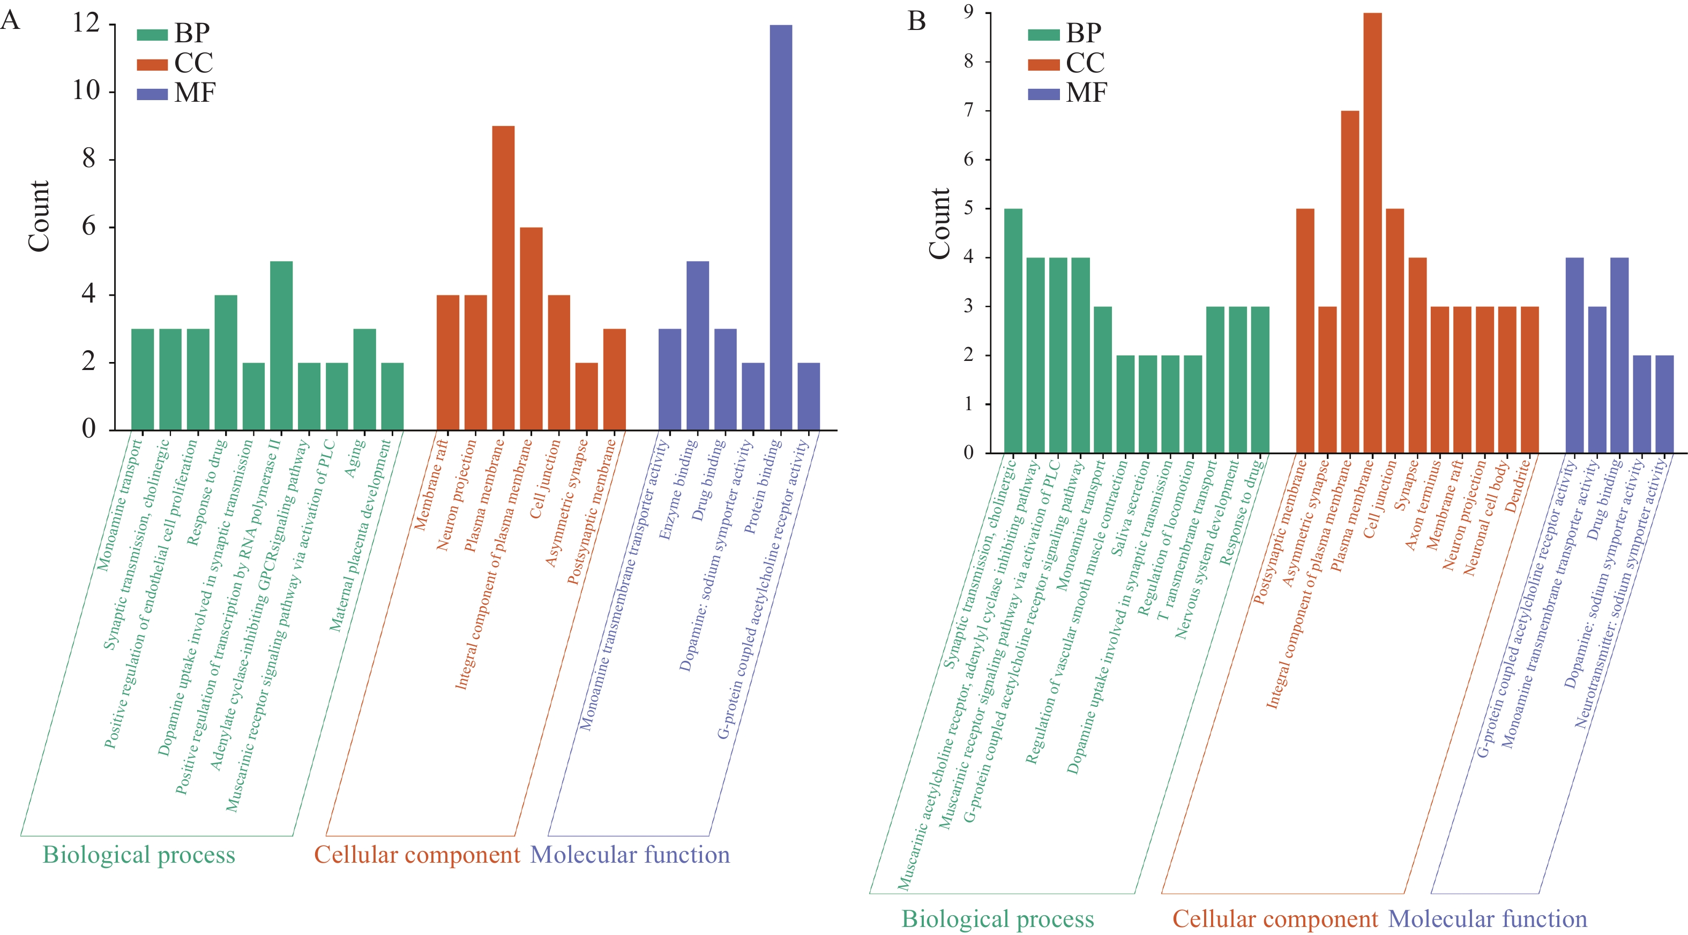
Fig. 4 GO enrichment analysis of effect enhancement and toxicity reduction
A, GO enrichment analysis of effect enhancement. B, GO enrichment analysis of the toxicity reduction.
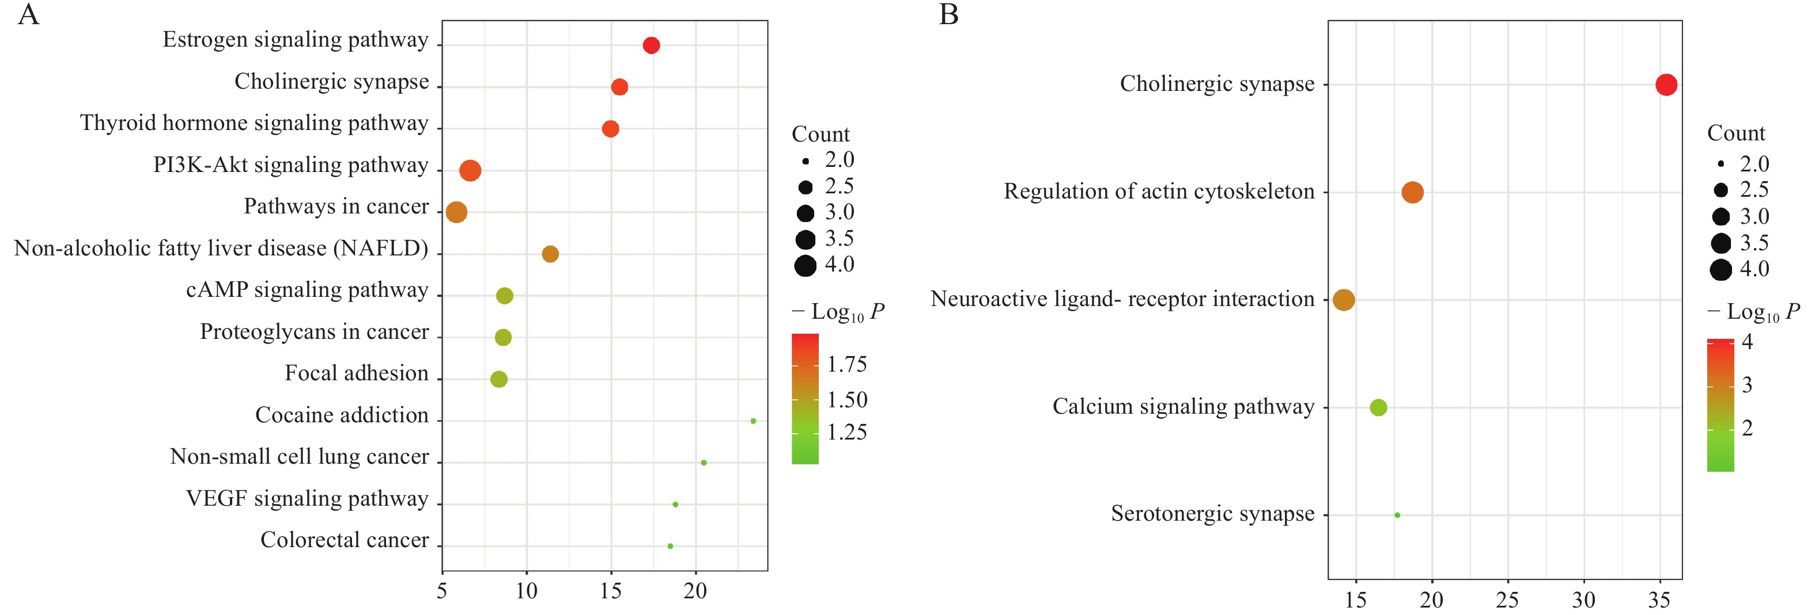
Fig. 5 KEGG enrichment analysis of effect enhancement and toxicity reduction
A, KEGG enrichment analysis of effect enhancement. B, KEGG enrichment analysis of toxicity reduction.
4 Discussion
WTD is an effective treatment for RA ^{[9]}. This is the first study to elucidate the underlying RA treatment effect-enhancing and toxicity-reduction mechanisms of the WTD Chinese herbs associated with therapeutic drug pairs. The main genes responsible for the enhanced effects of the Chuanwu (Aconiti Radix) and Huangqi (Astragali Radix) combination were PGR. Excess estrogen and progesterone may play a protective role in RA etiology. Women may have a decreased risk of developing RA during pregnancy when estrogen and progesterone levels are high ^{[10]}. However, the main gene responsible for WTD toxicity is KCNH2, which is the most common gene associated with long QT (time from the start of the QRS complex to the end of the T wave) and Brugada syndromes. Several studies have reported cardiovascular toxicity associated with Chuanwu (Aconiti Radix) ^{[11, 12]}. Interestingly, the expression of CHRM2, CHRM3, MMP2, and SLC6A2 were identical concerning effect enhancement and toxicity reduction. Most genes in the cholinergic system were enhanced. The first study to explore cholinergic anti-inflammatory mechanisms in arthritis evaluated the therapeutic response to nicotine and a selective α7 agonist (AR-R17779) in collagen-induced arthritis in mice ^{[13]}. Both drugs reduced the clinical signs of arthritis, decreased joint swelling and bone erosion, and reduced the serum levels of the inflammatory cytokines, tumor necrosis factor-α (TNF-α), and interleukin-6 (IL-6). Other studies demonstrated that the severity of arthritis was increased by vagotomy ^{[14]} and deletion of the α7nAChR nicotinic receptor ^{[15]}.
Effect enhancement pathway analyses suggested that Chuanwu (Aconiti Radix) and Huangqi (Astragali Radix) combination mainly regulates the estrogen and PI3K/Akt signaling pathways in RA, which has been demonstrated in previous studies. For example, estrogen withdrawal in RA patients with menopause can indirectly affect osteoclast bone resorption and accelerate bone loss and osteoporosis by increasing pro-inflammatory cytokine production ^{[16]}. Activation of the PI3K/Akt signaling pathway may affect the anti-apoptotic properties of synovial fibroblasts, thereby affecting synovial proliferation in RA ^{[17-19]}. This pathway can also regulate the production of RA-related inflammatory mediators ^{[20, 21]}. However, pathway analysis of Gancao (Glycyrrhizae Radix et Rhizoma) and Chuanwu (Aconiti Radix) combination showed that the toxicity pathways mainly included cholinergic synapses, the calcium signaling pathway, actin cytoskeleton regulation, and neuroactive ligand-receptor interactions. Clinical manifestations of drug toxicity caused by Chuanwu (Aconiti Radix) are dominant in the digestive, nervous, and cardiovascular systems ^{[22-24]}. Digestive toxicity often manifests as nausea, vomiting, burning stomach sensation, salivation, abdominal pain, diarrhea and so on. Peripheral nervous system damage causes skin ant line feeling, formication, tingling, and numbness. Central nervous system damage is characterized by dizziness, blurred vision, and comatosis. Cardiovascular system damage is characterized by hypotension, arrhythmia, and possible cardiac arrest. Aconitine, mesoaconitine, and hypoaconitine are the main toxic components of Chuanwu (Aconiti Radix).
Combining Chuanwu (Aconiti Radix) with Gancao (Glycyrrhizae Radix et Rhizoma) can reduce the toxicity of Chuanwu (Radix Aconiti) and enhance its efficacy ^{[25]}. The combination of aconite alkaloids and active components in Gancao (Glycyrrhizae Radix et Rhizoma) had anti-inflammatory effects, relieving the symptoms of adjuvant arthritis in rats. Combining the two compounds resulted in improved efficacy compared to aconite or alkaloids alone ^{[26]}. The toxicity mechanism was associated with significant abnormalities in the spontaneous beating rate, the amplitude of spontaneous oscillations, and relative intracellular ${Ca}^{2+}$ concentrations. Moreover, disruption of intracellular ${Ca}^{2+}$ homeostasis in cardiac excitation-contraction coupling is a crucial mechanism of arrhythmic cytotoxicity in aconitine-induced cardiomyocytes ^{[27]}. Glycyrrhizic and glycyrrhetinic acid influenced the absorption and metabolism of aconitine and new aconitine in the body ^{[28]}. Licorice flavonoids and triterpene saponins can antagonize the arrhythmias caused by aconitine ^{[29]}.
Based on the network pharmacology analysis, we suggest that Chuanwu (Aconiti Radix) and Huangqi (Astragali Radix) combination plays an important role in enhancing therapeutic efficacy, which is mainly achieved through the estrogen and PI3K/Akt signaling pathways. Chuanwu (Aconiti Radix) and Gancao (Glycyrrhizae Radix et Rhizoma) combination plays a role in decreasing toxicity, which involves the cholinergic synapses and calcium signaling pathways. Cholinergic synapses were predicted to be the common pathways for effect enhancement and toxicity reduction. An important consideration is also the “window of opportunity” regarding maintaining cholinergic synapse pathway homeostasis as it is crucial to effect enhancement and toxicity reduction.
Our study has some inherent limitations based on network pharmacology analysis. First, the TCMSP database was used to screen the active compounds (OB ≥ 30% and DL ≥ 0.18). Future studies should consider using high-performance liquid chromatography (HPLC) to identify the main chemical components of WTD. Further in vivo and in vitro experimental validation studies should be performed to confirm the compatibility principle of WTD.
Fundings
Macau Science and Technology Development Fund (0003/2019/AKP and 0010/2020/A1), Guangdong Basic and Applied Basic Research Foundation (2020B1515130005), and Guangdong-Hong Kong-Macau Joint Lab on Chinese Medicine and Immune Disease Research, Guangzhou University of Chinese Medicine (2020B1212030006). This work was supported by a grant from the “Macau Young Scholars Program” (AM2020017).

Competing Interests
The authors declare no conflict of interest.

References
- HE L, LIU C, SUN C, et al. Wu-Tou decoction inhibits angiogenesis in experimental arthritis by targeting VEGFR2 signaling pathway. Rejuvenation Research, 2018, (21): 442–455.
- LAN WY, TANG F, MA WK, et al. Meta-analysis of randomized controlled trials of treating rheumatoid arthritis with Wutou Tang combined with western medicine. Rheumatism and Arthritis, 2019, 1(8): 36–45.
- PENG ZX, LIU LZ, LIU GB, et al. Clinical study on relationship between imaging changes of early rheumatoid arthritis and modified Wutou Decoction. Liaoning Journal of Traditional Chinese Medicine, 2019, 46(5): 1008–1012.
- LI SR, XIE X. Clinical observation on the treatment of rheumatoid arthritis with methotrexate and Wutou Decoction. Journal of Practical Traditional Chinese Medicine, 2016, 32(8): 794.
- XIE Y, MAI CT, ZHENG DC, et al. Wutou decoction ameliorates experimental rheumatoid arthritis via regulating NF-kB and Nrf2: Integrating efficacy-oriented compatibility of traditional Chinese medicine. Phytomedicine: International Journal of Phytotherapy and Phytopharmacology, 2021, 85: 153522.
- ABELSON MB, OUSLER WG, NALLY LA, et al. Alternative reference values for tear film break up time in normal and dry eye populations. Advances in Experimental Medicine and Biology, 2002, 506: 1121-1125.
- HU XY, PEN GP, CHEN RY. Study on anti-arrhythmia effects of total flavonoids of licorice. Chinese Traditional and Herbal Drugs, 1996, 27(12): 733–735.
- LUO TT, LU Y, YAN SK, et al. Network pharmacology in research of Chinese eedicine formula: methodology, application and prospective. Chinese Journal of Integrative Medicine, 2020, 26(1): 72–80.
- XU T, LI S, SUN Y, et al. Systematically characterize the absorbed effective substances of Wutou Decoction and their metabolic pathways in rat plasma using UHPLC-Q-TOF-MS combined with a target network pharmacological analysis. Journal of Pharmaceutical and Biomedical Analysis, 2017, 141: 95–107.
- SILMAN A, KAY A, BRENNAN P. Timing of pregnancy in relation to the onset of rheumatoid arthritis. Arthritis & Rheumatology, 1992, 35(2): 152–155.
- YANG M, JI X, ZUO Z. Relationships between the oxicities of Radix Aconiti Lateralis Preparata (Fuzi) and the toxicokinetics of its main diester-diterpenoid alkaloids. Toxins, 2018, 10(10): 391.
- ZHOU H, ZHANG P, HOU Z, et al. Research on the relationships between endogenous biomarkers and exogenous toxic substances of acute toxicity in Radix Aconiti. Molecules, 2016, 21(12): 1623.
- VAN DER ZANDEN EP, BOECKXSTAENS GE, DE JONGE WJ. The vagus nerve as a modulator of intestinal inflammation. Neurogastroenterol Motility, 2009, 21(1): 6–17.
- LI T, ZUO X, ZHOU Y, et al. The vagus nerve and nicotinic receptors involve inhibition of HMGB1 release and early pro-inflammatory cytokines function in collagen-induced arthritis. Journal of Clinical Immunology, 2010, 30(2): 213–220.
- VAN MAANEN MA, STOOF SP, LAROSA GJ, et al. Role of the cholinergic nervous system in rheumatoid arthritis: aggravation of arthritis in nicotinic acetylcholine receptor α7 subunit gene knockout mice. Annals of the Rheumatic Diseases, 2010, 69(9): 1717–1723.
- SAPIR-KOREN R, LIVSHITS G. Postmenopausal osteoporosis in rheumatoid arthritis: the estrogen deficiency-immune mechanisms link. Bone, 2017, 103: 102–115.
- LEECH MT, MORAND EF. Fibroblasts and synovial immunity. Current Opinion in Pharmacology, 2013, 13(4): 565–569.
- ZHANG HG, WANG Y, XIE JF, et al. Regulation of tumor necrosis factor alpha-mediated apoptosis of rheumatoid arthritis synovial fibroblasts by the protein kinase Akt. Arthritis & Rheumatology, 2001, 44(7): 1555–1567.
- SONG B, LI XF, YAO Y, et al. BMP9 inhibits the proliferation and migration of fibroblast-like synoviocytes in rheumatoid arthritis via the PI3K/AKT signaling pathway. International Immunopharmacology, 2019, 74: 105685.
- CAHILL CM, ROGERS JT. Interleukin (IL) 1beta induction of IL-6 is mediated by a novel phosphatidylinositol 3-kinase-dependent AKT/IkappaB kinase alpha pathway targeting activator protein-1. The Journal of Biological Chemistry, 2008, 283(38): 25900–25912.
- HU J, MAO Z, HE S, et al. Icariin protects against glucocorticoid induced osteoporosis, increases the expression of the bone enhancer DEC1 and modulates the PI3K/Akt/GSK3β/β-catenin integrated signaling pathway. Biochemical Pharmacology, 2017, 136(15): 109–121.
- ZHOU W, LIU H, QIU LZ, et al. Cardiac efficacy and toxicity of aconitine: a new frontier for the ancient poison. Medical Research Reviews. 2021, 41(3): 1798–1811.
- CHAN YT, WANG N, FENG Y. The toxicology and detoxification of Aconitum: traditional and modern views. Chinese Medicine. 2021,16(1): 61.
- CHAN YT. Aconite poisoning. Clinical Toxicology. 2009, 47(4): 279-285.
- GAO Y, XIE LY, LU ZQ. Research progress on the toxicology of aconite and its compatibility. Tianjin Pharmacy, 2020, 32(1): 65–69.
- YANG JH, ZHANG HY, WAN HT, et al, Experimental study on combination of aconite alkaloids and active substances from licorice against adjuvant arthritis in rats. Chinese Traditional and Herbal Drugs, 2010, 41(3): 439–444.
- HOOVER DB. Cholinergic modulation of the immune system presents new approaches for treating inflammation. Pharmacology & Therapeutics, 2017, 179: 1-16.
- SHEN H, ZHU LY, YAO N, et al. The effect of the compatibility of Radix Aconiti Laterlis and Radix Glycyrrhizae on pharmacokinatic of aconitine, mesaconitine and hypacmitine in rat plasma. Journal of Chinese Medicinal Materials, 2011, 34(6): 937–942.
- WANG LY, YANG JH, ZHANG YY, et al. Preliminary study on material base of the decreasing toxicity and increasing efficacy in the compatibility of aconite with licorice. Journal of Emergency in Traditional Chinese Medicine, 2011, 20(2): 248–250.

