Influence of tanshinone on rabbit malignant arrhythmias and calmodulin signal transduction pathway after myocardial infarction

ZHOU Dai-xing, WANG Zhao-hua
Department of Emergency Medicine, Affiliated Tongji Hospital, Tongji Medical College, Huazhong University of Science and Technology, Wuhan, Hubei, 430030, China
Corresponding author: WANG Zhao-hua, E-mail: wangzhaohua726@163.com

Abstract: Objective: To explore influence of tanshinone on rabbit malignant arrhythmias and calmodulin signal transduction pathway after myocardial infarction. Methods: A total of 30 rabbits were randomly and equally divided into sham operation group (sham group), model group and tanshinone group. Acute myocardial infarction model was established through ligating left anterior descending branch of coronary. After modeling, the rabbits were randomly and equally divided into model group and tanshinone group. Incidence rate of malignant arrhythmias, action potential duration (APD) of three myocardial layers (namely endocardium layer, myocardium layer and epicardium layer), transmural dispersion of repolarization, Ca²⁺ concentration, compared among three groups. Results: Incidence rate of malignant arrhythmias in tanshinone group was significantly lower than that of model group (20.0% vs. 70.0%, P<0.01); compared with sham group, there were significant rise in transmural dispersion of repolarization, 90% APD, Ca2+ concentration, expression levels of calmodulin and calmodulin kinase Ⅱ of three layers in model group and tanshinone group (P<0.01 all) ; compared with model group, there were significant reductions in transmural dispersion of repolarization[(46.2±10.9) ms vs.(35.5±8.8) ms], 90% APD [epicardium layer, (231.5±17.4) ms vs.(211.0±16.3) ms], Ca²⁺ concentration [epicardium layer, (132.0±12.3) mmol/L vs.(102.3±10.3) mmol/L], expression levels of calmodulin [epicardium layer, (0.724±0.014) vs. (0.563±0.014)] and calmodulin kinase Ⅱ[epicardium layer, (0.759±0.019) vs. (0.589±0.017)] in tanshinone group, (P<0.05～0.01). Conclusion: Tanshinone possesses anti-malignant arrhythmias effect after myocardial infarction. Its mechanism may be regulating calmodulin and calmodulin kinase Ⅱ signal transduction pathway.
Key words: Tanshinone; Myocardial infarction; Arrhythmias, cardiac
Supported by Fund Project: National Natural Youth Funded Project (81001571), Natural Science Foundation Project of Hubei Province (2103CFB080)
Article number 1008-0074(2016)01-01-06
Doi: 10.3969/j. issn. 1008-0074.2016.01.01

丹参酮对兔心梗后恶性心律失常及钙调蛋白信号转导通路的影响/周代星，王照华//华中科技大学同济医学院附属同济医院急诊内科，湖北武汉430030
通讯作者：王照华，E-mail：wangzhaohua726@163.com

摘要:目的:探讨丹参酮对兔心梗后恶性心律失常及钙调蛋白信号转导通路的影响。方法:将30只家兔随机均分为假手术组、模型组和丹参酮组，通过对冠状动脉左前降支进行结扎来建立急性心肌梗死模型,然后随机分为模型组和丹参酮组。观察并比较三组家兔恶性心律失常发生率、三层心肌(心内膜下层、心肌层和心外膜下层)中的动作电位时程、跨壁复极离散度、三层心肌细胞中的钙离子浓度、钙调蛋白和钙调蛋白激酶Ⅱ表达水平。结果:丹参酮组恶性心律失常发生率显著低于模型组(20.0%比70.0%, P<0.01)；与假手术组比较，模型组和丹参酮组心内膜下层、心肌中层和心外膜下层的90%动作电位时程、跨壁复极离散度、钙离子浓度、钙调蛋白和钙调蛋白激酶Ⅱ表达水平显著升高( P均<0.01)，且与模型组比较，丹参酮组三层心肌的跨壁复极离散度[(46.2±10.9) ms比(35.5±8.8) ms], 90%动作电位时程[心外膜下层, (231.5±17.4) ms比(211.0±16.3) ms]、钙离子浓度[心外膜下层, (132.0±12.3) mmol/L比(102.3±10.3) mmol/L]、钙调蛋白[心外膜下层, (0.724±0.014)比(0.563±0.014)]和钙调蛋白激酶Ⅱ[心外膜下层, (0.759±0.019)比(0.589±0.017)]表达水平均显著降低(P<0.05～0.01)。结论:丹参酮具有抗心肌梗死后恶性心律失常的作用，其作用机制可能为调节钙调蛋白和钙调蛋白激酶Ⅱ信号转导通路。
关键词: 丹参酮；心肌梗死；心律失常，心性
基金项目：国家自然青年基金资助项目(81001571)，湖北省自然科学基金资助项目(2103CFB080)
文章编号：1008-0074(2016)01-01-06 中图分类号：R542.2209 文献标识码：A
Doi: 10.3969/j. issn. 1008-0074.2016.01.01

Arrhythmias during early acute myocardial infarction (AMI) is caused by ventricular repolarization and cardiac electrical activity instability from myocardial injury and acute myocardial ischemia ^{[1]}, which will easily lead to occurrence of malignant arrhythmias or even death. Therefore, therapy of malignant arrhythmias after AMI is very important. Salvia miltiorrhiza is a frequently used drug for invigorating blood circulation and eliminating stasis in traditional Chinese medicine, which is usually used for treating cardiovascular diseases^{[2]}. Modern science research indicates that multiple active components in Salvia miltiorrhiza play very important role in treating cardiovascular diseases. For example, tanshinone, an effective component in Salvia miltiorrhiza, has been proved to possess anti-oxidation, clearing oxygen free radical, anti-myocardial ischemia, anti-platelet aggregation and anti-atherosclerosis effects etc.^{[3]}. Another research found that tanshinone also possessed anti-ventricular arrhythmia and reducing cardiac events effect, but the mechanism was still not clear ^{[4]}.
Research found that calmodulin is a signal molecule that may cause arrhythmias, and calmodulin has become the target of many drugs that preventing and treating malignant arrhythmias after AMI ^{[5]}. Thus, the present study used rabbit to establish AMI model, studied the influence of tanshinone on malignant arrhythmias and calmodulin level within rabbit after AMI modeling in order to reveal the mechanism of anti-arrhythmia and reducing cardiac events of tanshinone.

- Materials and methods
1.1 Animal and grouping
A total of 30 New Zealand long ear white rabbits weighing 1.8 kg ~2.2 kg were selected, including 15 males and 15 females. The rabbits were bought from Tongji Medical College of Huazhong University of Science and Technology. The 30 rabbits were randomly and equally divided into sham operation group (sham group), model group and tanshinone group, five males and five females in each group.
1.2 Main reagents and apparatus
Main reagents: tanshinone injection (SPH No.1 Biochemical & Pharmaceutical Co., Ltd); calmodulin and calmodulin kinase Ⅱ antibody (Biowride company); second antibody (Rockland Company).
Main apparatus: RM6240B type multi-channel physiological signal collecting & processing system and SEF-1B high resistance micro electrode amplifier (Chengdu Apparatus Factory); Hoefer electrophoresis machine (Amersham Biosciences Company).

  - Methods
1.3.1 Model establishment and administration Coronary left anterior descending was ligated in model group and tanshinone group, if cyanosis occurred in myocardium under ligating string, and ST segment elevated by 0.5 mV and didn’t fall back within 30 min after ligation, then it’s defined as a successful rabbit AMI model establishment; for sham group, the chest was only opened without any process. After successful establishment for rabbit AMI model, 5 ml normal saline was injected through ear vein in sham group and model group, while 5 ml, 3 mg/kg tanshinone injection was injected through ear vein in tanshinone group.
1.3.2 Index observation Long-range ECG was used to record incidence of malignant arrhythmia in sham group, model group and tanshinone group after successful model establishment; floating glass electrode method was used to measure action potential duration (APD) and transmural dispersion of repolarization of epicardium layer, myocardium layer and endocardium layer; fluorescent probe Fura-2/AM load/confocal microscope was used to measure change of Ca²⁺ concentration in myocytes of above mentioned three layers; Western blotting method was used to measure expression of calmodulin and calmodulin kinase Ⅱof myocytes in above mentioned three layers.
1.4 Statistical treatment
SPSS 20.0 software was used to perform statistical treatment. Measurement data were expressed as mean ± standard deviation ($\bar{x}±s$), comparison among multiple groups was performed using analysis of variance, for those with significant difference, comparison between two groups was further performed using t test. Numeration data was expressed as percentage, and its comparison between groups was performed using chi-square test. P<0.05 was regarded as possessing significant difference.

- Results
2.1 Comparison of incidence rate of malignant arrhythmias among three groups
Rabbits in sham operation didn’t occur malignant arrhythmias; both model group and tanshinone group received coronary ligation. Incidence rate of malignant arrhythmias was 70.0% and 20.0% in model group and tanshinone group respectively, and that in tanshinone group was significantly lower than that of model group, P<0.01. They were shown in table 1 and figure 1.

2.2 Comparison of APD and transmural dispersion of repolarization in three myocardium layers among three groups
The present study found that compared with sham group, there were significant rise in 90% APD and transmural dispersion of repolarization of epicardium layer, myocardium layer and endocardium layer in model group, P<0.01; compared with model group, there were significant reductions in 90% APD and transmural dispersion of repolarization in three myocardium layers in tanshinone group, P<0.01. They were shown in table 2.

Table 1 Comparison of incidence rate of malignant arrhythmias among three groups (n=10)
Group | Cases | Malignant arrhythmias  n(%)
Sham operation group | 10 | 0(0)
Model group | 10 | 7(70.0)△△
Tanshinone group | 10 | 2(20.0)△△▲▲
χ²/P |  | 36.774/0.001
P₁ |  | 0.001
P₂ |  | 0.001
P₃ |  | 0.001
χ²/P_{1:}Comparison between sham group and model group, χ²/P₂:Comparison between sham group and tanshinone group, χ²/P₁: Comparison between model group and tanshinone group, compared with sham group△P<0.05, △△P<0.01; compared with model group ▲P<0.05, ▲▲P<0.01,
AMI: Acute myocardial infarction, similarly hereinafter.

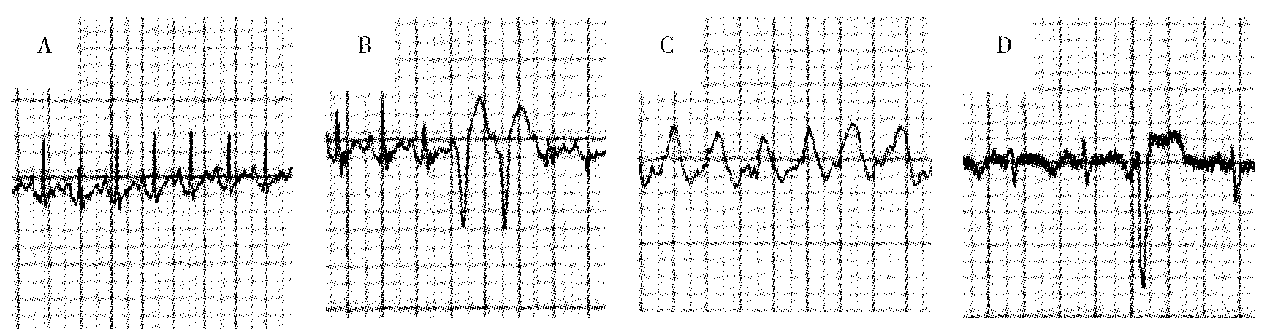
A：Sham group；B：Frequent premature ventricular contraction；C：Ventricular tachycardia；D：Sporadic premature ventricular contraction
Fig 1 ECG of arrhythmia of acute myocardial infarction model in rabbits

Table 2 Comparison of 90% APD and transmural dispersion of repolarization in three myocardium layers among three groups($\bar{x}±s$)
Group | Cases | 90% APD (ms) |  |  | Transmural dispersion of repolarization(ms)
Group | Cases | Epicardium layer | Myocardium layer | Endocardium layer | Transmural dispersion of repolarization(ms)
Sham group | 10 | 189.4±21.4 | 211.5±20.6 | 184.2±20.4 | 27.3±7.1
Model group | 10 | 231.5±17.4△△ | 266.7±20.1△△ | 220.5±19.3△△ | 46.2±10.9△△
Tanshinone group | 10 | 211.0±16.3△△▲▲ | 240.1±19.5△△▲▲ | 204.6±18.8△△▲▲ | 35.5±8.8△△▲▲
F/P |  | 24.093/0.001 | 12.435/0.001 | 16.345/0.001 | 8.996/0.002
P₁ |  | 0.001 | 0.001 | 0.001 | 0.002
P₂ |  | 0.001 | 0.001 | 0.001 | 0.001
P₃ |  | 0.003 | 0.005 | 0.006 | 0.004
APD: Action potential duration, similarly hereinafter.

  - Changes of Ca²⁺concentration in three myocardium layers in three groups
The present study found that compared with sham group, there were significant rise in Ca²⁺concentration in epicardium layer, myocardium layer and endocardium layer in model group, P<0.01; compared with model group, there were significant reductions in Ca²⁺concentrationin of three myocardium layers in tanshinone group, P<0.05～0.01. They were shown in table 3.

Table 3 Comparison of Ca²⁺concentration in three myocardium layers among three groups($\bar{x}±s$, mmol/L)
Group | Cases | Epicardium layer | Myocardium layer | Endocardium layer
Sham group | 10 | 81.4±10.4 | 92.3±10.6 | 83.2±9.9
Model group | 10 | 132.0±12.3△△ | 144.8±11.1△△ | 131.5±12.6△△
Tanshinone group | 10 | 102.3±10.3△△▲▲ | 113.9±10.0△△▲ | 103.4±10.1△△▲
F/P |  | 21.052/0.001 | 35.969/0.001 | 42.425/0.001
P₁ |  | 0.001 | 0.001 | 0.001
P₂ |  | 0.003 | 0.001 | 0.002
P₃ |  | 0.009 | 0.010 | 0.013

  - Changes of expression levels of calmodulin and calmodulin kinase Ⅱ in three myocardium layers in three groups
The present study found that compared with sham operation group, there were significant rise in calmodulin and calmodulin kinaseⅡexpression levels in epicardium layer, myocardium layer and endocardium layer in model group, P<0.01 all; compared with model group, there were significant reductions in expression levels of calmodulin and calmodulin kinase Ⅱ in three myocardium layers in tanshinone group, P<0.05～0.01. They were shown in table 4 and figure 2.
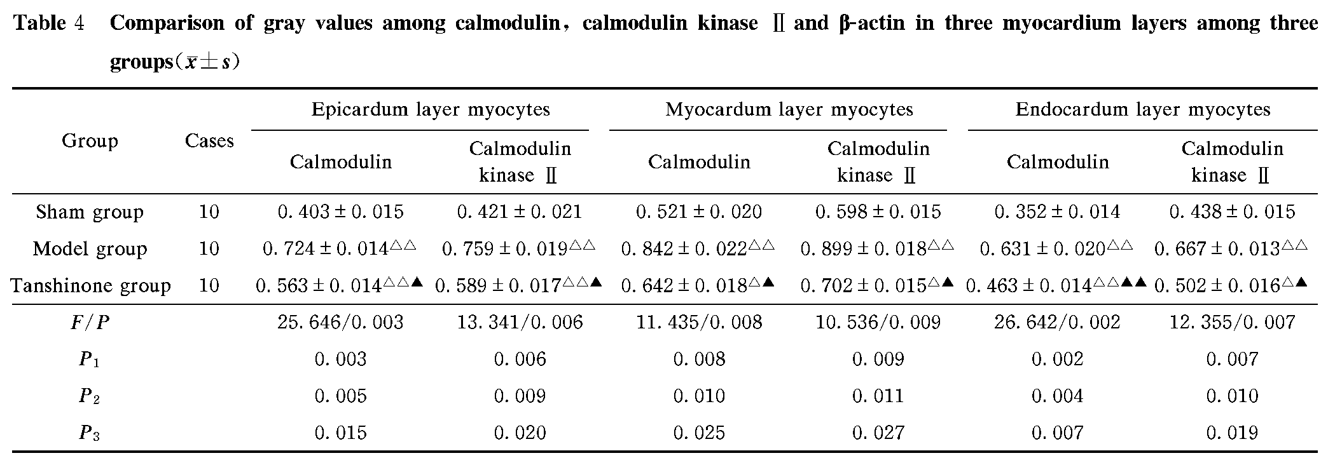
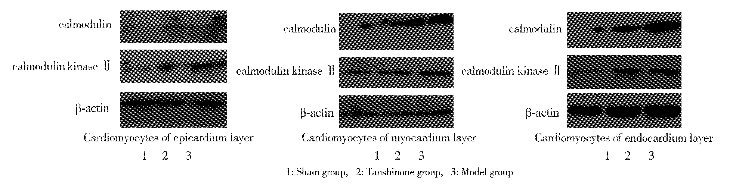
Figure 2 Comparison of expression levels of calmodulin and calmodulin kinase Ⅱ in three myocardium layers among three groups

- Discussion
Malignant arrhythmia occurred after myocardial infarction is a major cause, but there is lack of effective therapeutic drugs and methods for malignant arrhythmias in clinic ^{[6]}. Current research thinks that the pathogenesis mechanism of malignant arrhythmia after myocardial infarction is mainly calcium ion overload in myocytes, so it relatively increases autonomy, stimulate trigger and reentry activity. The trigger activity mainly refers to afterdepolarization, which includes early afterdepolarization and delayed afterdepolarization ^{[7-8]}. Early afterdepolarization is caused by prolonged APD and calcium channel re-opening. Some research found that activation of calmodulin kinase Ⅱmay lead to occurrence of early afterdepolarization and delayed afterdepolarization, and calmodulin kinase Ⅱ is activated by compound of calmodulin and Ca ^{2+ [9-10]}. When Ca ²⁺ overload in myocytes occurs, it causes activation of multiple signal transduction pathways in myocytes, including calmodulin/calmodulin kinase Ⅱ signal transduction pathway ^{[11]}. Some research indicated that compared with endocardium layer and epicardium layer myocytes, left ventricular myocardium layer myocytes were different, whose APD was longer than those of the two formers, and it lead to inconsistency of transmural repolarization in ventricular wall, when dispersion of transmural repolarization rose, there were occurrence of afterdepolarization, trigger and reentry activity in human myocardium, and it finally formed malignant arrhythmia ^{[12]}.
Tanshinone is an effective active component in frequently used cardiovascular traditional Chinese medicine—Salvia. In traditional Chinese medicine, Salvia can treat cardiovascular diseases, including effects of inhibiting platelet aggregation, anti-thrombus and anti-heart failure etc^{[13]}. Tanshinone can protect injured myocardium caused by AMI ^{[14]}. A study indicated that tanshinone can significantly improve electrophysiology of hypertrophic myocardium, and it can reduce Ca ²⁺ influx towards myocytes ^{[15]}. Results of the present study indicated that tanshinone can significantly reduce incidence rate of malignant arrhythmia, APD and transmural dispersion of repolarization, and can reduce Ca ²⁺ concentration, expression levels of calmodulin and calmodulin kinaseⅡ in three layers of myocytes in AMI rabbits. These results indicated that tanshinone can reduce incidence rate of malignant arrhythmia after myocardial infarction, and its possible mechanism: it may be realized via modulating calmodulin and calmodulin kinase Ⅱ signal transduction pathway.

Reference
[1] HU Li-hua, HU Tao-hong, DING Li-ping, et al. Comparison of morbidity characteristics between early-onset patients and aged patients with acute myocardial infarction [J]. Chin J Cardiovasc Rehabil Med, 2012,21(5):492-495.
[2] ZHAO Li, ZHENG Zhi, ZHAO Rong. Effects of polyphenol acid salt of Salvia miltiorrhiza on plasma plasminogen balance in patients with brain infarction [J].Chin J Cardiovasc Rehabil Med,2010,19(5):549-551.
[3] ZHAO Yang, LU Yin, ZHENG Shi-zhong, et al. Research progress on pharmacological effects of cryptotanshinone[J].China J Tradition Chin Med Pharm,2010,25(11):1839-1841.
[4] DU Qiu-ming, WANG Cun-xuan. Effects of sodium tanshinoneⅡA sulfonate on arrhythmia induced by myocardial ischemia-reperfusion [J].Chin J Geriatr Heart Brain Vessel Dis,2011,13(4):349-351.
[5] Hao LY, Wang WY, Minobe E, et al. The distinct roles of calmodulin and calmodulin kinase Ⅱ in the reversal of run-down of L-type Ca(2+) channels in guinea-pig ventricular myocytes[J]. J Pharmacol Sci,2009,111(4):416-425.
[6] WEI Wei. Diagnostic and therapeutic progress of malignant arrhythmias[J].South China J Cardiovasc Dis,2014,20(5):678-682.
[7] CHU Hong-xia, RUAN Lei, FAN Jing-jing, et al. Pacing-site dependent differences of myocardial repolarization time of left ventricular wedge in canine[J].Acta Med Univ Sci Technol Huazhong,2011,40(4):373-378.
[8] DING Shao-xiang. Research progress of J wave and mechanism of ion flow formed by phase 2 reentry[J].Chin J Gerontol,2012,32(12):2676-2678.
[9] Strom M, Wan X, Poelzing S, et al. Gap junction heterogeneity as mechanism for electrophysiologically distinct properties across the ventricular wall[J].Am J Physiol Heart CircPhysiol,2010,298(3):H787-H794.
[10] WANG Zhan, LI Dong-yang, CAO Yu. Calmodulin and arrhythmias of hypertrophic myocardium[J].Progress Anat Sci,2010,16(4):364-366.
[11] LI Zhe. Change of calmodulin-mediated type L ion channel current in rat model with arrhythmia caused by ischemia/reperfusion[J].J Hainan Med Coll,2013,19(12):1627-1630.
[12] HUANG Shao-hong, RONG Jian, WANG Shu-yun, et al. Interstitial calcium and sarcolemal NCX expression in rat myocardial ischemia-reperfusion injury in vivo[J]. Acta Med Univ Sci Technol Huazhong,2012,41(1):76-79.
[13] WANG Zhao-hua, ZHENG Zhi, LIANG Qian-sheng, et al. Tanshinone intervention on electrophysiological abnormality of hypertrophic myocardium [J].Chin J Emerg Med, 2008, 17(10):1039-1044.
[14] ZHANG Hui-hui, HUANG Shu-wei, WANG Lin-li, et al. Protection of tanshinone on myocardium injured by reperfusion in rabbits with acute myocardial infarction[J].Chin J Modern App Pharm, 2013,30(10):1062-1066.
[15]YE Yong, YANG Dan-dan, TU Qian. Experimental research of angiogenenic effects of tanshinonⅡA on the chick embryo chorioallantoic membrane (CAM) model[J].Res Integ Trad Chin & West Med, 2010, 2(2):61-63, 67.

