Comparative study between intervention transcatheter direct thrombolysis and vein thrombolysis plus anti-coagulation therapy for treating lower extremity deep venous thrombosis

/XU Guo-jian// Surgery Department of Thyroid and Vessel, First People's Hospital of Foshan City, Foshan, Guangdong, 528000, China

Abstract: Objective: To compare the therapeutic effect of intervention transcatheter direct thrombolysis and vein thrombolysis and anti-coagulation drugs on lower extremity deep venous thrombosis (DVT). Methods: A total of 61 patients with lower extremity DVT accorded with inclusion standards were selected. They were randomly divided into intervention transcatheter direct thrombolysis group (n=30, intervention group) and vein thrombolysis and anti-coagulation group (n=31, thrombolysis + anti-coagulation group). Patients were treated for four weeks as a course. Results: Total effective rate of intervention group was significantly higher than that of thrombolysis + anti-coagulation group (93.33% vs. 64.52%), χ2=4.987, P=0.032. There were no significant differences in hemorheology indexes between two groups before treatment, P>0.05. Compared with before treatment, after treatment, there were significant reductions in high shear whole blood viscosity, low shear whole blood viscosity, plasma viscosity and fibrinogen level in intervention group, P<0.05 all; there were significant reductions in plasma viscosity and fibrinogen level in thrombolysis + anti-coagulation group, P<0.05 both. After treatment, compared with thrombolysis + anti-coagulation group, there were significant reductions in low shear whole blood viscosity [(12.10±2.13) mPa·s vs. (11.08±1.67) mPa·s] and plasma viscosity [(1.85±0.13) mPa·s vs. (1.31±0.09) mPa·s] in intervention group, P<0.05 both. After treatment, total effective rate of vessel open up in intervention group was significantly higher than that of thrombolysis + anti-coagulation group (90.00% vs. 61.29%), χ2=4.173, P=0.047. Conclusion: For patients with acute DVT and no operation contraindications, therapeutic effect of transcatheter direct thrombolysis is more significant. It can significantly improve hemorheology and vessel open up rate, it may be recommended as the preferred in clinic.
Key word: Catheterization; Thrombolytic therapy; Venous thromboembolism
Article number 1008-0074(2015)04-
Doi: 10.3969/j. issn. 1008-0074. 2015. 04.

介入导管直接溶栓与静脉溶栓并抗凝治疗下肢深静脉血栓的对比研究/徐国建, 广东佛山市第一人民医院血管甲状腺外科, 广东 佛山 528000

摘要: 目的：对比导管直接溶栓和静脉溶栓加抗凝治疗下肢深静脉血栓的临床疗效。方法：选择符合纳入标准的下肢深静脉血栓患者61人，随机分为介入直接溶栓组(30例，介入组)和静脉溶栓+抗凝组(溶栓+抗凝组, 31例)。治疗4周为一疗程。结果：介入组总有效率为93.33%，显著高于溶栓+抗凝组的64.52% ( χ2=4.987, P=0.032)。两组治疗前血液流变学指标差异无统计学意义(P>0.05)。与治疗前比较，治疗后介入组全血高切粘度、全血低切粘度、血浆粘度及纤维蛋白原水平均显著降低(P均<0.05)；溶栓+抗凝组只有血浆粘度、纤维蛋白原水平显著降低(P均<0.05);与溶栓+抗凝组比较，治疗后介入组全血低切粘度[(12.10±2.13)mPa·s比(11.08±1.67)mPa·s]和血浆粘度[(1.85±0.13)mPa·s比(1.31±0.09)mPa·s]显著降低 (P均<0.05)。治疗后介入组血管开通总有效率为90.00%，显著高于溶栓+抗凝组的61.27%, χ2=4.173, P=0.047。结论：对于急性期深静脉血栓形成并且无手术禁忌证的患者，导管直接溶栓疗效更显著，能明显改善血液流变学和提高血管开通率，可推荐为临床首选。
关键词: 导管插入术；血栓溶解疗法；静脉血栓栓塞
文章编号：1008-0074(2015)04- 中图分类号：R543.3 文献标识码：A
Doi: 10.3969/j. issn. 1008-0074. 2015. 04.

Anticoagulation therapy has been generally acknowledged as a main therapeutic method for low extremity deep vein thrombosis (DVT) by academia, while thrombolysis therapy also has been proved as an effective method treating DVT by a lot of researches ^{[1].} Because interventional surgery can rapidly clear venous thrombus in a short time, and protect structure and function of venous valves etc. ^{[2]}, so its application gradually increases in clinic. The present research aimed at discussing advantages and disadvantages of above two methods in order to guide coming treatment.

1 Data and methods
1.1 General data
A total of 61 patients with lower extremity DVT, who hospitalized in our hospital from Mar 2012 to Mar 2014, were enrolled, including 34 men and 27 women. They were divided into two groups: intervention transcatheter direct thrombolysis group (n=30, intervention group) , the age was 19~71(42.37±7.42) years old and the course of disease was 5~14 (8.25±5.21)d, and the involved limbs included 16 cases with left side, eight cases with right side and six cases with both sides; and vein thrombolysis and anti-coagulation group (thrombolysis + anti-coagulation group, n=31), the age was 21~72(44.78±6.15) years old and the course of disease was 5~14(8.73±4.93)d, and the involved limbs included 21 cases with left side, six cases with right side and four cases with both sides. There were no significant difference in gender, age, course of disease and involved limbs between two groups, P>0.05.

1.2 Inclusion standards
(1) Diagnosis accord with diagnosis and treatment guidelines for DVT (second edition) ^{[3]}; (2) staging of disease is acute phase (course of disease is within four weeks); (3) No related therapeutic contraindications, such as thrombolysis, anticoagulation and intervention etc.; (4) Patients complicated with severe heart, brain, liver and renal disease and psychosis etc. are excluded; (5) Patients or entrusted people (patient’s family) sign the informed consent.

1.3 Therapeutic methods
Intervention group: catheter was delivered to the opening of common iliac vein through internal jugular vein or femoral vein, then delivered into iliac-femoral vein under the guidance of guidewire or steel needle, switching guidewire was placed, then thrombolysis catheter was put in, lateral aperture segment of which was placed in distal end of thrombus. Urokinase was infused, 600 000 ~ 10 000 000 U/24h, it can be divided into three/four times, 15~20 min infusion every time. Low molecular weight heparin sodium 12 000 ~ 18 000 U/24h was intravenously dripped via catheter, and thrombolysis catheter was retained for 2~3d ^{[4]}. Thrombolysis+anti-coagulation group: intravenous injection of urokinase with loading dose of 4000 U/kg within 30min; the maintenance dose was 600 000 ~ 1 200 000 U/d for 48~72h, it can be maintained for 5~7d if necessary. Patients received anticoagulation therapy after thrombolysis course ended. Coagulation indexes were monitored.

1.4 Observation indexes
(1) Judging basis of therapeutic effect: referred to therapeutic effect assessment standards revised by peripheral vascular disease committee of China Association of Integrative Medicine in 1995; the therapeutic effect were divided into clinical cure, apparent effect, effective and no effect ^{[2]}; (2) Hemorheology indexes: whole blood high shear viscosity, low shear viscosity， plasma viscosity and fibrinogen content; (3) B ultrasound apparatus was used to observe vessel recanalization.

1.5 Statistical method
SPSS 20.0 software was used to perform all statistical analysis. Measurement data were expressed as mean ± standard deviation ($\bar{x}±s$), its comparison between two groups was performed using t test. Ranked data was analyzed using rank test. Numeration data was expressed as percentage, and its comparison was performed using chi-square test. P<0.05 was regarded as possessing significant difference.

2 Results
2.1 Comparison of therapeutic effects between two groups
Total effective rate of intervention group was significantly higher than that of thrombolysis + anti-coagulation group (93.33% vs. 64.52%), χ2=4.987, P=0.032. They were shown in table 1.

Table 1 Comparison of therapeutic effects between two groups [n (%)]
Group | Clinical cure | Apparent effect | Effective | No effect | Total effective rate
Intervention group (n=30) | 15(50.00) | 9(30.00) | 4(13.33) | 2(6.67) | 29(93.33) △
Thrombolysis + anti-coagulation group (n=31)  χ2/P | 11(35.48) | 4(12.90) | 5(16.13) | 11(35.48) | 20(64.52)  4.987/0.024
Compared with medical therapy group △P<0.05. Similarly hereinafter.

2.2 Comparison of hemodynamic indexes between two groups
Compared with before treatment, after treatment, there were significant reductions in high shear whole blood viscosity, low shear whole blood viscosity, plasma viscosity and fibrinogen level in intervention group, P<0.05 all; there were significant reductions in only plasma viscosity and fibrinogen level in thrombolysis + anti-coagulation group, P<0.05 both. There were no significant difference in hemorheology indexes between two groups before treatment, P>0.05. Compared with thrombolysis + anti-coagulation group, after treatment, there were significant reductions in low shear whole blood viscosity and plasma viscosity in intervention group, P<0.05 both. They were shown in table 2.
2.3 Comparison of recanalization between two groups after treatment
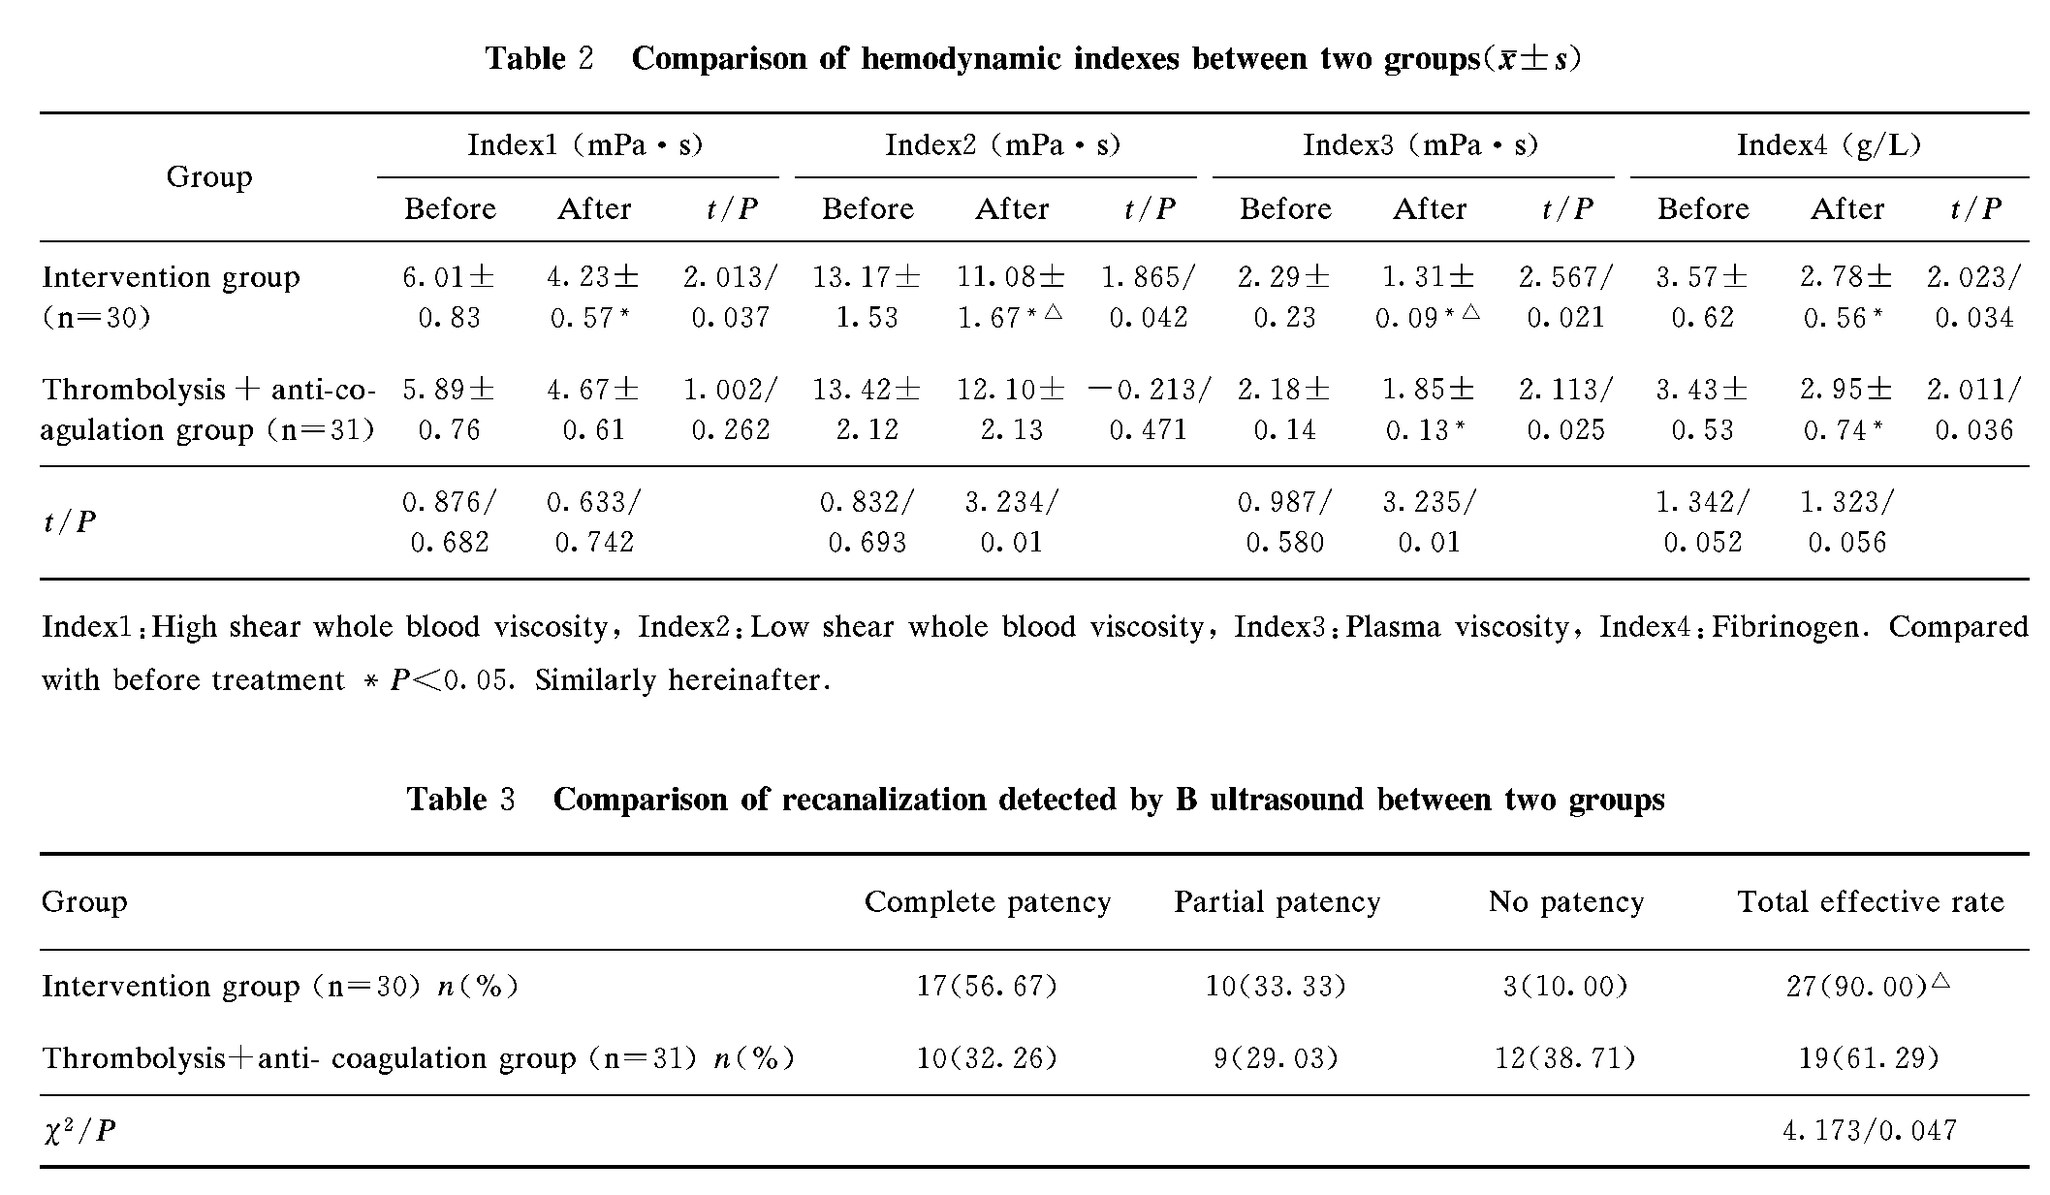
After treatment, there were 17 cases with complete patency, 10 cases with partial patency and three cases without patency in intervention group, so the total effective patency rate was 90.00%; there were 10 cases with complete patency, nine cases with partial patency and 12 cases without patency, so the total effective patency rate was 61.29% in thrombolysis + anti-coagulation group. That of intervention group was significantly higher than that of thrombolysis + anti-coagulation group (χ2=4.173, P=0.047). They were shown in table 3.

3. Discussion
For now, clinical frequent risk factors for lower extremity DVT include operation, wound, immobilization on the bed, cardio- and cerebrovascular diseases and malignant tumor etc ^{[6-11]}. Along with B ultrasonography develops, detection rate of DVT rises year by year, American relative research data indicated that in recent years, total incidence rate of venous thromboembolism rose by 33.1% ^{[12]}. Recent foreign related study found that compared with white people, morbidity of DVT was lower but rose very rapidly in Asian population ^{[13]}. Currently, the most used therapeutic methods for DVT of acute phase are surgical intervention and oral thrombolysis and anticoagulation drugs. Antithrombotic and thrombolysis treatment guidelines for venous thromboembolism formulated by American Thoracic Society in 2008 recommended transcatheter direct thrombolysis technique as a preferred method treating DVT of acute phase. Advantages of transcatheter direct thrombolysis technique were: (1) the thrombolysis catheter directly deliver high concentration thrombolytic drugs to thrombus sites, thrombolysis efficiency is high; (2) incidence rate of systemic bleeding is low; (3) it possesses wide indications. As to oral thrombolysis and anticoagulation treatment, it’s usually a preferred therapeutic plan especially for acute phase DVT patients with course of disease ≤7d. Foreign scholars found that thrombolysis possessed definite therapeutic effect after five-year long-term follow-up ^{[14]}.
In the present study, total effective rate of intervention group was significantly higher than that of thrombolysis + anti-coagulation group (93.33% vs. 64.52%), P=0.032. There were no significant difference in hemorheology indexes between two groups before treatment, P>0.05. Compared with before treatment, after treatment, there were significant reductions in high shear whole blood viscosity, low shear whole blood viscosity, plasma viscosity and fibrinogen level in intervention group, P<0.05 all; there were significant reductions in only plasma viscosity and fibrinogen level in thrombolysis + anti-coagulation group, P<0.05 both. After treatment, compared with thrombolysis + anti-coagulation group, there were significant reductions in low shear whole blood viscosity and plasma viscosity in surgical intervention group, P<0.05 both, suggesting that transcatheter direct thrombolysis can significantly improve hemorheology, reduce blood viscosity and decrease the possibility of further aggravating embolism. B ultrasound examination indicated that total effective rate of recanalization in intervention group was significantly higher than that of thrombolysis + anti-coagulation group (90.00% vs. 61.29%), P=0.047, suggesting that compared with thrombolysis + anti-coagulation drugs, transcatheter direct thrombolysis can really significantly improve hemodynamic state. The causes may be that transcatheter direct thrombolysis makes the time for drug to reach thrombus much shorter than that of vein thrombolysis, and the drug concentration is higher. We need to suggest that, some study indicated that external application of traditional Chinese medicine as an auxiliary measure can significantly reduce complications and improve therapeutic effect ^{[15]}, it is worth reference.
In summary, for DVT patients in acute phase without operation contraindications, therapeutic effect of transcatheter direct thrombolysis is more significant and definite. It can significantly improve hemorheology and hemodynamics, and should be the first choice in clinical

Reference
[1]Vascular Surgery Group of Chinese Medical Association Surgery Branch. Diagnosis and treatment guidelines for deep vein thrombosis (2nd edition) [J]. Chin J Surg, 2012, 50(7): 611-614.
[2]GU Han-cheng. Clinical observation of therapeutic effect of conbined treatment of traditional Chinese on lower extremity deep vein thrombosis during acute phrase [D]. Beijing University of Chinese Medicine, 2013.
[3]WANG Guo-jie, ZHANG Zhuo-jin. Early diagnostic value of plasma D-dimer detection for lower extremity deep vein thrombus [J]. J Pract Med, 2012, 28(14): 2368-2370.
[4] Interventional Group of Chinese Medical Association Radiology Branch. The consensus among Chinese interventional experts on the standard of interventional therapy for deep venous thrombosis of lower extremity [J]. J Intervent Radiol, 2011, 20(7): 505-510.
[5] Deitelzweig SB, Johnson BH, Lin J, et al. Prevalence of clinical venous thromboembolism in the USA: current trends and future projections [J]. Am J Hematol, 2011, 86(2): 217-220.
[6] ZHANG Xiao-li, LI Xiao-liang, ZHENG Xue-jun. Pathogenic factor analysis in 72 cases with deep venous thrombosis [J]. World J Integ Trad & West Med, 2012, 7(1): 81-82.
[7] ZHANG Qing, XING Xiang-yang. Etiology and treatment of deep venous thrombosis of lower extremities [J]. Contemp Med, 2011, 17(30): 19-20.
[8] ZHANG Yan. Cause analysis and nursing of aged patients with lower extremity deep venous thrombosis from department of orthopedics [J]. J Reg Anat Oper Surg, 2011, 20(1): 80, 83.
[9] ZHAO Zhen-feng, GAO Zhi-ying, ZONG Su-mei. Cause analysis and nursing measure for 11 cases with lower extremity deep venous thrombosis [J]. Nurs Pract Res, 2011, 8(3): 57-58.
[10]XIA Xian, WANG Lin. Diagnosis and treatment of lower extremity deep venous thrombosis after orthopaedic surgery [J]. Zhejiang J Traum Surg, 2011, 16(3): 316-317.
[11] ZHANG Jin, LI Qing-hua. Causes and prevention of lower extremity deep venous thrombosis after lower limb fracture surgery [J]. Guide China Med, 2011, 9(2): 73-74.
[12] HAN Xiao-gang. Cause analysis and diagnostic methods for lower extremity deep venous thrombosis [J]. Shanxi Med J: Second Half, 2012, 41(12): 1270-1271.
[13] WANG Wan-hong，ZHANG Rong-lin，CHENG Yong at al. Study for application of tirofiban in intra-infarct-related artery after manual thrombas aspiration in patients with acute
myocardial infarction. [J] Chin J Cardiovasc Rehabil Med, 2012, 21(5):521-525
[14]Jang MJ, Bang SM, Oh D. Incidence of venous thromboembolism in Korea: from the Health Insurance Review and Assessment Service database[J]. J Thromb Haemost, 2011, 9(1): 85-91.
[15]AbuRahma AF, Perkins SE, Wulu JT, et al. Iliofemoral deep vein thrombosis: conventional therapy versus lysis and percutaneous transluminal angioplasty and stenting [J]. Ann Surg, 2001, 233(6):752-760,
[16]LIN Xue-mei, FU Mei-hua, LIN Yao-ru, et al. Observation of therapeutic effect of Shuangbaisan external application on diseased limb edema of lower extremity deep venous thrombosis [J]. Shenzhen J Integr Trad & West Med, 2011, 21(5): 302-304.

