Correlation between obesity and prethrombotic state in patients with coronary heart disease
GUO Jia-jia¹, HU Song², WANG Li-na¹, MAO Yong-jun², WANG Ren-ping²// 1. Teaching and Research Office for Geriatric Medicine, Medical College of Qingdao University, Qingdao, Shandong, 266021, China; 2. Affiliated Hospital of Qingdao University (Department of Geriatrics: HU Song, MAO Yong-jun; Physical Examination Center: WANG Ren-ping)
Corresponding author: WANG Ren-ping, E-mail: beautyyibei@163.com

Abstract: Objective: To explore the correlation among overweight, obesity and markers of prethrombotic state in patients with coronary heart disease (CHD). Methods: A total of 288 patients to hospital from 2013 to 2014 and diagnosed as CHD by coronary angiography were selected. According to body mass index (BMI), they were divided into CHD control group (n=106), overweight group (n=121) and obesity group (n=61). Levels of fibrinogen (Fg), plasma D dimmer (D-D), von Willebrand factor (vWF), antithrombin Ⅲ (AT-Ⅲ) and plasminogen activator inhibitor (PAI)-1 were compared among three groups, then received correlation analysis.Results: Compared with CHD control group, there were significant rise in levels of triglyceride, total cholesterol, fasting blood glucose and mean arterial pressure, morbidity rates of hypertension and diabetes mellitus in overweight group and obesity group, P<0.05 or <0.01. Compared with CHD control group, there were significant rise in levels of Fg [(2.89±0.60) g/L vs. (3.54±0.63) g/L vs. (3.92±0.94) g/L], D-D [(282.13±73.15) ng/ml vs. (390.04±73.54) ng/ml vs. (471.92±80.38) ng/ml], vWF [(108.62±24.66)% vs. (138.45±25.96)% vs. (161.20±29.39)%] and PAI-1 [(6.97±1.28) ng/ml vs. (9.60±1.73) ng/ml vs. (12.33±2.16) ng/ml] in overweight group and obesity group, P<0.01 all, and those of obesity group were significantly higher than those of overweight group, P<0.01 or <0.05; AT-Ⅲ level [(89.94±17.99)% vs. (69.89±20.22)%] significantly reduced in obesity group (P<0.05). Pearson correlation analysis indicated that BMI was positively correlated with markers of prethrombotic state [Fg: r=0.536, P<0.001; D-D: r=0.250, P<0.001; vWF: r=0.611, P<0.001;PAI-1: r=0.788,P<0.001). Conclusion: BMI is positively correlated with markers of prothrombotic state in CHD patients.
Key words: Obesity; Thrombosis; Coronary disease
Article number 1008-0074(2015)03-
Doi: 10.3969/j. issn. 1008-0074. 2015.03.

冠心病患者肥胖与血栓前状态的相关性研究/郭佳佳¹, 胡 松², 王丽娜¹, 毛拥军², 王仁萍² //1. 青岛大学医学院老年医学教研室, 山东 青岛 266021；2. 青岛大学附属医院 (老年医学科: 胡松，毛拥军, 体检中心: 王仁萍)
通讯作者：王仁萍，E-mail：beautyyibei@163.com

摘 要: 目的:探讨冠心病患者超重、肥胖与血栓前状态标志物之间的相关性。 方法：选择2013-2014年来院就诊的, 经冠脉造影确诊为冠心病(CHD)的288名患者，根据BMI被分为CHD对照组(106例)、超重组(121例)和肥胖组(61例)，对比三组患者的血栓前状态标志物:纤维蛋白原（Fg）、血浆D-二聚体（D-D），血管假性血友病因子（vWF），抗凝血酶Ⅲ（AT-III），纤溶酶原激活物抑制剂-1（PAI-1）水平的差别，并进行相关性分析。 结果：与CHD对照组比较，超重和肥胖组的患者血甘油三酯(TG)、总胆固醇(TC)、空腹血糖、平均动脉压水平, 高血压和糖尿病患病率均显著升高(P<0.05或<0.01)。与CHD对照组相比，超重和肥胖组Fg[(2.89±0.60) g/L比(3.54±0.63) g/L比(3.92±0.94) g/L], D-D [(282.13±73.15) ng/ml比(390.04±73.54) ng/ml比(471.92±80.38) ng/ml], vWF [(108.62±24.66)%比(138.45±25.96)%比(161.20±29.39)%]和PAI-1 [(6.97±1.28) ng/ml比(9.60±1.73) ng/ml比(12.33±2.16) ng/ml]水平均显著升高(P均<0.01)，且肥胖组的显著高于超重组的(P<0.01或<0.05)；肥胖组的AT-III水平[(89.94±17.99)%比(69.89±20.22)%]显著下降(P<0.05)。Pearson相关分析显示：BMI和血栓前标志物呈显著正相关（FIB: r=0.536, P<0.001; D-D: r=0.250, P<0.001;vWF: r=0.611, P<0.001;PAI-1: r=0.788, P<0.001）。结论：在冠心病患者BMI与血栓前状态标志物呈正相关关系。
关键词：肥胖症；血栓形成；冠心病
文章编号：1008-0074(2015)03- 中图分类号：R541.409 文献标识码：A
Doi: 10.3969/j. issn. 1008-0074. 2015.03.

Recently, morbidity of obesity has significantly risen in worldwide, and some researches find that prethrombotic state, such as hypercoagulable state can reflect patient’s condition aggravation, suggesting morbidity and mortality of coronary heart disease (CHD) rise^{[1]}. Although the association between obesity and cardiovascular diseases has been recognized for a long time, there were rare researches focus on influence of obesity on prethrombotic state and its molecular mechanism. Therefore, the present research compared and studied levels of prethrombotic state markers among normal weight, overweight and obesity groups of CHD, and discussed the pathophysiological mechanism for obesity caused prethrombotic state.

1. Data and methods
1.1 Subjects
A total of 288 patients to hospital of Qingdao University from 2013 to 2014, and diagnosed as CHD by coronary angiography were enrolled, including 186 men and 102 women with age (59.08±12.39) years. According to their body mass index (BMI), patients were divided into CHD control group (n=106, BMI: 18.5~23.9 kg/m²), overweight group (n=121, BMI: 24~27.9 kg/m²) and obesity group (n=61, BMI: ≥28 kg/m²). Exclusion standards were as follow: heart diseases of other types (including myocarditis, pericarditis, valvular heart disease and rheumatic heart disease etc), atrial fibrillation, acute infection, liver and renal failure, pregnancy, and the use of drugs interfering coagulation system, such as warfarin and heparin. The study was approved by ethics committee and all subjects signed informed consent.
1.2 Clinical data collection
The age, gender, past medical history (presence of hypertension, smoking and diabetes mellitus or not), blood pressure, body weight and height were collected through inquiring medical history and physical examination, BMI were measured through body weight and height; mean arterial pressure (MAP) were calculated from systolic and diastolic blood pressure. Roche Hitachi 7600 automatic biochemical analyzer was used to measure levels of triglyceride (TG), total cholesterol (TC), high density lipoprotein cholesterol (HDL-C), low density lipoprotein cholesterol (LDL-C) and fasting blood glucose (FBG).
1.3 Measurements of coagulant indexes
The 3ml elbow venous blood was taken in morning fasting state, placed it in tube containing 10% sodium citrate, shaken well, then centrifuged at 3000 r/min for 20 min and separated plasma immediately. The sample was stored in -80℃ fridge for detection. Automatic coagulometer analyzer (STA-R instrument provided by STAGO company) was used to measure levels of plasma fibrinogen (Fg), plasma D dimmer (D-D) and antithrombin Ⅲ (AT-Ⅲ); enzyme linked immunosorbent assay (ELISA) was used to measure levels of von Willebrand factor (vWF), and plasminogen activator inhibitor (PAI)-1.
1.4 Statistical analysis
SPSS 17.0 software was used to perform statistical analysis. Measurement data were expressed as mean ± standard deviation ($\bar{x}±s$), comparison among multiple groups was performed using one way ANOVA, and paired comparison was performed using LSD-t test; numeration data were presented as percentage and its comparison was performed using chi-square test; Pearson correlation analysis was used to analyze continuous variables, and scatter diagram was used to show the correlation among variables. P<0.05 was regarded as possessing significant difference.
2. Results
2.1 Comparison of clinical features
One way ANOVA indicated that levels of TG, TC, FBG and MAP in overweight group and obesity group were significantly higher than those of CHD control group, P<0.01 all?. Besides, chi-square test indicated that percentages of hypertension and diabetes mellitus in overweight group and obesity group were significantly higher than those of CHD control group, P<0.05, <0.01?. They were shown in table 1.

Table 1 Comparison of general data and biochemical indexes among three groups
 | CHD control  group (n=106) |  | Overweight  group (n=121) | Obesity group (n=61) | F/χ² | P | P_{1：2} | P_{1：3} | P_{2：3}
Age (years) | 58.01±12.56 |  | 59.37±12.57 | 60.36±13.68 | 0.753 | 0.472 | 0.074 | 0.099 | 0.854
Male n(%) | 59(55.7) |  | 82(67.8) | 42(68.9) | 5.873 | 0.053 | 0.075 | 0.103 | 0.100
BMI (kg/m²) | 21.52±1.76 |  | 25.79±1.23△△ | 29.33±1.22△△▲▲ | 639.790 | 0.001 | 0.001 | 0.001 | 0.001
Triglyceride  (mmol/L) | 1.32±0.89 |  | 1.56±1.07 | 1.90±0.96△△▲ | 5.524 | 0.004 | 0.270 | 0.001 | 0.011
Total cholesterol (mmol/L) | 4.23±1.09 |  | 4.45±1.04 | 4.84±1.09△△▲▲ | 6.262 | 0.002 | 0.120 | 0.001 | 0.001
HDL-C(mmol/L) | 1.23±0.36 |  | 1.14±0.20△ | 1.17±0.21△ | 1.809 | 0.166 | 0.010 | 0.014 | 0.727
LDL-C(mmol/L) | 2.25±0.84 |  | 2.37±0.92 | 2.69±0.60△△ | 2.277 | 0.104 | 0.355 | 0.009 | 0.064
Fasting blood  glucose (mmol/L) | 5.50±1.27 | 5.69±1.33 |  | 6.18±1.81△△▲ | 5.094 | 0.007 | 0.400 | 0.001 | 0.013
Mean arterial  pressure (mmHg) | 104.86±11.64 | 109.14±15.72 |  | 113.64±14.31△△ | 7.807 | 0.005 | 0.056 | 0.001 | 0.105
Diabetes mellitus n(%) | 36(34.0) |  | 37(30.6) | 32(52.5) △ | 9.399 | 0.009 | 0.669 | 0.023 | 0.066
Hypertension n(%) | 58(54.7) |  | 83(68.6) △ | 45(73.8) △ | 7.613 | 0.022 | 0.040 | 0.020 | 0.497
Smoking n(%) | 45(42.5) |  | 46(38.0) | 25(41.0) | 0.478 | 0.787 | 0.501 | 0.872 | 0.749
HDL-C: High density lipoprotein cholesterol, LDL-C: Low density lipoprotein cholesterol, CHD: Coronary heart disease, BMI: Body mass index. P_{1：2} was comparison between group 1 (CHD control group and group 2 ( overweight group ) , P_{2：3} was comparison between group 2 and group 3 (obesity group). Compared with CHD control group △P<0.05, △△P<0.01; compared with overweight group ▲P<0.05, ▲▲P<0.01. Similarly hereinafter.

2.2 Comparison of prethrombotic state marker levels among three groups
One-way ANOVA of prethrombotic state markers in three groups indicated that levels of Fg, D-D, vWF and PAI-1 in overweight group and obesity group were significantly higher than those of CHD control group (P<0.01), and AT-III level of obesity group was significantly lower than that of CHD control group (P<0.05). They were shown in table 2.

Table 2 Comparison of prethrombotic state marker levels among three groups ($\bar{x}$±ｓ)
 | Fibrinogen (g/L) | D-dimer (ng/ml) | vWF(%) | Antithrombin III(%) | PAI-1(ng/ml)
CHD control group (n=106) | 2.89±0.60 | 282.13±73.15 | 108.62±24.66 | 89.94±17.99 | 6.97±1.28
Overweight group (n=121) | 3.54±0.63△△ | 390.04±73.54△△ | 138.45±25.96△△ | 72.04±20.52 | 9.60±1.73△△
Obesity group (n=61) | 3.92±0.94△△▲▲ | 471.92±80.38△△▲ | 161.20±29.39△△▲▲ | 69.89±20.22△ | 12.33±2.16△△▲▲
F | 49.471 | 11.438 | 83.329 | 3.292 | 175.346
P | 0.001 | 0.001 | 0.001 | 0.039 | 0.001
P_{1:2} | 0.001 | 0.002 | 0.001 | 0.291 | 0.001
P_{1:3} | 0.001 | 0.001 | 0.001 | 0.011 | 0.001
P_{2:3} | 0.001 | 0.043 | 0.001 | 0.085 | 0.001
vWF：von Willebrand factor, PAI-1: Plasminogen activator inhibitor-1. Similarly hereinafter.

2.3 Pearson correlation analysis
Pearson correlation analysis indicated that BMI was positively correlated with markers of prethrombotic state [Fg: r=0.536, P＜0.001; D-D: r=0.250, P＜0.001; vWF: r=0.611, P＜0.001;PAI-1: r=0.788,P＜0.001). They were shown in table 3 and figure 1.
Table 3 Pearson correlation analysis
 | Age |  | BMI |  | Fasting blood glucose |  | Mean arterial pressure
 | r | P | r | P | r | P | r | P
Fibrinogen | 0.076 | 0.200 | 0.536 | 0.001 | 0.052 | 0.381 | 0.303 | 0.001
D-dimer | 0.029 | 0.628 | 0.250 | 0.001 | 0.030 | 0.607 | 0.227 | 0.018
vWF | 0.052 | 0.409 | 0.611 | 0.001 | 0.157 | 0.008 | 0.531 | 0.076
PAI-1 | 0.085 | 0.151 | 0.788 | 0.001 | 0.169 | 0.004 | 0.193 | 0.007
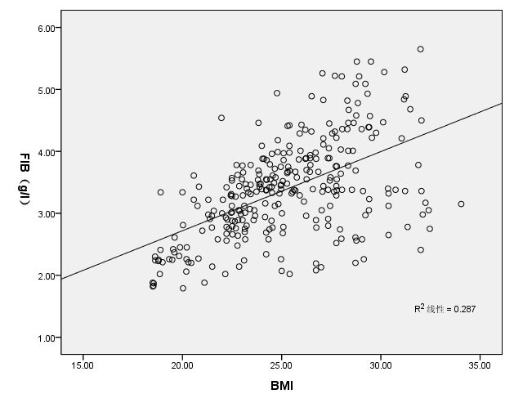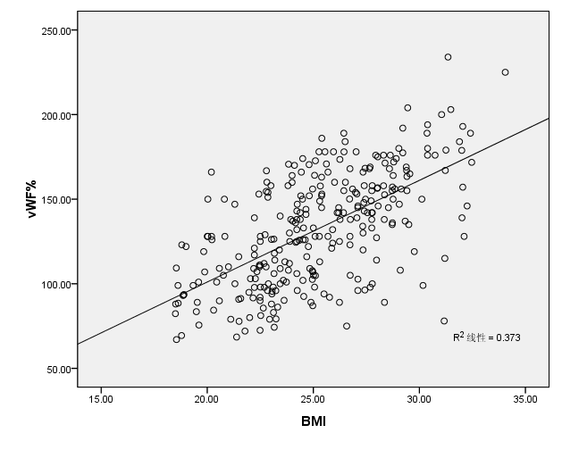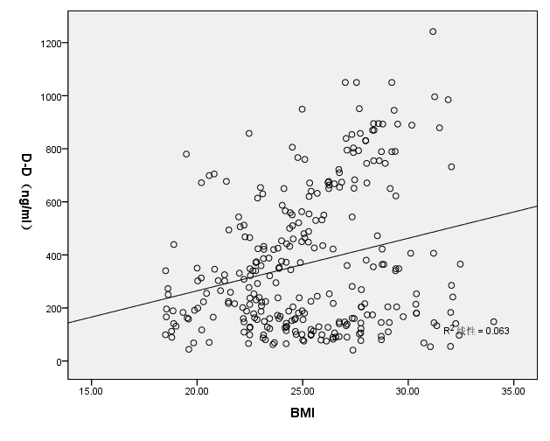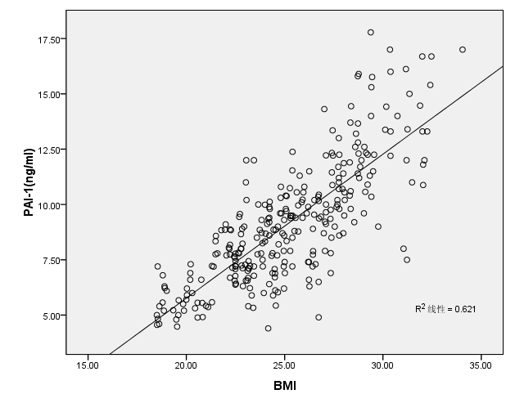
Fig.1 Correlation scatter diagram between BMI and prethrombotic state markers in CHD patients

3. Discussion
Obesity mainly through hyperlipidemia and inflammation increases plaque vulnerability ^{[2]} and biological active molecules produced by adipose tissue aggravates endothelial function impairment, abnormal function of haemostatic and fibrinolytic systems ^{[3]}. Therefore, obesity has been proved to be related to increased risk of cardiovascular morbidity and mortality.
Previous researches have suggested that obesity-related cardiovascular complications started in children; prothrombotic state has existed in obese children without established metabolic syndrome and prethrombotic state played a key role in the development of cardiovascular diseases ^{[4,5]}. The present research indicated that compared with normal weight group, there were significant rise in levels of MAP, FBG, blood lipids and prethrombotic state markers in overweight and obese patients; furthermore, high BMI was significantly correlated with prethrombotic state in patients with coronary disease and obesity.
Adipocytes cytokines are produced in portal circulation by hepatic metabolism. Blood Fg is a substrate for thrombin in the final step of coagulation cascade, which is essential for platelet aggregation. Blood Fg level is strongly, consistently correlated with cardiovascular risk^{[5]}. Liver and adipocytes can produce PAI-1, which is main physiological inhibitor of fibrinolysis ^{[6]}. PAI-1 is related to obesity, the present study indicated that BMI was significantly correlated with PAI-1, further suggesting BMI was related with impaired fibrinolytic capacity in cardiovascular diseases and atherosclerotic plaque, thus aggravate enhanced platelet aggregation and thrombosis ^{[7]}.
Other components of coagulation cascade, such as D-D, AT-III and vWF levels, are also related to obesity ^{[8]}. The present study has also indicated that multiple cytokines secreted by dysfunctional adipocytes may aggravate development of hypercoagulable state.

Reference
[1] Blokhin IO, Lentz SR. Mechanisms of thrombosis in obesity[J]. Curr Opin Hematol, 2013, 20(5):437-444.
[2] Eckel RH, Barouch WW, Ershow AG. Report of the National Heart, Lung, and Blood Institute-National Institute of Diabetes and Digestive and Kidney Diseases Working Group on the pathophysiology of obesity-associated cardiovascular disease [J]. Circulation, 2002, 105(24):2923-2928.
[3] Després JP. Cardiovascular disease under the influence of excess visceral fat [J]. Crit Pathw Cardiol, 2007, 6(2):51-59.
[4] Stoppa-Vaucher S, Dirlewanger MA, Meier CA, et al. Inflammatory and prothrombotic states in obese children of European descent[J]. Obesity (Silver Spring), 2012, 20(8):1662-1668.
[5] Koenig W. Fibrin(ogen) in cardiovascular disease: an update[J]. Thromb Haemost, 2003, 89(4): 601–609.
[6] Shimomura I, Funahashi T, Takahashi M, et al. Enhanced expression of PAI-1 in visceral fat: possible contributor to vascular disease in obesity [J]. Nat Med, 1996, 2(7): 800–803.
[7] Schäfer K, Konstantinides S. Adipokines and thrombosis[J]. Clin Exp Pharmacol Physiol, 2011, 38(12):864-871.
[8] Nagai N, Hoylaerts MF, Cleuren AC, et al. Obesity promotes injury induced femoral artery thrombosis in mice[J]. Thromb Res, 2008, 122(4): 549–555.

