Influence of exercise rehabilitation on heart function, and plasma levels of angiotensin Ⅱ and endothelin-1 in patients with CHF of CHD
YAN Xue-an
//Health Management Center, 154th Central Hospital of PLA, Xinyang, Henan, 464000, China

Abstract: Objective: To observe the therapeutic effect of exercise rehabilitation training on patients with coronary heart disease (CHD) complicated chronic heart failure (CHF). Methods: According to odd and even number, a total of 96 patients were randomly divided into rehabilitation exercise group (n=48) and routine treatment group (n=48). Rehabilitation exercise group received exercise rehabilitation training based on routine treatment for eight weeks. Changes of NYHA cardiac function class, left ventricular ejection fraction (LVEF) and 6 min walking distance (6MWD) were observed and compared between two groups before and after treatment. Enzyme linked immunosorbent assay (ELISA) was used to measure plasma levels of angiotensin Ⅱ (AngⅡ) and endothelin-1 (ET-1) in two groups before and after treatment. Results: (1) Compared with routine treatment group after eight-week treatment, there was significant improvement in NYHA cardiac function [(2.12±0.71) classes vs. (1.26±0.54) classes], and significant rise in LVEF [(38.26±6.49)% vs. (47.03±5.96)%] and 6MWD [(390.55±40.12) m vs. (501.23±44.37) m] in rehabilitation exercise group, P<0.05 or <0.01; (2) After treatment, plasma levels of AngⅡ and ET-1 significantly reduced in both groups, and those of rehabilitation exercise group were significantly lower than those of routine treatment group in patients with same NYHA cardiac function class, P<0.05 or<0.01. Conclusion：Exercise rehabilitation training can improve cardiac function, decrease plasma levels of angiotensin Ⅱ and endothelin-1 and possess high safety in patients with chronic heart failure.
Key words：Coronary disease; Heart failure; Rehabilitation
Article number 1008-0074(2015)01-
Doi: 10.3969/j. issn. 1008-0074. 2015. 01.

运动康复对冠心病慢性心衰患者心功能,血管紧张素Ⅱ及内皮素-1水平的影响/闫学安// 解放军第一五四中心医院健康管理中心，河南 信阳 464000

摘要: 目的：观察运动康复训练对冠心病慢性心衰患者的治疗效果。方法：96例患者根据单双号被随机分成康复运动组和常规治疗组，各48例。康复运动组在常规治疗基础上配合运动康复训练，疗程8周。观察并比较两组患者治疗前后NYHA心功能分级变化、左室射血分数（LVEF）、6min步行距离。采用酶联免疫（ELISA）法检测两组患者治疗前后血浆血管紧张素Ⅱ（AngⅡ）、内皮素-1（ET-1）含量的变化。结果：（1）治疗8周后，与常规治疗组比较，康复运动组患者NYHA心功能分级[(2.12±0.71)级比(1.26±0.54)级]显著改善，LVEF [(38.26±6.49)%比(47.03±5.96)%]、6min步行距离[(390.55±40.12)m比(501.23±44.37)m]显著提高（P＜0.05或P<0.01）；（2）治疗后两组病人血浆AngⅡ及ET-1水平均显著下降，且康复运动组血浆AngⅡ及ET-1水平均较常规治疗组更显著下降（P<0.05 或 <0.01）。结论：慢性心力衰竭患者进行运动康复训练可以改善心功能，降低血浆血管紧张素Ⅱ及内皮素-1水平,且安全性高。
关键词：冠心病；心力衰竭；康复
文章编号：1008-0074(2015)01- 中图分类号：R541.409 文献标识码：A
Doi: 10.3969/j. issn. 1008-0074. 2015. 01.

Chronic heart failure (CHF) is a very frequent clinical syndrome. It’s decompensation syndrome resulted from cardiac ventricular long-term pressure or volume overload caused by heart structure or functional disease, which can cause essential or secondary myocardial diastolic/systolic dysfunction, leading to ventricular filling disorder and ejection dysfunction, the cardiac output cannot meet metabolic need of body, so tissue blood hypoperfusion, venous congestion of pulmonary and/or systemic circulation occur; CHF is a progressive aggravating clinic syndrome ^{[1]}. In recent years, its morbidity rate gradually increases, occupied about 1.5%~2%, and it’s more high in those over 60 years, about 6%~10% ^{[2]}. Traditional anti-heart failure treatment claims patients to rest in bed in order to decrease myocardial oxygen consumption, but many researches didn’t support it in recent years. American College of Cardiology and USA Department of Health and Human Services have determined that exercise rehabilitation treatment can be regarded as routine therapy for rehabilitation of patients with chronic and stable heart failure. The present study aimed at observing influence of exercise rehabilitation on cardiac function and plasma levels of angiotensin Ⅱ (AngⅡ) and endothelin-1 (ET-1) in CHF patients, and preliminarily explore the therapeutic effect of exercise rehabilitation treatment on aged CHF patients and its mechanisms.

1 Data and methods
1.1 Data
According to New York Heart Association (NYHA) cardiac function classification, a total of 96 inpatients with NYHA cardiac function class Ⅱ～Ⅳ, who hospitalized from Jul 2012 to Jul 2013, were selected, and all cases were accorded with Chinese diagnostic standard of CHD and heart failure. According to odd and even number, the 96 patients were randomly divided into two groups. In rehabilitation exercise group, there were 48 cases, including 36 males and 12 females with age (58.0±l2.1) years; there were 20 CHD cases, 14 cases with hypertensive heart disease, 10 cases with hypertension complicated CHD and four cases with dilated cardiomyopathy; there were eight cases, 22 cases and 18 cases with NYHA class Ⅱ, Ⅲ and Ⅳ respectively. There were 48 cases in routine treatment group, including 32 males and 16 females with age (57.0±11.7) years; there were 22 CHD cases, 14 cases with hypertensive heart disease, six cases with hypertension complicated CHD and six cases with dilated cardiomyopathy; there were six cases, 26 cases and 16 cases with NYHA class Ⅱ, Ⅲ and Ⅳ respectively. Patients in both groups were excluded for severe brain, kidney, blood, respiratory, and digestive system diseases, and those who suffered from malignant arrhythmia during hospitalization, and received electrical defibrillation, cardiopulmonary resuscitation and pacemaker implantation. After statistical analysis, data of two groups didn’t possess significant difference (P>0.05), so they were comparable.
1.2 Therapeutic methods
Both groups received routine therapeutic plan according to therapeutic principle of CHF: received routine oxygen inhalation, medication with diuretics, cardiotonics, vasodilators, β receptor blockades and angiotensin converting enzyme inhibitor (ACEI) etc., and blood pressure was controlled under 130/80mmHg, blood glucose and blood lipids were also controlled, the course of treatment was eight weeks. Based on routine treatment and nursing, rehabilitation exercise group received rehabilitation exercise training according to program formulated by Nanjing Medical University [3] , it is adopted energy protection and layering technique according to NYHA heart function class. The program was shown in table 1.

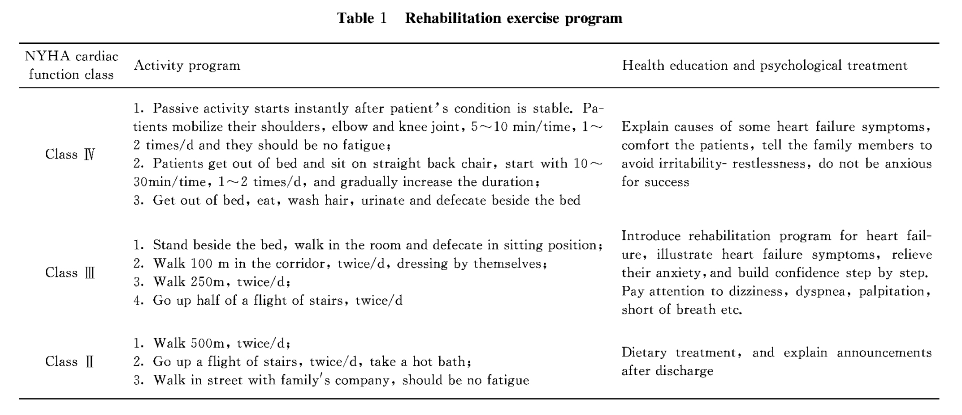
1.3 Observed indexes
Following index changes were observed in both groups on hospitalization and 8th weeks after treatment: ① Clinical cardiac function assessed by NYHA cardiac function classification; ② Cardiac function assay: left ventricular ejection fraction (LVEF) was measured by ultrasonocardiograph produced by Philips Company, the probe frequency was 2.0~4.0 MHz, LVEF was measured on parasternal left ventricular long-axis mitral chordae tendineae level using M echocardiography; ③ determine 6 min walking distance (6MWD) from 6min walking test; ④ Plasma levels of AngⅡ and ET-1 determination: enzyme linked immunosorbent assay (ELISA) meter was used to measure AngⅡ and ET-1 levels, 3 ml fasting venous blood was taken before and after treatment respectively, put in tube containing EDTANa2 and centrifuged 8 min by 3000r/min, then plasma was separated and placed in EP tube, stored in -20 ℃ fridge, then plasma concentrations of AngⅡ and ET-1 were measured by ELISA method. All kits were bought from American BIOSITE Company.
1.4 Statistical method
SPSS 15.0 software was used to perform statistical analysis. Measurement data were expressed as mean ± standard deviation ($\bar{x}±s$), and its comparison was performed using analysis of variance and LSD-t test. P<0.05 was regarded as possessing significant difference.

2 Results
2.1 Comparison of cardiac function, LVEF and 6 MWD between two groups before and after treatment
At hospitalization, there were no significant differences in NYHA cardiac function class, LVEF and 6 MWD between two groups. After eight-week treatment, compared with routine treatment group, there was significant improvement in NYHA cardiac function class, LVEF (P<0.05), and significant rise in 6MWD (P<0.01) in rehabilitation exercise group. They were shown in table 2.
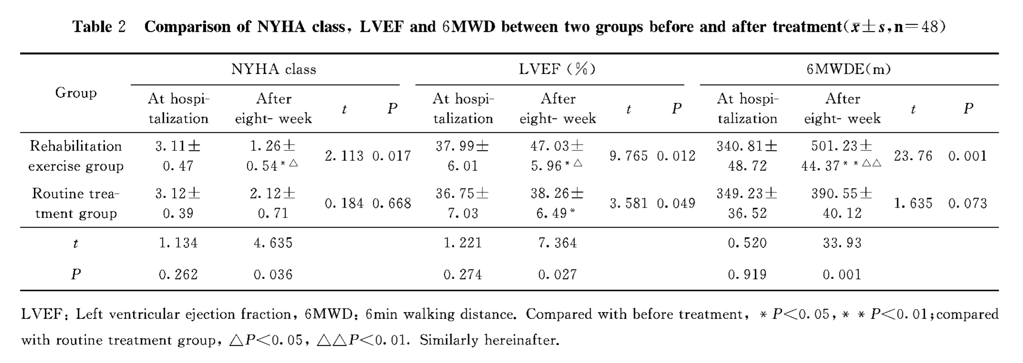
2.2 Comparison of plasma Ang II and ET-1 levels between two groups before and after treatment
The plasma levels of Ang II and ET-1 between two groups were no significant difference before treatment; after eight- week treatment, plasma levels of Ang II and ET-1 all significantly reduced, but compared with patients with same cardiac function class of routine treatment group, those were significantly lower in rehabilitation exercise group (P<0.05 or <0.01). They were shown in table 3.

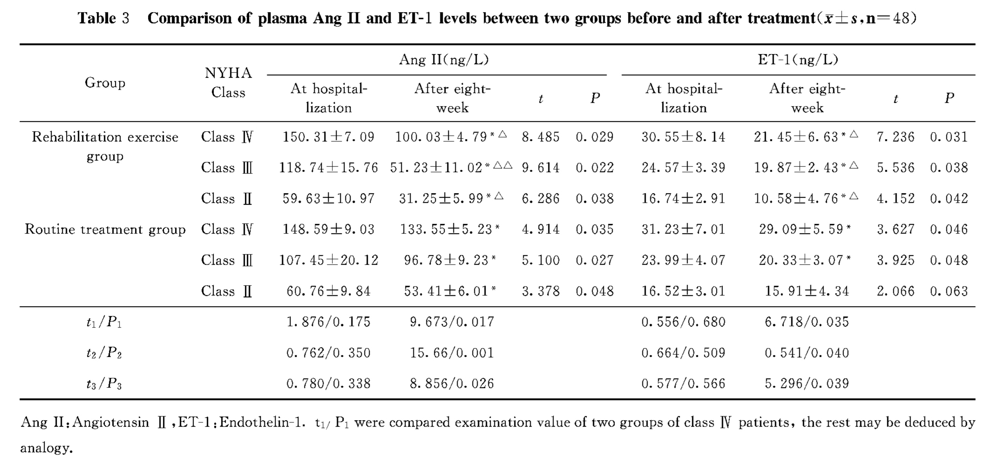

3 Discussion
CHF is cardiac diastolic and systolic dysfunction caused by different causes, it makes cardiac output cannot meet the need general metabolism, then leads to clinical syndrome featured by abnormal hemodynamics and neurohormonal activation ^{[1]}. A research indicated that neurohormonal activation played a very important role in pathogenesis of heart failure, and AngⅡ and ET-1 played important role in CHF occurrence. There exists endothelial dysfunction in patients with heart failure, the balance between NO and ET released by endothelial cells is broken, leading to endothelium-dependent vascular diastolic and systolic dysfunction, then the patients show significant maladjustment symptoms ^{[4]}. AngⅡ is a highly active substance in vivo, which can bind with AngⅡ receptor 1, leading to endothelial dysfunction and left ventricular hypertrophy, and AngⅡ abnormality is almost throughout the whole process of cardiovascular disease occurrence. Both AngⅡ and ET-1 act on vascular endothelium in common, leading to peripheral vascular remodeling, limit blood reserve of skeletal muscle, then reduce exercise tolerance, potentially affect myocardial structure and function^{[5]}, therefore reducing plasma AngⅡ and ET-1 level is thought to be one of primary targets in treating heart failure. In present study, exercise training can reduce AngⅡ and ET-1 levels, activities of renin-angiotensin-aldosterone system (RAAS) and sympathetic nervous system (SNS), break vicious circle between continuous activation of SNS, RAAS and myocardial damage, then relieve myocardial damage and delay ventricular remodeling ^{[6]}. In present study, during early period of rehabilitation therapy, levels of AngⅡ and ET-1 significantly rose, after eight-week rehabilitation exercise training, they significantly reduced compared with early period of treatment, indicating that exercise rehabilitation training can reduce plasma levels of AngⅡ and ET-1 (P<0.05) and promote rehabilitation of patients.
Some viewpoints thought that physical activity (exercise) were inappropriate for patients with heart failure, and resting in bed was emphasized in these patients. Some researches suggested that long-term resting in bed would reduce adaption state of body ^{[7]}. Clinical cardiac function and LVEF are the most routine indexes judging patient’s cardiac function. The present study used three indexes to evaluate rehabilitation exercise effect, namely clinical heart function, LVEF and 6MWD. After eight-week treatment, compared with routine treatment group, the clinical cardiac function class significantly improved (P<0.05); the LVEF and 6 MWD significantly rose in rehabilitation exercise group (P<0.05 or P<0.01), therefore, standardized exercise training and physical activity can promote patient’s function recovery. Mechanism of exercise rehabilitation in CHF patients may be that exercise may improve skeletal muscle function and tolerance, improve endothelial function in peripheral blood circulation, reduce peripheral vessel resistance, decrease the activities of SNS and RAAS, relieve cardiac burden and improve left ventricular function. Therefore, moderate rehabilitation exercise is beneficial for cardiac function improvement in these patients.
In summary, it’s very necessary to perform rehabilitation exercise under the premise of fully understanding CHF patient’s condition, careful plan and closely monitor. Rehabilitation exercise can improve patient’s cardiac function in a greater extent and reduce neurohormonal level in vivo. Therefore, rehabilitation exercise is worthy of clinical extension.

Reference
[1] YE Ren-gao, CHEN Hao-zhu. Practical internal medicine [M]. Beijing: People’s Medical Publishing House, 2004: 1091-1111．
[2] HU Da-yi, MA Chang-sheng. Practice of cardiology 2005—New progress and clinical cases [M]. Beijing: People’s Medical Publishing House, 2005：573-575．
[3] WANG Gang, WANG Tong. Occupational therapy clinical applications [M]. Beijing: Huaxia Publishing House, 2005：472-481．
[4] Burnett JC Jr. Coronary endothelial dysfunction in the hypertensive patient: from myocardial ischemia to heart failure [J]. J Hum Hypertens, 1997, 11(1):45-49.
[5] Drexler H. Endothelium as a therapeutic target in heart failure [J]. Circulation, 1998, 98(24): 2652-2655.
[6] ZHANG Zi-bin, Tsung O. Cheng, ZHANG Yu-chuan. Congestive heart failure [M]. Beijing: Science and Technology Documentation Press, 2002: 1067.
[7] LI Li, LI Rui-jie, SONG Li-fen, et al. Rehabilitating exercise improves heart function and quality of life in old patients with chronic heart failure [J]. Chin J Cardiovasc Rehab Med, 2006, 15(4): 315-318

