Correlation between glycosylated hemoglobin level and coronary SYNTAX score in patients with coronary heart disease

LIU Tian-min, ZHOU Fang, XIAO Hong-kai, HUANG Yin, LIU Xiao-hui, LIN Xiu-fang//
Department of Cardiology, Fifth Affiliated Hospital of SUN Yat-sen University, Zhuhai, Guangdong, 519000, China
Corresponding author: LIN Xiu-Fang, E-mail: linxiufang_126@126.com

Abstract: Objective: To explore the correlation between glycosylated hemoglobin (HbA1c) level and severity of coronary artery disease in patients with coronary heart disease (CHD). Methods: Clinical data of 515 patients, who hospitalized in department of cardiology and received coronary angiography (CAG) examination, were analyzed. According to CAG results, they were divided into CHD group (n=370) and normal CAG group (n=145); according to HbA1c level, CHD patients were further divided into HbA1c<7% group (n=282) and HbA1c≥7% group (n=88), according to SYNTAX score, they were divided into SYNTAX score low risk group (n=181, 1~22 scores), intermediate risk group (n=125, 23~32 scores) and high risk group (n=64, ≥33 scores). HbA1c level was compared and analyzed among all groups. Results: Coronary SYNTAX score of HbA1c≥7% group was significantly higher than that of HbA1c<7% group [(25.6±9.97) scores vs. (20.92±10.26) scores, P<0.01]. HbA1c levels in high risk and intermediate risk groups were significantly higher than those of normal CAG group and low risk group [(8.74±0.83) scores, (7.74±0.62) scores vs. (5.12±0.49) scores vs. (5.68±0.59) scores], P<0.01 all, and that of low risk group was significantly higher than that of normal CAG group, , P<0.01 all. Pearson correlation analysis indicated that HbA1c level was positively correlated with coronary SYNTAX score (r=0.764, P<0.01). Conclusion: Glycosylated hemoglobin level is positively correlated with severity of coronary artery disease. Its level in those with higher SYNTAX score is significantly higher than those with low SYNTAX score.
Key words: Hemoglobin A, glycosylated; Coronary artery disease; Risk factors
Article number 1008-0074(2014)05-479-05
Doi: 10.3969/j. issn. 1008-0074. 2014.05.02

冠心病患者糖化血红蛋白水平与冠脉SYNTAX评分的相关性/刘天民，周芳，肖宏凯，黄茵，刘小慧，林岫芳*//中山大学附属第五医院心血管内科，广东 珠海 519000
通讯作者：林岫芳，E-mail: linxiufang_126@126.com
摘要：目的： 探讨冠心病患者糖化血红蛋白水平与冠脉病变严重程度的相关性。方法： 选择心内科住院并行冠状动脉造影检查的515例患者资料进行分析，按照冠脉造影结果分为冠心病组（370例）和冠脉造影结果正常组（145例）；冠心病组患者再按糖化血红蛋白水平分为HbA₁c＜7%组（282例）和HbA₁c≥7%组（88例），按SYNTAX评分分为SYNTAX评分低危组（1-22分，181例）、中危组（23-32分，125例）及高危组（≥33分，64例）三个亚组，分析比较各组间糖化血红蛋白水平的差异。结果：HbA₁c≥7%组冠心病患者的冠脉SYNTAX 评分显著高于HbA₁c＜7%组[(25.6±9.97)分比(20.92±10.26)分，P<0.01]。SYNTAX评分高危组和中危组HbA1c水平显著高于冠脉造影正常组、低危组[(8.74±0.83)分、(7.74±0.62)分比(5.12±0.49)分比(5.68±0.59)分]，且低危组也显著高于正常组（P均<0.01）。Pearson相关分析显示HbA1c水平与SYNTAX评分呈正相关(r=0.764, P<0.01)。结论:糖化血红蛋白水平与冠脉病变严重程度呈正相关，SYNTAX评分高者糖化血红蛋白水平明显高于SYNTAX评分低者。
关键词：血红蛋白A，糖基化；冠状动脉疾病；危险因素
文章编号：1008-0074(2014)05-479-05 中图分类号：R541.409 文献标识码：A
Doi: 10.3969/j. issn. 1008-0074. 2014.05.02

Diabetes mellitus (DM) is not only an independent risk factor，but also a most important risk factor for coronary heart disease (CHD). A lot of domestic and foreign epidemiological data proved that compared with people with normal blood glucose, CHD morbidity significantly rises in DM patients, and it occurs early, develops rapidly and prognosis is poor；there are about 80% patients possessing abnormal glucose metabolism among CHD patients ^{[1, 2]}. Many domestic and foreign researches had discussed the correlation between glycosylated hemoglobin (HbA1c) and CHD, but there still exists controversy on the conclusion ^{[3-6]}. Coronary SYNTAX score can more fully and comprehensively evaluate severity of coronary artery disease. The present study made a retrospective analysis on clinical data of patients who hospitalized in our department of cardiology and received coronary angiography (CAG) examination, explored the correlation between HbA1c level and severity of coronary artery disease and the interrelation among other CHD risk factors and HbA1c during CHD development based on introducing SYNTAX scoring system.

1. Subjects and methods
1.1 Subjects
A total of 515 cases with relatively complete data, who hospitalized in department of cardiology in fifth hospital of Sun Yat-sen University from Mar 2003 to Nov 2012 and received CAG examination, were enrolled, including 374 men and 141 women with age 27~85 (60.08±10.69) years.
1.2 Methods
General data of subjects were recorded. CAG and judgment of coronary artery disease severity: Judkins method was used to perform selective left and right CAG. Then according to CAG results, subjects were divided into normal CAG group (n=145) and CHD group (n=370). SYNTAX scoring calculator (version 2.11) downloaded from SYNTAX Score official network station (http://www.syntaxscore.com) was used to score coronary artery disease of the enrolled subjects. According to SYNTAX score results, CHD group was further divided into low risk group (n=181, 1~22 scores), intermediate risk group (n=125, 23~32 scores) and high risk group (n=64, ≥33 scores). According to HbA1c level, CHD group was divided into HbA1c<7% group (n=282) and HbA1c≥7% group (n=88). HbA1c level was compared and analyzed among normal CAG group and CHD subgroups with different SYNTAX scores, and SYNTAX score was compared between HbA1c<7% group and HbA1c≥7% group.
1.3 Statistical treatment
SPSS 13.0 for windows was used to perform statistical analysis. Measurement data were expressed as mean ± standard deviation ($\bar{x}±s$), and its comparison was performed using t test. Numeration data were expressed as percentage and its comparison was performed using chi-square test. Comparison of measurement data among multiple groups was performed using one way ANOVA, and the comparison between two groups was performed using LSD-t test. P<0.05 was regarded as possessing significant difference.

2. Results
2.1 Comparison of HbA1c level among CHD all subgroups and normal CAG group One-way ANOVA indicated that there were significant differences in HbA1c levels among
SYNTAX score low risk group, intermediate risk group, high risk group and normal CAG group
(F=6.16, P=0.001). Further analysis indicated that HbA1c levels in high risk and intermediate risk
group were significantly higher than those of normal CAG group and low risk group; HbA1c level in high risk group was significantly higher than that of intermediate risk group, and that of low risk group was significantly higher than that of normal CAG group, P<0.01 all. They were shown in table 1.
2.2 Comparison of risk factors and SYNTAX score between CHD HbA1c<7% group and HbA1c≥7% group
There were no significant difference in sex, age, smoking history, levels of blood pressure (except pulse pressure), blood lipids and total bilirubin, number of diseased coronary vessels and percentage of patients complicated essential hypertension between HbA1c<7% group and HbA1c≥7% group ( P>0.05 all); but percentage of patients complicated DM, pulse pressure level and SYNTAX score of HbA1c≥7% group were significantly higher than those of HbA1c<7% group, P<0.05 or <0.01. They were shown in table 2.

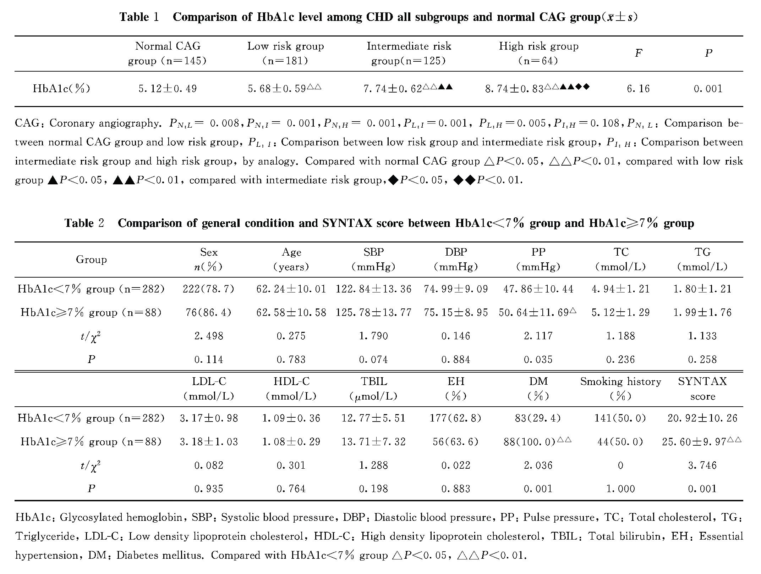
2.3 Correlation analysis between HbA1c level and coronary SYNTAX score
Pearson correlation analysis indicated that HbA1c level was positively correlated with coronary SYNTAX score (r=0.764, P<0.01).

3. Discussion
HbA1c is regarded as the gold standard for screening DM and judging blood glucose control condition. More and more researches demonstrated that HbA1c was related with CHD and it’s a predictive index for DM，CHD and arteriosclerosis ^{[7-9]}. The role of HbA1c in occurrence and development of CHD is mainly presented in following aspects: HbA1c can elevate viscocity, reduce deformability and fluidity for red blood cell（RBC）, and make 2, 3-diphosphoglyceric acid (2, 3-DPG) concentration significantly reduce in RBC, and it can lead to Bohr effect weakened or disappeared and cause histanoxia. Elevated HbA1c indicated that the body is under hyperglycemic state, protein glycosylation and oxygenation aggravate, glycosylation products lead to expression elevating for adhesion factor and chemotactic factor genes, make lymphocytes and monocytes move inward and form foam cells, and stimulate monocyte/macrophage and vascular endothelial cells to express adhesion molecules and secret pro-inflammatory cytokines, then aggravate development of atherosclerosis; HbA1c increases release of endothelin, reduces the release of nitric oxide and prostacyclin, making vascular systolic capacity impaired, and it can cause anti-platelet aggregation effect weaken of endothelial cells and lead to thrombosis; besides, glycosylation products also increase matrix metalloproteinase, accelerate collagen decompose, weaken fibrous cap of plaques, make plaque break, then lead to increased incidence rate of coronary events ^{[10-12]}.
Results of the present study indicated that SYNTAX score of HbA1c≥7% group was significantly higher than those of HbA1c<7% group. After subjects were grouped again according to SYNTAX score, it suggested that HbA1c level of SYNTAX score high risk group was significantly higher than those of intermediate risk, low risk groups and normal CAG groups; HbA1c level of intermediate risk group was significantly higher than those of low risk and normal CAG groups, and that of low risk group was significantly higher than that of normal CAG group.
Previous researches usually used number of diseased coronary vessels to express severity of coronary artery disease, hereby to study the relationship between HbA1c level and CHD. The present study introduced SYNTAX scoring system to judge the severity of coronary artery disease. Sianos and Kappetein etc designed and put forward SYNTAX scoring in 2005 in order to evaluate the complexity of coronary disease. It not only considers the number of significant lesions and lesion located vessels, but also fully assesses the complexity of each lesion, including calcification, thrombus, bifurcation lesion and its type etc ^{[13, 14]}. Therefore, it can more fully and comprehensively assess the severity of coronary disease. The present study introduced SYNTAX score and used it to present the severity of coronary artery disease; its result was Pearson correlation analysis indicated that HbA1c level was positively correlated with coronary SYNTAX scores, so HbA1c may be a predictive index for DM and CHD.

Reference
[1] Iung B, Baron G, Butchart EG, et al. A prospective survey of patients with valvular heart disease in Europe: The Euro Heart Survey on Valvular Heart Disease [J]. Euro Heart J, 2003, 24: 1231-1243.
[2] China Heart Survey Group. Cross-sectional study on the prevalence of abnormal glucose metabolism in patients with coronary artery disease in China—China Heart Survey [J]. Chin J Endocrinol Metab, 2006, 22(1):7-10.
[3] Selvin E, Steffes MW, Zhu H, et al. Glycated hemoglobin, diabetes, and cardiovascular risk in nondiabetic adults [J]. N Engl J Med, 2010, 362(9): 800-811.
[4] Pradhan AD, Rifai N, Buring JE, et al. Hemoglobin A1c predicts diabetes but not cardiovascular disease in nondiabetic women [J]. Am J Med, 2007, 120(8): 720-727.
[5] Selvin E, Coresh J, Golden SH, et al. Glycemic control, atherosclerosis, and risk factors for cardiovascular disease in individuals with diabetes: the atherosclerosis risk in communities study [J]. Diabetes Care, 2005, 28(8): 1965-1973.
[6] JIN Wen-sheng, PAN Chang-yu, LU Ju-ming, et al. Glycemia is an independent marker for atherosclerosis [J]. Chin J Diabetes, 2005, 13(1):19-22.
[7] Selvin E, Coresh J, Golden SH, et al. Glycemic control and coronary heart disease risk in persons with and without diabetes: the atherosclerosis risk in communities study [J]. Arch Intern Med, 2005, 165(16): 1910-1916.
[8] Preiss D, Sattar N. HbA1c: a useful cardiovascular risk marker in those without diabetes? [J]. Diabetologia, 2010, 53(12): 2468–2469.
[9] YAN Jian-ping. Correlation among levels of glycosylated hemoglobin,blood lipid and carotid atherosclerosis in patients with type 2 diabetes mellitus [J]. Chin J Cardiovasc Rehab Med,2013,22（4）: 358-360
[10] Vasudevan AR, Burns A, Fonseca VA. The effectiveness of intensive glycemic control for the prevention of vascular complications in diabetes mellitus [J]. Treat Endocrinol, 2006, 5(5): 273-286.
[11]Bartnik M, Malmberg K, Norhammar A, et al. Newly detected abnormal glucose tolerance: an important predictor of long-term outcome after myocardial infarction [J]. Eur Heart J, 2004, 25(22): 1990-1997.
[12] Khan HA, Sobki SH, Khan SA. Association between glycaemic control and serum lipids profile in type 2 diabetic patients: HbA1c predicts dyslipidemia [J]. Clin Exp Med, 2007, 7(1): 24-29.
[13] Sianos G, Morel MA, Kappetein AP, et al. The SYNTAX Score: an angiographic tool grading the complexity of coronary artery disease [J]. Euro Intervention, 2005, 1(2): 219-227.
[14] Serruys PW, Onuma Y, Garg S, et al. Assessment of the SYNTAX score in the Syntax study [J]. Euro Intervention, 2009, 5(1): 50-56.

