Correlation between exercise lowering blood pressure and arterial baroreflex sensitivity in spontaneously hypertensive rats

PAN Yan-xia¹, DANG Na², HUANG Xiu-zhen¹
1. Department of Rehabilitation Medicine, Fujian Medical University, Fuzhou, Fujian, 350004, China; 2. Department of Cardiology, Hospital of Fuding City, Fuding, Fujian, 355200, China
Corresponding author: PAN Yan-xia, E-mail: ypan266@sina.com

Abstract: Objectives: To explore the influence of exercise training on the arterial baroreflex sensitivity （BRS）and correlation between blood pressure and BRS in spontaneously hypertensive rats (SHR). Methods: Male SHR（n=20）and normotensive Wistar rats（n=20）were randomly assigned to normality group and exercise group, n=10 in each group. Rats in two exercise groups received treadmill training at a speed of 20 m/min for 60 min/d, 6 d/w for eight weeks. Systolic blood pressure (SBP) and heart rate (HR) were measured using a tail-cuff method in a conscious state. Intravenous injections of phenylephrine (PE) and sodium nitroprusside (NP) were used to induce depressor and pressor reflex respectively. The ratio of HR over mean arterial pressure (MAP) (HR /MAP) after administration of PE or NP was regarded as an index of depressor reflex sensitivity (BRS-PE) and pressor reflex sensivity (BRS-NP). Results: After eight-week exercise training, compared with SHR normality group, there were significant reduction in resting SBP [(180±8.5) mmHg vs. (163.6±10.7) mmHg] and in HR [(368.4±13.3) beats/min vs. (345.0±9.8) beats/min] in SHR exercise group, P<0.01 both. However, there was no significant difference in resting SBP between Wistar exercise and normality groups (P>0.05), compared with Wistar normality group, there was significant reduction in HR [(362.2 ± 13.0) beats/min vs. (343.9 ± 10.2) beats/min, P <0.05] in Wistar exercise group. Compared with SHR normality group, there were significant rise in BRS [BRS-PE: (0.89 ± 0.13) bpm/mmHg vs. (1.32 ± 0.22) bpm/mmHg, BRS-NP： (0.60± 0.09) bpm/mmHg vs. (1.21± 0.26) bpm/mmHg, P<0.01] in SHR exercise group, but still lower than those of Wistar normality group [BRS-PE: (1.96±0.23) bpm/mmHg, BRS-NP: (1.32±0.17) bpm/mmHg]. Pearson linear correlation analysis indicated that MAP was significantly inversely correlated with BRS (r=-0.734, P<0.01) in SHR normality and exercise group. Conclusion: Exercise training may significantly decrease SHR blood pressure; it is related to improved baroreflex sensitivity induced by exercise, indicating that enhanced baroreflex may be an important mechanism of exercise therapy in hypertensive patients.
Key words: Exercise; Hypertension; Baroreflex
Supported by Fund Project: Science research program of Education Committee of Fujian Province (JA09112), Professor Grants of Fujian Medical University (JS09001)
Article number 1008-0074(2014)04-364-06
Doi: 10.3969/j. issn. 1008-0074. 2014.04.02

自发性高血压大鼠运动降压与压力反射敏感性的相关性/潘燕霞¹，党娜²，黄秀珍¹//1.福建医科大学医学技术与工程学院康复治疗学系，福建 福州 350004；2.福建省福鼎市医院心内科
通讯作者：潘燕霞, E-mail: ypan266@sina.com

摘要： 目的：探讨运动训练对自发性高血压大鼠（SHR）动脉压力反射（BRS）敏感性的影响及血压与BRS的相关性。方法：雄性SHR大鼠和正常血压Wistar大鼠各20只被随机各分成常态（安静）组和运动组，每组10只。两运动组大鼠进行8周跑台训练（20 m/min，60 min/d，6 d/周）。采用尾套法测量清醒大鼠的收缩压（SBP）和心率（HR）。静脉注射苯肾上腺素(PE)和硝普钠(NP)分别诱发降压反射和升压反射，以反射前后的心率与平均动脉压变化值之比(HR / MAP) 作为降压反射敏感性（BRS-PE）和升压反射敏感性(BRS-NP)指标。结果：8周运动结束时，SHR运动组静息SBP[(163.6 ± 10.7 )mmHg 比（180.0 ± 8.5） mmHg]和HR [(345.0 ± 9.8) 次/min比(368.4 ± 13.3) 次/min]较SHR常态组显著下降, P均 < 0.01。Wistar运动组静息SBP与常态组无明显差异（P>0.05），但HR较常态组显著下降 [（343.9 ± 10.2 ）次/min比（362.2 ± 13.0）次/min，P < 0.05 ]。SHR运动组的BRS-PE[(1.32 ± 0.22) bpm/mmHg 比（0.89 ± 0.13） bpm/mmHg] 和BRS-NP[（1.21± 0.26） bpm/mmHg比（0.60 ± 0.09）bpm/mmHg]较SHR常态组明显提高， P均 < 0.01，但仍低于Wistar常态组的BRS[BRS-PE：（1.96±0.23） bpm/mmHg, BRS-NP: (1.32 ± 0.17) bpm/mmHg]。Pearson线性相关分析显示，SHR常态组和运动组的平均动脉压与BRS呈显著负相关(r = -0.734，P < 0.01)。结论：运动训练能显著降低SHR的血压, 它与运动改善压力反射敏感性有关，提示增强的压力反射功能可能是高血压运动疗法的重要机制。
关键词：运动；高血压；压力感受器反射
基金项目：福建省教育厅项目（JA09112），福建医科大学教授基金（JS 09001）
文章编号：1008-0074(2014)04-364-06 中图分类号：R544.109 文献标识码：A
Doi: 10.3969/j. issn. 1008-0074. 2014.04.02

Arterial baroreflex is a core mechanism of maintaining blood pressure homeostasis, which plays an important role in regulation of blood pressure (BP) in either normal or disease states. However, the arterial baroreflex function is attenuated in some cardiovascular diseases such as hypertension and heart failure. Some studies have indicated that baroreflex sensitivity to heart rate (HR) and sympathetic nerve activity were significantly attenuated in hypertensive patients and animals, resulting in sympathetic hyperactivity and BP or BP fluctuation increase ^{[1, 2]}. Furthermore, reduced arterial baroreflex sensitivity increases the risk of cardiovascular events in patients with hypertension and suggests poor prognosis ^{[3]}.
Exercise training receives more and more attention for its role in prevention and adjuvant treatment of cardiovascular diseases, and exercise therapy is gradually applied for rehabilitation treatment of cardiovascular diseases, such as hypertension, coronary heart disease and chronic heart failure etc. ^{[4]} Many studies had demonstrated that mild- or middle- intensity exercise training significantly decreased blood pressure in hypertensive patients and delayed progression of hypertension ^{[5]}. However, the mechanism for exercise training decreases blood pressure is not completely clarified. A study indicated that lowering blood pressure is considered to be associated with reduced sympathetic nerve overactivity ^{[5]}. Other study indicated that exercise training might inhibit sympathetic nerve activity via the enhancement of baroreflex function, since the baroreflex is a sympathetic inhibitory reflex ^{[6]}. Therefore, the present study was to observe the influence of exercise training on blood pressure and baroreflex sensitivity (BRS) in spontaneously hypertensive rats (SHR) and to explore the correlation between reduced blood pressure level and BRS in SHR.

1. Materials and methods
1.1 Animals and exercise protocol
Male SHR and normotensive Wistar rats weighing 250-280 g were bought from Shanghai Laboratory Animal Center of Chinese Academy of Sciences. According to random number table, hypertensive and normotensive rats were randomly assigned to either sedentary (S) or exercise (E) group. There were four groups as follow: Wistar (S), Wistar (E), SHR (S) and SHR (E), n=10 in each group. Rats were housed in cages under light/dark (12/12 h) and room temperature (23~24℃) with free access to standard chow and tap water. All experimental procedures were approved by the Animal Care and Use Committee of Fujian Medical University.
Exercise training was performed on an electrical treadmill for eight weeks. Briefly, rats ran on a treadmill at an initial speed of 10 m/min, 0% grade, 10~15 min/d for six days during the 1st week. The speed and grade of the treadmill were gradually increased to 20 m/min and 10% grade, and the exercise duration was increased to 60 min/d during the 2nd and 3rd week. Since the 4th week, these parameters (20 m/min, 10% grade, 60 min/day, and six d/week) were preserved till the end of training. Normality rats were used as a control.
1.2 Measuring tail arterial systolic blood pressure using tail-cuff method
The tail arterial systolic arterial pressure (SBP) in a conscious rat was measured weekly using a noninvasive computerized tail-cuff system (BP-600, Chengdu Taimeng Science and Technology Ltd Co.). Before the measurement, rats were warmed for 10 min at 30℃ in thermostatic chamber in order to detect pulsations of tail artery. SBP was averaged by 3 measurements.
1.3 Measurement of rat BRS（Baroreflex sensitivity）
On 24thh after eight-week exercise training, rats were anesthetized for BRS measurement. One femoral artery cannulation was connected to BL-420F biological experiment system (Chengdu Taimeng Science and Technology Ltd Co.) for recording mean arterial pressure (MAP) and heart rate (HR). One femoral vein was cannulated for using drugs and anesthesia. Intravenous injection of phenylephrine (PE, 6 μg/kg) or sodium nitroprusside (NP, 15μg/kg) induced pressor and reflex bradycardia or depressor and reflex tachycardia, respectively. The ratio of HR to MAP (HR/MAP) induced by PE or NP was calculated as an index of depressor or pressor baroreflex sensitivity (BRS-PE and BRS-NP).
1.4 Correlation analysis between BRS and MAP in SHR
In general, arterial baroreflex regulates blood pressure mainly through depressor reflex whereas pressor reflex plays a role only in the hypovolemia in order to compensatory increase BP. Correlation studies on exercise lowering BP and BRS are mainly by depressor baroreflex sensitivity. Therefore, BRS of exercise and normality SHR groups were regarded as independent variable; MAP was regarded as dependent variable to perform Pearson linear correlation analysis.
1.5 Statistical analysis
SPSS 17.0 was used to perform statistical analysis. Measurement data were expressed as mean ± standard deviation ($\bar{x}±s$), comparisons of BRS among four groups were performed using ANOVA, and comparison of BRS between two groups was performed using LSD-t test. SBP
as possessing significant difference. and HR before and after exercise were compared using paired t test. P<0.05 was considered.

2 Results
2.1 Comparison of SBP and HR in normality group and exercise group of SHR and Wistar rats before and after exercise training
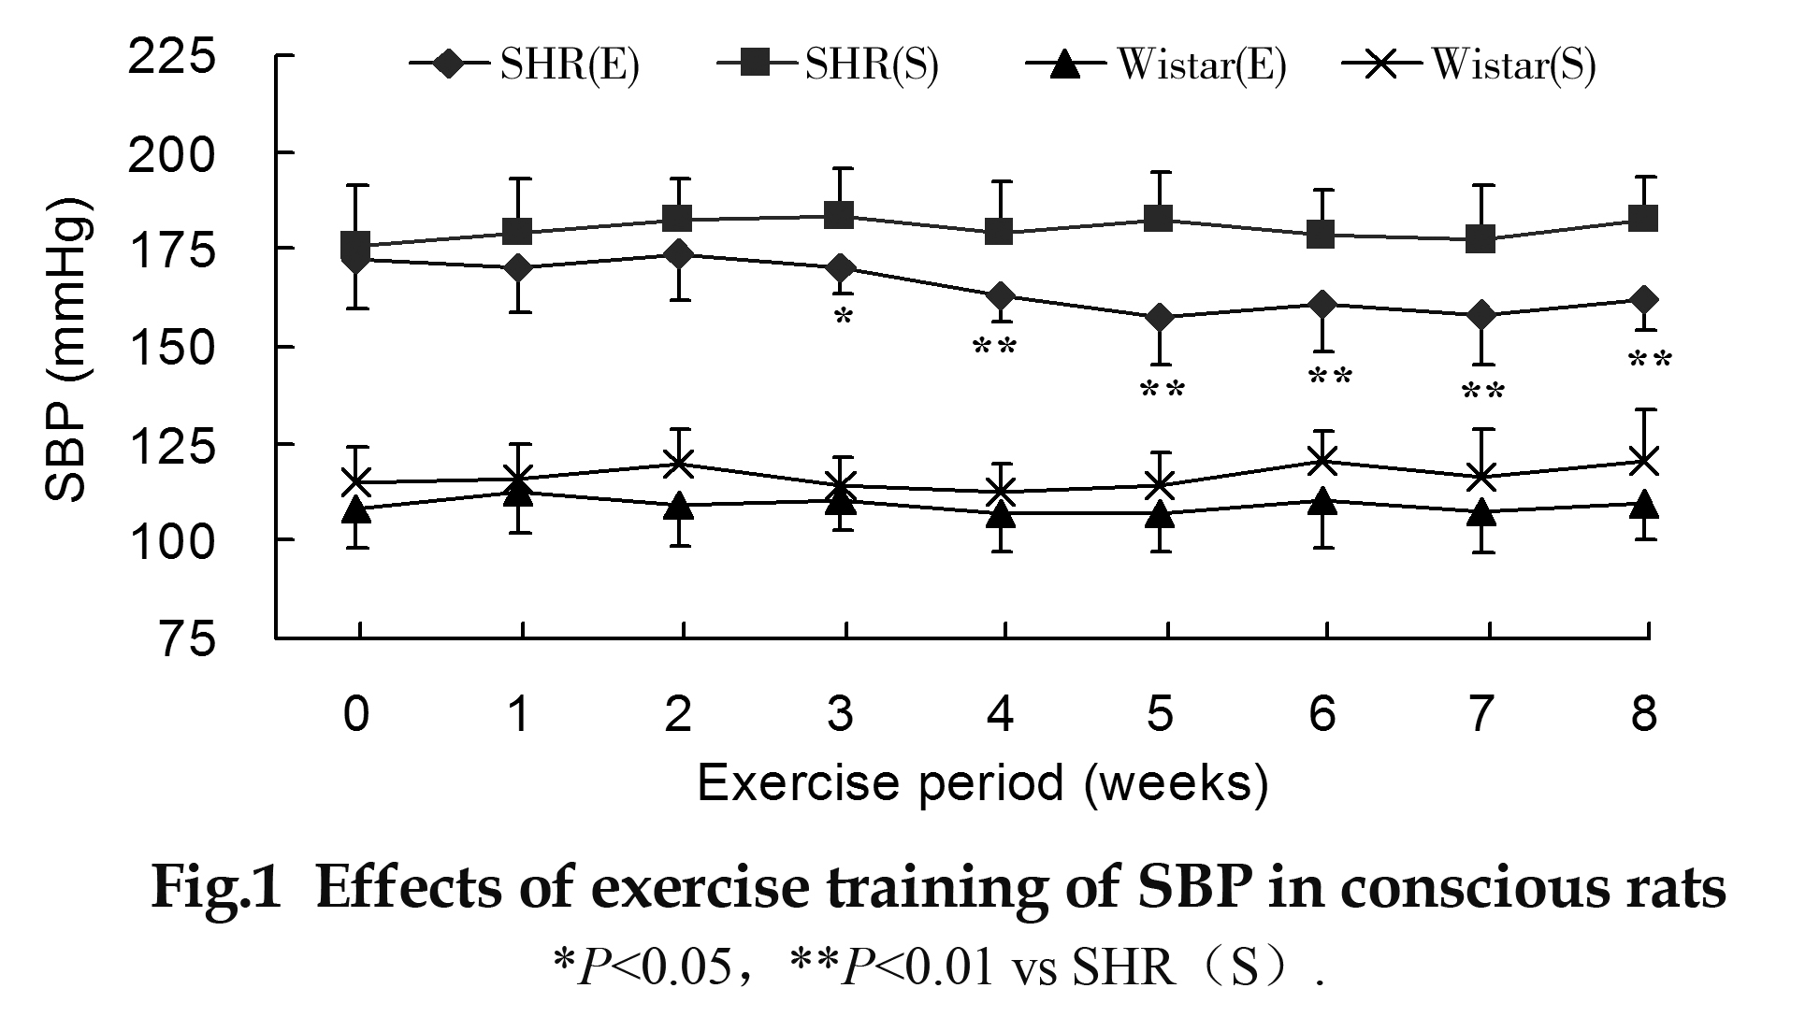
Before exercise training，there were all no significant differences in SBP between Wistar (E) group and Wistar(S) group, SHR (E) group and SHR (S) group. Figure 1 showed changes in SBP in four groups of rats during the eight weeks of exercise training. Before exercise training, SBP of two SHR groups was similar. After four weeks of exercise, SBP level in SHR (E) group began to be significantly decrease than that of SHR(S) group. As exercise time increased, it further lowered till the end of exercise training. In SHR(E) group, exercise training decreased SBP from (172.5 ± 12.5) mmHg to (163.6 ± 10.0) mmHg (t = 2.935, P = 0.017), but there was no significant difference in Wistar(E) group before and after exercise training （t=1.482,P=0.172）. After exercise training, SBP of SHR(E) group significantly decreased than that of SHR (S) group [（163.6±10.0）mmHg vs. （180.0 ± 8.5）mmHg, P＜0.001＝, but there was no significant difference between Wistar (E) group and Wistar (S) group, P＞0.05.
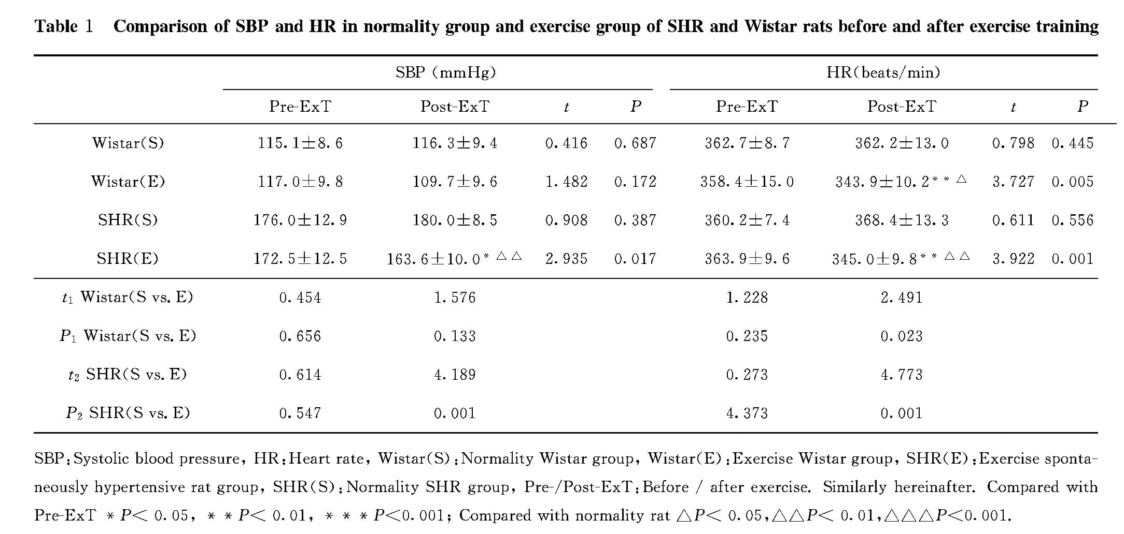
Before exercise training， there were all no significant differences in HR between Wistar (E) group and Wistar(S) group, SHR (E) group and SHR (S) group. After exercise training HR significantly decreased from (363.9 ± 9.6) beats/min to (345.0 ± 9.8) beats/min (t = 5.606, P = 0.001) in SHR (E) group, and from (358.4 ± 15.0) beats/min to (343.9 ± 10.2) beats/min (t = 3.727, P = 0.005) in Wistar (E) group. HR of SHR(E) group significantly decreased than that of SHR (S) group [（345.0 ± 9.8） beats/min vs.（368.4 ± 13.3）beats/min, t = 4.773, P = 0.001]; HR of Wistar(E) group also significantly decreased than that of Wista (S) group [（343.9 ± 10.2） beats/min vs.（362.2 ± 13.0）beats/min, t = 2.491, P = 0.023]
They were shown in table 1.

2.2 Influence of exercise training on BRS of SHR and Wistar rats
BRS-PE in SHR(S) group was significantly lower than that in Wistar (S) group [(0.89 ± 0.23) vs.（1.96 ± 0.23），P<0.01). The exercise training obviously improved BRS of SHR up to（1.31 ± 0.26 ，P<0.01）, but still lower than that of Wistar(S) (P<0.01). There was no significant difference in BRS-PE between Wistar (E) group and Wistar(S) group after eight-week exercise.
BRS-NP of SHR(S) group was significantly lower than that of Wistar(S) group [(0.60 ± 0.09) vs.（1.32 ± 0.23）.P <0.01)]. After eight-week exercise training, BRS-NP of SHR(E) group significantly improved up to [（1.21 ± 0.26）,P<0.01] , so it was no significant difference with Wistar(S) (P＞0.05). They were shown in table 2. There was also no significant difference in BRS-NP between Wistar (E) group and Wistar(S) group after eight-week exercise (P＞0.05)..
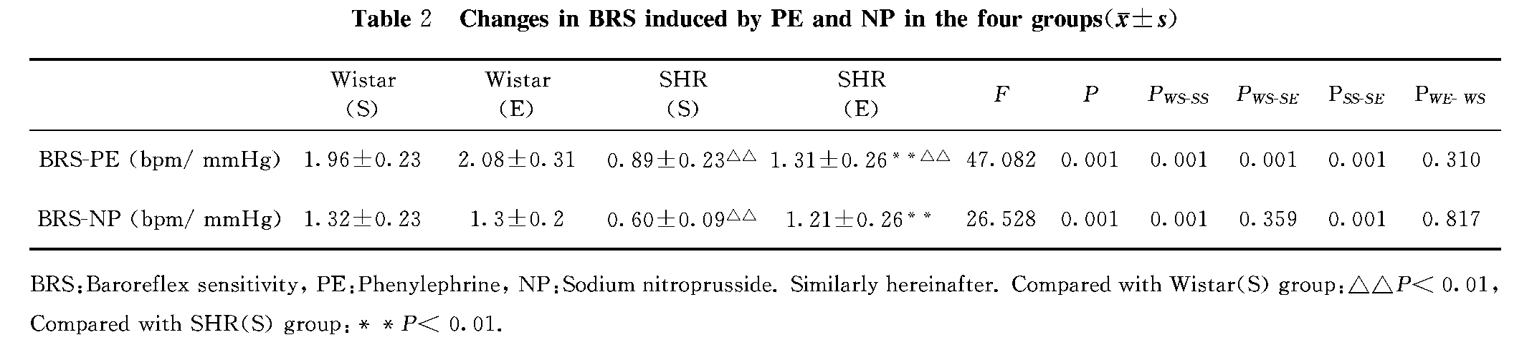
2.3 Correlation analysis between MAP and BRS in sedentary and exercise SHR group
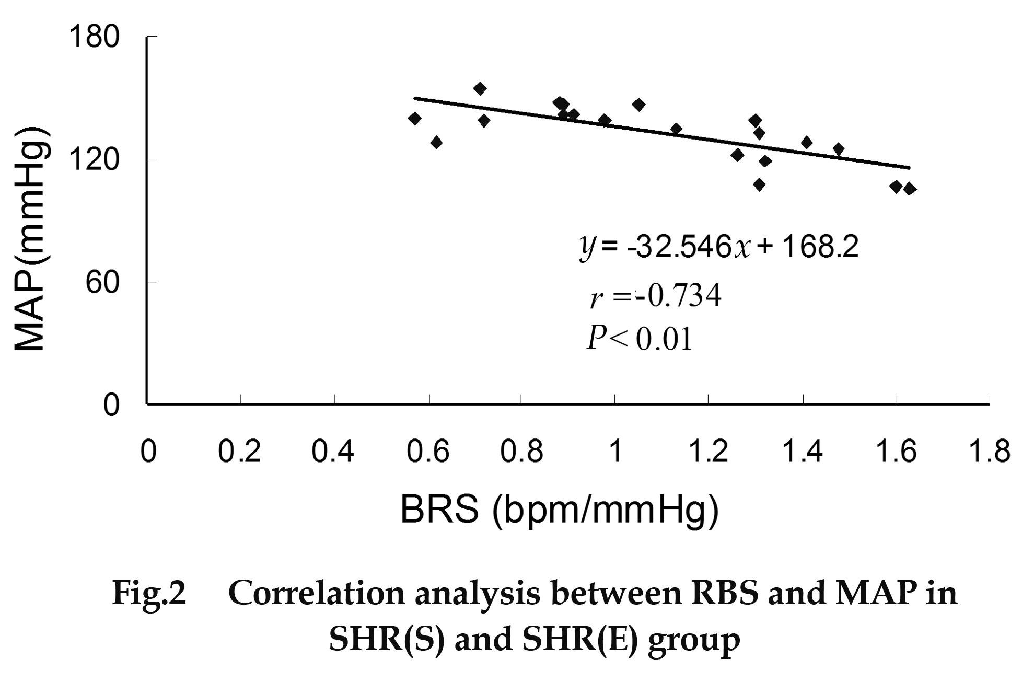
In order to assess whether reduction in blood pressure was related to the enhanced BRS in SHR after exercise training, BRS of SHR(S) and SHR(E) group were regarded as independent variable, MAP of these two groups were regarded as dependent variable to perform Pearsoncorrelation analysis indicated that BRS were negatively correlated with MAP （r=-0.734, P < 0.05）in SHR(S) and SHR(E) group. It was showed in Figure 2.

3. Discussion
The major finding of the present study was that moderate exercise training may improve baroreflex sensitivity (BRS) for regulated HR in SHR, which was associated with lowering blood pressure. These responses were specific for the training SHR and not observed in training Wistar rats. In addition, exercise training also decreased the resting HR in both SHR and Wistar rats.
In cardiovascular physiology, the baroreflex is an important mechanism for maintaining blood pressure homeostasis. When blood pressure elevates or reduces, it buffers blood pressure variation in a manner of negative feedback. Lots of evidence showed that the BRS is reduced in hypertensive patients and animals, which may be associated with the occurrence of hypertension ^{[1, 2]}. Our study also confirmed that when intravenous injection of vasoactive agents elevated or reduced BP, the BRS in hypertensive rats was great reduction compared with normotensive rats. Nevertheless, the reduced BRS increased the risks of cardiovascular events and developing arrhythmias ^{[3]}. Thus, the treatment aimed at improvement of baroreflex function seems to be an important strategy for control of hypertension and its complications.
More and more clinical trials and animal experiments indicated that exercise therapy decreased not only blood pressure but also the morbidity and mortality of cardiovascular diseases ^{[5]}. Modification of unhealthy lifestyle, especially exercise training, should be the foundational treatment of antihypertensive therapy. Some investigators have demonstrated that low and middle intensity exercise training had better antihypertensive effect than high intensity exercise in hypertension ^{[6,8]}. Therefore, a low-intensity exercise about 55% of maximum oxygen consumption (Vo₂ max) was performed in the present study. After four weeks of exercise training, SBP in SHR began to fall. After eight weeks of exercise training, SBP reduced about 16 mmHg in exercise SHR group compared with normality SHR, similar to findings reported in literature [8]. However, the mechanisms for exercise lowering blood pressure in hypertension are not completely understood. Some reported that exercise training may decrease total peripheral vascular resistance and cardiac output or increase vascular compliance in hypertension ^{[4, 7]}. Exercise training also reduced plasma norepinephrine level ^{[4, 5]} and sympathetic nerve activity ^{[9, 11]} or increased vagal activity ^{[9]} in hypertension. Exercise training regulating sympathovagal balance may be related with enhancing BRS ^{[9, 11]}. The present results indicated that exercise training improved BRS and enhanced lowering blood pressure effect in SHR, similar results reported that after three 60min exercise sessions per week for four months in never-treated hypertensive patients, which was associated with blood pressure fall and BRS restored ^{[6]}. Based on above findings, we demonstrated that MAP is inversely correlated with BRS in normality and exercise trained SHR group by Pearson analysis. In fact, the clinical trials recently confirmed that the electric stimulation of carotid sinus baroreceptor mimicking baroreceptor activated by exercise training produced sustained blood pressure reduction in resistant hypertension ^{[1]}. In contrast, removal of baroreflex afferent nerves may abolish the depressor benefits of exercise training ^{[10]}. Our previous study showed that exercise training did not show significant effect on BRS in normal condition ^{[11]}. Nevertheless, Brum et al ^{[12]} reported that exercise training improved BRS in normotensive rats. This discrepancy may be because of differences in age starting to exercise. The age starting to exercise was at young stage (eight weeks old) in their study, but at adult stage (16 weeks old) in our study.
The reduced resting HR induced by exercise training has been considered to be a characteristic index of evaluating the effect of exercise training. In the present experiment, we observed that the resting HR from two exercise groups were significant reduction compared with their corresponding normality groups, which meant the exercise protocol performed in the present study was effective. These are several possible explain for bradycardia after exercise training. One possibility is that exercise training enhances vagal outflow to the sinoatrial node mediated by baroreflex function ^{[9]}. Another possibility is that exercise training directly causes an intrinsic rhythm change in pacemaker cells of the sinoatrial node ^{[8]}.
In conclusion, low-intensity exercise training is effective in lowering blood pressure in hypertension. The improved BRS regulated heart rate contributes to, at least in part, the reduction in blood pressure. These data further support the viewpoint that moderate exercise training is a unique nonpharmacological therapy for the treatment of human hypertension.

Reference
[1] Heusser K, Tank J, Engeli S, et al. Carotid baroreceptor stimulation, sympathetic activity, baroreflex function, and blood pressure in hypertensive patients [J]. Hypertension, 2010, 55(3): 619-626.
[2] Cisternas JR, Valenti VE, Alves TB, et al. Cardiac baroreflex is already blunted in eight weeks old spontaneously hypertensive rats [J]. Int Arch Med, 2010, 3:2.
[3] Ormezzano O, Cracowski JL, Quesada JL, et al. Evaluation of the prognostic value of Baroreflex sensitivity in hypertensive patients: the EVABAR study[J]. J Hypertens, 2008, 26(7): 1373-1378.
[4] LIU Jiang-sheng, LIU Nan. Rehabilitation of hypertension [J]. Chin J Cardiovasc Rehab Med,
2006, 15(Suppl):75-82.
[5] Cornelissen VA, Smart NA. Exercise training for blood pressure: a systematic review and meta-analysis [J]. J Am Heart Assoc, 2013, 2(1):e004473.
[6] Laterza MC, de Matos LD, Trombetta IC, et al. Exercise training restores baroreflex sensitivity in never-treated hypertensive patients [J]. Hypertension, 2007, 49(6):1298-1306.
[7] Dimeo F, Pagonas N, Seibert F, et al. Aerobic exercise reduces blood pressure in resistant hypertension [J]. Hypertension, 2012, 60(3):653-658.
[8] Véras-Silva AS, Mattos KC, Gava NS, et al. Low-intensity exercise training decreases cardiac output and hypertension in spontaneously hypertensive rats [J]. Am J Physiol, 1997, 273 (6 Pt 2):H2627-H2631.
[9] Legramante JM, Galante A, Massaro M, et al. Hemodynamic and autonomic correlates of postexercise hypotension in patients with mild hypertension [J]. Am J Physiol Regul Integr Comp Physiol, 2002, 282(4):R1037-R1043.
[10] Ceroni A, Chaar LJ, Bombein RL, et al. Chronic absence of baroreceptor inputs prevents training-induced cardiovascular adjustments in normotensive and spontaneously hypertensive rats [J]. Exp Physiol, 2009, 94(6):630-640.
[11] Pan YX, Gao L, Wang WZ, et al. Exercise training prevents arterial baroreflex dysfunction in rats treated with central angiotensin II [J]. Hypertension, 2007, 49(3):519-527.
[12] Brum PC, Da Silva GJ, Moreira ED, et al. Exercise training increases baroreceptor gain sensitivity in normal and hypertensive rats [J]. Hypertension, 2000, 36(6):1018-1022.

