Influence of rehabilitation intervention on quality of life in patients with coronary heart disease

YUAN Ke
Department of Rehabilitation Medicine, Three Gorges Central Hospital of Chongqing, Wanzhou, Chongqing, 404000, China

Abstract: Objective: To explore influence of rehabilitation intervention on quality of life in patients with coronary heart disease (CHD). Methods: A total of 108 CHD patients were selected from department of cardiology of our hospital. They were randomly and equally divided into routine treatment group and rehabilitation intervention group (received bedside rehabilitation intervention based on routine treatment). The course of treatment was eight weeks. The medical outcomes 36 item short form health survey (SF-36) was used to assess quality of life before and after treatment of two groups. Results: There were no significant difference in scores of SF-36 at primary evaluation between two groups, P>0.05; when re-evaluation after eight-week treatment, there were no significant difference in all scores of SF-36 in routine treatment group compared with before treatment, P>0.05. Compared with primary evaluation and routine treatment group after treatment, there were significant improvements in all indexes [Physiology: bodily pain (69.89±16.84) vs. (54.62±16.77) vs. (56.63±6.74), role-physical (54.56±35.62) vs. (29.84±39.07) vs. (29.44±37.12), general health (65.74±15.82) vs. (48.49±8.79) vs. (48.28±10.29),Psychology: vitality (62.92±14.31) vs. (37.57±16.65) vs. (38.31±16.32), role-emotional (51.37±18.94) vs. (25.05±14.57) vs. (28.27±12.04), social functioning (74.02±9.35) vs. (47.49±9.87) vs. (51.35±9.29), mental health (72.18±13.26) vs. (55.69±14.05) vs. (58.43±11.36), P<0.01 all] except physical functioning in rehabilitation intervention group after treatment. Conclusion: Rehabilitation intervention can effectively improve quality of life in patients with coronary heart disease.
Key words: Rehabilitation; Coronary artery disease; Quality of life
Supported by Fund Project: Chongqing municipal key discipline funded project (2008-47)
Article number 1008-0074(2013)06-
Doi: 10.3969/j. issn. 1008-0074. 2013. 06.

康复干预对冠心病患者生活质量的影响/袁柯//重庆三峡中心医院康复医学科, 重庆 万州 404000

摘要：目的：探讨康复干预对冠心病患者生活质量的影响。 方法：选择本院心内科冠心病患者108例，被随机均分为常规治疗组和康复干预组（在常规治疗的基础上接受床旁康复治疗），疗程8周，采用36项简易一般健康调查表（SF-36）对两组患者治疗前后生活质量进行评价。 结果：初评时，两组SF-36评分比较差异无显著性（P>0.05）。8周治疗结束复评时常规治疗组所有SF-36评分与治疗前比较均无显著差异（P>0.05）。 康复干预组治疗后与初评时及常规治疗组治疗后比较，除生理机能指标无显著差异（P>0.05）外，其他指标均有显著改善[生理：躯体疼痛 （69.89±16.84）比（54.62±16.77）比（56.63±6.74），生理职能 （54.56±35.62）比（29.84±39.07）比（29.44±37.12），总体健康 （65.74±15.82）比（48.49±8.79）比 （48.28±10.29），心理：活力（62.92±14.31）比（37.57±16.65） 比 （38.31±16.32），情感职能 （51.37±18.94）比（25.05±14.57）比（28.27±12.04），社会功能（74.02±9.35）比 （47.49±9.87）比 （51.35±9.29），精神健康（72.18±13.26）比（55.69±14.05）比 （58.43±11.36）]，P均<0.01] 。结论：康复干预能有效提高冠心病患者的生活质量。
关键词: 康复；冠状动脉疾病；生活质量
基金项目：重庆市重点学科基金资助项目（2008--47）
文章编号1008-0074(2013)06-534-04 中图分类号：R541.409 文献标识码：A
Doi: 10.3969/j. issn. 1008-0074. 2013. 06-534-04.

Coronary heart disease (CHD) is one of main diseases that seriously threaten human life and health now ^{[1]}. Along with medical techniques progress and develop, CHD mortality significantly decreases. The survived patients not only call for life lengthening, but also desire for satisfaction of quality of life and healthy level ^{[2]}. The present study performed bedside rehabilitation intervention for CHD patients admitted in department of cardiology, and satisfying therapeutic effects were obtained. They were reported as follow.

1. Data and methods
1.1 Clinical data
A total of 108 cases, they were randomly selected from CHD patients admitted in department of cardiology of our hospital from Dec 2010 to Jan 2013, were enrolled. All patients were accorded with WHO diagnostic standard for CHD ^{[3]}. Exclusion standards were as follow: unstable angina pectoris, patients with unstable condition of disease, blood pressure decreased during exercise, patients with fever and relative/absolute contraindications. The 108 patients were randomly and equally divided into routine treatment group and rehabilitation intervention group. There were no significant difference in general data between two groups (P>0.05), so they were comparable. They were shown in table 1.
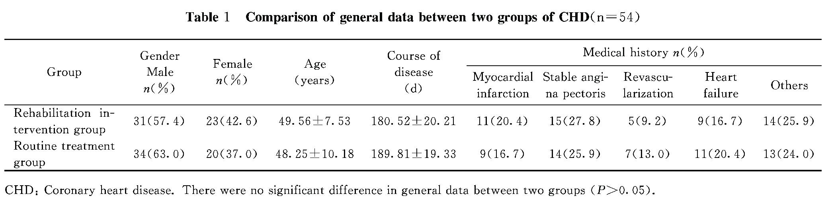
1.2 Methods
Both groups received the same routine medical treatment. Besides, rehabilitation intervention group received bedside rehabilitation intervention under the guidance of rehabilitation therapist. The plan was as follow in detail.
1.2.1 Health education: Patients received health education since two days before study started. Education content included (1) introduction of risk factors for CHD, such as hypertension, diabetes mellitus, smoking, hyperlipidemia, obesity and long-time sitting etc. Patients were encouraged to change their unhealthy lifestyles, relax their mood, maintain adequate sleep, do exercise with one’s power and to control body weight and blood pressure etc; (2) introduction of self-treatment method at onset, attentions and adverse effects of medications, and distribution of health education data etc.
1.2.2 Active and passive exercises: According to individual condition of each patient, they started with passive activity of four limbs on bed, and then gradually transited to active activity, which included exercise in standing position, straight walking. Exercise in standing position: upper limbs exercise combined respiratory training; treadmill training and other aerobic exercises can also be considered, the frequency was twice/d and duration was 45min/time. The concrete prescription set referred to report of LIU Jiang-sheng ^{[4]}. The training should be performed under supervision of rehabilitation therapist, and emergency medicine and equipments were prepared just in case.
1.2.3 Psychological intervention: Good communication should be established with patients, and their psychological problems should be deeply comprehended. Listening, encouragement, support and dredging should be actively used, and patients should be led to face diseases with good mental attitude and active lifestyle. Confidence and courage should be established to conquer diseases, and family was encouraged to participate, and give adequate mental support.
1.3 Assessment of therapeutic effect
Assessment of therapeutic effect was performed on quality of life in two groups, which was according to medical outcomes 36 item short form health survey（SF-36）of Chinese version, began from two aspects of physiological health and psychological health, and each aspect involved four items of assessment respectively. Contents of physiological health were physical functioning, bodily pain, role-physical and general health; contents of psychological health were vitality, role-emotional, social functioning and mental health. Patients received primary evaluation within 24h after entering group, and they received re-evaluation when treatment ended after eight weeks.
1.4 Statistical treatment
SPSS 15.0 software was used to perform statistical analysis. Measurement data were expressed as mean ± standard deviation ($\bar{x}±s$) and its comparison was performed using two independent samples t test; numeration data were expressed as percentage and its comparison was performed using chi-square test. P<0.05 was regard as possessing significant difference.

2. Results
There were no significant difference in all scores of SF-36 at primary evaluation between two groups before treatment, and in routine treatment group before and after treatment, P>0.05 all. When re-evaluation after eight-week, compared with primary evaluation and routine treatment group, there were significant improvements in all indexes except physical functioning (P>0.05) in rehabilitation intervention group, P<0.01 all. They were shown in table 2.

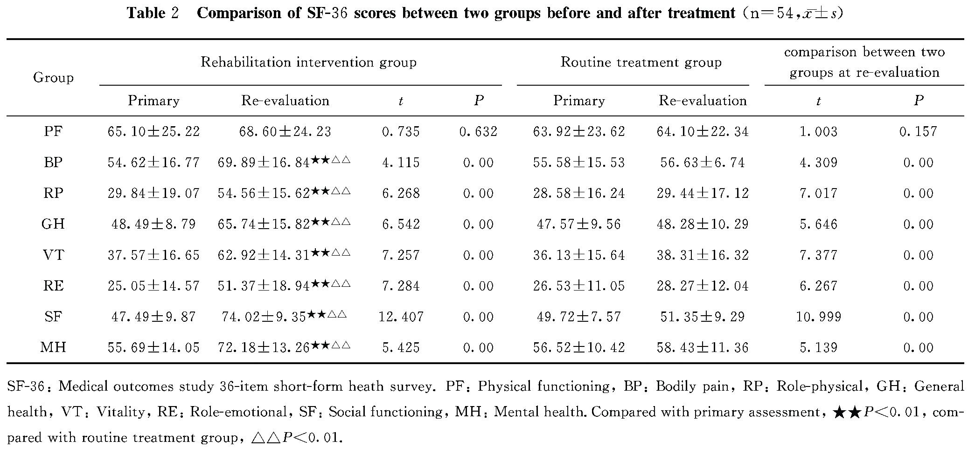

3. Discussion
Now there are large amounts of researches about rehabilitation training for CHD, how to perform scientific rehabilitation training has become one of important issues in cardiovascular rehabilitation area. Scholars have proposed that CHD patients should perform early exercise therapy on 1952 ^{[6]}. After 30 or more years, UK and USA etc. did a lot of researches on early exercise for CHD, and all of them thought that moderate exercise and load can effectively decrease mortality of patients with cardiovascular diseases; meanwhile effect of exercise cannot be underestimated in preventing cardiovascular diseases ^{[7-9]}. Results of the present study indicated that rehabilitation intervention can significantly increase SF-36 scores in CHD patients; in another word, it can effectively improve quality of life in CHD patients, which was consistent with foreign relative report ^{[10]}.
Rehabilitation intervention starts with health education, advocates patients to have reasonable diet and cultivate good exercise habits. It also gives complete health education and proper plan for family exercise for patients on the verge of discharge. It teaches patients to effectively regulate their own psychological status, wean the bad living hobbies etc. Good mood, psychological status and proper exercise can effectively decrease incidence rate of cardiovascular events ^{[11]}. A report ^{[12]} indicated that mortalities of patients participating or not in cardiac rehabilitation were 5% and 36% respectively. Because in patients participating in cardiac rehabilitation, blood lipid level can significantly improve, blood pressure can maintain at a relative low level, atherosclerotic plaque on coronary artery shows a reversing trend, myocardial ischemia reduces, and it’s slow even if it develops. Exercise also makes patients maintain an appropriate body weight and improves their physical strength. In a word, after health education, mental intervention and guidance of exercise training, patients systemically learned relative knowledge of CHD, so their recognizing ability of prevention and control of risk factors was reinforced; they can correctly face disease, defeat disease with active mental status; then improve their quality of life.
Social progress promotes medical development, medical mode is also changing. Now the disease is not the center any more, patients are also not satisfied with just life lengthening, they hope to return to society and their workplace via decreasing disability; and they hope to create more value for others and society, manifesting and realizing themselves. Rehabilitation intervention on cardiovascular diseases also comply with the request of social development and patients, it is worth our extension and exploration, and provide our contribution for a better tomorrow in patients with cardiovascular diseases.

Reference
[1] Yohannes AM, Doherty P, Bundy C, et al. The long-term benefits of cardiac rehabilitation on depression, anxiety, physical activity and quality of life [J]. J Clin Nurs, 2010, 19(19-20):2806-2813.
[2] Höfer S, Kullich W, Graninger U, et a1. Cardiac rehabilitation in Austria: long term health-related quality of life outcomes [J]. Health Qual Life Outcomes, 2009，7:99．
[3] XU Ji-min. Naming and diagnostic standard of ischemic heart disease—joint report of ISFC/WHO task force on clinical naming standardization [J]. Int J Cardiovasc Dis, 1979, 59(6): 607-609.
[4] LIU Jiang-sheng. Significance of exercise and exercise prescription for patients with heart disease [J]. Chin J Phys Med Rehabil, 2008, 30(1):64-66.
[5] Blumenthal JA. New frontiers in cardiovascular behavioral medicine: comparative effectiveness of exercise and medication in treating depression [J]. Cleve Clin J Med, 2011, 78 (Suppl 1):S35-S43.
[6] Levine SA, Lown B. “Armchair” treatment of acute coronary thrombosis [J]. J Am Med Assoc, 1952, 148 (16):1365-1369．
[7] HUANG Bin, NI Juan, SHEN Guang-yu. Effects of comprehensive rehabilitation therapy on symptoms and exercise capacity in patients with coronary heart disease [J]. Chin J Cardiovasc Rehabil Med, 2012, 21(3): 231-233.
[8] WANG Cheng-long, WANG Qiang. Attention to effect of cardiac rehabilitation therapy on patients with coronary heart disease after revascularization [J]. Chin J Cardiovasc Rehabil Med, 2012, 21(3)：325-327.
[9] ZHENG Hua, YUAN Xiao-jing. Influence of rehabilitative training on aerobic exercise function in patients with coronary heart disease [J]. Chin J Phys Med Rehabil, 2012, 34(4): 293-294.
[10] Carvalho VO, Bocchi EA, Guimarães GV. Aerobic exercise prescription in adult heart transplant recipients: a review [J]. Cardiovasc Ther, 2011, 29(5): 322-326.
[11] WU Zhi-yong, ZENG Min. Progress of cardiac rehabilitation [J]. Hainan Med J, 2012, 23 (12): 117- 119.
[12] YANG Tian-lun, GUO Lan-yan, SHEN Li. Attention to mental and psychological rehabilitation in patients with coronary heart disease after percutaneous coronary intervention [J]. Chin J Cardiol, 2012, 40(2):92-93.

