Influence of left-thoracic radiotherapy on heart function and quality of life in patients with breast cancer after breast-conserving surgery

Long Fei, Zhang Xin-feng, Wang Cong, Li Yang
Department of Mastology, Liaoning Provincial Tumor Hospital, Shenyang, Liaoning, 110004, China

Abstract: Objective: To observe the influence of left-thoracic radiotherapy on heart function and quality of life in patients with breast cancer after breast-conserving surgery. Methods: A total of 35 patients with breast cancer, who recently received breast-conserving surgery and left-thoracic radiotherapy, were continuously selected as radiotherapy group. They received routine echocardiography (ECG), tissue Doppler imaging (TDI) and evaluation of Chinese questionnaire of quality of life in patients with cardiovascular diseases (CQQC) before and after radiotherapy. The results were compared with those of 31 patients (control group), who received radical mastectomy without breast radiotherapy in the same period. Results: There were no significant difference in left heart function indexes by ECG and TDI, all dimensional and total scores of CQQC between two groups before radiotherapy (P>0.05 all). After five-week treatment, compared with evaluation before radiotherapy and control group after treatment, there were significant decrease in E [(0.90±0.32) cm/s vs. (0.90±0.38) cm/s vs. (0.86±0.29) cm/s], E/A [(1.28±0.46) vs. (1.28±0.45) vs. (1.20±0.38)], Em [(10.12±1.93) cm/s vs. (9.95±1.64) cm/s vs. (7.51±1.12) cm/s], Em/Am [(1.25±0.26) vs. (1.24±0.23) vs. (0.90±0.15)] （P<0.05 all）, all dimensional scores （P<0.05～<0.01）and total score [(67.36±7.87) scores vs. (63.75±7.26) scores vs. (52.83±6.40) scores] （P<0.01）of CQQC in radiotherapy group. Conclusion: There are often decrease in left heart function and quality of life in patients with breast cancer undergoing left-thoracic radiotherapy after breast-conserving surgery, so it’s necessary to perform targeted rehabilitative treatment.
Key words: Breast Neoplasms; Radiotherapy; Ventricular function, left; Quality of life
Supported by Fund Project: Natural science foundation fund project of Liaoning province in 2010 (20102119)
Article number 1008-0074(2013)06-
Doi: 10.3969/j. issn. 1008-0074. 2013. 06.

左侧胸部放疗对乳腺癌保乳术患者心功能及生活质量分的影响/龙飞，张鑫丰，王聪，李阳//辽宁省肿瘤医院乳腺科, 辽宁 沈阳 110004

摘要：目的：观察左侧胸部放疗对乳腺癌保乳术患者的心功能及生活质量的影响。方法：连续选择新近接受乳腺癌保乳手术并进行了左侧胸部放射治疗的患者35例（放疗组），于放射治疗前、后接受了常规超声心动图（ECG）及组织多普勒（TDI）检测以及“中国心血管病人生活质量评定问卷（CQQC)”评估，并与31例同期接受乳腺癌根治术，且未接受胸部放疗患者（对照组）的检查结果进行比较。结果：两组对象放射治疗前ECG、TDI检查的左心功能指标，和CQQC量表各维度评分及CQQC总分无显著差异（P均>0.05）。5周治疗后，与治疗前及对照组治疗后比较，放疗组的E[(0.90±0.32) cm/s比(0.90±0.38) cm/s比(0.86±0.29)(cm/s]，E/A[(1.28±0.46)比(1.28±0.45)比(1.20±0.38)]，及Em[(10.12±1.93)cm/s比(9.95±1.64) cm/s比(7.51±1.12) cm/s]，Em/Am[(1.25±0.26)比(1.24±0.23)比(0.90±0.15)]显著降低（P均<0.05）；同时CQQC量表所有维度评分（P<0.05～<0.01）及CQQC总分[(67.36±7.87)分比(63.75±7.26)分比(52.83±6.40)分] （P<0.01）也明显减少。结论：接受左侧胸部放疗的乳腺癌保乳术患者常有左心功能及生活质量下降，应进行有针对性的康复治疗。
关键词：乳腺肿瘤；放射疗法；心室功能，左；生活质量
基金项目：2010年辽宁省自然科学基金资助项目（20102119）
文章编号: 1008-0074(2013)06-578-06 中图分类号：R815.209 文献标识码：A
Doi: 10.3969/j. issn. 1008-0074. 2013. 06.

Radiotherapy possesses an important position in therapeutic plan of breast cancer (BC). Recent research found that after breast-conserving surgery plus radiotherapy, survival rate of 1~10 years and local recurrence rate in women with early BC were the same as those undergoing radical mastectomy. The difference is that the former retains breast and improves quality of life, making number of BC women who receive breast-conserving surgery plus radiotherapy rapidly increase. Radiation-induced heart disease (RIHD) is an adverse effect frequently seen in these treatments. Some researches ^{[1-3]} reported that cardiac dysfunction occurred in most BC patients receiving left-thoracic and mediastinum radiotherapy. A group of BC patients who recently received breast-conserving surgery were selected in the present study, observed for changes of heart function and scores of quality of life questionnaire after left-thoracic radiotherapy from the angle of rehabilitation medicine, and compared with those of BC inpatients receiving radical mastectomy without breast radiotherapy (control group). They were reported as following.

1. Subjects and methods
1.1 Subjects
Patients who received breast-conserving surgery and postoperative radiotherapy in our hospital from Jan 2010 to Dec 2012 were selected. Inclusion standards were as follow: ① patients who were first diagnosed as BC according to clinical and iconographic manifestations and pathology examination; ② patients accorded with stage 0~Ⅱ of breast cancer staging standards of
Union for international cancer control (UICC), and received breast-conserving surgery; ③ patients who received whole range radiotherapy. Exclusion standards were as follow: ① radiation field was mainly the right; ② patients complicated with various organic heart disease, hypertension and diabetes mellitus. The present study enrolled 35 cases BC women undergoing breast-conserving surgery plus radiotherapy (radiotherapy group). A total of 31 patients, who received radical mastectomy without breast radiotherapy in the same period, were enrolled and regard as control group, and they were accorded with inclusion standard ① and exclusion standard ②. Comparison of baseline data between two groups was shown in table 1.
Table 1 Comparison of baseline data between two groups（$\bar{x}±s$）
Group | Age (years) | Education years (years) | Brainworker n (%) | Manual worker  n (%) | BC course  (months)
Radiotherapy group (n=35) | 45.69±5.22 | 14.07±3.15 | 24(68.57) | 11(31.43) | 2.74±0.51
Control group (n=31) | 46.03±5.38 | 14.21±3.29 | 19(61.29) | 12(38.71) | 2.68±0.47
t /χ2  p | -0.26  0.80 | -0.18  0.86 | 0.42  0.69 | 0.38  0.61 | 0.50  0.62
BC: Breast cancer. Similarly hereinafter.

1.2 Methods
1.2.1 Method of breast radiotherapy： Varian Clinac 23EX type two-photon medical linear accelerator produced by American Varian Company was used to perform breast radiotherapy. The same ray method was used to project on regularly divided left anterior thoracic area, five times/week, 2 Gy/time for five weeks, accumulated radiation dose in target area volume was ≥50 Gy，according with early radiation injury of radiation injury staging standards of American radiation therapy oncology group (RTOC) in 1995.
1.2.2 Measurement items and methods for left heart function of routine echocardiography (ECG) and tissue Doppler imaging (TDI): Philips iE33 heart-specific color echocardiographic system was used in the present study. Working frequency of the probe was 2.5~3.5 MHz, frequency of scanning frame was >60 frame/s. Subjects were laid in left lateral decubitus, and following indexes of cardiac function were routinely measured: (1) Left heart function indexes of ECG: ① left ventricular end-diastolic dimension (LVEDd); ② left ventricular end-systolic dimension (LVESd); ③ left ventricular ejection fraction (LVEF); ④ left ventricular fractional shortening (LVFS); ⑤ transmitral early diastolic peak flow velocity (E); ⑥ transmitral late diastolic peak flow velocity (A); ⑦ E/A; (2) Left heart function indexes of TDI: ① mean mitral annulus systolic peak velocity (Sm); ② mean early diastolic mitral annular velocity (Em); ③ mean late diastolic mitral annular velocity (Am); ④ mean Em/Am. Both groups received first evaluation of ECG and TDI before radiotherapy, and re-evaluation after five weeks.
1.2.3 Evaluation of heart disease-related scale of quality of life： Heart disease-related scale of quality of life used in the present study was Chinese questionnaire of quality of life in patients with cardiovascular diseases (CQQC) ^{[4]}, which was formulated by professional committee of cardiovascular diseases of Chinese association of rehabilitation medicine and editorial board of Chinese journal of cardiovascular rehabilitation medicine（written by LIU jiang-sheng）. CQQC included 24 small questions and can be summarized as six dimensions: ① physical strength (including one question: participation in rehabilitative exercise or not); ② patient's condition (including six questions: angina pectoris, palpitation, short of breath, influence on life, recognition of disease and concept of life and death); ③ medical condition (including two questions: satisfaction on treatment and medical staff); ④ general living (including five questions: diet, insomnia, self-aware health, entertainment and sexual life); ⑤social psychological conditions (including seven questions: depression, anxiety, memory, intelligence, life confidence, relation with relatives and couple); ⑥ working status (including two questions: working capability and interpersonal relations). Sum of all question scores in every dimension was the score of every dimension, the sum of all dimensional scores were the total score of CQQC, the higher the total score was, the better quality of life was. Evaluation time of CQQC, measuring time of ECG and TDI were the same in two groups.

1.3 Statistical treatment
SPSS 17.0 software was used to perform statistical analysis. Measurement data were expressed as mean ± standard deviation ($\bar{x}±s$), its comparison between two groups was performed using t test. Numeration data were expressed as percentage, and its comparison between two groups was performed using chi-square test. P<0.05 was regard as possessing significant difference.

2. Results
2.1 Comparison of ECG indexes for left heart function at different time between two groups
The results showed that there were no significant difference in ECG indexes for left heart function in the first evaluation between two groups (P>0.05 all). Compared with first evaluation and control group after five-week treatment, there were significant decrease in E and E/A in radiotherapy group after five-week treatment, P<0.05 all. They were shown in table 2.
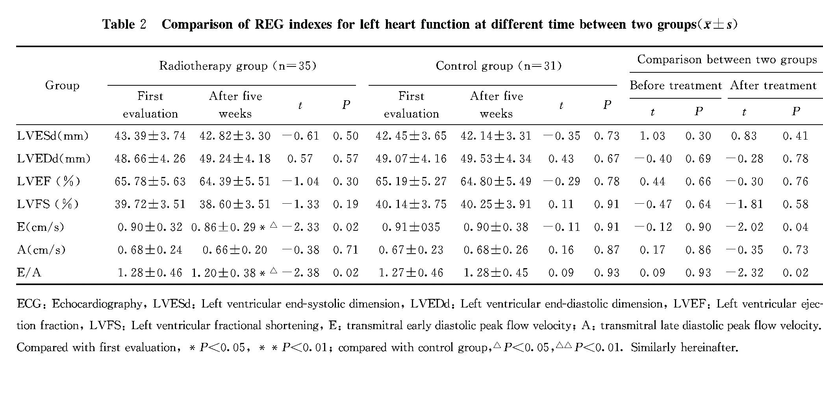
2.2 Comparison of TDI indexes for left heart function at different time between two groups
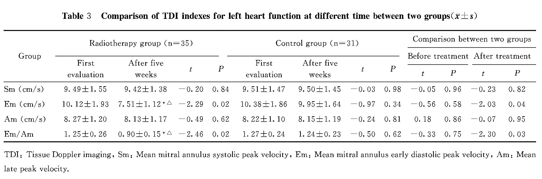
The results indicated that there were no significant difference in TDI indexes for left heart function in the first evaluation between two groups, P>0.05 all. Compared with first evaluation and control group after five-week treatment, there were significant decrease in Em and Em/Am in radiotherapy group after five-week treatment, P<0.05 all. They were shown in table 3.
2.3 Comparison of scores of CQQC at different time between two groups
There were no significant difference in all dimensional and total scores of CQQC in first evaluation before radiotherapy between two groups, P>0.05 all. Compared with first evaluation, there were significant decrease in scores of total scores and all dimensions (P<0.01) except physical strength and working status （P<0.05）of CQQC; Compared with control group after five-week treatment, there were significant decrease in scores of total scores （P<0.01）and all dimensions except physical strength, working status and General living（P<0.05）.They were shown in table 4.
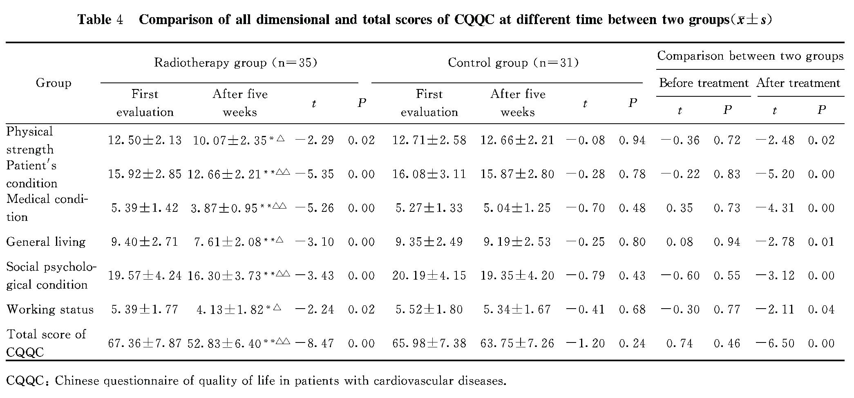
3. Discussion
Heart had been thought to be the most insensitive organ in vivo; however, recent researches ^{[5-6]} found that after it was exposed to radiation, RIHD was also easy to occur, clinical manifestations were radiation pericarditis, cardiomyopathy, pancarditis, radiation coronary heart disease and symptoms of cardiac dysfunction etc, even if no apparent above diseases occurred, myocardial contractility decrease can also occur in early period after radiation. Though postoperative radiotherapy can decrease recurrence rate in women with breast cancer after undergoing breast-conserving surgery, RIHD occurrence may still affect their quality of life and survival time. So, modern oncology cardiology comes into being because of demand. It raises a wholly new idea, whose core definition is that heart is an important organ maintaining life in vivo, once RIHD occurs, it will seriously affect quality of life or even threaten life of patients. Therefore, it’s very important to explore and summarize the rhythm of cardiac injury caused by radiotherapy after breast-conserving surgery, optimize and improve radiotherapy plan according to it, and formulate a series of rehabilitation intervention plan aiming at RIHD.
TDI is a noninvasive measuring technique for heart function rapidly developed in recent years, which can three-dimensionally evaluate myocardial systolic and diastolic function from multideck of time and space, and accurately understand influence of radiotherapy on heart function. The present study found that, some indexes of ECG and TDI for left heart function significantly decreased after radiotherapy.
CQQC is a universal scale for quality of life for cardiovascular diseases in China, which is formulated by professional committee of cardiovascular diseases of Chinese association of rehabilitation medicine and editorial board of Chinese journal of cardiovascular rehabilitation medicine. It is specially used for evaluating various heart diseases in Chinese people, covers manifestations and problems of many cardiovascular diseases, overcomes difference of national and culture condition and possesses fairly good reliability and validity. In the present study, compared with before treatment and control group after treatment, there were significant decrease in most dimensional scores and total scores of CQQC （P<0.05～<0.01）in women undergoing breast-conserving surgery after breast radiotherapy. The results were similar with those of some foreign researches ^{[7-9]}.
The possible mechanisms ^{[10-12]} for RIHD induced by breast radiotherapy after breast-conserving surgery may be: radiation acts on projecting area of heart, makes edema and denaturalization of capillaries and coronary artery endothelial cells, leading to coagulation and thrombosis in relative micro vessels, myocardial microcirculation disorder, causes myocardial ischemia and hypoxia and decrease of contractility, finally myocardial fibrosis occurs, heart systolic and diastolic function impairs. Some relative domestic and foreign animal experiments ^{[13-14]} also supported these theories.
In summary, breast radiotherapy in women undergoing breast-conserving surgery can cause many cardiovascular reactions. These phenomena should get serious attention from medical staff of department of oncology, cardiology and rehabilitation medicine. They should be given whole-range monitoring in time and as early as possible, and given direction rehabilitation therapy, which will play important role in improving their long-term prognosis and quality of life.

Reference
[1] Evans SB, Sioshansi S, Moran MS, et al. Prevalence of poor cardiac anatomy in carcinoma of the breast treated with whole-breast radiotherapy: reconciling modern cardiac dosimetry with cardiac mortality data [J]. Am J Clin Oncol, 2012, 35(6):587-592.
[2] Darby SC, Ewertz M, McGale P, et al. Risk of ischemic heart disease in women after radiotherapy for breast cancer [J]. N Engl J Med, 2013, 368(11):987-998.
[3] McGale P, Darby SC, Hall P, et al. Incidence of heart disease in 35,000 women treated with radiotherapy for breast cancer in Denmark and Sweden [J]. Radiother Oncol, 2011, 100(2):167-175.
[4] LIU Jiang-sheng, MA Chen-ming, LIU Wen-xian, et al. Evaluation of Chinese questionnaire of quality of life in patients with cardiovascular disease [J]. Chin J Cardiovasc Rehabil Med, 2008, 17(4)：309-312.
[5] Stewart FA, Seemann I, Hoving S, et al. Understanding radiation-induced cardiovascular damage and strategies for intervention [J]. Clin Oncol (R Coll Radiol), 2013, 25 (10):617-624.
[6] Dogan SM, Bilici HM, Bakkal H, et al. The effect of radiotherapy on cardiac function [J]. Coron Artery Dis, 2012, 23(3):146-154
[7] Erven K, Jurcut R, Weltens C, et al. Acute radiation effects on cardiac function detected by strain rate imaging in breast cancer patients[J]. Int J Radiat Oncol Biol Phys, 2011, 79(5):1444-1451.
[8] TIAN Qing, YUAN Jian-jun. Doppler tissue imaging assessment of early left ventricular function in patients with left breast cancer radiotherapy [J]. Chin J Med Ultrasound (Electronic edition), 2011, 8(10):2148-2152.
[9] ZHANG Zhuo, ZOU Li-juan, LI Guang-sen, et al. Quantitative tissue velocity imaging evaluation of early left ventricular function in breast cancer patients treated with radiotherapy [J]. Chin J Ultrasound Med, 2007, 23(3): 185-187.
[10] Filopei J, Frishman W. Radiation-induced heart disease [J]. Cardiol Rev, 2012, 20(4): 184-188.
[11] Martinou M, Gaya A. Cardiac complications after radical radiotherapy [J]. Semin Oncol, 2013, 40(2):178-185.
[12] XU Yi-bin, LI Ruo-gu, FANG Wei-yi. Cardiac dysfunction induced by anti-tumor therapy [J]. Int J Cardiovasc Dis, 2009, 36(6):365-368.
[13] ZHOU Wei-bing, LUO Quan-yong, FENG Yan, et al. Radiation-induced heart disease due to intrathonacic tumor radiotherapy of a single dose to the rabbits’ heart [J]. Chin J Radiat Oncol, 2007, 16(3)：230-234.
[14] Barjaktarovic Z, Shyla A, Azimzadeh O, et al. Ionising radiation induces persistent alterations in the cardiac mitochondrial function of C57BL/6 mice 40 weeks after local heart exposure[J]. Radiother Oncol, 2013, 106(3):404-410.

