Effect of curcumin on cardiac remodeling and heart function change induced by adriamycin in rats

LU Jun-kun¹, LIU Yang², LV Wei-juan¹, ZHAO Wei³, Wang Yan-qin¹*// 1. Second Department of Cardiology, First Affiliated Hospital of Jiamusi University, Jiamusi, Heilongjiang, 154002, China; 2. Second Hospital of Daqing City; 3. Public Health College of Jiamusi University
Corresponding author: WANG Yan-qin, E-mail: wyqdoctor@163.com

Abstract: Objective: To study the effect of curcumin on cardiac remodeling and heart function change induced by adriamycin in rats. Methods: A total of 50 SD rats were randomly divided into blank control group (n=10), adriamycin group (n=20) and curcumin intervention group (n=20). General conditions of rats, including weight, hair color, diet and activity capacity, were observed. Left ventricular ejection fraction (LVEF), left ventricular fractional shortening (LVFS) and left ventricular end-diastolic dimension (LVEDd) were observed by echocardiography. Rat heart was weighed and levels of cardiac collagen type Ⅰ and Ⅲ were observed using immunohistochemistry method. Results: Compared with blank control group after experiment, there were significant increase in heart weight [(168.53±26)mg vs. (208.34±31)mg], heart weight/body weight [(0.36±0.06) vs. (0.52±0.08)], and significant decrease in body weight [(469.27±34)g vs. (428.47±45)g]; significant increase in LVEDd [(4.87±0.19)mm vs. (7.49±0.83)mm], significant decrease in LVEF [(69.53±6.25)% vs. (41.46±4.38)%] and LVFS [(45.83±3.79)% vs. (17.25±2.92)%] in adriamycin group, P<0.05 all, significant increase in expression rates of collagen type Ⅰ and Ⅲ, P<0.01.Compared with adriamycin group, there were significant increase in body weight (452.46±38)g, significant decrease in heart weight (178.73±38)mg, heart weight/body weight (0.39±0.07); significant decrease in LVEDd (5.96±0.65)mm and significant increase in LVEF (53.12±5.43)% and LVFS (36.57±3.66)%, P <0.05 all; significant decrease in expression rates of collagen type Ⅰ and Ⅲ in curcumin group, P <0.01. Conclusion: Curcumin can improve cardiac remodeling and heart function induced by adriamycin in rats.
Key words: Curcumin; Ventricular remodeling; Collagen type I; Collagen type III; Ventricular function
Supported by Fund Project: Scientific research topic of health department of Heilongjiang Province (2009-322)
Article number 1008-0074(2013)04-
Doi: 10.3969/j. issn. 1008-0074. 2013. 04.

姜黄素对阿霉素诱导的大鼠心脏重构及心功能改变的研究/卢均坤¹，刘洋²，吕维娟¹，赵伟³，王燕琴^{1＊}//1. 佳木斯大学附属第一医院循环二科，黑龙江 佳木斯 154002；2大庆市第二医院；3. 佳木斯大学公共卫生学院
通讯作者: 王燕琴， E-mail: wyqdoctor@163.com

目的： 研究姜黄素对阿霉素引起的大鼠心脏重构及心功能改变的作用。方法： 50只SD大鼠随机分为空白对照组，阿霉素组，姜黄素干预组，观察大鼠的一般情况(体重、毛色、饮食、活动能力)，以超声心动图观察大鼠左室射血分数（LVEF）、左室短轴缩短分数（LVFS）、左室舒张末期内径（LVEDd），称量大鼠心脏重量，以免疫组化法观察大鼠心肌Ⅰ、Ⅲ型胶原的变化。结果：实验后，与空白对照组相比，阿霉素组大鼠心脏重量[(168.53±26)mg比(208.34±31)mg]、心脏重量/体重[(0.36±0.06)比(0.52±0.08)] 显著增加, 体重[(469.27±34)g比(428.47±45)g] 显著减轻; LVEDd[(4.87±0.19)mm比(7.49±0.83)mm]明显增加, LVEF[(69.53±6.25)%比(41.46±4.38)%]、LVFS[(45.83±3.79)%比(17.25±2.92)%]明显降低（P均<0.05）; Ⅰ、Ⅲ型胶原蛋白表达率明显升高（P<0.01）。与阿霉素组大鼠比较, 姜黄素组大鼠体重(452.46±38)g显著增加, 心脏重量(178.73±38)mg、心脏重量/体重(0.39±0.07) 显著减轻, LVEDd(5.96±0.65)mm显著降低 , LVEF(53.12±5.43)% LVFS(36.57±3.66)%显著增加（P均<0.05）;Ⅰ、Ⅲ型胶原蛋白表达率明显降低（P<0.01）。结论：姜黄素能改善阿霉素引起的鼠心脏重构和心功能改变。
关键词：姜黄素；心室重构；胶原I型；胶原III型；心室功能
基金项目：黑龙江省卫生厅科研课题（2009-322）
文章编号：1008-0074(2013)04- 中图分类号：R54 文献标识码：A

Adriamycin is a member of anticancer drug family of anthracyclines, application of anthracyclines in treatment of malignant tumor can cause complications such as cytotoxicity, especially frequently cause myocardial cytotoxicity, which can lead to myocardial cell apoptosis, myocardial fibrosis, myocardiopathy, arrhythmias and congestive heart failure in many patients ^{[1]}. Change of cardiac structure is caused by changes of myocardial cells and myocardial interstitial cells；ratio of myocardial interstitial collagens of different types plays an important role in myocardial fibrosis, especially ratio of collagen type Ⅰ and Ⅲ is of important significance for maintenance of cardiac structure and intact function. Through establishing adriamycin-induced myocardial injury model in rats, the present study explored influence of adriamycin on myocardial remodeling and fibrosis in rats and effect of curcumin intervention to provide experimental evidence for prevention and treatment of myocardial injury induced by adriamycin.

1 Materials and methods
1.1 Animals
A total of 50 healthy SD male rats of 12-week old were selected and their weights were about 350g. All rats were provided by animal experiment center of Jiamusi University.
1.2 Drugs and reagents
Adriamycin was produced by Zhejiang Haizheng Pharmaceutical Co. Ltd, and curcumin was produced by Ningbo Chinese Medicine Pharmaceutical Co. Ltd; Immunohistochemistry kits were bought from Wuhan Boster Biological Engineering Co. Ltd.

1.3 Animal grouping
The 50 SD rats were randomly divided into blank control group (n=10, received normal diet and normal saline injected intraperitoneally), adriamycin group (n=20, received normal diet and adriamycin 2.5mg/kg injected intraperitoneally, once a week for six weeks) and curcumin group (n=20, adriamycin was given as the same way as adriamycin group, received normal diet and curcumin 200mg·kg⁻¹·d⁻¹ by lavage for six weeks).

1.4 Sample collection
At 11th week the experiment ended, blood was taken via eyeball ablation in all rats; Supernatant was taken after centrifugation at 4℃, 3 000r/min and reserved.

1.5 Experiment methods
1.5.1 Detection of ventricular remodeling：One rat was randomly selected from each group and executed before experiment and the other rats were executed after experiment ended. Heart was taken, left ventricle (including interventricular septum) was separated, fat tissue outside the heart was got rid of. Then the heart was washed and water was absorbed up by filter paper. Heart weight (HW) and body weight (BW) were measured respectively, and heart weight/body weight was expressed as HW/BW.
1.5.2 Left heart function detected by ultrasound： Rat was anesthetized by intraperitoneal injection of chloral hydrate. Small probe of color Doppler ultrasonic diagnostic equipment was used. Left heart function, including left ventricular end-diastolic dimension (LVEDd), left ventricular ejection fraction (LVEF) and left ventricular fractional shortening (LVFS) were measured.
1.5.3 Myocardial tissue pathology and electro microscope observation： After 4% formalin fixation for 24h, myocardial tissue was embedded by paraffin, sheared into thin slices about 5μm, stained by hematoxylin-feosin, then microscope was used to observe pathological changes of myocardial tissue, which was judged by hypertrophic extent and cytoplasmic cavity denaturation extent. Then the tissue was fixed by 2% glutaral, and by 1% osmic acid, embedded by Epon812, sheared into 70~80 nm, electronically stained by lead and uranium, then electron microscope was used to observe.
1.5.4 Observing collagen type I and III by immunohistochemistry: All operations were accorded to kit instructions. Work titers were all 1:100. Blank control with phosphate buffer and normal rabbit serum control substituting negative control of primary antibody were set in every experiment. Light microscope was used to observe pathological changes of myocardial tissue and distribution of collagen, then tissue was dehydrated by ethanol and mounted by transparent gum. Medical pathological image analyzing system was used to analyze collagen protein type I and III. Positive signal of immunohistochemistry received integration optical density image automatic measurement and analysis.

1.6 Statistical analysis
SPSS 13.0 software was used to perform statistical treatment. Measurement data were expressed as mean ± standard deviation ($\bar{x}±s$) and its comparison between two groups was performed using t test. P＜ 0.05 was regard as possessing significant difference.

2 Results
2.1 Change of HVW/BW ratio in rats
As shown in table 1, there were no significant difference in heart weight, body weight and HVW/BW among three groups before experiment (P＞0.05); After experiment, compared with blank control group, there was significant decrease in body weight, and significant increase in heart weight and HVW/BW (P<0.05 all) in adriamycin group; Compared with adriamycin group, there was significant increase in body weight, and significant decrease in heart weight and HVW/BW (P<0.05 all) in curcumin group.

2.2 Change of heart function in rats
Before experiment there was no significant difference in heart function among three groups（P＞0.05）. After experiment, compared with blank control group, there was significant increase in LVEDd and significant decrease in LVEF and LVFS in adriamycin group, P<0.05 all; Compared with adriamycin group, there was decrease in LVEDd and increase in LVEF and LVFS in curcumin group. They were shown in table 2.

Table 1 Comparison of heart weight, body weight and HVW/BW among three groups ($\bar{x}±s$)
Group | HW (mg) | BW (g) | HW /BW
Blank control group
before experiment (n=1) | 147.62 | 376.58 | 0.39
after experiment (n=19) | 168.53±26 | 469.27±34 | 0.36±0.06
Adriamycin group
before experiment (n=1) | 148.28 | 372.43 | 0.40
after experiment (n=19) | 208.34±31△▲ | 428.47±45△▲ | 0.52±0.08△▲
Curcumin group
before experiment (n=1) | 142.36 | 353.69 | 0.40
after experiment (n=19) | 178.73±38 | 452.46±38 | 0.39±0.07
HW: Heart weight, BW: Body weight, HW/BW: Heart weight/body weight. Compared with blank control group △P<0.05, △△P<0.01, compared with curcumin group ▲P<0.05, ▲▲P<0.01. Similarly hereinafter.

Table 2 Comparison of LVEDd, LVEF and LVFS among three groups ($\bar{x}±s$)
Group | LVEDd(mm) | LVEF(%) | LVFS(%)
Blank control group (n=9) | 4.87±0.19 | 69.53±6.25 | 45.83±3.79
Adriamycin group (n=19) | 7.49±0.83△▲ | 41.46±4.38△▲ | 17.25±2.92△▲
Curcumin group (n=19) | 5.96±0.65 | 53.12±5.43 | 36.57±3.66
LVEDd: Left ventricular end-diastolic dimension, LVEF: Left ventricular ejection fraction,LVFS: Left ventricular fractional shortening.

2.3 Light and electron microscope measurement of myocardial tissue in three groups of rats
In blank control group, no apparent denaturation was found in myocardial tissue of rat; the myofilament arranged in order, and their structure were clear under electron microscope; in adriamycin group, arrangement of muscle fibers was confused and muscle fibers were hypertrophic; mitochondrial crest decreased; expanded sarcoplasmic reticulum, obvious vacuolization, broken myofilament were found under electron microscope; in curcumin group, arrangement of partial muscle fibers was confused, the degree of hypertrophy was light; some mitochondrial crest decreased and there’s no broken myofilament under electron microscope. They were shown in figure 1 and 2.

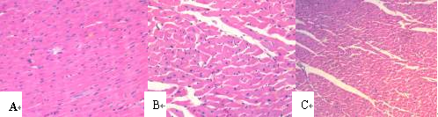
Fig .1 Myocardial tissue HE staining of three groups under light microscope
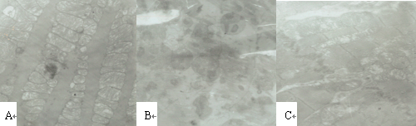
Fig 2. Myocardial tissue and mitochondria of three groups under electron microscope

2.4 Immunohistochemistry measurement
Medical pathological image analyzing system found that there were a few expressions of collagen protein type Ⅰ and Ⅲ in myocardial cells of normal rats; Compared with blank control group，there were significant increase in expressions of collagen protein type Ⅰ and Ⅲ in adriamycin group; Compared with adriamycin group, there were significant decrease in expressions of collagen protein type Ⅰ and Ⅲ in curcumin group. Integration optical density image automatic measurement showed that compared with blank control group，there were significant increase in integration optical density of collagen protein type Ⅰ and Ⅲ in adriamycin group, and it significant increased than that of curcumin group (P＜0.01 all). They were shown in figure 3, 4, 5 and table 3.

Table 3 Comparison of optical density among three groups ($\bar{x}±s$)
Group | Blank control group (n=9) |  | Adriamycin group  (n=19) |  | Curcumin group (n=19)
collagen protein type Ⅰ  collagen protein type Ⅲ | 1469.2±127.4  1143.6±131.5 |  | 68362.3±1869.3△△▲▲  53618.5±2347.2△△◆▲ |  |  | 15096.8±387.3  10294.7±404.9
P | 0.000 | 0.000 |  | 0.000

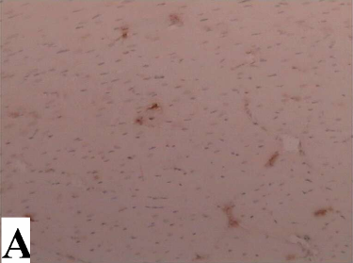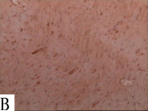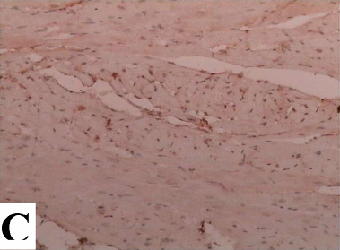
C
Fig. 3 Myocardial tissue and expression of myocyte collagen protein type Ⅰ in three groups

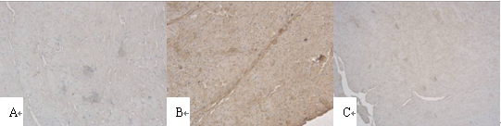

Fig. 4 Myocardial tissue and expression of myocyte collagen protein type Ⅲ in three groups
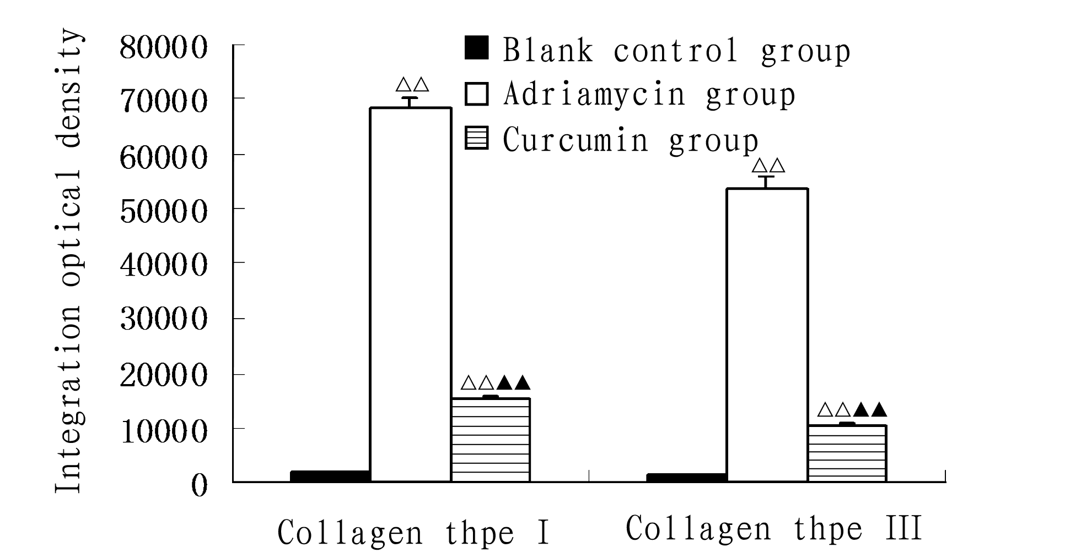
Fig. 5 Comparison of integration optical density of myocardial collagen type Ⅰ and Ⅲ among three groups
Compared with blank control group △P<0.05, △△P<0.01, compared with curcumin group ▲P<0.05, ▲▲P<0.01

3 Discussion
Adriamycin can cause myocardial myofibril loss and myocyte vacuolar degeneration, leading to cardiac left ventricular fractional shortening decrease ^{[2, 3]}；Cardiac injury may lead to ventricular remodeling. Study of recent 10 years indicated that among postchemotherapy patients occurred myocardial toxicity, congestive heart failure occurred in about 5~20% patients because of dilated cardiomyopathy (DCM) ^{[4]}. In chronic adriamycin myocardial injury model, myocardial cell apoptosis and necrosis can lead to progressive heart function decrease, leading to irreversible congestive heart failure ^{[5]}. The present experiment found that left ventricle significantly dilated, and there were significant decrease in body weight, LVEF and LVFS, and significant increase in HW/BW in adriamycin group, proving that adriamycin has serious influence on cardiac structure and function; Simultaneous proving that curcumin can reverse adverse effects of adriamycin on heart. Deng et al ^{[6]} also found that after given adriamycin to rats, their LVFS fell from 53% of the initial two days to 31% after eight weeks, left ventricular chamber significant dilated and displayed features of DCM.
Curcumin is a low molecular weight polyphenols natural compound, which is frequently used medication, may treat cardiovascular diseases ^{[7]}. In vivo and vitro experiment, curcumin can inhibit cardiac hypertrophy ^{[8]}. Curcumin possesses wide pharmacological effects and it can lower levels of urine protein, serum creatinine and urea nitrogen in renal hypertension rat model ^{[9]}. Wang et al ^{[10]} found that in ischemic reperfusion experiment of rat, curcumin can lower malondialdehyde level, inhibit activity of matrix metalloproteinase, decrease extracellular matrix degradation and collagen deposition, making collagen protein concentration in myocardial scar decrease and increase quality of survival myocardium. The present study found that histopathological features of adriamycin group were arrangement of muscle fibers in confused, muscle fibers was hypertrophic; and mitochondrial crest decreased, sarcoplasmic reticulum expanded, obvious vacuolization and myofilaments broke under electro microscope; after given curcumin, myocyte and mitochondrial injury significantly relieved, proving that curcumin can relieve injury of adriamycin on myocardium and protect cardiac function. A study indicated that protective effect of curcumin on cardiac function may be related with its anti-oxidant effect ^{[11]}..
Heart collagen fiber is important component in constitution of cardiac network frame, these structures are very important for maintenance of normal heart function. Extracellular matrix deposition in early period of many cardiovascular diseases is protection for myocardial injury; however, irreparable deposited extracellular matrix can cause myocardial fibrosis, and finally lead to organ function failure ^{[12]}. Deposition of collagen type Ⅰ and Ⅲ is the main cause of myocardial fibrosis, decrease expression of their genes and synthesis can inhibit and reverse myocardial fibrosis. The present study found that immunohistochemistry showed that levels of collagen type Ⅰ and Ⅲ in adriamycin group significantly increased compared with normal rats, and curcumin intervention can decrease expressions of collagen type Ⅰ and Ⅲ, suggesting that curcumin can improve myocardial fibrosis. On the whole, the present study indicated that curcumin can resist cardiac injury caused by adriamycin, and improve myocardial fibrosis and protect heart function.

Reference
[1] Takemura G, Fujiwara H. Doxorubicin-induced cardiomyopathy from the cardiotoxic mechanisms to management [J]. Prog Cardiovasc Dis, 2007, 49(5): 330-352.
[2] Ito H, Miller SC, Billingham ME, et al. Doxorubicin selectively inhibits muscle gene expression in cardiac muscle cells in vivo and in vitro [J]. Proc Natl Acad Sci U S A, 1990, 87(11):4275-4279.
[3] Torti FM, Bristow MM, Lum BL, et al. Cardiotoxicity of epirubicin and doxorubicin: assessment by endomyocardial biopsy [J]. Cancer Res, 1986, 46(7):3722-3727.
[4] van Dalen EC, van der Pal HJ, Kok WE, et al. Clinical heart failure in a cohort of children treated with anthracyclines: a long-term follow-up study [J]. Eur J Cancer, 2006, 42(18): 3191-3198.
[5] Xiao J, Sun GB, Sun B, et al. Kaempferol protects against doxorubicin-induced cardiotoxicity in vivo and in vitro [J]. Toxicology, 2012, 292(1):53-62.
[6] Deng S, Kruger A, Schmidt A, et al. Differential roles of nitric oxide synthase isozymes in cardiotoxicity and mortality following chronic doxorubicin treatment in mice [J]. Naunyn Schmiedebergs Arch Pharmacol, 2009, 380(1):25-34.
[7] Maheshwari RK, Singh AK, Gaddipati J, et al. Multiple biological activities of curcumin: a short review [J]. Life Sci, 2006, 78(18): 2081-2087.
[8] Li HL, Liu C, de Couto G, et al. Curcumin prevents and reverses murine cardiac hypertrophy [J]. J Clin Invest, 2008, 118(3): 879–893.
[9] Tapia E, Soto V, Ortiz-Vega KM, et al. Curcumin induces Nrf2 nuclear translocation and prevents glomerular hypertension, hyperfiltration, oxidant stress, and the decrease in antioxidant enzymes in 5/6 nephrectomized rats [J]. Oxid Med Cell Longev, 2012; 2012: 269039.
[10] Wang NP, Wang ZF, Tootle S, et al. Curcumin promotes cardiac repair and ameliorates cardiac dysfunction following myocardial infarction [J]. Br J Pharmacol, 2012, 167(7): 1550–1562.
[11] Appiah-Opong R, Commandeur JN, van Vugt-Lusenburg B, et al. Inhibition of human recombinant cytochrome P450s by curcumin and curcumin decomposition products [J]. Toxicology, 2007, 235(1-2):83-91.
[12] Kim S, Iwao H. Molecular and cellular mechanisms of angiotensin II mediated cardiovascular and renal diseases [J]. Pharmacol Rev, 2000, 52(1): 11-34.

