Relation between perfusion speed and acute separation of myocardial cells in New Zealand rabbits

XU Xiao-feng¹, LI Wei-hua^{1, 2}, HUANG Zheng-rong²//1.Department of Cardiology, First Clinic Medical College of Fujian Medical University, Xiamen, Fujian, 361000, China. 2. Department of Cardiology, First Hospital of Xiamen
Corresponding author: LI Wei-hua, E-mail: liweihuam@hotmail.com

Abstract: Objective: To establish a simple, stable and high success rate separation method of myocardial cells in New Zealand rabbits. Methods: Compared influence between perfusion speed of 50 r/min (8 ml/min) and 65 r/min (11 ml/min) of Langendorff perfusion device on cell separation during separation course of myocardial cells. Results: Compared with perfusion speed of 50 r/min, there was significant decrease in time to obtain cells [(33±9.10) min vs. (19.29±2.73) min], and significant increase in success rate (50% vs. 91%) and survival rate [(38.26±2.63) % vs. (85.71±2.21) %] by perfusion speed of 65 r/min, P<0.01 all. Conclusion: Perfusion speed is an important factor that affects acute separation of myocardial cells in New Zealand rabbits, and 65r/min perfusion speed may be more stable and successful to obtain single myocardial cell.
Keywords: Cell separation; Myocardium; Rabbits
Supported by Fund Project: National natural science fund project (81170090); Fujian province natural science fund for distinguished youths (2009D015); Innovation project of distinguished youths talent in science and technology of Xiamen city (3502Z20116009); scientific research fund of science and technology bureau of Xiamen city (3502Z20094006)
Article number 1008-0074 (2012) 06-
Doi: 10.3969/j. issn. 1008-0074.2012.06.

灌流速度与新西兰兔心肌细胞急性分离的关系/徐小凤¹，李卫华^{1,2}，黄峥嵘²//1. 福建医科大学第一临床医学院心内科，福建 厦门 361000，2. 厦门市第一医院心内科
通讯作者：李卫华，E-mail: liweihuam@hotmail.com

摘要：目的 建立一种简单，稳定，成功率高的新西兰兔心肌细胞分离方法。方法：比较分离细胞过程中 Langendorff灌流装置的灌流速度[50r/min(8ml/min)和65r/min(11ml/min)]对细胞分离的影响。结果 ：与灌流速度为50r/min时比较，灌流速度为65r/min获得细胞所需时间[(33±9.10) min比(19.29±2.73) min]明显缩短，*成功率（50%比91%）、存活率[（38.26±2.63）%比（85.71±2.21）%]明显提高 (P均<0.01)。结论：灌流速度是影响新西兰兔心肌细胞急性分离的重要因素，65r/min灌流速度能更稳定、成功获取单个心肌细胞。
关键词：细胞分离；心肌；兔
基金项目：国家自然科学基金资助项目（81170090）；福建省自然科学杰出青年基金（2009D015）；厦门市杰出青年科技人才创新计划项目(3502Z20116009)；厦门市科技局科研基金(3502Z20094006)
文章编号：1008-0074(2012)06- 中图分类号：Q952 文献标识码：A
Doi: 10.3969/j. issn. 1008-0074.2012.06.

Studying electrophysiological features of myocardial cells using patch-clamp technique has been widely applied in areas such as physiology and pharmacology. Acquisition of ideal myocardial cells is the basis and key of successful patch-clamp experiment. No matter four-step ^{[1]} or two-step ^{[2]} separation method performed in many laboratories, the time for cell separation and its success rate are very unstable. After control of temperature, pH and oxygen supply, the present study adjusted revolutions of perfusion peristaltic pump, to realize adjustment of perfusion speed, for a set of simple, stable, high efficient separation method of myocardial cells in New Zealand rabbits was established.

1. Materials and methods
1.1 Materials
1.1.1 Reagents & solutions: Collagenase Ⅰ, proteinase E, taurine, EGTA, N-2 -hydroxyethyl piperazine- N-2- ethanesulfonic acid (HEPES), Mg-ATP and bovine serum albumin (BSA) were all bought from Sigma Company, the following reagents were all analytical reagents made in China. Normal Tyrode solution (mmol/L): NaCl 135, KCl 5.4, NaH₂PO₄ 1.4, MgCl₂ 1.0, CaCl₂ 1.8, glucose 10, HEPES 10, pH was adjusted to 7.35 using NaOH; Calcium-free Tyrode solution was normal Tyrode solution without CaCl₂. KB solution (mmol/L): KOH 85, L-Glu 50, KCl 30, Taurine 20, KH₂PO₄ 30, HEPES 10, glucose 10, EGTA 0.5, MgCl₂ 1.0, pH was adjusted to 7.35 using HCl.
1.1.2 Instruments: MultiClamp 700B patch-clamp amplifier (American Axon company), IX51 inverted microscope (Japan Olymp company), glass microelectrode puller P-97 (American Sutter company) and quartz double water distiller (Jiangsu Zhengji instrument Co. Ltd.).
1.2 Methods
Separation of myocardial cells: New Zealand rabbits were provided by animal center of Xiamen University, male or female unlimited with weight 1.8~2.0 kg. Separation procedures were based on past studies, and improved ^{[3, 4]}. Heparin sodium 500 IU/kg was injected via ear vein for anticoagulation, after rabbits were anesthetized by 30 mg/kg pentobarbital sodium, they received thoracotomy quickly and heart was taken out, put heart in 4℃ Tyroide’s solution pre-bubbling oxygen. The heart was clipped and cleaned, then connected to Langendorff perfusion device for retrograde perfusion. Firstly, heart received 5~10 min perfusion with calcium-free Tyroide’s solution until heart effluent became clean, heart expanded and was rosy, and heart beat stopped, indicating that residual blood in heart was cleaned up. Then 50 ml Tyroide’s solution with collagenase I 0.6 mg/ml, proteinase E 0.1 mg/ml and 0.1% BSA (including calcium 0.05 mmol/L) was used for circulating perfusion for 15~30 min. After expanded and became soft, heart was taken, sheared, blew and striked in KB solution, standing for 1h at room temperature and supernatant was taken, then saved in 4℃ fridge as reserve. Temperature was controlled at 36~37℃ during the whole process of perfusion, and pure oxygen was continuously supplied. The present experiment used perfusion speeds of 50 r/min and 65 r/min respectively, and other conditions were the same.
1.3 Statistical treatment
SPSS 17.0 software was used to perform statistical analysis. Measurement data were expressed as ($\bar{x}±s$) and its comparison was performed using t test of independent sample, one-factor analysis of variance was performed for compared among multiple groups, the P<0.05 was regard as possessing significant difference..

2. Results
2.1 Perfusion by 50 r/min (8 ml/min)
Endpoint time of separation was not fixed, there was large fluctuation and separated time was longer. Survival rate of cell was（38.26±2.63%）%. Normal single myocardial cell expresses as long strip after separation and its cross striations are clear. Abnormal cells were dead cells, contractive cells or in poor state, their cross striations were not clear（Fig B, D）. Rate of successful cell separation was of 50%. The rate of successful cell separation and survival rate of cell by perfusion speed of 50 r/min all significantly lower than those of by perfusion speed of 65 r/min （P <0.01 all）. They were shown in table 1.
2.2 Perfusion by 65 r/min (11 ml/min)
Endpoint time of separation was fixed, separation time was shorter and damage to cells was few. Survival rate of cells was （85.71 ±2.21）%. Cells were in good state, their stripes were clear（Fig A, C）, good adherent to wall and easy on the clamp. Rate of successful cell separation was of 91%. They were shown in table 1.

Table 1 Influence of different perfusion speeds on cell separation
50 r/min group 65 r/min group
Time (min)  Success rate (%) | 33±9.10 19.29±2.73△△
Time (min)  Success rate (%) | 50 91 △△
Survival rate (%) 38.26±2.63 85.71 ±2.21△△
Notes: Compared with 50 r/min group, △P<0.05, △△P <0.01

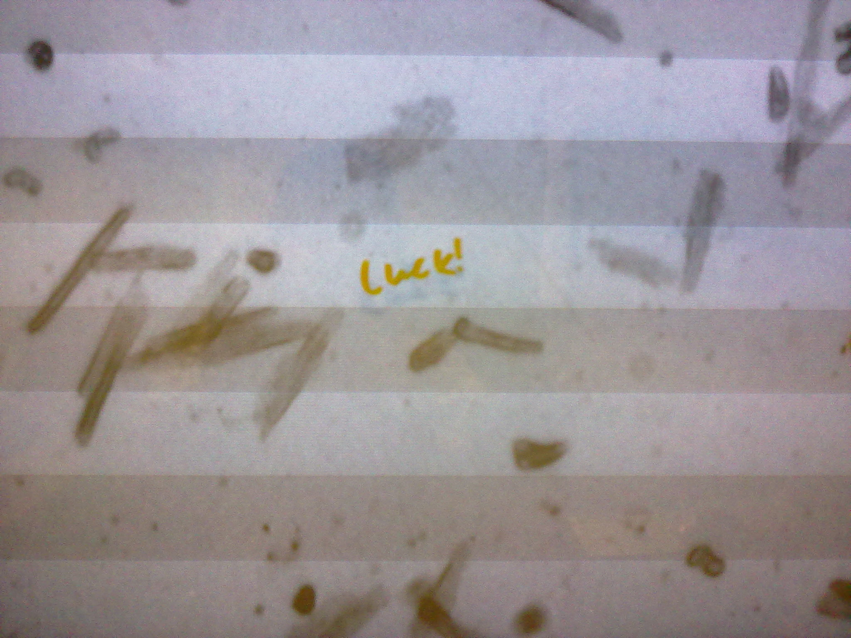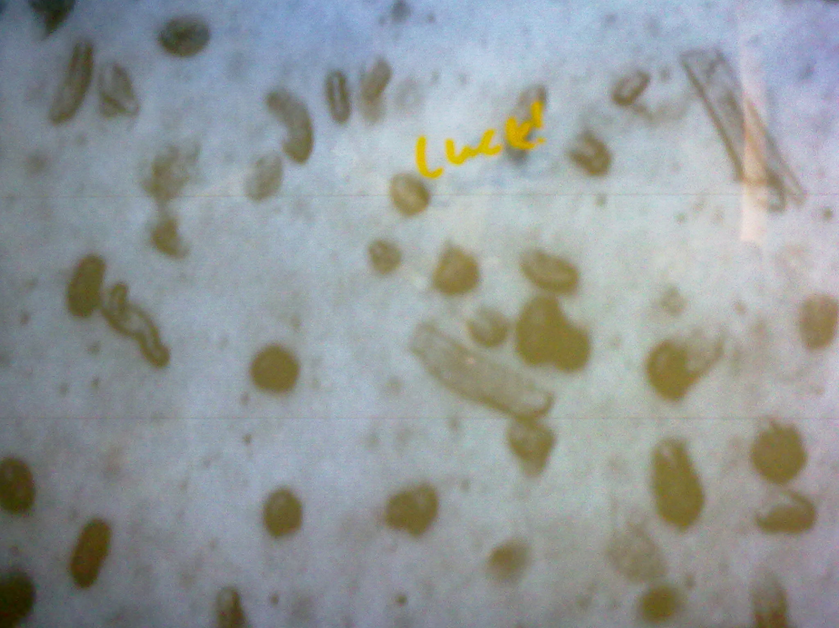
Fig A.65r/min(11 ml/min) Fig B.50r/min(8 ml/min)
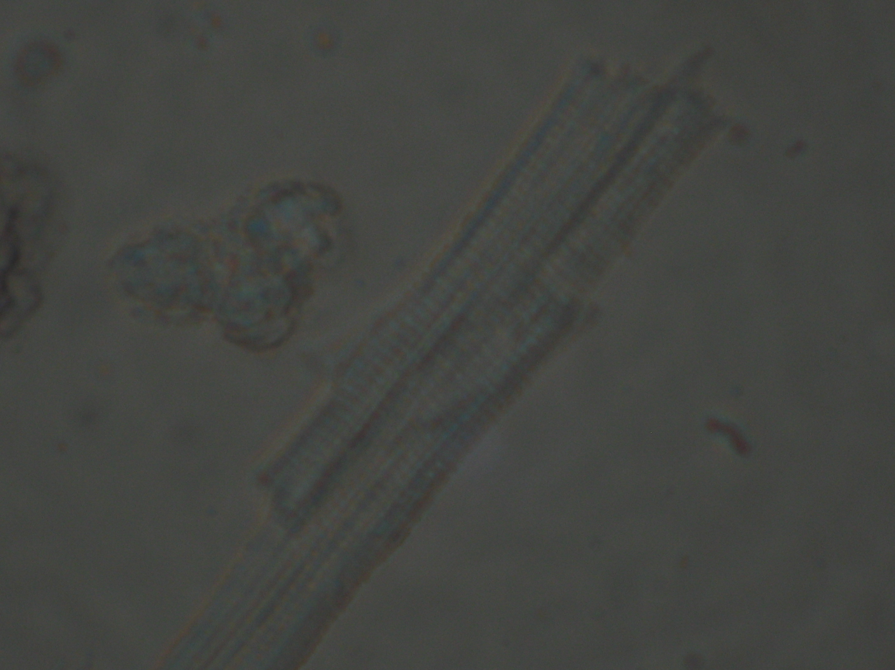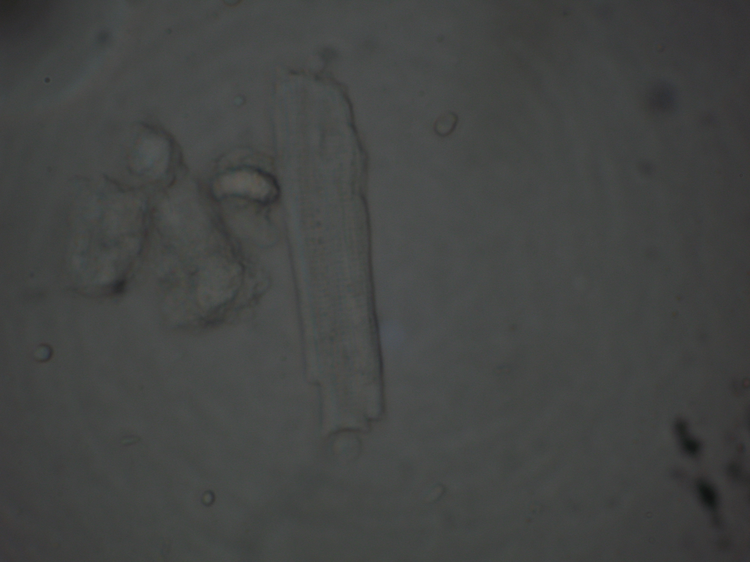
Fig C.65r/min(11 ml/min) Fig D. 50r/min(8 ml/min)

Fig A, B ：Acute separated myocardial cells by 65r/min, 50r/min perfusion speed respectively under 4×10 times magnifying lens
Fig C, D：Acute separated myocardial cells by 65r/min, 50r/min perfusion speed respectively under 10×10 times magnifying lens
3. Discussion
A normal single myocardial cell expresses as long strip after separation and its cross striations are clear. When temperature, pH and oxygen supply are adjusted to best, the separated cells are still not ideal and success rate is very low in low flow rate. During perfusion in low rotational speed (50 r/min), separated time was longer, survival rate of cells and success rate were lower. Its possible causes may be that there are inevitable few impurity or undissolved particles in perfusion solution, or a few blood remains in coronary artery, when perfusion speed is too slow, these materials can’t be washed out in time, thus they gather more and more, and finally cause occlusion in small, large and even main coronary artery, so that solution contained enzyme can not well perfuse and digest myocardium. In higher perfusion speed (65 r/min), even if there are some impurity, the faster perfusion also can wash out these impurity in time, not leading to accumulation and occlusion. Thus in higher perfusion speed, the perfusion state is good, separated time is shorter, state of myocardial cells is more fine, cross striations of myocardial cells are clear and survival rate is higher. Therefore perfusion speed is a very key factor for separation of myocardial cells.

Reference
[1] PEI JM, ZANG YM, NIU GB, et al. Separation and preservation of myocardial cells [J]. Chin J Cardiac Funct, 1996 , 8 (1):53-54.
[2] ZHANG Zi-guan, LI Wei-hua, HUANG Zheng-rong, et al. Studies on the isolation method from the cardiac myocyte of SD rats [J]. Chin J Cardiovasc Rehabil Med, 2010, 19(3):274-275.
[3] Tytgat J. How to isolate cardiac myocytes [J]. Cardiovasc Res, 1994, 28(2):280-283.
[4] Li Y. Ion channels with the patch-clamp technique [M]. Lanzhou: Gansu culture press, 2001: 98-200

