Influence of exercise on expressions of PPAR-γ and Glut-4 in mice with insulin resistance

LIU Jie ¹, CAI Ying ², FENG Yan-jing ², LIU Sui-xin ²//1. Hunan College of Traditional Chinese Medicine, Zhuzhou, Hunan, 412012, China; 2. Cardiovascular Disease Rehabilitation Center, Xiangya Hospital of Central South University
Corresponding author: LIU Sui-xin, E-mail: heartsuixin@hotmail.com

Abstract: Objective: To observe influence of exercise on expressions of peroxisome proliferators-activated receptor-γ (PPAR-γ) and glucose transporter-4 (Glut-4) in skeletal muscle tissue of mice with insulin resistance (IR) induced by high fat diet, and preliminarily investigate mechanism of swimming training improves IR. Methods: A total of 30 eight-week-old healthy male C57BL /6J mice were randomly divided into normal diet group (n=10), high fat diet group (n=10) and high fat diet + exercise group (HE group, n=10, mice received 12-week swimming training). Body weight and fasting blood glucose (FBG) of mice were measured every week. After 12-week swimming training, fasting insulin (FINS) was measured by radioimmunoassay and IR index (IRI) was calculated; expressions of PPAR-γ and Glut-4 mRNA in skeletal muscle tissue were detected by reverse transcription polymerase chain reaction (RT-PCR). Results: Compared with normal diet group, body weight significantly increased in high fat diet group; body weight of HE group was significantly lower than that of high fat diet group (P<0.05). Compared with normal diet group, there were significant increase in FINS, FBG and IRI in high fat diet group and HE group (P<0.01). Compared with high fat diet group, there were significant decrease in FINS [(14.00±7.12) mmol/L vs. (10.17±3.88) mmol/L], FBG [(9.49±1.28) mmol/L vs. (8.03±1.67) mmol/L] and IRI [(1.47±0.38) vs. (1.06±0.27), P<0.05 all], and significant increase in expressions of PPAR-γ [(0.95±0.17) vs. (2.37±0.41)] and Glut-4 mRNA [(0.68±0.24) vs. (1.54±0.28), P<0.01 both] in HE group. Conclusions: Exercise may significantly improve insulin resistance, and the mechanism may be related with upregulation of expressions of PPAR-γ and Glut-4 mRNA in skeletal muscle, regulation of glucose metabolism and promotion of transduction of insulin signal.
Key words: Exercise; Insulin; Peroxisome proliferator-activated receptors; Monosaccharide transport proteins
Supported by Fund Project: Foundation of Hunan provincial science and technology department (06SK3090), Fund project of Hunan provincial health department (B2006-036)
Article number 1008-0074(2012)06-566-06
Doi: 10.3969/j. issn. 1008-0074. 2012. 06.01

运动对胰岛素抵抗小鼠PPAR-γ、Glut-4表达的影响/刘杰¹, 蔡颖², 冯彦景², 刘遂心²//1. 湖南中医药高等专科学校，湖南 株洲 412012；2. 中南大学湘雅医院心血管康复中心
通讯作者：刘遂心，E-mail: heartsuixin@hotmail.com
摘要: 目的：观察运动对高脂饮食诱导的,产生胰岛素抵抗的小鼠骨骼肌组织过氧化物酶体增殖物激活受体-γ（PPAR-γ）、葡萄糖转运体-4（Glut-4）表达的影响，初步探讨游泳训练改善胰岛素抵抗的作用机制。方法：将30只8周龄健康雄性C57BL /6J小鼠随机分为三组：正常饮食组(n=10)、高脂饮食组(n=10)和高脂饮食+运动组 (运动组, n=10, 进行为期12周的游泳训练)。每周测小鼠体重和空腹血糖（FBG）。干预12周后，放射免疫法测空腹血胰岛素（FINS），并计算胰岛素抵抗指数（IRI）；逆转录聚合酶链式反应法检测骨骼肌组织PPAR-γ、Glut-4 mRNA表达。结果：与正常饮食组比较，高脂饮食组体重明显增加；运动组较高脂饮食组体重明显减轻(P<0.05)。高脂饮食组和运动组FINS、FPG、IRI水平均较正常饮食组明显升高（P<0.01）。与高脂饮食组相比，运动组FINS[(14.00±7.12) mmol/L比(10.17±3.88) mmol/L]、FPG [(9.49±1.28) mmol/L比(8.03±1.67) mmol/L]、IRI [(1.47±0.38)比(1.06±0.27)]水平明显降低（P<0.05）， PPAR-γ [(0.95±0.17)比(2.37±0.41)]、Glut-4 mRNA [(0.68±0.24)比(1.54±0.28)]表达明显增加（P<0.01）。结论：运动可明显改善胰岛素抵抗，其机制可能与上调骨骼肌PPAR-γ及Glut-4 mRNA的表达，调节糖代谢，促进胰岛素信号转导有关。
关键词：运动；胰岛素；过氧化物酶体增殖物激活受体；单糖转运蛋白质类
基金项目：湖南省科技厅基金课题(06SK3090), 湖南省卫生厅基金课题(B2006-036)
文章编号：1008-0074(2012)06- 566-06 中图分类号：R587.109 文献标识码：A
Doi: 10.3969/j. issn. 1008-0074. 2012. 06.01

In 1995, Stern put forward the famous common soil theory, he thought that diabetes mellitus (DM), hypertension and coronary heart disease all grew from the common soil of insulin resistance (IR), namely IR was common risk factor of these diseases [1] and it’s main line throughout many metabolism-related diseases. How to improve and relieve IR and prevent occurrence of DM has become focal point of present study. Exercise can enhance glucose transporter and phosphorylation in muscle cells, increase synthesis of muscle glycogen, therefore decrease blood glucose; other clinical studies indicated that exercise can decrease insulin dose in DM patients and it helps to recover islet cell function and improve IR. Mechanism of exercise improving insulin sensitivity is still not clear today.
Peroxisome proliferator-activated receptors (PPARs) family takes part in a series of wide physiological process from metabolism of glucose and fatty acid to cell differentiation, inflammatory response and vascular biology regulation, and it’s closely related with IRI. PPAR-γ can increase body sensitivity to insulin [2] and modulate balance of glucose and lipid metabolism in vivo [3]. Glucose transporter -4 (Glut-4) is a main glucose transporter in muscle and fat tissues. Insulin can promote intake of glucose in muscle and fat tissues through Glut-4. Glut-4 and PPAR-γ are important nodes in insulin signal transduction pathway; defect of their expressions can lead to glucose metabolic disorder and cause IR. The preset study used high fat diet to induce IR in mice, observe influence of exercise on expressions of PPAR-γ and Glut-4 mRNA in skeletal muscle tissue of mice with IR（IR mice）in order to explore mechanisms of exercise improving glucose metabolism and insulin signal transduction in IR mice.

1. Materials and methods
1.1 Experimental materials
A total of 30 eight-week-old healthy male C57BL /6J mice with weight (20±2) g were selected (provided by experimental animal center of Xiangya medical college of Central South University). Rearing environment of all mice was SPF grade, temperature was 25~30℃, air humidity was 60% and photoperiod was 12h (6:00~18:00) every day. Mice received adaptive feeding for one week. Basic fodders were provided by animal department of Central South University; high sugar and fat fodders were made by adding 12% ripe lard, 20% sucrose and 2.5% cholesterol to basic fodders, after all ingredients fully mixed, fodder was forming by compaction. Cholesterol (purity 99.7%) was bought from Beijing Dingguo biotechnology Co. Ltd., insulin radioimmunoassay kits were bought from Beijing atomic high tech nuclear technology application Co. Ltd., TRIZOL was bought from American Invitrogen Company, RNA reverse transcription kits were bought from Fermentas Company, 2×Taq PCR MasterMix was bought from Tiangen Reagent Company. Primers were synthesized by Shanghai Shenggong biotech service Co. Ltd.
1.2 Animal grouping
According to random number table method, the 30 mice were randomly divided into normal diet group (n=10), high fat diet group (n=10) and high fat diet + exercise group (HE group, n=10). Normal diet group was fed with basic fodders; high fat diet group and HE group were fed with high fat fodders. Every mouse was weighed before intervention, then weighed and recorded once every week.
1.3 Exercise intervention
According to training methods in references ^{[4, 5]}, mice in HE group underwent swimming training: the first week was exercise adaption period, time for swimming was 15 min on 1st day, 30 min on 2nd day, and gradually increased to 60 min at the end of first week. Since second week, mice were trained 60 min every day, five times a week for 12 weeks. Temperature of water was (35 ±1) ℃ and water depth was 38 cm.

1.4 Measurement method of indexes
1.4.1 Measurement of serological indexes: At the end of 12th week, fasting and water deprivation were performed for 12h overnight in mice. Eyeballs were culled and taken 1 ml blood on second day. Fasting blood glucose (FBG) was measured in automatic biochemical analyzer (ROCHE MODULAR SWA), and fasting insulin (FINS) was measured by radioimmunoassay method, then insulin sensitivity index (ISI) and homeostasis model-insulin resistance index
（lnHoma-IR）were calculated; ISI=ln [1/FBG×FINS)]; lnHoma-IR =FBG（mmol/L）×FINS（mU/L）/22.5.
1.4.2 Treatment of specimen: After eyeball were culled and taken blood, and mice were executed, soleus specimen of right lower limb was taken and saved in liquid nitrogen for detection by reverse transcription polymerase chain reaction (RT-PCR).
1.4.3 Detection of mRNA expression in skeletal muscle tissue by RT-PCR method: Tissue specimen was quickly mashed in liquid nitrogen, then 1 ml TRNZOL was added. Total RNA was extracted according to instruction, A260/A280 ratio was measured by ultraviolet spectrophotometry and purity was tested, A260/A280 ratio was 1.8~2.0. Reverse transcription was conducted according to procedure on reverse transcription kit. The mRNA gene sequence of mice mesh was obtained from GeneBank. Primer was designed through Primer Premier 5 software. Sequences were as follow:
glyceraldehyde phosphate dehydrogenase (GAPDH): Sense: 5'TCCACCACCCTGTTGCTGTA 3', Antisense: 5'ACCACAGTCCATGCCATCAC 3'; β-actin: Sense: 5'TTCCGATAACGAACGAGA- CTCT 3', Antisense: 5'TGGCTGAACGCCACTTGTC 3'; PPAR-γ: Sense: 5'ACCACTCGCATT- CCTTTGAC 3', Antisense: 5'ATCGCACTTTGGTATTCTTGGAG 3'; Glut-4: Sense: 5'CCAACC- TGCCTAACAATGCC 3', Antisense: 5'TGGTCGGCTGACAAGGAGGA 3'.
The cDNA 1 µl was taken as template, and then 10 µM upstream and downstream primers every 0.5µl, 5 µl of 2×Taq PCR MasterMix and 3 µl of ddH₂O were added in order. Total reaction system was 10 µl. Reaction condition between β-actin and GAPDH was: predenaturation for 4 min at 95℃, denaturation for 30 s at 95℃, annealing for 30 s at 55℃, extending 1 min at 72℃, after 30 cycles, finally extending 5 min at 72℃; reaction condition of PPAR-γ was predenaturation for 4 min at 94℃, denaturation for 30 s at 94℃, annealing for 30 s at 52℃, extending 1 min at 72℃, after 35 cycles, finally extending 5 min at 72℃; Reaction condition of Glut-4 was predenaturation for 4 min at 94℃, denaturation for 30 s at 94℃, annealing for 30 s at 60℃, extending 1 min at 72℃, after 30 cycles, finally extending 5 min at 72℃. PCR products underwent electrophoresis in 2.5% agarose gel. Digital pictures were taken by TANON GIS2020 gel analyzer, optical density value was scanned and analyzed by gel image analysis software - BandScan V5.0 software and compared with that of β-actin.
1.5 Statistical analysis
SPSS 16.0 statistical software was used to perform statistical treatment. Measurement data were expressed as ($\bar{x}$±s). Data with variance homogeneity (P>0.05) received Levene test. Mean comparison among multiple samples was performed using one-factor analysis of variance, comparison between two groups was performed using LSD-t test. PPAR-γ、GLUT-4mRNA were relative optimal density value, whose comparison was performed using q test. P<0.05 was regard as possessing significant difference.

2. Results
2.1 Comparison of body weight among three groups
After 12-week swimming training, compared with normal diet group, there was significant increase in body weight of mice in high fat diet group (P<0.05), and body weight in HE group was significantly lower than that of high fat diet group (P<0.05). They were shown in table 1.
Table 1 Comparison of body weight among three groups before and after 12-week swimming training ($\bar{x}$±s)
Group | n | Body weight (g)
Group | n | Before swimming | After swimming
Normal diet group | 10 | 20.8±2.4 | 26.8±2.5
High fat diet group | 10 | 20.5±2.6 | 30±2.4△
HE group | 10 | 21±2.2 | 27±2.2▲
Notes: High fat diet + exercise group: HE group, compared with normal diet group △ P＜0.05, △△P<0.01；compared with high fat diet group ▲P＜0.05, ▲▲P<0.01; similarly hereinafter.

2.2 Comparison of levels of FINS, FBG and Ln Homa-IR among three groups
After 12-week swimming training, compared with normal diet group, there were significant increase in levels of FINS（fasting insulin）and FBG (P<0.01), and significant increase in lnHoma-IR in high fat diet group and HE group (P<0.05 both). Compared with high fat diet group, there were significant decrease in levels of FINS, FBG and lnHoma-IR in HE group (P<0.05 or <0.01), indicating that 12-week swimming can significantly improve IR. They were shown in table 2.

Table 2 Comparison of levels of FINS, FBG and lnHoma-IR among three groups after 12-week swimming training ($\bar{x}$±s)
Group | n | FINS (mmol/L) | FBG (mmol/L) | ln Homa-IR
Normal diet group | 10 | 5.41±2.42 | 6.91±2.42 | 0.04±0.06
High fat diet group | 10 | 14.00±7.12△△ | 9.49±1.28△△ | 1.47±0.38△
HE group | 10 | 10.17±3.88△△▲ | 8.03±1.67△△▲ | 1.06±0.27▲▲
Notes: FINS: fasting insulin, FBG: fasting blood glucose, Homa-IR: homeostasis model-insulin resistance index
2.3 Expressions of PPAR-γ、Glut-4 in liver of three groups
Compared with normal diet group, expression of PPAR-γ decreased in high fat diet group, but difference between two groups was not significant (P>0.05); Compared with normal diet group, expression of Glut-4 significantly decreased in high fat diet group (P<0.01). Compared with high fat diet group, there were significant increase in expressions of PPAR-γ and Glut-4 in HE group (P<0.01). They were shown in table 3, figure 1 and 2.

Table 3 Comparison of expressions of PPAR-γ and Glut-4mRNA in liver among three groups of mice ($\bar{x}$±s)
Group | PPAR-γ | Glut-4
Normal diet group | 1.27±0.26 | 1.87±0.32
High fat diet group | 0.95±0.17 | 0.68±0.24△△
HE group | 2.37±0.41△△▲▲ | 1.54±0.28▲▲
Notes: PPAR-γ: peroxisome proliferator-activated receptor-γ, Glut-4: glucose transporter -4. Similarly hereinafter.

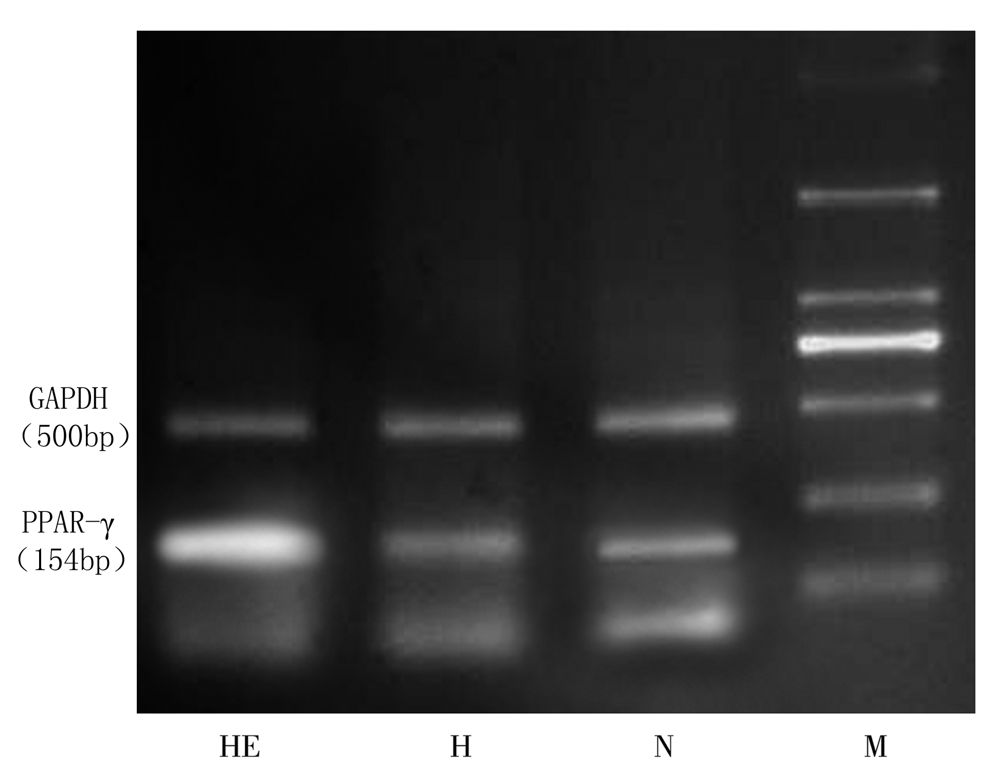
Fig 1 Expression of PPAR-γ in skeletal muscles in three groups
Notes: HE: high fat diet + exercise group, H: high fat diet group, N: normal diet group, M: marker, GAPDH: glyceraldehyde phosphate dehydrogenase, similarly hereinafter.

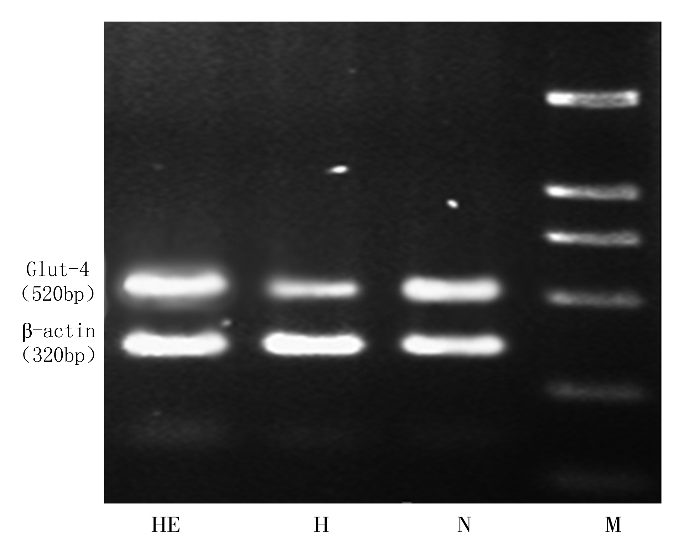
Fig 2 Expression of Glut-4 in skeletal muscles in three groups

Glut-4(520bp)

3. Discussion
C57BL/6J mice were fed with high fat diet to establish IR model in the present study. After 12-week high fat diet induction, levels of FINS and FBG in high fat diet group and HE group were significantly higher than those of normal diet group (P<0.01), and IRI significantly increased (P<0.05), indicating that IR model was successfully established. After 12-week swimming training, compared with high fat diet group, there were significant decrease in body weight, FINS, FBG and lnHoma-IR in HE group, indicating that exercise can decrease body weight, blood glucose and insulin level, increase insulin sensitivity and then significantly improve IR. All these are consistent with studies overseas.
PPAR-γ plays an important regulatory role in many complicated metabolism of mammals, such as oxidation of fatty acid and glucose metabolism. After PPAR-γ activated by ligand, its mechanism improving IR may involve [6]: (1) Enhancing insulin signal transduction: PPAR-γ of super-physiological activity can promote expression of PI-3K subunit p85 [7], meanwhile increase cAMP activated protein （CAP）transcription, promote insulin signal transduction and improve IR; (2) PPAR-γ takes part in expression of some key enzyme genes during glucose metabolism, such as increase expression of Glut-4 gene in fat and skeletal muscle tissue, increase transportation velocity and utility rate of glucose. Agonists of PPAR-γ include natural and synthetic agonists. Thiazolidinediones (TZDs) drug is synthetic agonist of PPAR-γ, TZDs promotes usage of muscle glucose and inhibits export of liver glycogen through enhancing effects of insulin in animal model and patients with IR [7], thus decreases blood glucose and then improves IR. Price of TZDs is high, and its adverse effects are more, such as may increase incidence rate of cardiovascular adverse events and mortality rate, and cause hepatotoxicity and colon tumors, so clinical physicians and patients prefer not to use it, though TZDs drugs possess definite effects in regulation of glucose and lipid metabolism. Therefore, looking for natural agonists of PPAR-γ becomes new direction of study today.
Skeletal muscle is one of important target organs of insulin. Glucose transportation in skeletal muscle is mainly active transport process. Glucose transporter 4 (Glut-4) is one of most important glucose transporters in skeletal muscle, responsible for regulation and transportation of 50%~80% glucose in body. In basic state, Glut-4 in skeletal muscle mainly exists in vesicles form within cells, only a few exist on cell membrane. When tissue receives stimulus from insulin or exercise, Glut-4 transports from intracellular to cell membrane via a series of signal transduction pathways, therefore increases transportation of glucose. Normal Glut-4 expression depends on normal insulin level and sensitivity. Inhibition of Glut-4 transcription occurs in insulin sensitivity defected animals. There was study indicated that PPAR-γ can up-regulate expression of Glut-4 via a series of signal transduction [9]. PPAR-γ and Glut-4 all are important pathway in insulin signal transduction.
The present study found that after swimming training, expression levels of PPAR-γ and Glut-4mRNA in skeletal muscles of mice were significantly higher than those of high fat diet group, prior study of our lab also indicated that aerobic exercise can significantly up-regulate expressions of liver PPAR-γ and skeletal muscle Glut-4mRNA in IR rats; Body weight, levels of FINS, FBG and lnHoma-IR in exercise group were significantly lower than those of high fat diet group. Above results indicated that swimming can significantly improve IR and its mechanism may be related with exercise activates PPAR-γ expression in skeletal muscle of mice, enhances insulin signal transduction, up-regulates expression of Glut-4mRNA and therefore increases transportation of glucose.
Reference

[1] Stern MP. Diabetes and cardiovascular disease. The “Commom Soil” hypothesis [J]. Diabetes, 2006, 44(4): 369-374
[2] Evans R M，Barish G D．Wang Y X．PPARs and the complex journey to obesity[J1．Nat Med，2004，10(4)：355—361．
[3] 陈永熙，王伟铭，周同，等．PPAR-γ作用及其相关信号转导途径[J]．细胞生物学杂志，2006，28(3)：382—386．
[4] Putman CT, Jones NL, Lands LC, et a1. Skeletal muscle pyruvate dehydrenase? activity during maximal exercise in humans [J]. Am J Physio1. 1995, 269(31): 58-68．
[5] Plog T, Stallknecht BM, Pedersen D, et al. Effect of endurance training on glucose transport capacity and glucose transporter expression in rat skeletal muscle [J]. Am J Physiol, 1990, 259(61): 778-786
[6] Kliewer SA, Lenhard JM, Willson TM, et al. A prostaglandin J2 metabolite binds peroxisome proliferator activated receptor gamma and promotes adipocyte differentiation [J]. Cell, 2002, 83 (5): 813-819
[7] Tuganova A, Klyuyeva A, Popov KM. Recognition of the inner lipoyl? -bearing domain of dihydrolipoy? transacetylase and of the blood glucose-lowering compound AZD7545 by pyruvate dehydrogenase kinase 2[J].Biochemistry, 2007, 46(29): 8592-8602
[8] Oliver WR，Shenk JL，Snaith MR，et al. A selective peroxisome proliferators activated receptor delta agonist promotes reverse cholesterol transport［J］Proc Natl Acad Sci，2001, 98 (9)：5306-5311.
[9] Kim HJ, Lee JS, Kim CK. Effect of exercise training on muscle glucose transporter 4 protein and intramuscular lipid content in elderly men with impaired glucose tolerance [J]. Eur J Appl Physiol, 2004, 93(3): 353-358.

