Influence of Wenxin particle on cardiac electrophysiology in depressed rats after myocardial infarction

LIANG Jin-jun, SHI Shao-bo, SHEN Jing-jing, WANG Fang, SHEN Ying-ying, YUAN Xiao-ran, QU Chuan, HUANG He, YANG Bo, HUANG Cong-xin//Department of Cardiology, People’s Hospital of Wuhan University, Wuhan, Hubei, 430060, China
Corresponding author: HUANG Cong-xin, E-mail: huangcongxin@yahoo.com.cn

Abstract: Objective: To investigate influence of Wenxin particle on cardiac electrophysiology in rats complicated with depression after myocardial infarction (MI). Methods: A total of 50 SD rats were randomly and equally divided into normal group, MI group, depression group, MI complicated with depression group (model group) and Wenxin particle group (Wenxin particle were given to model rats by gavage, 2 g/d, 28d). Model（MI complicated with depression）rats were made by acute ligation of left coronary artery and supply chronic unpredictable mild stress in order. The influences of Wenxin particle on cardiac electrophysiological indexes, such as monophasic action potential (MAP90), left ventricular effective refractory period (ERP) and ventricular fibrillation threshold (VFT) were evaluated in Wenxin particle group. Results: (1) Compared with normal group, there were significant decrease in behavior scores (P<0.05) in model group, after four-week treatment with Wenxin particle, their behavior scores significantly increased (P<0.01); (2) Compared with normal group, there were significant increase in MAPD90 and ERP, and significant decrease in VFT in model group (P<0.05); compared with model group, there were significant decrease in MAPD90 [(89.33±7.12) ms vs. (72.29±8.37) ms] and ERP [(84.00±6.57) ms vs. (68.00±7.43) ms], and significant increase in VFT [(7±3.11)V vs. (29±5.60)V] in Wenxin particle group, P<0.05. Conclusion: Wenxin particle can improve cardiac electrical remodeling in rats complicated with depression after myocardial infarction, including decrease monophasic action potential duration and effective refractory period, and raise ventricular fibrillation threshold.
Keywords：Myocardial infarction; Depression; Electrophysiologic techniques, cardiac
Supported by Fund Project: National natural science foundation (81200139), Natural science foundation project of Hubei province (2011CDC157), “211 Engineering” construction project of Wuhan University, Independent research project of Wuhan University (4104006, 302274019)
Article number 1008-0074(2012)06-649-6
Doi: 10.3969/j. issn. 1008-0074. 2012. 06.29

稳心颗粒对心肌梗死后抑郁大鼠心脏电生理的影响/梁锦军, 石少波, 谌晶晶, 王芳, 谌莹莹, 袁晓冉, 曲 川, 黄 鹤, 杨 波, 黄从新//武汉大学人民医院心内科， 湖北 武汉 430060
通讯作者：黄从新，E-mail: huangcongxin@yahoo.com.cn

摘要: 目的: 运用稳心颗粒干预心肌梗死后合并抑郁大鼠，探讨其对心梗后抑郁大鼠心脏电生理的影响。方法：选择SD大鼠50只，均分为正常组，心梗组，抑郁组，心梗后抑郁组（模型组）和稳心颗粒干预组（以2g/d的稳心颗粒给模型组大鼠灌胃28d）。先后通过急性结扎左冠脉和给予慢性不可控的温和应激，制作心肌梗死后抑郁模型大鼠，予稳心颗粒干预，评价其对模型大鼠在体单向动作电位（MAP90）、左室有效不应期（ERP）和室颤阈值（VFT）等电生理学指标的影响。结果: 1.与正常组相比，模型组行为学评分有显著下降（P<0.05），经过4周稳心颗粒治疗后，其行为学评分显著上升（P<0.01）；2. 与正常组相比，模型组MAPD90和ERP明显延长，VFT明显降低（P<0.05）；稳心颗粒干预后，与模型组比较，稳心颗粒组MAPD90[(89.33±7.12) ms比(72.29±8.37) ms]、ERP[(84.00±6.57) ms比(68.00±7.43) ms]明显缩短，VFT[(7±3.11)V比(29±5.60)V]明显升高（P<0.05）。结论: 稳心颗粒能改善心肌梗死后抑郁大鼠心脏电重构，包括缩短单向动作电位和、左室有效不应期，提高室颤阈值。
关键词：心肌梗死；抑郁；电生理学技术，心脏
基金项目：国家自然科学基金（81200139）、湖北省自然科学基金项目(2011CDC157)、武汉大学“211工程”建设项目、武汉大学自主科研项目(4104006、302274019)
文章编号：1008-0074(2012)06-649-6 中图分类号：R542.22 文献标识码：A
Doi: 10.3969/j. issn. 1008-0074. 2012. 06.29

Patients with myocardial infarction (MI) are usually complicated with depression, and those with depression often possess worse clinical outcome. Lane et al ^{[1]} found that incidence rate of medium-severe depression (BECK score > 10 scores) was 30.9% in MI patients during hospital stay, increased to 37.7% on fourth month and it’s as high as 37.2% after one year [1]. Besides, incidence rate of cardiovascular event, all-cause and cardiac-cause mortality of patients with depression after MI were significantly higher than those of control group, which may be related with depression emotion increasing incidence of arrhythmias [2, 3]. Wenxin particle possesses good effect in treatment of arrhythmias and it’s safe in patients with coronary heart disease [4, 5]. But there is no report on whether it’s safe and effective in patients with depression after MI. Therefore, the present study established model of rats complicated with depression after MI, used Wenxin particle to intervene those rats to study its influence on electrophysiological indexes, including monophasic action potential duration (MAPD₉₀), left ventricular effective refractory period (ERP) and ventricular fibrillation threshold (VFT) etc.

- Data and methods
1.1 Experimental rats
Healthy male SPF grade SD rats with body weight 120~150g were all bought from experimental animal center of Wuhan University, and placed in experimental animal center of people’s hospital of Wuhan University, their rearing conditions were consistent with experimental requirements. A total of 50 rats were randomly and equally divided into normal group, MI group, depression group, MI complicated with depression group (model group) and Wenxin particle group (model rats received 2 g/d Wenxin particle by gavage for 28d).
1.2 MI model
Rats were weighed, and anesthetized by intraperitoneal injection of 0.1 g/L pentobarbital sodium solution (40~50 mg/kg) and fixed on experimental board in supine position after anesthesia. Rats were routinely disinfected, covered towels, electrocardiography (ECG) monitored by subcutaneous electrode of limb, received intubation and connected to ventilator for artificial ventilation (pressure 2 kPa, frequency 70 times/min; small animal ventilator TKR-400H bought from Jiangxi Teli company). Then parasternal left thoracotomy of rat was performed, pericardium was tore and heart was fully exposed. Coronary artery left anterior descending or circumflex branch was ligated 1~2 mm beneath left atrial appendage, monitored by ECG. The mark of successful surgery was ST segment elevated for 0.2 mV in II, III, aVF or I, aVL leads in ECG, and ST segment fused with R wave. After surgery, 800 000 U penicillin was given intramuscularly for three days to prevent infection.
1.3 Identification of MI model
(1) Surface ECG: Its examination method was as above; (2) Masson staining: Hearts of all model rats were taken after electrophysiological experiment, myocardium in infarct area received Masson staining, the specimen was placed under microscope after mounting, then DPS camera system was used to take pictures under ×100 and ×400 visual field. Collagen fiber was presented as blue while myocardial fiber was presented as red.
1.4 Depression model
Three days after establishment of MI model, chronic unpredicted mild stress (CUMS) was used to establish depression model in MI rats: rat cage tilted 45° for 24h, damp litter was placed in cage for 24h, behavior of rats was limited for 24h; swimming in 4℃ ice water for 5min, fasting for 24h, water deprivation 24h were performed; tail was clamped for 1min and 24h continuous illumination was performed. Above eight stimulations were randomly arranged into 28d, a kind of stimulation every day and each kind of stimulation appeared for 3~4 times. A stimulation didn’t appear continuously, making rats cannot predict occurrence of stimulation [3].
1.5 Identification of depression model
(1) Syrup consumption test: Rats were trained to adapt to drinking syrup before experiment (two bottles were placed in each cage, both were filled with 1% sucrose water for the first 24h; one bottle was filled with 1% sucrose water and the other one was filled with pure water for the second 24h). After water was prohibited for 24h, animal basic syrup water/pure water consumption test started. A bottle filled with 1% syrup water and a bottle filled with pure water prepared before test were given to every rat at the same time. Syrup water consumption amount of rats were calculated after one hour and used to evaluate related behavioral score; (2) Open field test: Size of open field was 120cm×90cm×35cm and the test started at 9:00-10:00 in the morning. Rat was placed in the middle of open field, automatic tracking system of animal behavior (Ethovision 3.0) was used to record and analyze rat behavior in the open field for 10 min. Main observing indexes including total course, mean moving velocity and standing times (two forepaws vacated or climbed the wall) were recorded and used to evaluate related behavioral score . Rat was tested alone and the field was cleared up between two rats. Open field test was performed before CUMS and on 28th day.
1.6 Measurement of electrophysiological indexes
LEAD2000B multi-lead physiological recorder (Sichuan Jingjiang general industrial Co. Ltd.) was used to record MAP, ERP and VFT of rats: (1) under sinus rhythm, MAP90 of myocardium within 3mm surrounding MI area was recorded (MAPD90 was defined as duration from MAP started to repolarization completed by 90%); (2) bipolar pacing electrode was placed on epicardium of right ventricular outflow tract and recording electrode was placed in area surrounding MI. Ventricular ERP was marked for S2 pre-stimulus can’t cause transmissible MAP. After continuous eight pulse stimulus S1 release, a premature beat stimulus S2 was discharge, S1S2 started from < S1S1 20ms and step length was -2ms; (3) paroxysmal high intensity stimulation was took in the end with perimeter 20ms, pulse width 4ms, duration of each stimulus was 5s and next stimulus started after 2s interval, pacing voltage started from 4V and increased by 1V every time. Ventricular fibrillation threshold was the lowest voltage that caused ventricular fibrillation.
1.7 Statistical treatment
SPSS 17.0 software was used to perform statistical analysis. Measurement data were expressed as mean ±standard deviation ($\bar{x}$±s) and its comparison between two groups was performed using two independent samples t test, and comparison among multiple groups was performed using one- factor ANOVA. P<0.05 was regard as possessing significant difference.

2. Results
2.1 Identification of MI model
After MI, surface ECG of rat indicated that ST segment elevated and fused with R wave in I and aV leads, S wave broadened and deepened in mirror surface leads such as Ⅲ lead, they were shown in figure 1. Masson staining indicated that myocardial cells in infarct district were replaced by collagen fibers, disordered arranged and expressed as blue, while normal myocardial cells regularity arranged and expressed as red，they were shown in figure 2.

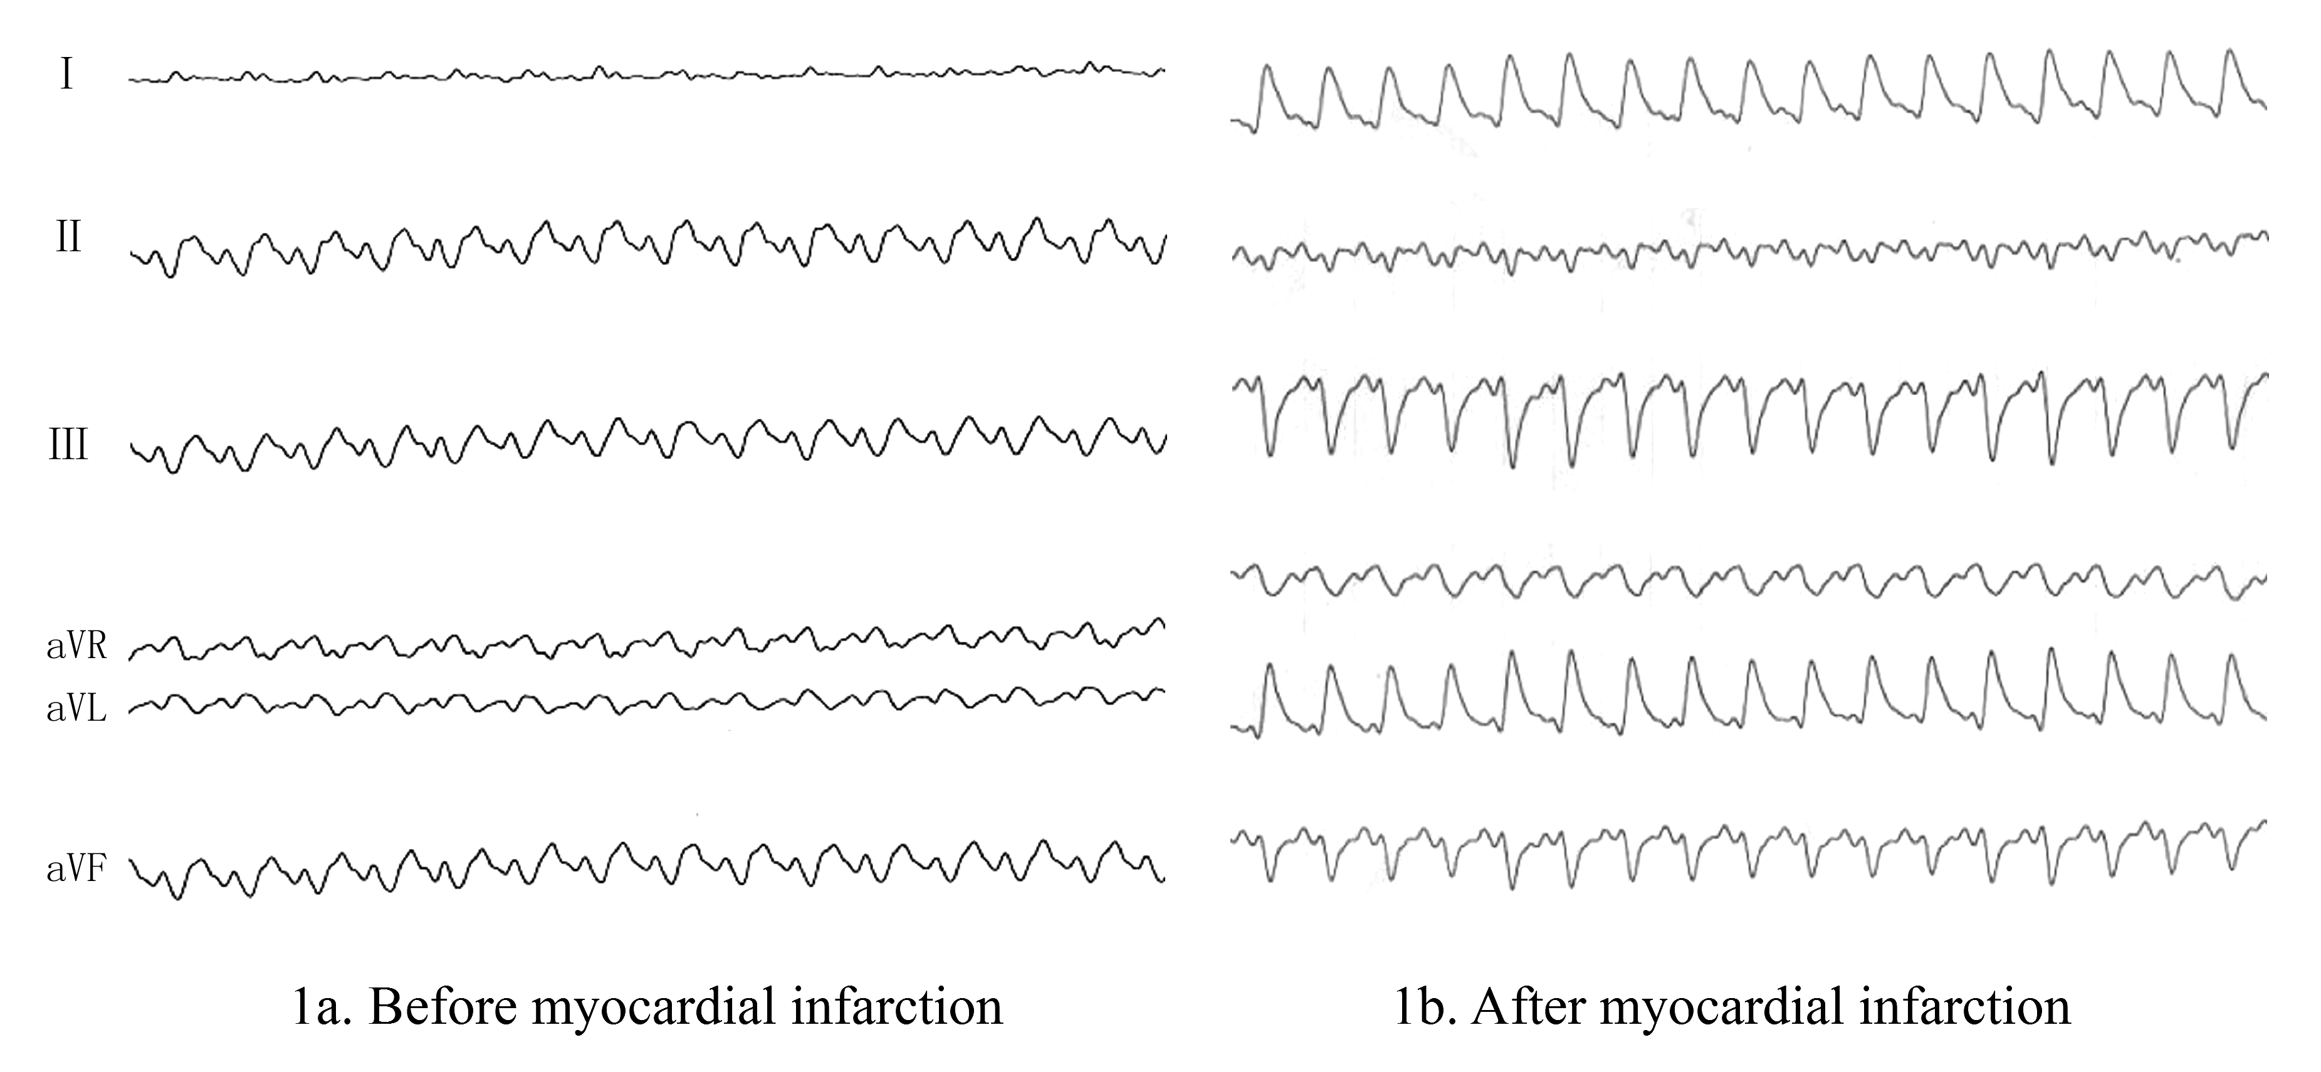Fig 1 Changes of electrocardiogram before and after myocardial infarction

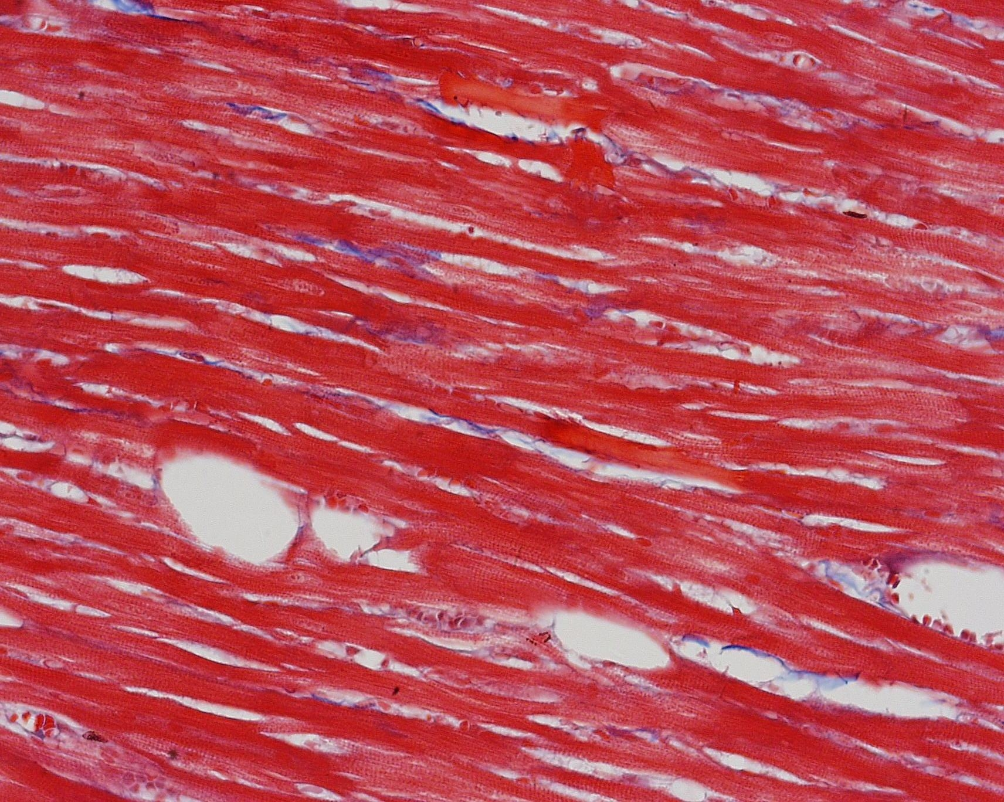 | 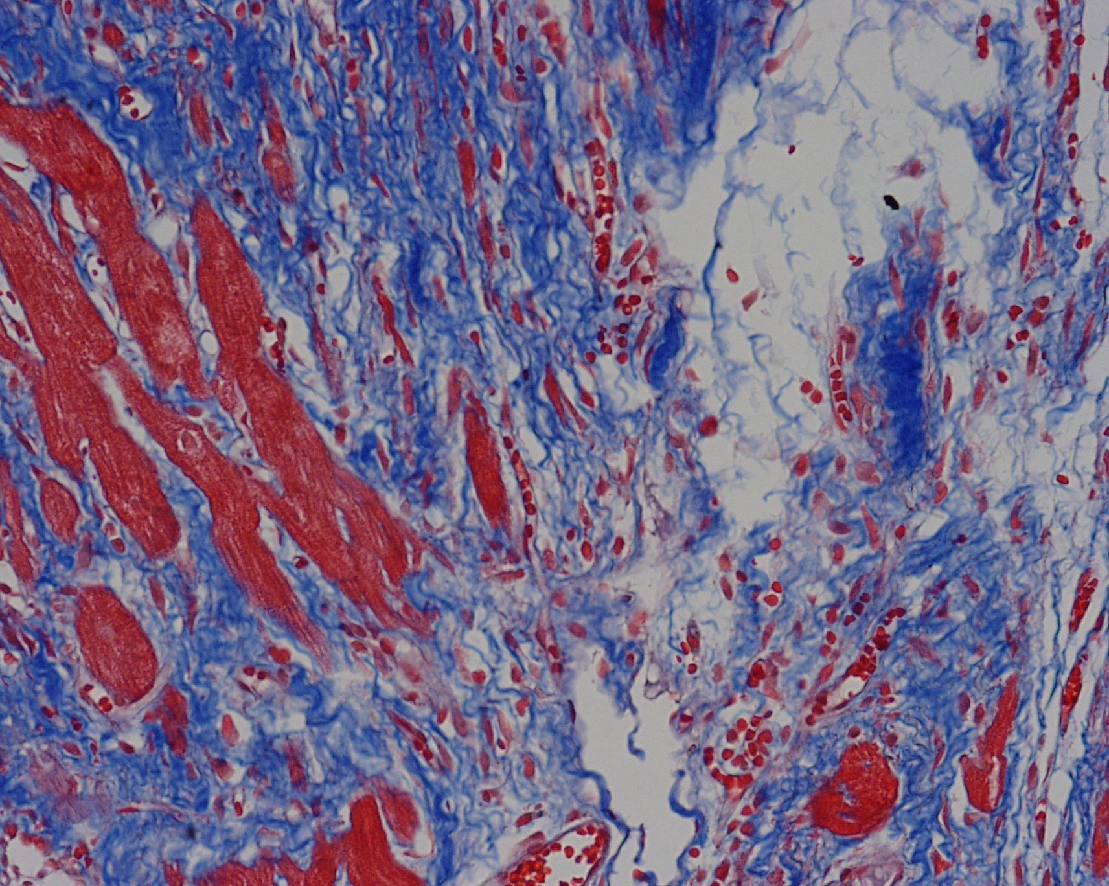
2a. Normal area | 2b. Myocardial infarction area
Fig 2 Results of Masson staining （400）in normal and myocardial infarction area

2.2 Identification of depression model
After CUMS 28d, behavioral scores of model group were significantly lower than those of MI group and normal group (P<0.05 or <0.01), and their scores significantly increased after Wenxin particle intervention (P<0.01). They were shown in table 1.
Table 1 Comparison of behavioral scores among five groups (n=10, $\bar{x}$±s)
Group | Sucrose water preference  (%) | Open field test
Group | Sucrose water preference  (%) | Creeping distance (m) | Creeping distance (cm/s) | Times of climbing wall (times)
Normal group | 83.22±21.01△△ | 37.29±10.70 | 6.80±1.77△ | 24±7△△
Myocardial infarction group | 52.00±24.25△△ | 30.27±6.26 | 5.30±1.48 | 21±6△
Depression group | 60.92±16.26△△ | 30.91±5.41 | 5.23±0.94 | 17±5
Model group | 49.13±20.78 | 29.51±9.54 | 4.98±1.59 | 11±5
Wenxin particle group | 69.64±8.58 △△ | 29.40±10.68 | 5.07±1.90 | 24±8△△
Notes: Compared with model group, △P<0.05, △△P<0.01. Similarly hereinafter.

2.3 Electrophysiological testing results in rats
Compared with normal group, there were significant extension in MAPD90 and ERP, and significant decrease in VFT in model group (P<0.05 or <0.01); after Wenxin particle intervention, MAPD90 and ERP significantly decreased, and VFT significantly elevated (P<0.05). They were shown in table 2.

Table 2 Comparison of electrophysiological indexes in rats among five groups (n=8, $\bar{x}$±s)
Group | MAPD₉₀（ms） | ERP(ms) | VFT(V)
Normal group | 71.86±7.52△ | 65.67 ±7.72 △△ | 18 ±3.02△
Myocardial infarction group | 83.67±2.89 | 73.33±4.22 | 11±1.41
Depression group | 77.78±6.38 △ | 70.54±9.35△ | 15±2.83△△
Model group | 89.33±7.12 | 84.00±6.57 | 7±3.11
Wenxin particle group | 72.29±8.37△ | 68.00±7.43△ | 29±5.60△△

- Discussion
Along with medical mode transforms into biology-society-psychology mode, people gradually pay attention to heart- psychology care. Depression of MI patients also receives more attention, depression after MI is a common physical and mental disease and the patients usually have a worse outcome. A meta-analysis found that risk of cardiac death in depression patients after MI was 2.4 times compared with control group, and risk of new cardiovascular events was two times compared with control group [6]. Depressive emotion increases mortality rate of MI patients may be related with arrhythmias. There are still 50% died of fatal ventricular arrhythmias in MI survivors. Arrhythmia and cardiac sudden death are more common in depression patients after MI. There was study found that there were many abnormal cardiac electrophysiological indexes in depression patients and animal models, and they were easier to induce ventricular arrhythmias [7]; depressive emotion is an independent predictive factor for ventricular arrhythmias in patients with cardiovascular disease [8].
The present study compared changes of monophasic action potential duration (MAPD), left ventricular effective refractory period (ERP) and ventricular fibrillation threshold (VFT) among different groups, in order to study myocardial electrical remodeling in model rats complicated with depression after MI, and Wenxin particle were given to rats in order to study its influence on electrical remodeling in model rats; its results display that both depression and MI lengthened MAPD90 and ERP, and decreased VFT in ventricular myocardium surrounding MI area. MAPD90 is the duration from MAP depolarization to repolarization 90%, representing change of action potential duration (APD).MAP can record transmembrane potential change of myocardial cell in live animal; it is better to reflect electrophysiological change in cardiac overall level, compared with transmembrane action potential. Above changes caused by depression may be related with disorder of autonomic nervous system, activity increase of hypothalamus- pituitary- adrenal (HPA) axis and immune dysfunction. Some studies indicated that MI can also cause above functional changes and influence MAPD₉₀, ERP and VFT ^{[9-12]}.
MAPD₉₀ and ERP of ventricular myocardium surrounding MI area in rats complicated with depression after MI were longer than those of MI rats, indicating that depression and MI may have cumulative effects in influence on electrophysiological characteristics of ventricular myocardium in rats. It may be one of causes why mortality rate and incidence rate of severe cardiac event in patients with coronary heart disease (CHD) complicated depression are higher than those of CHD patients without depression. Wenxin particle is a kind of Chinese patent medicine that can treat many arrhythmias via many routes [13]. The present study found that Wenxin particle can improve behavior and myocardial remodeling in model rats complicated with depression, including shortening MAPD90 and ERP, and raising VFT in model rats. However, specific molecular mechanism of depressive emotion increase arrhythmias in CHD patients is still not clear, likewise Wenxin particle how improves electrical remodeling in model rats needs further study.

Reference
[1] Lane D, Carroll D, Ring C, et al. The prevalence and persistence of depression and anxiety following myocardial infarction[J]. Br J Health Psychol, 2002, 7(Pt 1):11-21.
[2] Hosseini SH, Yousefnejad K, Tabiban S, et al. Effects of depression and anxiety symptoms on cardiac mortality following myocardial infarction: a 2-year follow-up[J]. Int J Psychiatry Clin Pract, 2011, 15(2):91-96.
[3] Reese RL, Freedland KE, Steinmeyer BC, et al. Depression and rehospitalization following acute myocardial infarction[J]. Circ Cardiovasc Qual Outcomes, 2011, 4(6):626-633.
[4] 陈文韬, 黄从新, 郭凯, 等. 稳心颗粒对大鼠心室肌细胞跨膜动作电位的影响[J]. 中国心脏起搏与心电生理杂志, 2010, 24(4):341-343.
[5] 王瑛, 付强, 刘海霞, 等. 稳心颗粒治疗老年缺血性心律失常的临床研究. 中华心血管病杂志, 2003, 31(12):890.
[6] 陈淑丽. 稳心颗粒治疗冠心病合并的心律失常疗效观察[J].心血管康复医学杂志, 2011,20(4):392
[7]Meijer A, Conradi HJ, Bos EH, et al. Prognostic association of depression following myocardial infarction with mortality and cardiovascular events: a meta-analysis of 25 years of research[J]. Gen Hosp Psychiatry, 2011, 33(3):203-216.
[8]Grippo AJ, Santos CM, Johnson RF, et al. Increased susceptibility to ventricular arrhythmias in a rodent model of experimental depression[J]. Am J Physiol Heart Circ Physiol, 2004, 286(2): H619-H626.
[9] Watkins LL, Blumenthal JA, Davidson JR, et al. Phobic anxiety, depression, and risk of ventricular arrhythmias in patients with coronary heart disease[J]. Psychosom Med, 2006, 68(5): 651-656.
[10]Brown AD, Barton DA, Lambert GW. Cardiovascular abnormalities in patients with major depressive disorder: autonomic mechanisms and implications for treatment[J]. CNS Drugs, 2009, 23(7): 583-602.
[11] Jokinen J, Nordström P. HPA axis hyperactivity and cardiovascular mortality in mood disorder inpatients[J]. J Affect Disord, 2009, 116(1-2):88-92.
[12]Su JA, Chou SY, Tsai CS, et al. Cytokine changes in the pathophysiology of poststroke depression[J]. Gen Hosp Psychiatry, 2012, 34(1):35-39.
[13] Leonard B, Maes M. Mechanistic explanations how cell-mediated immune activation, inflammation and oxidative and nitrosative stress pathways and their sequels and concomitants play a role in the pathophysiology of unipolar depression[J]. Neurosci Biobehav Rev, 2012, 36(2):764-785.
[14] 卢志红, 吴旭斌, 刘伶, 等. 稳心颗粒对急性冠脉综合征合并心律失常影响的多中心临床研究[J]. 实用临床医药杂志, 2010,14(1):59-62.

