Expressions of endothelin-1 in primary cultured atrial myocytes during early rapid pacing

/LIU Yan-xia¹, ZHANG Po², ZHU Xian-yang², HAN Xiu-min², ZHANG Duan-zhen², WANG Qi-guang²//1. Second Department of Cadres, General Hospital of Shenyang Military Command, Shenyang, Liaoning, 110016, China; 2. Cardiovascular Disease Institute of PLA, General Hospital of Shenyang Military Command, Shenyang, Liaoning, 110016, China
Corresponding author: ZHANG Po, E-mail: zplyx@yahoo.com.cn
Abstract: Objective: To study the expressions of endothelin-1 in primary cultured atrial myocyte model at early stages of atrial fibrillation by rapid pacing. Methods: The primary rat atrial myocytes were cultured, in which a rapid paced cell model was established. The polymerase chain reaction (RT-PCR) and enzyme-linked immunosorbent assay (ELISA) were applied to detect the messenger ribonucleic acid (mRNA) expression and secretion of endothelin-1 on 3 h, 6 h, 12 h and 24 h after rapid pacing. Results: Compared with before pacing, there were continuous and significant increase in expression of ET-1mRNA [ (0.31±0.02) vs. (0.52±0.07), (0.62±0.09), (0.75±0.05) ] and secretion of endothelin-1 [ (3.4±0.8) ng/L vs. (6.0±1.4) ng/L, (8.3±1.5) ng/L, (11.2±2.1) ng/L] on 6 h, 12 h and 24 h after rapid pacing, P<0.01 all. Conclusion Expressions of ET-1mRNA and secretion of endothelin-1 significantly increase depend on time in early rapid pacing atrial myocytes, indicating that endothelin-1 participates in atrial pathological remodeling during atrial fibrillation.
Key words: Atrial fibrillation; Myocardium; Remodeling; Endothelin-1
Supported by Fund Project: Funded project for doctors of Liaoning Province (20081043)
Article number 1008-0074(2012)04-341-04
Doi: 10.3969/j. issn. 1008-0074. 2012. 04.01

快速起搏大鼠心房肌细胞内皮素-1表达变化/刘艳霞¹, 张坡², 朱鲜阳², 韩秀敏², 张端珍², 王琦光²//1. 沈阳军区总医院干二科，辽宁 沈阳 110016；2. 沈阳军区总医院全军心血管病研究所，辽宁 沈阳 110016
通讯作者：张坡，E-mail: zplyx@yahoo.com.cn

摘要：目的 ：利用原代培养的心房肌细胞建立快速起搏模型，研究在快速起搏早期内皮素-1（ET-1）表达的变化。方法：以原代培养大鼠心房肌细胞，建立快速起搏细胞模型，利用酶联免疫吸附(ELISA)法和逆转录聚合酶链式反应(RT-PCR)方法检测在快速起搏3、6、12、24 h后内皮素-1的mRNA表达和分泌量的变化。结果：与起搏前比较，快速起搏6 h后ET-1的mRNA表达[(0.31±0.02)比(0.52±0.07)、(0.62±0.09)、(0.75±0.05)]和分泌量[(3.4±0.8) ng/L比(6.0±1.4) ng/L、(8.3±1.5) ng/L、(11.2±2.1) ng/L]持续增加 (P均<0.01)。结论 ：快速起搏早期，原代培养心房肌细胞内皮素-1的mRNA表达和分泌量随起搏时间增加，提示内皮素-1参与了房颤时心房病理重构。
关键词： 心房颤动；心肌；内皮素-1
基金项目：辽宁省博士启动基金资助项目（20081043）
文章编号：1008-0074(2012)04--341-04 中图分类号：Q 952.609 文献标识码：A
Doi: 10.3969/j. issn. 1008-0074. 2012.04.01

Atrial fibrillation (AF) is a most common arrhythmia and its pathophysiological mechanism is still not clear now. Recent study found that atrial pathological remodeling was an important cause for hard to cardioversion of AF, these pathological changes included atrial myocyte hypertrophy, atrial enlargement and interstitial fibrosis ^{[1]}. Change of endothelin-1 (ET-1) level is common basis of these pathological changes ^{[2]}, which plays an important role in atrial remodeling. The present study established cell model of rapid pacing by primary cultured atrial myocyte and observed change of ET-1 expression at early stage of rapid pacing cell in order to study molecular basis of atrial pathological remodeling in early stage of AF.

- Materials and methods
  - Experimental material
Experimental material included: DMEM media, fetal bovine serum and D-hank’s solution （bought from Hyclong company）; type Ⅱ collagenase and 5-bromodeoxyuridine（Sigma company）; enzyme linked immunosorbent assay (ELISA) kits for ET-1 （USA R&D company）; BL-420⁺ biological function experimental system （Chengdu Taimeng technology company.）
1.2 Animals
Wistar male and female neonatal rats about two-week old were provided by experimental animal center of general hospital of Shenyang military command.
1.3 Methods
1.3.1 Selection, purification and culture of cells: Benardeau et al ^{[3]} culture method of primary atrial myocytes was referred and improved. Left and right atriums of rats were taken and washed by serum-free media, then atriums were cut into muscle particle with diameter about 1 mm. The cells were digested by 0.08% trypsin combined 0.1% collagenase. Number of cells was adjusted to 1×10⁵/ml and single cell suspension was vaccinated in culture bottle. Culture bottle were placed in 37℃, including 5% CO2 incubator for 2 h, then differential adhesion separation method was performed and Brdu was added to purify myocardial cells. Culture solution was changed after 24 h and DMEM culture solution without Brdu was added for continuous culture.
1.3.2 Rapid pacing atrial myocytes: When about 80% cells adhered to wall observed by inverted microscope, culture plates were placed in electric field and stimulated by BL-420+ biological function experimental system (stimulated frequency 10 Hz, intensity 1.5 V/cm) in 37℃, 5% CO2 incubator, stimulated durations were 3, 6, 12 and 24 h respectively. The cell of control group not receive stimulate. .
1.3.3 Expression of ET-1mRNA detected by reverse transcription polymerase chain reaction (RT-PCR): (1) Design and synthesis of amplification primers: complementary deoxyribonucleic acid (cDNA) sequence of ET was searched in gene pool and Premier 5.0 software was used to design primers. Upstream: 5’-AACCATGGATTATTTGTCCATG-3’, downstream: 5’-AGTGTT- GACCCAAATGATGTC-3’, amplified segment 230 bp; internal reference was β-actin, upstream: 5’-TGAGAGGGAAATCGTGCGTGAC-3’, downstream: 5’-ATCTGCTGGAAGGTGGACAGT- GAG-3’, amplified segment 453 bp; (2) Extraction of total DNA and synthesis of first chain of cDNA: Tripure reagent was used to extract total RNA of cells, ratios of 260/280 absorbance of all RNA samples were 1.7~2.0. Reverse transcription kit was used to synthesize first chain of cDNA; (3) Reaction condition of PCR: 94℃ for 45 s, reannealing at 56.8℃ for 60 s, then 72℃ for 1.5 min, the first cycle was 94℃ for 2.5 min, total 35 cycles, and it’s 72℃ for 10 min before the end; (4) PCR products underwent 2.0% agarose gel electrophoresis, imaging by gel formatter, calcula- ted grey scale integral of electrophoretic bands and compared with β-actin.
1.3.4 Measurement of ET-1 level: Cell culture medium of all stimulation groups was collected. ELISA was used to measure level of ET-1 (bought from U.S.A R&D company).
1.3.5 Statistical treatment: SPSS 13.0 edition software was used to perform statistical analysis. Measurement data were presented as mean + standard deviation (±s), t test was used to compare. Numeration data were presented as percentage and chi-square test was used to compare among all groups. P<0.05 was regard as possessing significant difference.

2. Results
2.1 Culture and identification of atrial myocytes ^{[3]}
Cultivated to 4th d, cultured atrial myocytes possessed multiple forms observed by inverted microscope, mainly manifested spindle, triangle or irregular in shape. Growth density of cell can reach about 80% area of flask bottom and the number can reach 2×10⁶～3×10⁶/flask. Most cells showed regular throb after adhesion 24~48 h. Over 90% cultured cells were anti-α-actin antibody staining positive by immunohistochemistry method, that further proving that cultured cells are atrial myocytes.

2.2 Change of ET-1 expression
Expression of ET-1mRNA significantly increased after rapid pacing 6 h, the longer pacing duration was, the higher expression level of ET-1mRNA was (Figure 1). Relative value of ET-1mRNA expression on 3, 6, 12 and 24 h were (0.32±0.01), (0.52±0.07), (0.62±0.09), (0.75±0.05), compared with 0 h (0.31±0.02), P<0.05, P<0.01, P<0.01, P<0.01 respectively. Secretion of ET-1 was parallel with expression of mRNA, secretion amount (ng/L) on 0, 3, 6, 12 and 24 h were (3.4±0.8), (3.3±0.6), (6.0±1.4), (8.3±1.5), (11.2±2.1) ; compared with 0 h, the ET-1 levels of 6,12,24 h were significantly increased（P<0.01 all）, were shown in Fig 2.
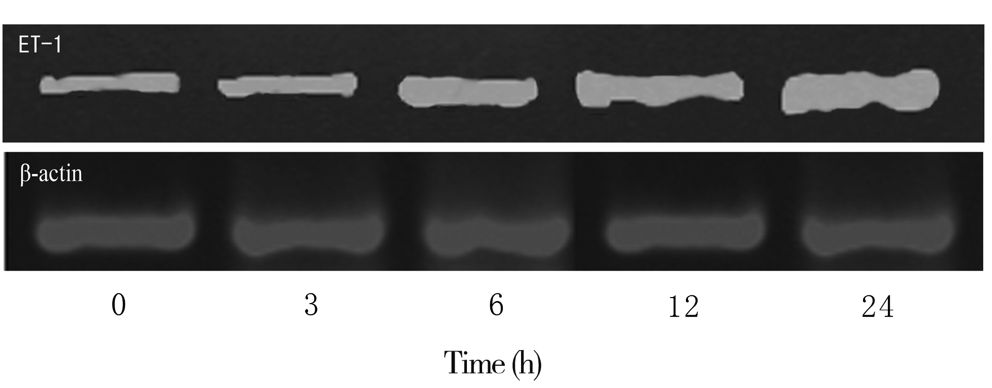
Figure 1． Reverse transcription polymerase chain reaction（RT-PCR） electrophoresis of endothelin-1mRNA in different pacing duration
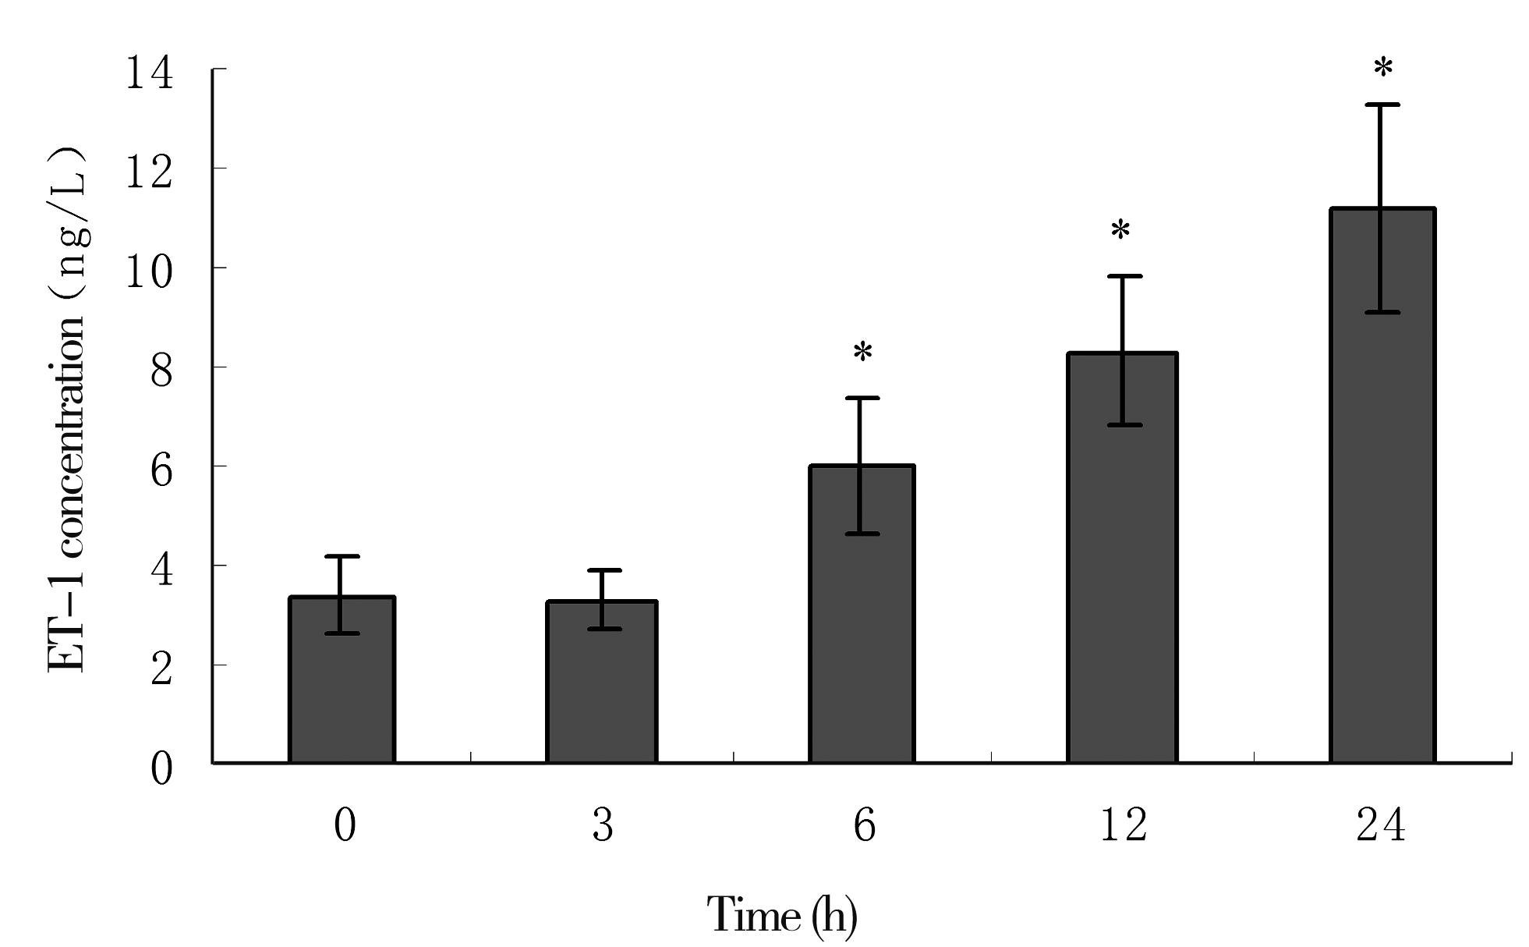
Figure 2. Influence of different pacing duration on level of endothelin-1 in atrial myocytes (*P<0.01)

3. Discussion
Recent studies indicated that atrial remodeling is the important cause that paroxysmal AF develop into persistent or permanent AF and it’s treatment is difficult. Atrial pathological remodeling includes atrial myocyte hypertrophy, atrial dilation and interstitial fibrosis ^{[1]}, and ET-1 level change is the common pathological basis of these changes. Clinicopathological study of small sample found that ET-1 level increased in myocardium of AF patients and it’s closely correlated with atrial fibrosis and persistent AF ^{[2]}.
At present, basic research on AF is mainly animal experiment and study on patients with persistent AF. Regardless of some achievements, there are still many limitations, such as no way to eliminate other confounding factors (neurohumoral and hemodynamic etc.) and no way to exactly interference etc. ^{[3]}. Myocardial cell culture model synthesizes advantages of acute separated myocytes and model in vivo, injured myocyte at separation can repair during culture process; it can exclude other confounding factors and study influence of multiple factors on myocyte in cellular level under a specific condition. Besides, myocardial cell culture model can be used for research on expressions of protein and gene and possesses important application value in molecular biological experiments. Electrophysiological study via atrial myocyte model by fast electric pacing possessed similar results to animal model ^{[4]}.
The present study used primary cultured atrial myocytes to establish rapid pacing AF model and made primary study on atrial pathological remodeling in early stage of AF. The results indicated that after rapid pacing, ET-1 expression level up regulated in atrial myocytes. It accorded with results of clinical study on AF patients ^{[2]}: that rapid atrial activation can lead to upregulated expression of ET-1 level in atrial myocytes. When AF occurs, local ET-1 level increased in atrium, it increases calcium concentration in atrial myocytes via autocrine or paracrine path and activates calmodulin, then activates Ca2+/calmodulin-dependent protein kinase and mitogen-activated protein kinase (MAPK). After a series of cascade reactions, it finally activates nuclear transcription factor CREB, makes Ser133 of CREB phosphorylated and starts transcriptions of relative genes such as ET-1 ^{[5]}. On one hand, it directly regulates ion current and negatively regulates expressions of ion channels (type L calcium channel and potassium channel Kv4.3 etc.), induces electric remodelling of atrial myocytes; on other hand, it promotes hypertrophy and structural changes of atrial muscle. In addition, ET-1 activates myocardium fibroblasts, causes atrial fibrosis, leads to atrial remodelling and finally promotes occurrence and persistence of AF.
ET-1 is the most strong vasoconstrictor factor found up to now, and is strong cell mitogen, participates in occurrence and development of pulmonary hypertension, myocardial infarction and heart failure etc ^{[6, 7]}. ET-1 is mainly synthesized and secreted by vascular endothelial cells. Recent study found that vascular smooth muscle cells, vascular adventitial fibroblasts ^{[8,9]}, myocardial cells, cardiac fibroblasts, tissue of lung and kidney all can synthesize and secrete ET-1. ET-1 participates in atrial contraction and fibrosis via variety of pathways. Neonatal rat myocardial cells cultured in vivo can synthesize and secrete ET-1. ET-1 increases instant calcium ion concentration in human atrium, increases atrial muscle contractility via PKC-IP3 signal path, meanwhile, it modulates myosin light chain kinase, influences phosphorylation of myosin light chain, changes sensitivity to calcium ion of myosin light chain and atrial muscle contractility via calcium-calmodulin pathway ^{[10]}. ET-1 level increased in atrial myocytes of AF patients and it’s closely correlated with atrial fibrosis and AF persistence ^{[2]}. ET-1 can promote activation, proliferate and secrete collagen of fibroblasts, differentiate into myofibroblasts and promote precipitation of extracelluar matrix, indicating that ET-1 may be an important signal pathway of occurrence, development and maintenance of AF and it may become a new target for prevention and treatment of AF.
The present study used atrial myocytes to establish rapid pacing AF model and found that ET-1 expression upregulated after rapid pacing for some time, indicating that it may be a molecular basis of atrial remodeling in AF. Whole modulation mechanism of ET-1 participating in atrial pathological remodeling is still a puzzle, how AF activation causes change of transcription and expression of ET-1 gene is an issue to be studied.

Reference
[1] Manning WJ, Gelfand EV. Left atrial size and postoperative atrial fibrillation: the volume of evidence suggests it is time to break an old habit [J]. J Am Coll Cardiol, 2006, 48(4):787-789.
[2] Mayyas F, Niebauer M, Zurick A, et al. Association of left atrial endothelin-1 with atrial rhythm, size, and fibrosis in patients with structural heart disease [J]. Circ Arrhythm Electrophysiol, 2010, 3(4):369-379.
[3] Bénardeau A, Hatem SN, Rücker-Martin C, et al. Primary culture of human atrial myocytes is associated with the appearance of structural and functional characteristics of immature myocardium [J]. J Mol Cell Cardiol, 1997, 29(5):1307-1320.
[4] Yang Z, Shen W, Rottman JN, et al. Rapid stimulation causes electrical remodeling in cultured atrial myocytes [J]. J Mol Cell Cardiol, 2005, 38(2):299-308.
[5] Anderson ME. Calmodulin kinase and L-type calcium channels; a recipe for arrhythmias [J]. Trends Cardiovasc Med, 2004, 14(4):152-161.
[6] Piechota A, Polańczyk A, Goraca A. Role of endothelin-1 receptor blockers on hemodynamic parameters and oxidative stress [J]. Pharmacol Rep, 2010, 62(1):28-34.
[7] Nguyen A, Thorin-Trescases N, Thorin E. Working under pressure: coronary arteries and the endothelin system [J]. Am J Physiol Regul Integr Comp Physiol, 2010, 298(5):R1188-R1194.
[8] An SJ, Boyd R, Wang Y, et al. Endothelin-1 expression in vascular adventitial fibroblasts [J]. Am J Physiol Heart Circ Physiol, 2006, 290(2):H700-H708.
[9] 杨震，刘晓方。内皮素与充血性心力衰竭[J].心血管康复医学杂志,2004,13(4):402-405
[10] Kockskämper J, von Lewinski D, Khafaga M, et al. The slow force response to stretch in atrial and ventricular myocardium from human heart: functional relevance and subcellular mechanisms [J]. Prog Biophys Mol Biol, 2008, 97(2-3):250-267.

