Evaluation for application of remote electrocardiogram recorder in community residents/LIANG Jin-jun, HUANG He, LIANG Di, FAN Yang, SHI Shao-bo, CHEN Fang, BAO Ming-wei, YANG Bo//Department of Cardiology, People’s Hospital of Wuhan University, Wuhan, Hubei, 430060, China
Corresponding author: HUANG He, E-mail: huanghe1977@hotmail.com

Abstract: Objective: To evaluate the value of clinical application of Heart of the City type TJH-03A remote electrocardiogram recorder (remote ECG). Methods: A total of 1 014 community residents from Wuhan received ECG examination by Heart of the City type TJH-03A remote ECG recorder. Clinical and ECG data of all subjects were collected and analyzed. Results: There were 359 (35.40%) cases with normal ECG and 655 (64.60%) cases with abnormal ECG, after remote ECG examination . There were 581 cases had a variety of arrhythmia in 655 cases with abnormal ECG, so there were 828 cases times with abnormal ECG, in which there were （1）320 cases times (38.65%) with repolarization abnormality,（2）98 cases times(11.84%) with sinus bradycardia, （3）98 cases times (11.84%)with myocardial ischemia,（4）78 cases times (9.42%)with conduction block,（5）56 cases times(6.76%) with ventricular hypertrophy and high voltage,（6）43 cases times(5.19%) with atrial premature beats（7）37 cases times (4.47%)with atrial fibrillation,（8）35 cases times (4.23%)with sinus tachycardia,（9）24 cases times (2.90%)with ventricular premature beats, （10）19 cases times (2.29%)with suspected myocardial infarction according to ECG abnormality rate order. In addition, there were 5 cases times with QT interval prolongation, and abnormal ECG with abnormality rate ≤3 cases times: atrial tachycardia, atrial flutter, supraventricular tachycardia, ventricular tachycardia, Brugada wave, dextrocardia. Conclusion: Heart of the City type TJH-03A remote electrocardiogram recorder is convenient to use, it can perform remote electrocardiogram record, and find a variety of arrhythmias. It’s important for ECG diagnosis, especially for diagnosis of arrhythmias.
Key words: Electrocardiography; Telemedicine; Arrhythmia
Supported by Fund project: National natural science foundation (8107014217); new century excellent talents support project of Ministry of Education (NCET-08-0414); excellent group project of natural science foundation of Hubei province (2007ABC011)
Article number 1008-0074(2012)-196-03
Doi: 10.3969/j. issn. 1008-0074. 2012. 02.08

远程心电记录仪在社区中应用的评价/梁锦军, 黄 鹤, 梁 荻, 范 阳, 石少波, 陈 芳, 包明威, 杨 波//武汉大学人民医院心内科，武汉，湖北，430060
通讯作者：黄鹤，E-mail: huanghe1977@hotmail.com

[摘要] 目的 探讨“城市之心” TJH-03A型远程心电记录仪的临床应用意义。方法 武汉市1014例社区居民接受“城市之心” TJH-03A型远程心电记录仪检查，收集并分析其临床及心电图资料。结果 远程心电图检查:正常者359例(35.40%)，异常者655例(64.60%)。异常者中有581名（88.7%）患者合并有多种心律失常，故共有828例次心电图异常，按异常率高低顺序前10位依次为（1）复极异常320例次(38.65%)，（2）窦性心动过缓98例次(11.84%)、（3）心肌缺血98例次(11.84%)、（4）传导阻滞78例次(9.42%)、（5）心室肥大及高电压56例次(6.76%)、（6）房性早搏43例次(5.19%)、（7）心房颤动37例次(4.47%)，（8）窦性心动过速35例次(4.23%)、（9）室性早搏24例次(2.90%)、（10）怀疑心梗19例次(2.29%)，其它:QT间期延长5例次，3例次以下的有: 房性心动过速、心房扑动、室性心动过速、室上性心动过速、Brugada波、右位心。结论：“城市之心” TJH-03A型远程心电记录仪操作方便，能实施远程心电记录，可发现多种心律失常，对心电图诊断，特别是心律失常诊断具有重要意义。
关键词:心电描记术；远程医学；心律失常
基金项目：国家自然科学基金（8107014217）、教育部新世纪优秀人才支持计划（NCET-08-0414）、湖北省自然科学基金优秀群体项目（2007ABC011）
文章编号：1008-0074 （2012）-196-03 中图分类号：R540.4109 文献标识码：A
Doi: 10.3969/j. issn. 1008-0074. 2012. 02.08

Cardiovascular events, especially coronary heart disease and severe arrhythmias, possess characteristics of sudden, transient, high lethality and unpredictability. Early discovery, prompt diagnosis and treatment are keys for avoiding occurrence of disasters ^{[1]}. As gold standard for diagnosis of arrhythmias, electrocardiogram (ECG) had been widely applied a long time. However, routine and Holter ECG possess disadvantage of hysterisis, therefore application of remote ECG recorder gradually gets more attention ^{[2]}. The present study focused on application of Heart of the City type TJH-03A remote ECG recorder in community residents and investigates its application value in monitoring, diagnosis and treatment of patients with heart disease.

- Data and methods

  - Subjects
A total of 1 014 patients from communities of Wuhan city, who received remote ECG monitoring in our hospital from May 2010 to May 2011, were enrolled in the study, in which there were 632 males and 382 females with age (43.4±10.2) years old. Inclusion criteria were patients who had chest pain, palpitation and flustered etc. before.
1.2 Methods
Heart of the City type TJH-03A remote ECG recorder, which was produced by Wuhan Tianhong science and technology development Co. Ltd, was used in the study. It’s performed by users themselves or performed in collaboration with medical staff. When felt illness in daily life, patients should open power switch of recorder for work (Figure 1). Recorder should be bound close to skin, it started to record after pushing record button. After recording, pushing sending button will send the data to ECG monitoring center via fixed telephone, or mobile telephone (Figure 2). Physician in ECG room analyzed measurement data of patients and made analysis reports.

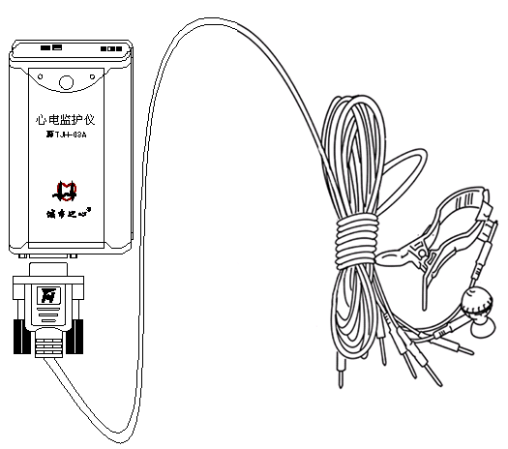
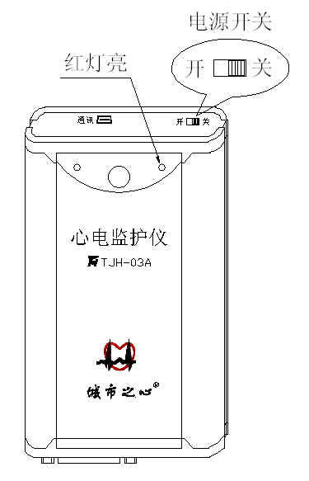

Figure 1 Figure 2

2. Results

There were 359 (35.40%) cases with normal ECG and 655 (64.60%) cases with abnormal ECG after remote ECG examination. A total of 581 cases had a variety of arrhythmia in 655 cases with abnormal ECG, so there were 828 cases times with abnormal ECG, in which there were 98 cases times with sinus bradycardia, 35 cases times with sinus tachycardia, 43 cases times with atrial premature beats, 24 cases times with ventricular premature beats, 37 cases times with atrial fibrillation, 56 cases times with ventricular hypertrophy and high voltage, 78 cases times with conduction block, 320 cases times with repolarization abnormality, 98 cases times with myocardial ischemia, 19 cases times with suspected myocardial infarction, five cases times with QT interval prolongation, three cases times with atrial tachycardia, atrial flutter, ventricular tachycardia, Brugada wave respectively , two cases times with supraventricular tachycardia, one case times with dextrocardia, were shown in table 1.
Table 1 Electrocardiography examination results of residents from communities of a district of
Wuhan city
ECG Cases times %
Sinus bradycardia 98 11.84
Sinus tachycardia 35 4.23
Atrial premature beats 43 5.19
Ventricular premature beats 24 2.90
Atrial tachycardia 3 0.36
Atrial flutter 3 0.36
Atrial fibrillation 37 4.47
Ventricular tachycardia 3 0.36
Supraventricular tachycardia 2 0.24
Ventricular hypertrophy and high voltage 56 6.76
Conduction block 78 9.42
Repolarization abnormality 320 38.65
Myocardial ischemia 98 11.84
Suspected myocardial infarction 19 2.29
Brugada wave 3 0.36
QT interval prolongation 5 0.60
Dextrocardia 1 0.12
Total 828 100.00
- Discussion
Coronary heart disease and severe arrhythmias are main causes of sudden cardiac death (SCD). About 70% SCD occurred outside the hospital, among which 82% SCD occurred at home and 15% occurred in public ^{[3]}. Early recognition of these diseases and shortening time between occurrence and treatment of disease can save lives effectively.
ECG is a most important tool for diagnosing coronary heart disease, especially arrhythmias. Since Willem Einthoven invented ECG machine for more than a century , ECG technology had been rapidly develop and was widely applied in clinic ^{[4]}. However, ECG machines that only record in hospital for a short time, such as routine ECG, bedside electrocardiographic monitoring, can’t meet clinical needs already, especially for subhealthy population and patients with latent cardiovascular diseases. Therefore, small, light, portable and easy-to-operate remote ECG machine just compensates for above disadvantages of ECG machines, expands clinical application range and conveniently serves for patients. Because patient out of hospital can send ECG data to physician by remote ECG , so heart diseases especially arrhythmias can be found and diagnosed in time^{[5]}, beside, it shorten diagnosis and treatment time of coronary heart disease and severe arrhythmias, thereby earns precious time for saving patients.
Application of this remote ECG recorder in 1 014 residents from communities of Wuhan indicated that its function is well. It both meets demand of ECG diagnosis for cardiovascular disease and may decrease trouble for patient go to ECG room and ECG physician take ECG recorder to ward for bedside monitoring of severe cases. Thus Heart of the City remote ECG recorder possesses application value , should be to spread.

Reference
[1] Abuladze GV, Nevieridze MI, Abashidze RI, et al. Ventricular arrhythmias and sudden cardiac death[J]. Georgian Med News, 2009, (168):50-53.
[2] Iwamoto J, Yonezawa Y, Ogawa HM, et al. A new mobile phone-based ECG monitoring system [J]. Biomed Sci Instrum, 2007, 43:318-323.
[3] Moore MJ, Glover BM, McCann CJ, et al. Demographic and temporal trends in out of hospital sudden cardiac death in Belfast[J]. Heart, 2006, 92(3):311-315.
[4] Cajavilca C, Varon J. Resuscitation great. Willem Einthoven: the development of the human electrocardiogram [J]. Resuscitation, 2008, 76(3):325-328.
[5] Yu Y, Liu J. Study on mobile phone based wireless ECG monitoring technology system typical demonstration applications [J]. Zhongguo Yi Liao Qi Xie Za Zhi, 2011, 35(1):11-14.

