Expressions of SUMO4, NF-κB and IκB in kidney of rats with type 2 diabetes mellitus and its significance/CHEN Si-jiao¹, WANG Da-nan², XU Jin-chun¹, LI Hong-yan¹, LIU Fu-rong², SONG Jin-dan²//1.Teaching and Research Office for Geriatric Disease, Department of Cadres Medical work, First Affiliated Hospital of China Medical University, Shenyang, Liaoning, 110001, China; 2. Medical Molecular Biology Research Institute of China Medical University, Key Laboratory of Cell Biology of Ministry of Health
Corresponding author: CHEN Si-jiao, E-mail: cnsysy@sina.com

Abstract: Objective: To study expressions of small ubiquitin-related modifier protein（SUMO）4 (SUMO4), nuclear factor (NF)- κB and inhibitory factor of NF-κB (IκB) in kidneys of rats with type 2 diabetes mellitus (T2DM). Methods: A total of ten 40-week-old male Goto-Kakizaki (GK) rats （with spontaneous diabetes mellitus）of specific-pathogen free (SPF) grade, and ten 40-week-old male Wistar rats of SPF grade were selected. The lesion of renal tissue was observed by hematoxylin eosin (HE) staining. Expressions of SUMO4, NF-κB and IκB in renal tissue were observed by immunohistochemistry methods. Results: In the GK rats, glomerular capillary ball hypertrophy, basilar membrane slightly thickening; glomerular mesangial cells hyperplasia, hypertrophy and renal tubular epithelial cells hypertrophy were observed. Compared with normal Wistar rats, expression levels of NF-κB [(0.232±0.034) vs. (0.634±0.058)], IκB [(0.242±0.027) vs. (0.712±0.078)] and SUMO4 [(0.160±0.031) vs. (0.545±0.045)] significantly increased in renal tissue of GK rats (P<0.01 all). Conclusion: Compared with Wistar rats, expressions of NF-κB, IκB and SUMO4 significantly increase in renal tissue of GK rats, suggesting that SUMO inhibiting transcriptional activity of NF-κB may exist in kidneys of T2DM rats. Therefore, sumoylation may be a new therapeutic target for inhibit renal microvascular lesion of diabetic disease.
Key words: Small ubiquitin-related modifier proteins, Transcription factor; Diabetes mellitus, type 2; Rats
Supported by Fund Project: Scientific and technological project in Liaoning Province (2011225052- 2011020216-428).
Article number 1008-0074(2012)01-01-04
Doi: 10.3969/j. issn. 1008-0074. 2012.01.01

SUMO4、NF-κB、IκB在2型糖尿病大鼠肾脏中的表达及意义/陈思娇¹，王大南²，徐锦春¹李红燕¹，刘芙蓉²， 宋今丹²//1.中国医科大学附属第一医院干部医疗工作部老年病教研室, 沈阳，辽宁，110001；2. 中国医科大学医学分子生物学研究所，卫生部细胞生物学重点实验室
通讯作者：陈思娇，E-mail: cnsysy@sina.com

摘要：目的：探讨2型糖尿病大鼠肾脏组织小泛素相关修饰蛋白4(SUMO4)、核转录因子(NF)-κB、NF-κB的抑制因子（IκB）的表达及意义。方法：取10只40周龄的无特定病原体（SPF）级雄性自发性糖尿病 (GK)大鼠，10只40周龄的SPF级雄性Wistar大鼠，通过HE染色法观察肾组织病变、免疫组化法观察肾组织的SUMO4与IκB、SUMO4与NF-κB表达情况。结果：GK大鼠的肾小球毛细血管球肥大，基底膜轻度增厚，肾小球系膜细胞增生、肥大，肾小管上皮细胞肥大。与正常Wistar大鼠比较，GK大鼠的肾脏NF-κB [(0.232±0.034)比(0.634±0.058)]、IκB[(0.242±0.027)比(0.712±0.078)] 及SUMO4 [(0.160±0.031)比(0.545±册0.045)]的表达水平均明显升高（P均<0.01）。结论：NF-κB、IκB及SUMO4在GK大鼠肾脏组织表达增多。从而推断在2型糖尿病大鼠肾脏SUMO 可能抑制NF-κB转录活性，SUMO化可能成为治疗糖尿病肾脏微血管病变的一个新靶点。
关键词：小泛素相关修饰蛋白质类；转录因子；糖尿病, 2型;大鼠
基金项目：辽宁省科学技术项目(2011225052- 2011020216-428)
文章编号：1008-0074 （2012）01-01-04 中图分类号：R 587.109 文献标识码：A
Doi: 10.3969/j. issn. 1008-0074. 2012.01.01

Small ubiquitin related modifier protein (SUMO) widely exist in all kinds of eukaryotic cells ^{[1-3]}, including SUMO1, SUMO2, SUMO3 and SUMO4. A study ^{[4]} found that No.21 lysine of IκBα was modified by SUMO1 and it’s the acted site of ubiquitin. IκBα modified by SUMO1 cannot be polyubiquitinated, therefore it can’t be degraded by proteases. The action is forming nuclear factor (NF)-κB—IκBα—SUMO1 complex that can inhibit signal transduction. Expression of SUMO1 can strongly inhibit NF-κB-dependent transcription. SUMO4 can down regulate transcriptional activity of NF-κB then inhibit immune response. The study ^{[4]} also found that SUMO4 significantly inhibited transcriptional activity of NF-κB in yeast two-hybrid system, and there existed negative feedback regulation between transcriptional activity of NF-κB and SUMO4. Once NF-κB was activated, some gene transcriptions related with immune response and expression of SUMO4 were activated , thus it can closely down-regulate immune response. GK (Goto-Kakizaki) rats are non-obesity animal models of spontaneous type 2 diabetes mellitus (T2DM) ^{[5]}, main symptoms of the rats are impaired secretion of insulin stimulated by glucose, impaired secretion of β cells, fasting hyperglycemia, increased generation of liver starch, moderate insulin resistance in liver, muscles and adipose tissues. After being sick for long time, many complications and nervous system diseases occur. Compared with many other rodent animal models of T2DM, blood glucose of GK rats increases as age increase, and then changes of renal structure and function occur. The feature is quite similar with T2DM patients developing into diabetic nephropathy.

1. Materials and methods

1.1 Materials
1.1.1 Main materials SUMO4 antibody (Abcam, mouse polyclonal to SUMO4); NF-κB P65 antibody [Cell Signaling, NF-κB (C22B4) Rabbit mAb＃4764]; IκB antibody (Cell Signaling， IκB (44D4) Rabbit mAb＃4812); Horseradish enzyme marked goat anti-rabbit IgG (H+L) (Zhongshanjinqiao,ZB-2301); Horseradish enzyme marked goat anti-mouse IgG (Zhongshanjinqiao,ZB-2305); ready-to-use type SABC immunohistochemical staining kits (Wuhan Boster Biological Engineering Ltd. SA1020); 3,3’-diaminobenzidine (DAB) coloring kits (Wuhan Boster Biological Engineering Ltd. AR1022); tetraethyl rhodamine isothiocyanate (TRITC) marked goat anti-rabbit IgG (Zhongshanjinqiao, ZF-0316); fluorescein isothiocyanate (FITC) marked goat anti-mouse antibody (Zhongshanjinqiao ,ZF-0312); Ⅷ factor; 0.1% type Ⅳ collagenase; DMEM medium containing 20% fetal bovine serum etc.
1.1.2 Animals Ten Wistar male rats of specific-pathogen free (SPF) grade (provided by department of animals of China Medical University); ten GK male rats with spontaneous DM (provided by Shanghai Slyke Company). Animals were divided into different cages to breed (SPF grade breeding room of department of animals of China Medial University), relative humidity was kept at (60±5)% in room and temperature was 20~22℃. Switch between day and night in rooms was automatically completed every 12h. Rats were free to drink water and they were fed with standard feeds for rats (bought from experimental animal center of China Medical University).
1.2 Experimental methods
1.2.1 Hematoxylin eosin (HE) staining Tissue pieces were regularly taken, fixed, paraffin embedding, then were sliced, deparaffinaged, washed by different ethanol solutions and water, stained by hematoxylin, then underwent color separation by acid alcohol, returned blue, stained by eosin, routinely dehydration, being transparent, mounting and finally was observed under light microscope.
1.2.2 Immunohistochemical methods Tissue pieces were routinely taken, fixed, paraffin embedding, then were sliced, deparaffinaged, underwent hydration, antigen repair, close; primary antibody (SUMO4 was from mouse, NF-κB and IκB were from rabbit), second antibody (horseradish enzyme marked goat anti-mouse IgG; horseradish enzyme marked goat anti-rabbit IgG) were used; for SABC stained by DAB, afterstained by hematoxylin, then underwent color separation by acid alcohol, returned blue, dehydration, being transparent, mounting and finally was observed under light microscope. Phosphate buffered saline (PBS) was used to substitute first antibody for negative control at the same time.
1.3 Statistical process
SPSS16.0 software was used to perform statistical process. Measurement data were presented as mean + standard deviation (±s), t test was used to compare between groups. P<0.05 was considered as possessing significant difference.

2. Results

2.1 Morphological observation
The glomerular capillary balls hypertrophy, basilar membrane slightly thickened; glomerular mesangial cells proliferated and hypertrophy, renal tubular epithelial cells also hypertrophy in kidneys of GK rats. No typical nodular glomerulosclerosis was observed, they were similar to prophase changes of diabetic nephropathy. There was no significant abnormality in normal Wistar rats. Comparison between the two groups was shown in Figure 1.
2.2 Expression levels of NF-κB, IκB and SUMO4 in renal tissue
Image observation: Expression of NF-κB, IκB and SUMO4 in kidney of GK rats were significantly higher than those of normal Wistar rats.
Semiquantitative analysis: OTPIMAS 6.5 software was used to perform image analysis. The results of color image were processed with semi-quantitative analysis method according to area and intensity of staining by TD2000 color image analysis system, and were shown by light density (OD). The darker the object is and the greater the optical density is, the greater the relative content of positive substance is. A total of 10 views under high power lens (×400) were randomly selected on every sample to measure its OD, mean OD of each sample was taken for statistical analysis.
Compared with Wistar rats, expression of NF-κB, IκB and SUMO4 significantly increased in renal tissues of GK rats (P<0.01 all). The results were shown in Table 1.

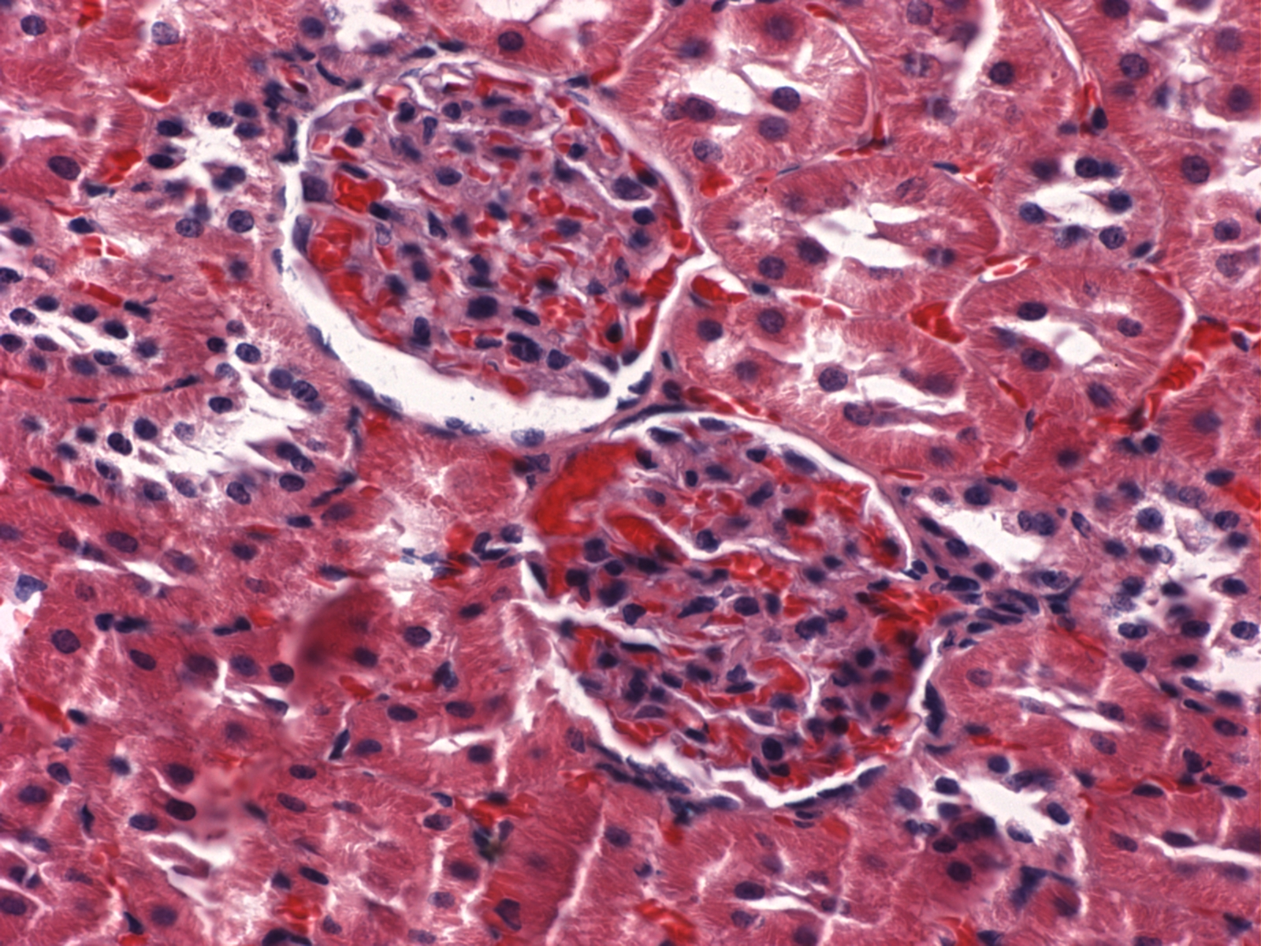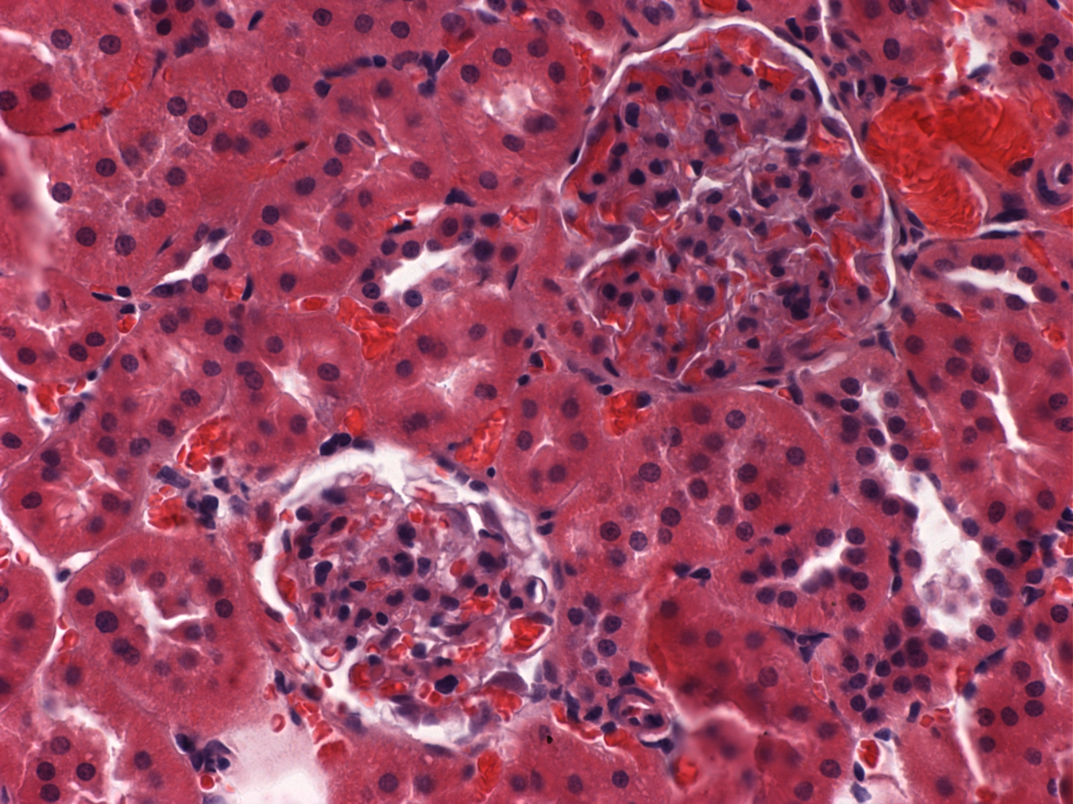
Normal Wistar rats GK rats with type 2 diabetes mellitus
Figure 1. Renal HE staining of Wistar rats and GK rats (× 400)
Notes: GK: Goto Kakizaki, HE: Hematoxylin eosin
Table 1 Expressions of NF-κB, IκB and SUMO4 in kidneys of Wistar rats and GK rats (±s, n=10)
Groups NF-κB IκB SUMO4
Wistar rats 0.232±0.034 0.242±0.027 0.160±0.031
GK rats 0.634±0.058△ 0.712±0.078△ 0.545±0.045△
Notes: GK: Goto Kakizaki, NF-κB：nuclear factor-κB, IκB：inhibitory factor of NF-κB, SUMO：small ubiquitin related modifier protein；compared with Wistar rats ΔP<0.01。

3. Discussion

Diabetic nephropathy is one of common chronic complications of DM and one of general microvascular complications of DM. Diabetic nephropathy is a chronic progressive damage and its symptoms occur later, once proteinuria occurs, course of disease is usually over 10 years. In addition, the mechanism of renal damage of DM is not very clear. Early effective intervention is also lacked so far^{[6]}. GK rats are a kind of DM rats without obesity and are developed by Goto etc. GK rats don’t occur glomerulosclerosis and interstitial fibrosis until they die . In the present study, the study aimed at observing early lesions of diabetic nephropathy and found out factors which can inhibit early lesions. If interventional therapy on such factors is effective, it’s of great significance for prevention and treatment of diabetic nephropathy.
Small ubiquitin-related modifier protein 4 (SUMO4) is an important member of ubiquitins protein family^{[7]}. SUMO4 are mainly expressed in immune organs^{[8]} and kidney^{[9]}. Sumoylation modification is a kind of multifunctional modification of post-translational protein, that is formation of iso-peptide bond between glycine in the C-terminal of SUMO and lysine in ε-amino side chain of target protein. The reactions is enzymatic cascade which is similar to ubiquitination. Function of sumoylation: target proteins of SUMO are mainly distributed in nucleus and nuclear pore complex, and there are also target proteins in cytoplasm and cell membrane, suggesting that SUMO possesses comprehensive biological functions in cells, and these functions are related with each other. Location and transportation of proteins and interactions among proteins can influence stability and integrity of genes and chromosomes and vice versa^{[10-11]}. There are still no reports about whether path of sumoylation inhibiting inflammation exist in diabetic nephropathy in domestic or overseas area. The present study focused on path of sumoylation negative regulating transcriptional activity of NF-κB, therefore inhibited inflammatory and immune reactions.
In the present study, early changes of diabetic nephropathy in GK rats were observed using HE staining method, and the expression of NF-κB, IκB representing inflammation reaction increased by immunohistochemistry in GK rat kidneys, indicating the classical pathway of inflammation had been activated during early period of kidney damage in diabetes, and while the pathway activated, the sumoylation reaction also occurred which can inhibit pathway activation. It proved our supposition to some extent that sumoylation can inhibit NF-κB-dependent transcriptional activity in early period of diabetic renal damage. For further confirmation, observation was also performed in glomerular endothelial cells. Expressions and co-localizations of NF-κB, IκB and SUMO4 in glomerular endothelial cells were observed under confocal microscope with immunofluorescence technique. Their expressions in glomerular endothelial cells in GK rats were higher than those of Wistar rats, NF-κB and SUMO4, IκB and SUMO4 are present of co-localization. In glomerular endothelial cells of normal Wistar rats, expression of SUMO4 was weak, both in nucleus and the cytoplasm, but expressions of NF-κB and IκB mainly existed in cytoplasm. Compared with normal Wistar rats not only the expression of SUMO4 significantly increased in nucleus and cytoplasm of glomerular endothelial cells , but also the expression of NF-κB and IκB in nucleus and cytoplasm significantly increased in GK rats. The co-localization sites of NF-κB and SUMO4, IκB and SUMO4 exists mainly in nucleus. Above study content has never been reported in domestic or overseas literature.

References
[1] Israël A. The IKK complex: an integrator of all signals that activate NF-kappaB? [J] Trends Cell Biol, 2000, 10(4): 129-133.
[2] Ruilope LM, Luño J. Angiotension blockade in type 2 diabetes renal disease [J]. Kidney Int Supp1, 2002, 82: S61-63.
[3] Guo D, Li M, Zhang Y, et al. A functional variant of SUMO4, a new I kappa B alpha modifier, is associated with type 1 diabetes [J]. Nat Genet, 2004, 36(8): 837-841.
[4] Bohren KM, Nadkarni V, Song JH, et al. A M55V polymorphism in a novel SUMO gene (SUMO-4) differentially activates heat shock transcription factors and is associated with susceptibility to type 1 diabetes mellitus [J]. J Biol Chem, 2004, 279(26): 27233- 27238 .
[5] Su HL, Li SS. Molecular features of human ubiquitin-like SUMO genes and their encoded proteins [J]. Gene, 2002, 296(1-2): 65-73.
[6] Scheschonka A, Tang Z, Betz H. Sumoylation in neurons: nuclear and synaptic roles? [J] Trends Neurosci, 2007, 30(3): 85-91.
[7] Olefsky JM. IKKepsilon: a bridge between obesity and inflammation[J]. Cell. 2009,138(5):834-836
[8] Knipscheer P, Klug H, Sixma TK,et al. Preparation of sumoylated substrates for biochemical analysis [J].Methods Mol Biol. 2009,497:201-210
[9] Andreou AM，Tavernarakis N．Sumoylation and cell signaling [J]．Biotechnol．2009；4 (12)：1740-1752．
[10 ] Garcia-Dominguez M, Reyes JC. SUMO association with repressor complexes, emerging routes for transcriptional control [J]. Biochimica Biophys Acta, 2009,1789（6-8）: 451–459
[11] 陈思娇, 李红燕，郭英华，等. 糖尿病微血管病SUMO基因163A／G多态性的相关性研究 [J]. 心血管康复医学杂志，2010，19（5）: 606 - 611

