Relationship among ambulatory pulse pressure, pulse pressure index and carotid intima-media thickness in aged patients with hypertension/XU Jin, LI Peng-hong, CHEN Jia, WU Xin//Department of Cardiology, Geriatric Hospital of Fujian Province, Fuzhou, Fujian, 350003, China

Abstract: Objective: To study relationship among ambulatory pulse pressure (PP), pulse pressure index (PPI) and carotid intima-media thickness (IMT) in aged patients with hypertension. Methods: The 24h ambulatory blood pressures of 159 subjects were measured, and their ambulatory PP [(mean systolic blood pressure (SBP) - mean diastolic blood pressure (DBP)] and ambulatory PPI (ambulatory PP/mean SBP) were calculated. Color Doppler ultrasonography was used to measure carotid IMT. Relationship between ambulatory PPI and carotid IMT was analyzed. Results: Pearson correlation analysis indicated that carotid IMT was correlated with age (r=0.353), mean SBP (r=0.594), mean DBP (r=-0.355), ambulatory PP (r=0.855) and ambulatory PPI (r=0.883), P<0.001 all. Multivariant gradual regressive analysis indicated that carotid IMT possessed significant linear correlation with ambulatory PP and ambulatory PPI (R²=0.789), and standardized regression coefficient β of ambulatory PPI (β=0.621) was higher than that of ambulatory PP (β=0.284) . Conclusion: Ambulatory pulse pressure index and ambulatory pulse pressure are good indicators for evaluation of carotid arteriosclerosis, and value of ambulatory pulse pressure index is more than .
Key words: Hypertension; Blood pressure monitoring, Ambulatory; Carotid arteries; Arteriosclerosis

老年高血压患者动态脉压和脉压指数与颈动脉内膜-中层厚度的关系/许 进 ，李鹏虹 ，陈 佳 ，吴 欣//福建省老年医院，福建，福州市，350003

摘要: 目的：探讨动态脉压及其指数与高血压患者颈动脉内膜-中层厚度(IMT)的关系。方法：测量159例研究对象的24小时动态血压，并计算动态脉压（平均收缩压-平均舒张压）及动态脉压指数（动态脉压/平均收缩压）。使用彩色多普勒超声检测颈动脉IMT。分析动态脉压指数与颈动脉IMT的相关性。结果：Pearson相关分析发现，颈动脉IMT与年龄（r=0.353）、平均收缩压（r=0.594）、平均舒张压（r=-0.355）、动态脉压（r=0.855）、动态脉压指数（r=0.883）有良好的相关性（P均<0.001）。进一步行多元逐步回归分析显示，颈动脉IMT与动态脉压及动态脉压指数具有显著线性关系（R²=0.789），动态脉压指数的标准回归系数（β, =0.621）大于动态脉压的β（=0.284）。结论：动态脉压指数和动态脉压是评价颈动脉血管硬化的良好指标，动态脉压指数的价值更大。
关键词: 高血压；血压监测，便携式；颈动脉；动脉硬化
文章编号：1008-0074（2011）06- 中图分类号：544.109 文献编识码 A
Doi:10.3969/j.issn.1008-0074.2011.06.

Essential hypertension is one of the most common cardiovascular diseases in aged people, and increasing extent of systolic blood pressure (SBP) and diastolic blood pressure (DBP) have been regarded as evidence for prediction of target organ damage in aged patients with hypertension for a long time. A lot of researches proved that pulse pressure (PP) is an indicator for arteriosclerosis and an independent risk factor for cardiovascular events ^{[1]}. As an early indicator for generalized arteriosclerosis, increased carotid intima-media thickness (IMT) is also an independent risk factor for cardiovascular and cerebrovascular events ^{[2]}. Relationship between them receives more and more attention ^{[3,4]}. Recent several years, some researches proved that pulse pressure index (PPI) can better reflect arteriosclerosis ^{[1]}. Through measuring 24h ambulatory blood pressure and carotid IMT in aged patients with hypertension, the study aims at explore relationship among ambulatory PPI, PP and carotid IMT.
1 Subjects and Methods
1.1 Subjects
A total of 159 aged patients with hypertension from January 2010 to December 2010 were enrolled. There were 91 men and 68 women with mean age (75.6±8.95) years. Inclusion criteria: ① The patients should accord diagnostic standard of essential hypertension established by WHO and international society of hypertension (ISH) in 1999; ② Age≥60 years old. Exclusion criteria: ①Secondary hypertension; ②Complicated with nephritis or nephrosis; ③Complicated with severe anemia, hyperthyroidism, severe valvular heart disease, acute myocardial infarction, congenital heart disease or diseases that affect PP.
1.2 Methods
1.2.1 Measurement of ambulatory blood pressure: all patients received 24h ambulatory blood pressure monitoring (ABPM) during admission. Ambulatory electrocardiogram blood pressure recorder was produced by Zhongjiankeyi limited company (type: CB-1804-B). From 8:00 to 21:00, blood pressure was measured and recorded every 30min; from 21:00 to 8:00, blood pressure was measured and recorded every one hour, and times of effective measurement would ≥90%. After records put into computer, 24h mean SBP (24hSBP) and 24h mean DBP (24hDBP) were calculated.
1.2.2 Carotid color Doppler ultrasonography: color Doppler ultrasonography machine was produced by American GE company (type: LOGIQ9), and probe frequency for detection was 12 MHz. Detections were performed on common carotid artery (CCA), beginning of internal carotid artery (ICA, 1~1.5 cm over bifurcation level) and bifurcation site of carotid arteries, and mean IMT of carotid arteries was measured.
1.2.3 Statistical analysis: SPSS 17.0 software package was used to perform statistical analysis. Measurement data were presented as mean value + standard deviation (±s). Pearson correlation analysis was used to find relationship among age, parameters of blood pressure and carotid IMT. If there were relationship, multivariant gradual regressive analysis was performed with carotid IMT as dependent variable and age and parameters of blood pressure as independent variables. P<0.05 was regard as possessing statistical significance.
2 Results
2.1 General data
Carotid IMT, age and parameters of blood pressure were shown in Table 1.
  - Pearson correlation analysis
Carotid IMT was negatively correlated with 24hDBP, and positively correlated with 24h mean systolic blood pressure , ambulatory PPI (r=0.883, P<0.001) and PP (r=0.855, P<0.001), were shown in picture 1 and 2.

Table 1 General data of 159 aged patients with hypertension (, n=159
 | Mean value
Carotid intima-media thickness (IMT, mm) | 1.00±0.16
Age (years old) | 75.60±8.95
24h mean systolic blood pressure (mmHg) | 136.86±12.99
24h mean diastolic blood pressure (mmHg) | 76.31±7.02
Mean arterial pressure (mmHg) | 96.49±7.57
Ambulatory pulse pressure (mmHg) | 60.55±11.94
Ambulatory pulse pressure index | 0.44±0.055

Table 2 Relationship among carotid IMT and other variables (Pearson, n=159)
Variables | Correlation coefficients | P value
Age | 0.353 | ﹤0.001
24h mean systolic blood pressure | 0.594 | ﹤0.001
24h mean diastolic blood pressure | -0.355 | ﹤0.001
Mean arterial pressure | 0.12 | 0.065
Ambulatory pulse pressure index | 0.883 | ﹤0.001
Ambulatory pulse pressure | 0.855 | ﹤0.001
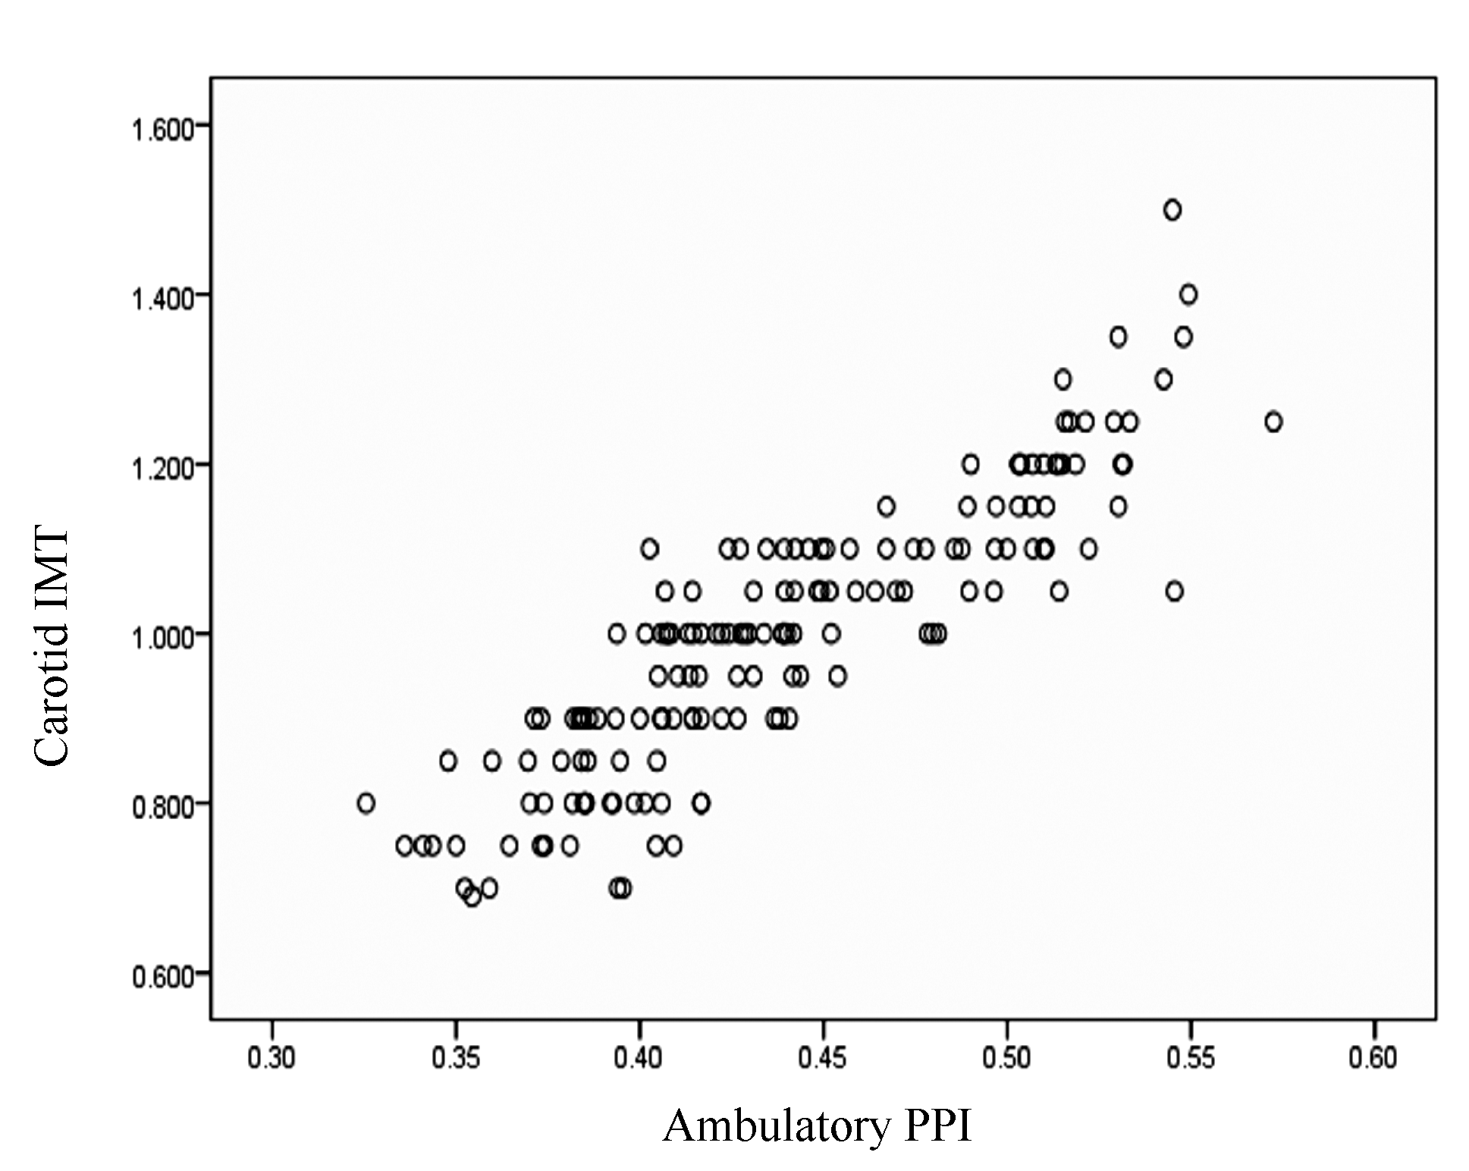
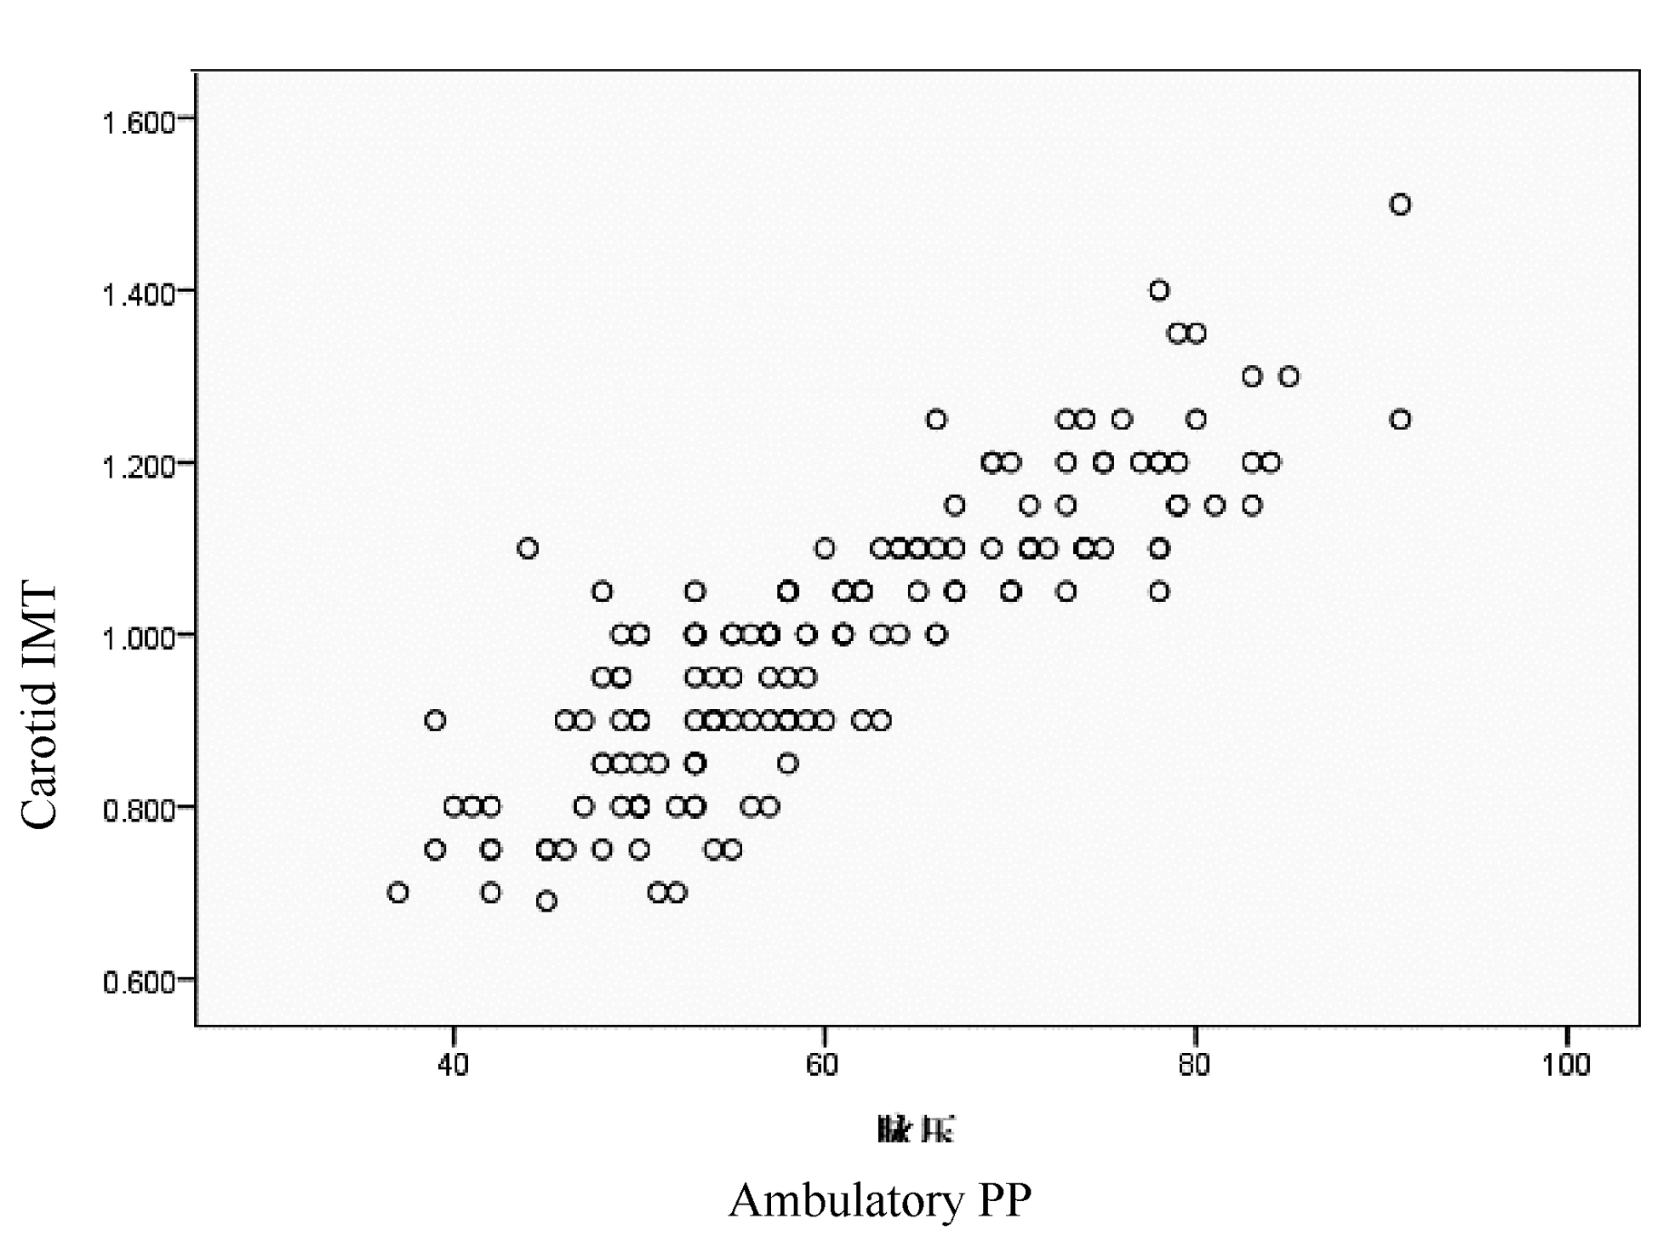
Fig.1 Correlation between carotid IMT and ambulatory PPI
Fig.2 orrelation between carotid IMT and ambulatory PP

Note: IMT: intima-media thickness, PP: pulse pressure, PPI: pulse pressure index.

  - Mutivariant gradual regressive analysis
Multivariant gradual regressive analysis showed that among the independent variables, only ambulatory PPI and ambulatory PP entered into equation; in model 1, only ambulatory PPI into equation, β=0.883 (P<0.001), R²=0.778; in model 2, ambulatory PPI and ambulatory PP into equation together, R² increased to 0.789. Therefore, ambulatory PPI and ambulatory PP possessed fine linear correlation with carotid IMT, and standardized regression coefficient of ambulatory PPI (β=0.621) was bigger than that of ambulatory PP (β=0.284), were shown in Table 3.

Table 3 Multivariant gradual regressive analysis among ambulatory PPI, ambulatory PP and carotid IMT
 |  | Standardized coefficient β | P | R²
Model 1 |  |  |  | 0.778
 | Ambulatory pulse pressure index | 0.883 | <0.001
Model 2 |  |  |  | 0.789
 | Ambulatory pulse pressure index | 0.621 | <0.001
 | Ambulatory pulse pressure | 0.284 | 0.002

3 Discussion
When large arterial compliance decreased, high SBP, low DBP and increased PP often occurred in aged patients with hypertension. Domanski et al ^{[5]} found that increased PP was independently correlated with increased carotid IMT, and it’s independent predictive factor for carotid arteriosclerosis. Increased PP led to increase of shearing force and tension force on vascular wall and increased oxidative reaction on local intima, decrease of secretion of endothelium-derived relax factor, vascular intima dysfunction, and promoted occurrence and development of atherosclerosis. These may be lead to increase of carotid IMT ^{[6]}.
There still exist some limitations in using PP level as evaluating indicator. PP possesses changeability in an individual, and blood pressure could have big fluctuation within a day and there was bigger fluctuation after short time intervention of drug. Yang LP et al ^{[1]} suggested that evaluation of vascular stiffness with PPI may be more reasonable. PPI=PP/SBP, thus variation of PPI is significantly lower than that of PP. PPI is a nondimensional value from 0 to 1. Because vascular compliance is a function in mathematics for pressure, PPI can theoretically reflect vascular compliance, when it gets close to 1, vascular compliance becomes worse; when it gets close to 0, vascular compliance becomes better. This study indicated that age and SBP were positively correlated with carotid IMT, and DBP was negatively correlated with carotid IMT in correlation analysis; correlation coefficients of PPI and PP correlated with carotid IMT were bigger than those of other parameters such as blood pressure and age. Further multivariant gradual regressive analysis indicated that only PPI and PP entered into regression equation, and standardized regression coefficient of PPI was bigger than that of PP. So PPI is a better index than PP for predicting athersclerosis, similar with other researtches ^{[7,8]}.
In summary, compared with PP, ambulatory PPI possesses more superiority evaluating arteriosclerosis in aged patients with hypertension, it’s better to combine PPI and PP to predict arteriosclerosis. Both indicators are noninvasive and easy to be applied and spreaded in primary hospitals.
References:
[1]杨鹏麟,徐定修,张素勤.脉压指数评价血管硬化的可行性探讨[J].中华心血管病杂志, 2002, 30 (6): 334-337.
[2]Bots ML, Hose AW, Koudstaal PJ, et al . Common carotid intima-media thickness and risk of stroke and myocardial infarction: the Rotterdam Study [J]. Circulation, 1997, 96 (5): 1432-1437.
[3]Riley WA, Evans GW, Sharrett AR, et al. Variation of common carotid artery elasticity with intima-media thickness: the ARIC Study. Atherosclerosis Risk in Communities [J]. Ultrasound Med Biol, 1997, 23 (2): 157-164.
[4]Inoue T，Matsuoka M, Nagahama K, et al. Cardiovascular risk factors associated with pulse pressure in a screened cohort in Okinawa, Japan [J]. Hypertens Res, 2003, 26 (2): 153-158.
[5]Domanski MJ，Mitchell GF，Norman JE, et a1. Independent prognostic information provided by sphygmomanometrically determined pulse pressure and mean arterial pressure in patients with left ventricular dysfunction [J]. J Am Coll Cardiol, 1999, 33(4): 951-958.
[6]Ceravolo R, Maio R, Pujia A, et al. Pulse pressure and endothelial dysfunction in never treated hypertensive patients [J]. J Am Coll Cardiol, 2003, 41 (10) : 1753-1758.
[7]Zureik M, Touboul PJ，Bonithon-Kopp C, et al. Cross-sectional and 4-year longitudinal associations between brachial pulse pressure and common carotid intima-media thickness in a general population. The EVA Study [J]. Stroke, 1999, 30(3): 550-555.
[8]许朝祥 王耀国 杜心清,等。主动脉脉压及脉压指数与冠状动脉病变严重程度的相关性《心血管康复医学杂志》 2008，19（6）： 535-538

