心血管康复医学杂志 2010年10月第19卷第5期 Chin J Cardiovasc Rehabil Med, Oct 2010, Vol 19 No. 5 501
Therapeutic effect of creatine phosphate in early diastolic dysfunction
Wang Ying ², Chen Yu-li ¹, Ma Lin-qing ², Li Feng-chun¹，Wang Bing ¹, Zhu Li-li ¹, Yi¹ Wei¹, Cui Yu-juan ¹, Yoko Nagai³，Shingo Sakamoto³，Jiang Zuo-hong ¹, Lin Yang ¹//1. Dalian Vitup International Medical Center, Dalian, Liaoning, 116001, China; 2. Changchun Central Hospital, Changchun, Jilin, 130051; 3. Tokushukai, Nozaki Hospital, Tokyo, Japan, 102-0093
Corresponding author: Wang Ying, WY19581105@sina.com
Abstract: Objective: To investigate the therapeutic effect of creatine phosphate sodium (CP, Neoton) at early stage of myocardium diastolic dysfunction. Methods: A total of 138 cases with myocardium diastolic dysfunction were divided into CP group (n=109) and routine treatment group (n=29). All the patients received routine treatment. The CP group received CP treatment based on routine treatment(CP 2g+5%glucose or 0.9% sodium chloride 100ml, iv. drip, for patients with mild diastolic dysfunction was 1time/d, patients with moderate diastolic dysfunction was 2 times/d), duration was 7~14 days. Color-coded Doppler echocardiography was used to detect transmitral peak early diastolic velocity (E-wave)，transmitral peak late diastolic velocity (A-wave)，peak early diastolic velocity of mitral annulus (Ea), and peak late diastolic velocity of mitral annulus(Aa), and the value of E/A ,Ea/Aa and E/Ea were calculated. Symptoms, signs and items from echocardiography were compared between the two groups before and after treatment. Results: After treatment, all symptoms and signs of patients in two groups significantly improved (P<0.05~0.01), and the marked effective rate in CP group was significantly higher than that of routine treatment group (96.2% vs. 57.1%, P<0.01). In CP group, the marked effective rate of E/A (81.65% vs. 10.34%), Ea/Aa (83.49% vs. 13.79%) and E/Ea (92.86% vs. 12.00%) were significantly higher than those in routine treatment group (P<0.01all). Conclusion: Creatine phosphate possesses marked effect for improve patient’s condition and diastolic dysfunction.
Key words: Heart failure, congestive; Phosphocreatine; Treatment outcome

磷酸肌酸对早期舒张功能障碍的疗效/王瑛²、陈玉丽¹、马临庆²、李峰春¹、王冰¹、朱丽丽¹、易威¹，崔玉娟¹、永井阳子³，坂本真吾³，姜佐红¹，林阳//1.维特奥国际医学中心，辽宁省大连市，116001. 2.长春市中心医院 3.日本德州会野崎病院。
通讯作者：王瑛 WY19581105@sina.com
摘要：目的：探讨磷酸肌酸钠(CP, 里尔统)治疗心肌早期舒张功能障碍的疗效。方法：心肌舒张功能障碍患者138例，分为磷酸肌酸钠组(109例)常规治疗组(29例)，所有患者均进行常规治疗。磷酸肌酸组在常规治疗的基础上，给予CP 2g+5%葡萄糖或0.9%的氯化钠100ml静脉滴注，轻度舒张功能减低者每天1次，中度舒张功能减退者每天2次，连续7~14d为1疗程。采用彩色多普勒超声心动图检测二尖瓣口舒张早期峰值流速(E)、二尖瓣口舒张晚期峰值流速(A)，二尖瓣环舒张早期速度峰值(Ea)、二尖瓣环舒张晚期速度峰值(Aa)，计算E/A比值，Ea/Aa比值和E/Ea比值，对比治疗前后两组临床症状、体征及彩色多普勒超声心动图各指标改善情况。结果：治疗后两组患者所有症状和体征均有明显的改善(P<0.05~0.01)，且磷酸肌酸钠组显效率(96.2%)明显高于常规治疗组的57.1%(P<0.01)。磷酸肌酸钠组E/A比值(81.65%：10.34%)、Ea/Aa比值(83.49%：13.79%)、E/Ea比值(92.86%：12.00%)的显效率均显著高于常规治疗组的(P均<0.01)。结论：磷酸肌酸钠对于改善心脏舒张功能和病情有显著疗效。
关键词：心力衰竭，充血性；磷酸肌酸；治疗结果
文章编号：1008-0074(2010)05-501-04 中途分类号：R541.6 文献标识码：A
Doi：10.3969/j.issn.1008-0074.2010.05.17

The morbidity rate of diastolic heart failure is as much as that of systolic heart failure. Furthermore, hospitalization rate of diastolic heart failure is gradually increased yearly. The prevention and treatment of heart failure has become a hot point in international cardiac study area. How to control the primary diseases which cause diastolic heart failure and correct diastolic dysfunction to prevent diastolic heart failure is particular import currently. Therefore, creatine phosphate (CP, Neoton) is used to reverse diastolic dysfunction, and reported the study effect as follows.
1. Data and Methods
1.1 General data:
From Feb to Aug in year 2010, the Chronic disease department of our center accepted many patients with heart disease of different kinds, including hypertension, hypertensive heart disease, coronary heart disease (old and acute myocardial infarction, angina), sick sinus syndrome, diabetes mellitus, arteriosclerosis and valvular heart disease (based on diagnostic standards of WHO). Among these patients, a total of 138 diastolic dysfunction patients were selected according to 2007 diagnostic standards of diastolic dysfunction of European society of cardiology. In the patients, there were 93 male and 45 female whose average age was (50±6)years. In which 109 patients (73 male and 36 female)received the treatment of CP based on routine treatment [creatine phosphate (CP)group], and 29 cases (20 male and 9 female) received routine treatment only(routine treatment control group).
1.2 Method:
All patients received routine treatment. The patients of CP group received CP(Neoton, Italian pharmaceutical company of Alfa Wassermann)intravenous drip and routine treatment, the method was CP 2g+5%glucose or 0.9% sodium chloride 100ml, iv. drip, for patients with mild diastolic dysfunction was 1time/d, patients with moderate diastolic dysfunction was 2 times/d, duration was 7~14 days..
1.3 Curative Effective Standards:
Symptoms: Palpitation, Short of Breath, Insomnia, Tiredness.
Standards: Marked effective ---the symptoms totally disappeared; Effective---the symptoms had been relieved; Ineffective---no any change
Signs: Pulmonary rales and bilateral lower limb edema
Standards: Marked effective ---pulmonary rales and bilateral lower limb edema disappeared; Effective---pulmonary rales and bilateral lower limb edema improved; Ineffective---no any change
Others: Blood pressure, heart rhythm, heart rate, early stage of kidney damage, routine blood test, liver function and ECG
Cardiac function:
(1)The equipment used: color Doppler GE V7 and Siemens S2000
(2)Measured method: The E(transmitral peak early diastolic velocity) / A(transmitral peak late diastolic velocity)ratio was measured by Doppler ultrasound blood flow technique. The sample volume was placed at the tip of the mitral valve leaflets in the four-chamber apical view. The Ea(peak early diastolic velocity of mitral annulus)/ Aa(peak late diastolic velocity of mitral annulus)ratio was measured by Doppler ultrasound tissue technique: the sample volume was placed in mitral annulus cross. The E / Ea ratio (left ventricular diastolic function indexes, more than 15 was positive for diastolic heart failure diagnosis, less than 8 was normal for diastolic function, ranging from 8 to 15 was diastolic dysfunction) was calculated.
(3)Evaluation standards:
①Diagnosis standards: Mild diastolic dysfunction: E/A <1, Ea/Aa<1, 8< E/Ea＜15.
Moderate diastolic dysfunction: E/A ＞1(pseudo-normalization), Ea/Aa<1, 8< E/Ea＜15
②Therapeutic effect standards:
marked effective: original E / A less than one to more than one, E / A pseudo-normalization to normal level, Ea / Aa ＞1, E / Ea <8; Effective : E / A, Ea / Aa ratio is much improved but still not back to normal, E / Ea is better than before but still more than eight; No effect: no obvious change for all indexes
2. Result:
After treatment, there was obvious improvement in symptoms and signs. The marked effective rate of symptoms and signs in CP group was significantly higher than that of control group (96.2% vs. 57.1%, P<0.01). Compared with before treatment, there was no significant abnormal change on tests of liver function, kidney function and serum after treatment. Please see table 1, table 2, picture 1 and picture 2.

Table 1 Comparison of clinical symptoms and signs before and after treatment between creatine phosphate (CP)
group and routine treatment control (control) group
 | CP group |  |  |  | Control group
 | Cases | Marked  effective (%) | Effective  (%) | Ineff-ective  (%) | Cases | Marked  effective (%) | Effective  (%) | Ineff-ective (%)
Palpitation | 74 | 74 (100) | 0 | 0 | 19 | 9(47.36) | 10(52.63) | 0
Chest distress | 65 | 65 (100) | 0 | 0 | 10 | 6(60.00) | 4(40.00) | 0
Insomnia | 71 | 65 (91.55) | 6 (8.45) | 0 | 23 | 7(30.43) | 14(60.87) | 2(8.70)
Shortness of breath on exertion | 63 | 63 (100) | 0 | 0 | 10 | 6(60.00) | 4(40.00) | 0
Tiredness | 95 | 95 (100) | 0 | 0 | 28 | 17(60.71) | 10(35.72) | 1(3.57)
Moist rales on base of lung | 108 | 98 (90.74) | 10 (9.26) | 0 | 28 | 19(67.88) | 9(32.12) | 0
Bilateral Lower limb edema | 108 | 98 (90.74) | 10 (9.26) | 0 | 26 | 19(73.08) | 7(26.92) | 0
Mean |  | 96.2△△ | 3.8 | 0 |  | 57.1 | 41.2 | 1.7
Note: Compared with control group △△P<0.01.
Table 2 Comparison of diastolic function before and after treatment in CP group and control group
 | CP group |  |  |  | Control group
 | Before  Treatment  (Cases) | After treatment (Cases) |  |  | Before  Treatment  (Cases) | After treatment (Cases)
 | Before  Treatment  (Cases) | Marked  Effective  (%) | Effective  (%) | Ineffec-  tive(%) | Before  Treatment  (Cases) | Marked effective  (%) | Effective  (%) | Ineffec-  tive (%)
E/A | 109 | 89 (81.65)△△ | 20(8.35) | 0 | 29 | 3(10.34) | 25(86.21) | 1(3.45)
Ea/Aa | 109 | 91(83.49)△△ | 18(16.51) | 0 | 29 | 4(13.79) | 23(79.31) | 2(6.9)
E/Ea | 98 | 91(92.86)△△ | 7(7.14) | 0 | 25 | 3(12) | 20(80) | 2(8)
Note: Compared with control group △△P<0.01.

Picture 1
Name: Mr. Ning, Gender: Male, Age: 43
Clinical diagnosis: Hypertension, hypertensive heart disease, early stage of kidney dysfunction, soft plaque buildup in carotid artery, unstable angina

(1)Blood flow Doppler:
Before treatment E/A>1 After treatment E/A>1
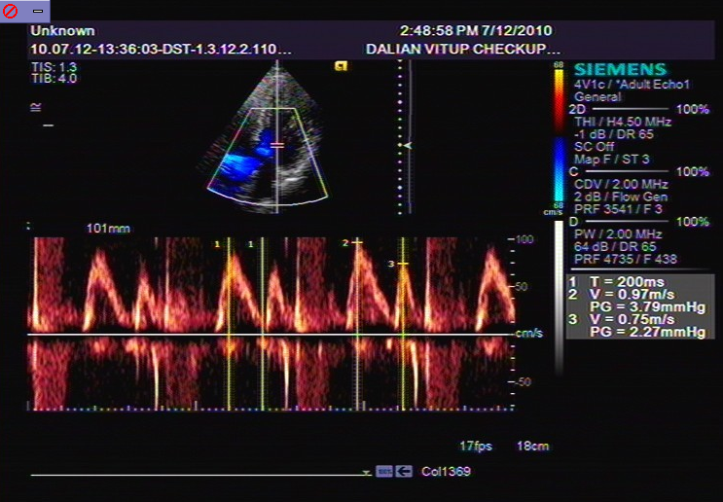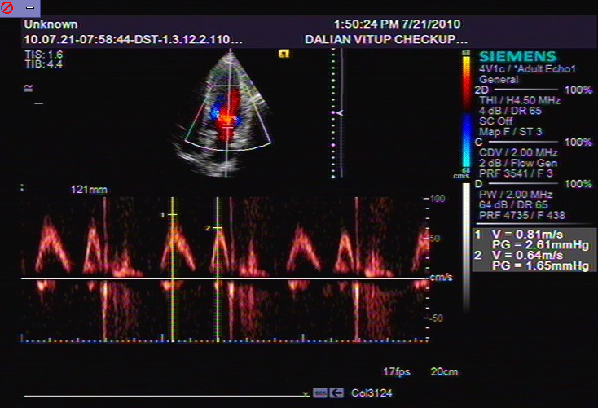
(2)Tissue Doppler:
Before treatment Ea/Aa<1 After treatment Ea/Aa>1
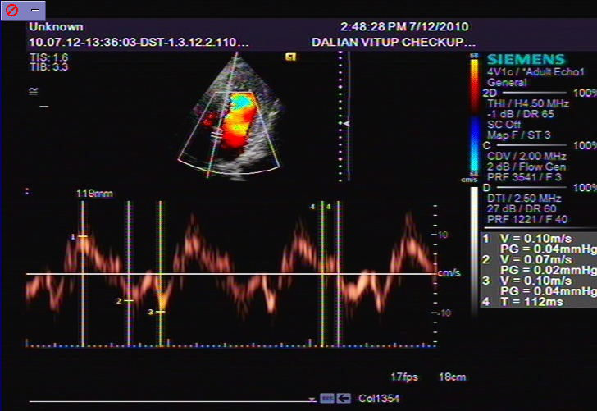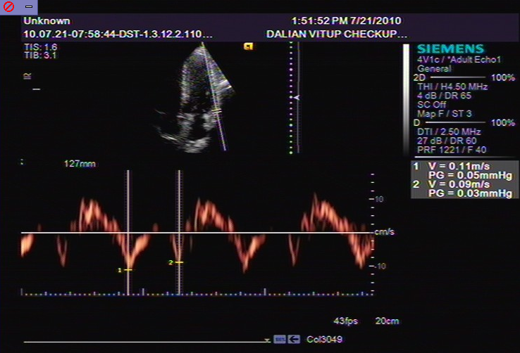

(3)Before treatment E/Ea =13.9 After treatment E/Ea =7.36
Picture 2
Name: Mr. Xu, Gender: Male, Age: 55
Clinical diagnosis: Hypertension (Ⅱstage, moderate risk), hypertensive heart disease, soft plaque buildup in carotid artery
(1)Blood Flow Doppler:
Before treatment E/A<1 After treatment E/A>1
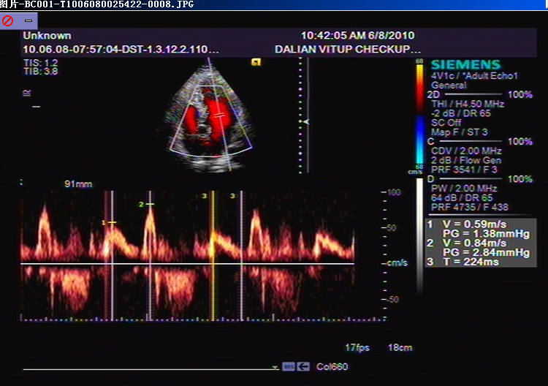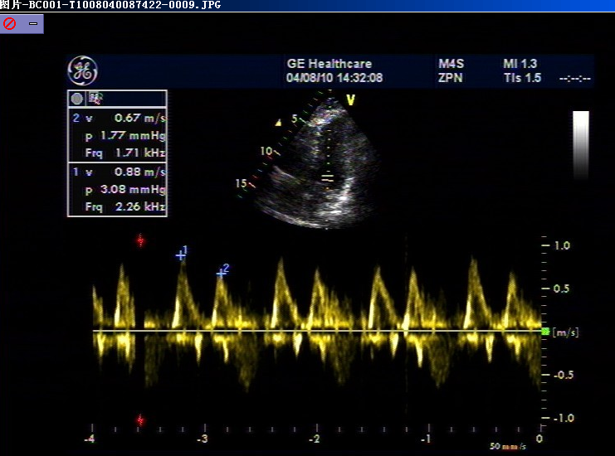
(2)Tissue Doppler:
Before treatment Ea/Aa<1 After treatment Ea/Aa>1
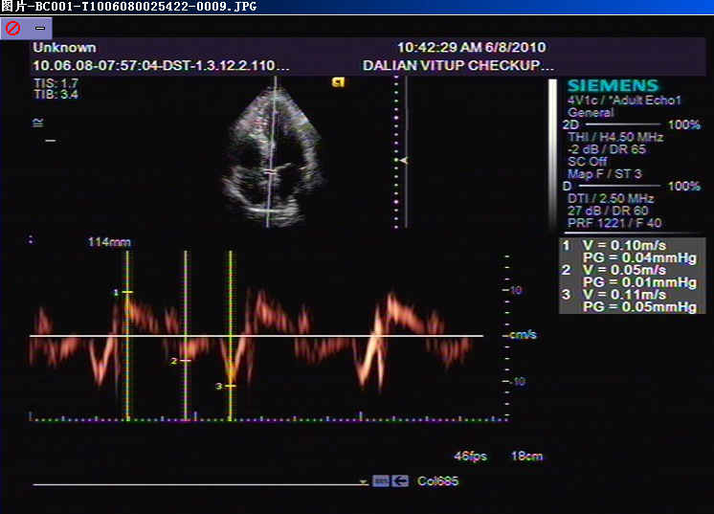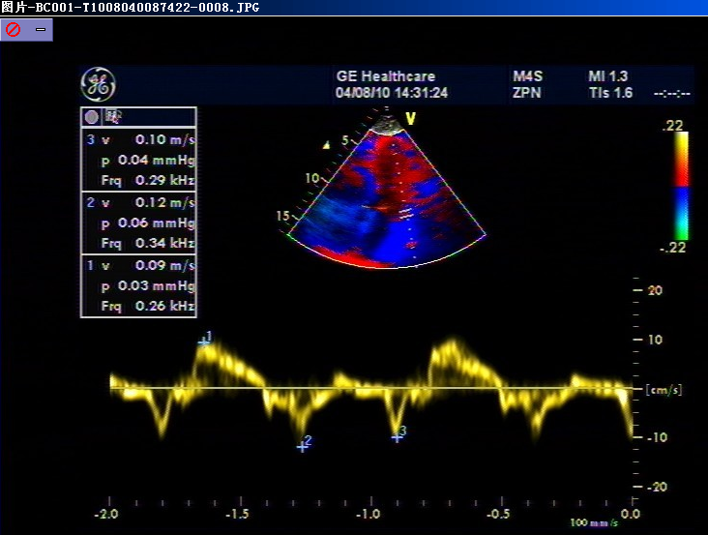

(3)Before treatment E/Ea=11.8 After treatment E/Ea=7.33

Discussion:
The morbidity rate of diastolic heart failure has been sharply rising followed by increasing morbidity rate of some other disease such as ageing of population, hypertension, diabetes, obesity, and coronary heart disease. Early intervention of primary disease and diastolic dysfunction is the key to prevent diastolic heart failure. The mechanisms of diastolic dysfunction were：(1)When the patients suffer from myocardial ischemia or myocardial hypertrophy, their calcium overload in the heart muscle is more likely to happen. All factors making trouble in process of myocardial cells reuptake or discharging the Ca²⁺ can cause calcium overload and diastolic dysfunction. These factors include ability and velocity of sarcopasmic reticulum (SR) reuptake Ca²⁺ decline, phosphorylation mediated by cAMP decline and phosphorylation of phospholamban decline etc.;(2)Stiffness of myocardial cells: Myocardial stiffness is directly related with the condition of myocardial cells. The stiffness of myocardial cells progressively increasing is an underlying cause diastolic dysfunction. When quantity and expression of connectin have been damaged, elasticity of myocardial cells will be reduce, and stiffness will be increase，afterwards, diastolic dysfunction appears; (3)The patients suffer from hypertension, hypertrophic cardiomyopathy and aortic stenosis, are more likely to suffer diastolic heart failure because chronically heavy pressure load may induce left ventricular hypertrophy and ventricular filling;(4)When myocardium is under ischemic state, because lack of oxygen, fatty acid oxidation decrease, oxidative phosphorylation of mitochondria block , ATP production in cells decrease and anaerobic glycolysis increase, so cause accumulation of myocardial metabolism waste, acidosis, cell structure and function change, more Ca²⁺ enter the cells, intracellular Ca²⁺ overload becomes more serious, thereby induce left ventricular diastolic dysfunction.
CP is an endogenous substance. It plays an important role in myocardial energy metabolism. Its molecule contains high-energy nitrogen-phosphorus bonds, which generate energy substance ATP of myocardial cells’ activity through Lohmann reaction(CP+ADP←→Cr+ATP). It has been proved that the CPK is key substance of that reaction, it contains 4 types of isozyme, which exist in the end gap of mitochondria, serolemma, sarcoplasmic reticulum and myofibril. They play an important role in cellular energy load, insurance of energy opening ion channel, and slipping of actin and myoglobulin, Hearse study showed that intracellular CP level will decline, then followed by ATP level decline, moreover CP level is lower than ATP level, when myocardial ischemia occurs. Also, it has been proved that exogenous CP is not only involved in energy metabolism of myocardial cells, but also has membrane protective effect.
CP can reduce calcium overload of myocardial cells, thereby diastolic function is improved. This medicine can deeply reach respective locus in cells, participate in Lohmann reaction, generate ATP, supply energy and therefore increase the activity of membrane pump, stable membrane phospholipids, reduce membrane damage and lower the calcium influx. Look from molecular level, the lack of O₂ will result in the reuptake Ca²⁺ activity of sarcoplasmic reticulum reduce, especially mitochondria, so it can improve diastolic dysfunction.
Our clinical observation had proved that intravenous therapy with CP can significantly increase clinical (96.2% vs. 57.1%) , E/A (81.65% vs. 10.34%), Ea/Aa (83.49% vs. 13.79%) and E/Ea (92.86% vs. 12.00%) effects, P<0.01 all , compared with routine treatment group, therefore, a better life quality will provided to the patients. Thereby creatine phosphate sodium has invaluable clinical significance in preventing and treating myocardium diastolic dysfunction

Reference
［1］郭继鸿.舒张性心衰的新理念.北京：人民卫生出版社，2009：10.
［2］李佳蓓，黄 岚，祝善俊. 心力衰竭时心肌能量代谢的研究进展. 心血管康复医学杂志, 2009, 18(1)：85.
［3］Hearse DJ, Stewart DA , Braimbridge MV,et al. Cellular protection during myocardial ischemia: the development and characterization of a procedure for the induction of reversible ischemic Circulation, Vol 54, 193-202.
［4］袁 彪 朱朗标 王冬青,等.外源性磷酸肌酸在心脏直视术中心肌保护效果的观察.解放军医学杂志，2000，25(2)：112-114.
［5］Grazioli G， Melzi， Strumia E.Multicenter controlled study of creatine phosphate in the treatment of heart failure.Current Therapeutic Research,1992,52(2):271-280.
［6］Scattolin G，Gabellini A，Desideri A.Diastolic function and creatine phosphate : an echocardiographic study.Current therapeutic research,1993, vol. 54, 562-571.
［7］刘瑛琪， 李天德，任艺虹，等.磷酸肌酸对心肌细胞线粒体的保护作用.心脏杂志，2004， 16(1)：14-16.
［8］王 琴.卡托普利对心脏病心衰患者心钠素的影响，新疆医学院学报，1996，1：24.
［9］吴 蔚，高 宁.磷酸肌酸治疗充血性心力衰竭的临床观察［J］.心血管康复医学杂志，2000，9(4)：52-54.
［10］Ferraro S. Acute and short-term efficacy of high doses of creatine phosphate in the treatment of cardiac failure. Cum Therap. Research，1990, 47 (6): 917.
［11］Pedone V. As assessment of the activity of creatine phosphate (Neoton) on premature ventricular beats by continuous ECG monitoring in patients with coronary cardiac disease. Clinical Trials J，1984, 21：91.
［12］Hearse DJ. Cellular protection during myocardial ischemia. Circulation 1976,54 (2):193
［13］Peter EP, James FS, Robert AB,et al. Myocardial high energy phosphate stores in cardiac hypertrophy and heart failure.Circ Res，1967，21：365-374.
(收稿日期：2010-08-24)

