MEDICLOUD: a holistic study on the digital evolution of medical data
Astha Modi¹, Nandish Bhayani², Samir Patel³, Manan Shah^{4, *}

1. Department of Information and Communication Technology, Pandit Deendayal Energy University, Gandhinagar, Gujarat 382007, India
2. Department of Information Technology, Charotar University of Science and Technology, Changa, Gujarat 388421, India
3. Department of Computer Science and Engineering, Pandit Deendayal Energy University, Gandhinagar, Gujarat 382007, India
4. Department of Chemical Engineering, Pandit Deendayal Energy University, Gandhinagar, Gujarat 382007, India

*Corresponding author: Doctor, E-mail: manan.shah@spt.pdpu.ac.in.
Manuscript received 2022-2-14; accepted 2022-5-10;
available online 2022-6-25.

[Abstract] The Corona Virus Disease 2019 (COVID-19) pandemic has taught us many valuable lessons regarding the importance of our physical and mental health. Even with so many technological advancements, we still lag in developing a system that can fully digitalize the medical data of each individual and make it readily accessible for both the patient and health worker at any point in time. Moreover, there are also no ways for the government to identify the legitimacy of a particular clinic. This study merges modern technology with traditional approaches, thereby highlighting a scenario where artificial intelligence (AI) merges with traditional Chinese medicine (TCM), proposing a way to advance the conventional approaches. The main objective of our research is to provide a one-stop platform for the government, doctors, nurses, and patients to access their data effortlessly. The proposed portal will also check the doctors’ authenticity. Data is one of the most critical assets of an organization, so a breach of data can risk users' lives. Data security is of primary importance and must be prioritized. The proposed methodology is based on cloud computing technology which assures the security of the data and avoids any kind of breach. The study also accounts for the difficulties encountered in creating such an infrastructure in the cloud and overcomes the hurdles faced during the project, keeping enough room for possible future innovations. To summarize, this study focuses on the digitalization of medical data and suggests some possible ways to achieve it. Moreover, it also focuses on some related aspects like security and potential digitalization difficulties.

[Key words] Cloud computing; Medical data; Digitalization; One-stop platform; Artifical intelligence (AI); Traditional Chinese medicine (TCM)
[DOI] 10.1016/j.dcmed.2022.06.002

1 Introduction
As the health care sector changes from volume-based service to value-based approach, keeping track of medical data becomes a tedious job while expecting doctors and nurses to be more productive and efficient in maintaining data ^{[1]}. A humungous amount of medical data is generated daily. Moreover, the Corona Virus Disease 2019 (COVID-19) pandemic has demonstrated the needs for new portals to record a large number of active cases, deaths, empty hospital beds, and available vaccine doses, etc. A platform for registration of vaccination slots is also needed, and the number of people who have taken their first dose, second dose, or both must be kept. The current system is based on several different databases; thus, it is necessary for us to focus on integrating all medical data under one platform. Moreover, it also becomes challenging to maintain paper records and query them ^{[2]}. Taken advantage of exponential technological advancements, a system that can digitize data is proposed herein.
A technique that combines information, computation, communication, and connection technologies to improve an entity by causing significant changes in its attributes is known as digital transformation ^{[3]}. Digitalization has several benefits, such as responsive and sustainable healthcare, prevention before treatment, re-modeling of patient-doctor relationship, expanding of the reach of healthcare professionals, as well as reduction of the financial costs related to both the clinics and patients. It also opens up a world of possibilities, including search functions for complete access and processing of professional data, computerized reminders to avoid medication errors, easy communication between doctors and nurses, and complete transparency ensuring legible documentation of a patient’s health ^{[4]}. To this end, we propose a system/portal wherein the patients and doctors’ data can be stored on the cloud. Cloud computing involves resource management via the Internet. The resources can include databases, servers, networking architectures, and serverless systems. Cloud service providers provide specific services for a raised need to manage such resources. It is a rapidly developing technology that significantly influences Internet technology (IT) businesses, academia, and many other fields ^{[5]}. Our study aims to provide a system that stores all patients and doctors' data on the cloud so one can be easy to access their data. The patients can access their data, reports, prescriptions, appointments, details of consultations with their doctors, and data of their visits to clinics. Further, doctors will have the privilege of viewing patients’ details, including their personal information and surgeries they have undergone, to prescribe medicines and maintain a schedule.
2 Advantages and disadvantages
There are certain advantages of the cloud over on-premises and manual paper systems, such as follows.
(i) High availability: the cloud architecture is designed to be highly available. Regardless of how many people access the portal at a time, cloud can always serve all users.
(ii) Scalability: there are specific systems currently running on-premises by the government; for instance, the online result publishing portal often grabs headlines for crashing on the day of result declaration. With the cloud, the number of servers can be scaled within seconds; it also provides an autoscaling feature to automate this process. With autoscaling, the government will also save on server costs when there is minimal traffic by decreasing the number of servers in play.
(iii) Reduced capital expense: cloud technology allows low up-front investment as the cost of building web servers and facilities to cool them is saved.
(iv) Reduced staff: as the infrastructure is maintained by giant cloud service providers like Amazon Web Services (AWS), Microsoft Azure, or Google Cloud Platform (GCP), there is no need to maintain a separate staff for securing the on-premises servers and providing regular security patch updates as many managed services are offered by the cloud service providers.
(v) Global access: as the servers of cloud service providers are located in almost every country and continent, data remains easily accessible from any corner of the world with very low latency.
(vi) Pay for the resources utilized: almost every cloud service uses the “Pay as you go” model; thus, the consumer has to pay only for the services they are using at any given moment with the option of availing more services in just a few clicks.
It also allows users to integrate various services, resulting in increased innovation and prolificity ^{[6]}. All this can be done with the help of the cloud. However, there are some disadvantages. For example, cloud follows a distributed approach for storing data, so companies are skeptical about the privacy and security of their data ^{[7]}.
Data is the valuable asset and security breaches can risk users' lives. Moreover, unauthorized access and corruption can lead the company to monetary loss, and have adverse consequences in consumers’ confidence disintegration, the company’s reputation damage, and brand erosion. One primary concern is security, which has emerged as a primary driver and a constraining factor of cloud computing adoption ^{[8]}. Various algorithms and mechanisms ensure data security, depending on their size, nature, and type of data possessed ^{[9]}. Data encryption, key management, security intelligence, and adequate access controls are used in cloud computing to guarantee strong security ^{[10]}. To access data securely, the users have to enter their social security numbers (Aadhar card number in case of India), which acts as a primary key, and enter a one-time password (OTP) which is sent to their registered mobile number. This becomes a pivotal factor in prevention of any unauthorized access.
Figure 1 depicts the process of OTP authentication. The user will submit his or her contact number along with Aadhar number during the first registration; then, whenever he or she has to log-in, the user can enter his or her twelve-digit Aadhar number that works as the primary key and requests an OTP on his or her registered contact number. Only after entering the correct OTP (usually valid between 90 to 180 seconds after the OTP’s appearance), he or she will be allowed to access his or her health dashboard.
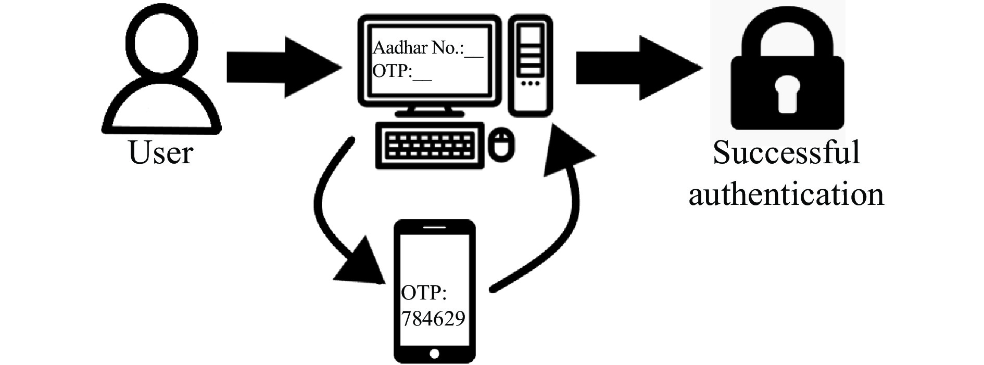
Fig. 1 OTP authentication
The cloud will enable users to access data securely, which means the users can open, view, and save files from anywhere in the world. This feature is helpful in emergencies, where patients can be treated from any part of a country by accessing their records through the portal. With comparatively easy applications to monitor patients inside hospital rooms, technology has progressed to the point where patients can go about their everyday lives at home while still being observed by using modern technology and sensors ^{[11]}. Remote access has some other advantages: an administrator can define different privileges for doctors and patients, troubleshooting becomes faster and easier, and files can be easily modified and controlled, promoting business growth.
One more reason for using the cloud is that it is more eco-friendly ^{[12]}. As mentioned above, our study tries to eliminate paper-based prescriptions and provide electronic prescriptions with the help of a portal. Paper-based prescriptions can lead to medication errors (MEs). According to the report presented by the Institute of Medicine (IOM), the number of annual deaths has increased because of MEs which has ranged between 44 000 and 98 000 ^{[13]}. E-prescriptions can reduce this number and save tons of paper used for prescriptions. E-prescriptions allow ambulatory care providers to submit prescriptions to pharmacies electronically. It can be a stand-alone solution or a part of the portal ^{[14]}. E-prescriptions not only minimize ME risks or adverse drug effects but also have a cost advantage. Moreover, the patients’ safety is also guaranteed ^{[15]}. Our portal enables doctors to prescribe medications to patients to guarantee their safety and limit MEs.
Our contribution lies in combining technology with the world of medicine, as it is explained in the following example. Let us consider a user is on a tour and has to visit a hospital because of some unforeseen reasons. The user would not be carrying his or her earlier medical records existing as hard copies at his or her home. It becomes difficult for the doctor to treat the user without past data. The frontline worker will have to study the entire case basing on a mere description of a disease described by the patient without any past dosage and prescription records. Our proposed system focuses on this issue and makes the data available anywhere with a few clicks; therefore, it benefits the doctor and saves time for both the user and the doctor. Further, there are limited chances of missing data when data is compared to maintain hard copies. According to a report proposed by World Health Organization (WHO) naming “Social Stigma associated with COVID-19”, people tend to hide sensitive diseases from a new doctor, which may lead to a major misunderstanding or the patient’s death; however, with data being available with a few clicks, such a communication becomes transparent and easy.
Another additional benefit of our portal is that it helps the government shortlist the number of genuine health workers, reducing malpractices. To stop this malpractice and save lives, our platform can verify an individual clinic before it can start practice. In the case of polyclinics, they have to provide a government verified National Accreditation Board for Hospitals and Healthcare Providers (NABHH) certificate. The prolific advancements in data science can also be applied to large-scale data. Countries with huge populations, such as China and India, can immensely benefit from the generated data. The patterns of diseases occurring in specific weather conditions can be listed. For instance, in the monsoon season, appropriate measures can be devised to contain malaria’s spread. This data can also classify diseases according to locations, which can narrow down their spread. For a country like China or India, endemic disease classification can work wonders in containing the infection at the ground level.
Thus, this study proposes a centralized system for everyone regarding any concern in the medical system, which is empowered by modern technology and an easy-to-use interface and heavily focuses on the digitalization of medical data. Further, it contributes to maintaining a uniform system that reduces tedious paperwork and simultaneously can be accessed worldwide with an advantage of residing under the secure umbrella of cloud computing, ultimately paving a way toward eco-friendly and secure data storage.
3 Literature survey
Before starting any studies, there are a few things that every researcher proposing a new work should consider and it is the work that is executed by the people on the same topic. A thorough study is always beneficial whenever an innovation occurs; it gives a clear idea of what accomplishments have been made by people working on related projects and also sets a template. Previous works are always a source of inspiration. Several previous studies have been done in the cloud computing and medical fields and there must have been certain ways in which previous studies would have been conducted ^{[16-25]}. This segment throws light on such studies and provides a background on how this study will merge the breeding technology of cloud computing with the continuous evolution of medical science.
SHARMA et al. ^{[16]} had proposed a system for electronic health records. These health records could be accessed by patients, doctors, trainees, family members, and health companies, and would reside in the cloud. According to them, various organizations had adopted cloud in their systems; however, some potential problems might still occur after organizations’ adopting of the cloud, such as device malfunctions, power cuts, or human errors. They had proposed software as a service (SaaS) for clinical services and system logins, platform as a service (PaaS) for reporting tests and integration with various environments, and information as a service (IaaS) for updates. There were cloud computing applications such as telemedicine, wherein the options of video conferencing and medical consultation software were available; clinical research where data was stored for further analysis; big data, which helped store money on hardware; and electronic medical records based on cloud which would be helpful in medical picture preservation. They had also discussed privacy concerns and interoperability in depth.
DEVADASS et al. ^{[17]} had suggested that adopting cloud technology could significantly revolutionize the healthcare system, particularly the profitability, efficacy, and dependability. Most countries supported cloud computing, and according to the statistics ^{[17]}, 37% of healthcare providers had strategic plans for the adoption of cloud, 22% were in the developing stage, and 25% had started adopting the cloud in their respective industries. Most consumers had found cloud computing cost-effective. However, a difficulty was that most consumers were not well equipped with the use of the Internet, a primary requirement for the cloud. A case study on healthcare in Malaysia pointed out that deploying cloud-based information and communication technology (ICT) solutions had become one of the most prominent trends, with a forecasted growth of 900 million by 2020, up from 900 million by 2020, up from 43 million by 2012 ^{[17]}. The Kumpulan Perubatan Johor (KPJ) Healthcare Berhad estimated that by implementing this initiative, they would be able to save 30% – 40% of their IT costs and expenses in the long run. By integrating cloud-based services with healthcare, Malaysia would benefit as a whole ^{[17]}.
MEKAWIE et al. ^{[18]} described how cloud computing could play a pivotal role in developing countries, and its implementation in Egypt. They discussed how they could conduct interviews and conferences with experts to understand and consider cloud computing as an economical option for application deployment. The authors agreed that the cloud could play a crucial role in e-Health; however, there was a catch in which it could increase the governments’ budget in developing countries. Discussing the implementation of cloud computing in Egypt, they agreed that there were cultural barriers when a modern technology was introduced to people, who faced difficulties while using it; however, they believed that education and a basic implementation could turn the tables in a very short period and might play a crucial part in modernizing the infrastructure and the standard of using technology as a service.
AHUJA et al. ^{[19]} studied the application of cloud computing in health care. Cloud computing had several advantages when deployed in healthcare. The authors stressed on cost efficiency, better utilization of resources, information access from anywhere, improved quality of services, and information sharing across different systems. They had discussed some considerations, such as the preparation of infrastructure, before transferring their data to the cloud. There could be healthcare security issues with cloud computing, such as data breaches; therefore, it was necessary to provide proper security. The authors had also discussed some cloud computing applications in health. Moreover, the cloud served as a global market for healthcare as many giants had been investing in this technology. Finally, the authors discussed the challenges faced in cloud computing, mainly paying close attention to security and interoperability.
MIRACLE et al. ^{[20]} described their study on cloud computing in healthcare from three aspects: opportunities, issues, and application. The study tried to analyze the business view on how cloud computing could be used as an opportunity for everyone to work on large amounts of collected data, including prescriptions, infection types, DNA sequences, illness trends, and many more aspects, and how the medical and healthcare industry could use them to predict what might come next. As for the issues, they highlighted how medical data could be sensitive and personal, and the possibility of it being used against people; for instance, a DNA sequence could be observed and then could be tampered to make something worse. Security and privacy concerns were briefly discussed, in which the authors highlighted poor encryption techniques, public administration interfaces, and separation failures as risks. Finally, the authors concluded that regardless of the concerns, digitization was inevitable and would be a crucial aspect of the modern world.
CAO et al. ^{[21]} focused on the Internet of Things (IoT) aspect of cloud-based medical health monitoring. In the first part, they performed a stress test to measure how many users could use the system simultaneously and come out with a logarithmic performance graph that said the lesser the ratio of added users, the better the performance; for example, the performance would be better when the number of users increased from 600 to 700, rather than when the number increased from 100 to 200, even though the same number of users were added in both cases. In the second part, they provided a deep insight into the use of Bluetooth communication technology to collect blood oxygen and pulse information in real-time. Finally, blood pressure and electrocardiogram measuring sensors were used to get the monitoring up and running at any given time. The applications were immense in children and elderly people’s healthcare, while monitoring fitness is for the generation in between.
SIVAN et al. ^{[22]} analyzed the cloud-computing schemes for e-Health systems, security challenges, and solutions. They had focused on a few advantages of cloud computing, such as access using web browsers with built-in single-sign-on (SSO), no need for virtual private network (VPN) to utilize cross-site or network resources, easy and improved management, scalability on demand, no maintenance costs associated with the physical architecture, and reduced power consumption. Some of the discussed issues were integrity, data violations, unsecured application programming interfaces (APIs), account hijacking, and lack of security technologies. They had classified some security solutions: cryptographic security and access control managers. Cryptographic security included blockchain-based encryption, public-key encryption, symmetric key encryption, searchable symmetric encryption, and broadcast encryption programs. Access control managers included consortium blockchain (CB) and full private blockchain (FPB). The solution proposed for security was through the use of a lightweight framework. This framework was introduced to the transport layer based on the secure health architecture to protect data exchange among servers without any additional security.
MASROM et al. ^{[23]} had performed a strength, weakness, opportunity, and threat (SWOT) analysis to investigate the adoption of cloud computing in healthcare. They had tried to identify the internal and external factors affecting this adoption. Strengths of cloud computing included easy access for patients, scalability, adaptability in catastrophic situations, better use of resources, ease of expansion, etc. The weaknesses of the cloud included the primary requirement of the stable Internet connection, difficult integration with local software, and lack of training. The opportunities of adopting cloud in healthcare comprised the availability of the latest technology to the users, which was beneficial for the healthcare sector as it allowed for the management of progress through capital outlay, flexibility to adapt to future demands, and provision for smart and quick solutions to problems. The threats were a lack of clear standard regulations and concerns about security, the loss of communication, the difficult integration with another platform, and healthcare personnel’s concern about the system's effectiveness.
RAO et al. ^{[24]} discussed the methods for enforcing cloud computing in the healthcare domain. They conducted a survey and segregated the responses basing on the subject’s knowledge of the cloud. The collected data were analyzed and interpreted, and then the results were derived from the data. The first result showed them the advantages of cloud computing: easy and faster access, less paperwork, fewer errors, easy data sharing, and reduced redundancy. Some disadvantages were also pointed out, such as a threat to data security and patient privacy, interoperability issues, and high setup costs. The second result showed the reasons behind the restrained adoption of cloud in healthcare. There were a few ways to overcome these disadvantages. Regarding data security, users should be educated on the measures taken for data safety. Unauthorized access could also be prevented by giving specific privileges to access only the required data.
ALIPOUR et al. ^{[25]} focused on building a questionnaire for healthcare workers regarding their opinions on the use of technology in public and private hospitals in Iran. They distributed seven hundred questionnaires with questions relating to technology in sections like security, complexity, costs, and compatibility; questions relating to organizational benefits referring to relative advantage, management support, and resource adequacy; and finally, questions on governmental policies and cognitive approach. Respondents from various age groups with different work experiences answered these questions; the authors found that organizational and technological dimensions were deemed as the most important ones from the users’ perspective. A few results also indicated that workers were uncomfortable using this modern technology.
4 MEDICLOUD system
4.1 Artificial intelligence (AI) in traditional Chinese medicine (TCM)
Before the study moves to the practical scenario, this section highlights the fusion of TCM and AI. TCM has been practiced over a long period. Over the years, TCM has become a fine technique among its practitioners. It comprises several minds and body practices along with herbal products to address the “quality of health” problems in the modern era. Practices like acupuncture, dietary therapy, and several other herbal medications have been a reason for certain breakthroughs ^{[26]}. Recent technological advancements and AI have made it possible to study and keep track of the clusters of data generated through these medicinal practices.
As the study moves to the digitization of medical data in this project, another application can also digitize the hard copied documentations of traditional Chinese medicinal practices. On the basis of AI, manuscripts handwritten in Mandarin can be digitized to reach a larger population. Moreover, with this advancement, AI can be used for further enhancing the current practices, ultimately leading to advanced medical science for future references.
One key application of modern era technology meeting TCM is in pulse diagnosis. In TCM, the “pulse classic” method is used to measure and diagnose a pulse. Several advancements can be achieved if people combine this method with machine learning and maintain a related dataset ^{[27]}. Tongue diagnosis has played a pivotal role in TCM for thousands of years. Yet, tongue recognition for TCM practitioners is subjective and challenging. Researchers have attempted to build computerized tongue recognition models by using AI, such as the use of image processing and statistical machine learning methods ^{[28, 29]}.
These applications and technological advancements can lead the healthcare sector toward a significant leap forward to Quality 4.0. Quality 4.0 has been applied during the COVID-19 era, enabling quality services for crucial clinical outcomes. It is ultimately an extension of the technological platforms created to enhance quality-related activities in TCM ^{[30]}.
Traditional medicines are of utmost importance to the Chinese as they have cured diseases where modern science and technology failed. Therefore, a method to combine these practices with cutting-edge technology to benefit the entire world is proposed. The use of AI with traditional Chinese medicinal practices can contribute to further discoveries and serve as an appropriate use-case of combining modern technology with TCM.
4.2 Proposed work
In this study, we have focused on merging two modern-day fundamentals and innovating a system that can benefit health care workers and patients. In the long run, after a sufficient amount of data is collected, the proposed system can also benefit several government agencies in maintaining a health dashboard and also the insurance industry through targeted advertisements for people prone to medical anomalies. The study kicks off by providing a consistent platform to its users for several tasks, such as registering for a new clinic or hospital, prescribing a new medicine, verifying the authenticity of a clinic, and logging in to remotely check prescriptions and medical reports from virtually anywhere. This decreases the amount of paper used daily for prescribing medicines, and provides security using an Aadhar number as a unique identifier of every person and using it to generate an OTP on a registered mobile device, thereby the platform enhances the security of sensitive and personal medical data. Everything is combined with the highly available, secure, and scalable nature of cloud computing.
Our study also focuses on tackling the issue regarding the increased usage of paper for prescribing medicines. India is a highly populated country; a huge amount of money is spent on prescriptions. To curb this cost and provide an eco-friendly solution, our study proposes a digital alternative wherein the doctor can prescribe to a patient through the portal only. The patient will then be able to get his or her medicine from the pharmacy using an e-prescription. This e-prescription ensures the correct interpretation of the prescribed drug and will reduce the errors because of wrong interpretations.
As shown by the tables in Figure 2, patients and health-workers are provided with their registration and login portals. The registration portals for individual clinics and polyclinics are different and dependent on each other. The login module is secure as the consumers are provided with an OTP facility. The other tables include medicine data, which contains attributes like name of medicine, quantity, and frequency. This table is dependent on the prescription table that gives a good overview of the visit details. The overall relationship between doctor and patient is many-to-many as the patient can consult multiple doctors, and one doctor will always have multiple patients. The general structure of the database is client-server, which is briefed below.
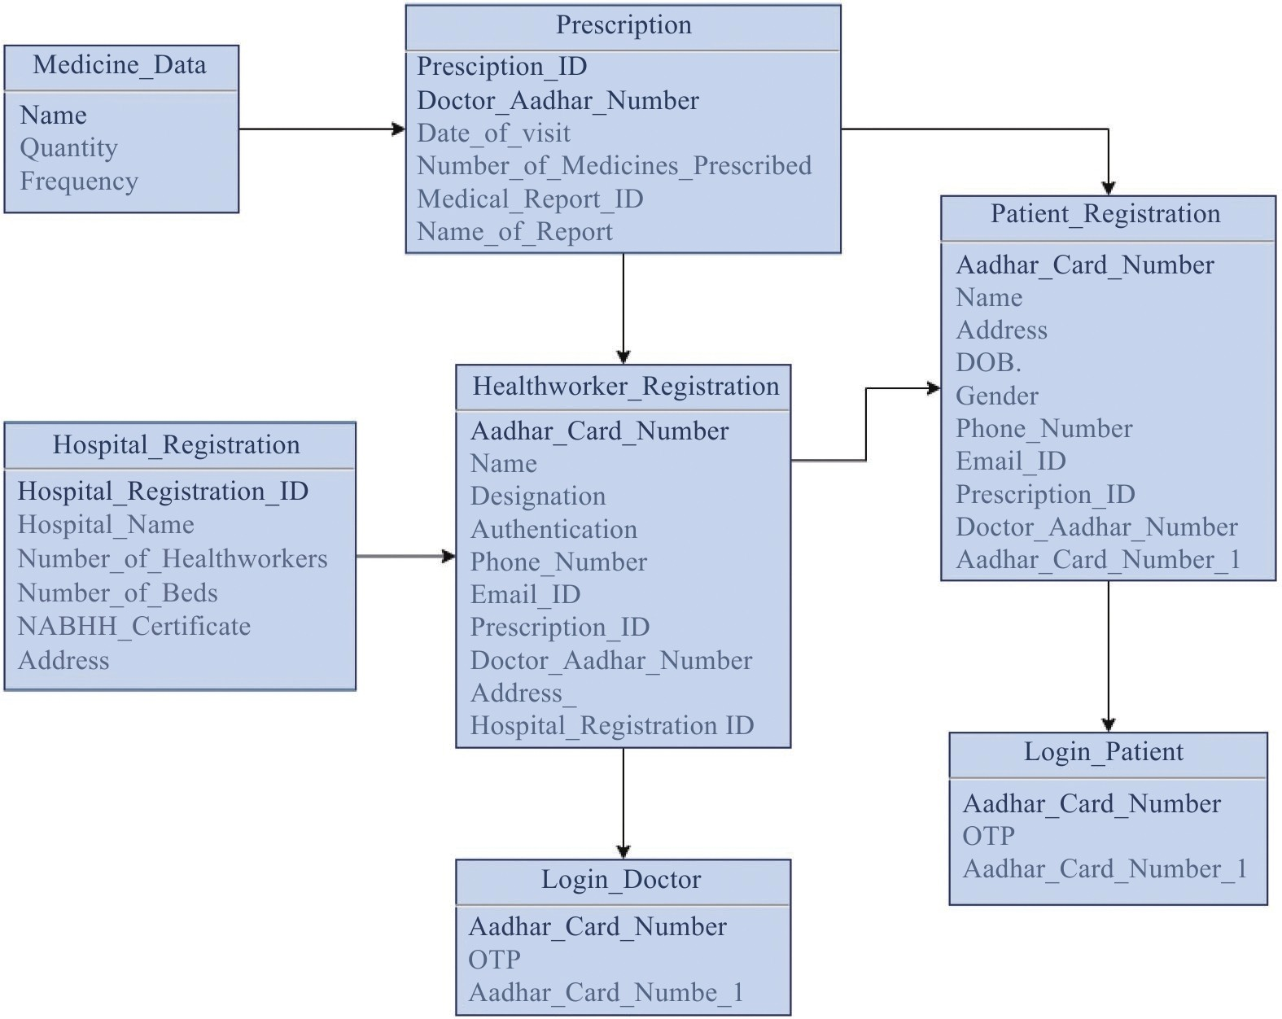
Fig. 2 Database diagram for storing patients and doctors’ data
Client-server architecture is always preferred for centralizing portal data. This study includes two client-server portals: the first one has the hospital and the government, and the second one has the user and the hospital as client and server, respectively, where the user is either a patient or medical staff. The architecture works as mentioned below.
In the first client-server architecture, the government will act as a server and the client (hospital) will be divided into two types: individual clinics and polyclinics. Here, the individual clinics would be required to provide data consisting of the doctor’s name, address, Aadhar number, contact information, and proof of the highest qualification. In a developing country like India, malpractices are rampant. A 2016 report by WHO states that approximately 57.3% of allopathic doctors in India do not have a genuine degree. These doctors’ practice without a degree has led to the loss of many lives. We have proposed a system wherein the clinic has to be registered on our platform to stop this malpractice. After the registration is complete, a committee will verify the authenticity of the clinic; if approved by the committee, the clinic can start its practice. To verify individuals, a committee will be set up to authenticate the clinics before the commencement of their practice. On the other end, polyclinics will be required to provide data consisting of the number of health workers, individual information regarding the doctor’s specialization, and other information mentioned for individual clinics, except the authentication requirement (proof of the highest qualification). The authenticity will be verified by the submission of the NABHH.
In the second client-server architecture, the hospital will act as a server, and the client will be of two types: health workers and patients. The client will be required to log in to the portal using an Aadhar number and OTP. If the client is a doctor, then he or she can view patient's data (past medical reports and prescriptions), and could edit the document for prescribing new medicines and recommending medical reports. If the client is a patient, he or she will have a view-only privilege.
4.3 Practical scenario and overview of architecture
Figure 3 shows in order to make this portal cloud-based we have used a few AWS services to demonstrate a practical cloud-based portal. The used services include Amazon Elastic Compute Cloud (EC2) instances, Application Load Balancer (ALB), Amazon Virtual Private Cloud (VPC), Amazon CloudWatch, Auto Scaling Groups, and Amazon Relational Database Service. As discussed above, two client-server architectures are used to build the portal. The left side of the architecture shows the portal containing the content used by doctors and the right side of the architecture shows the portal containing the content used by patients.
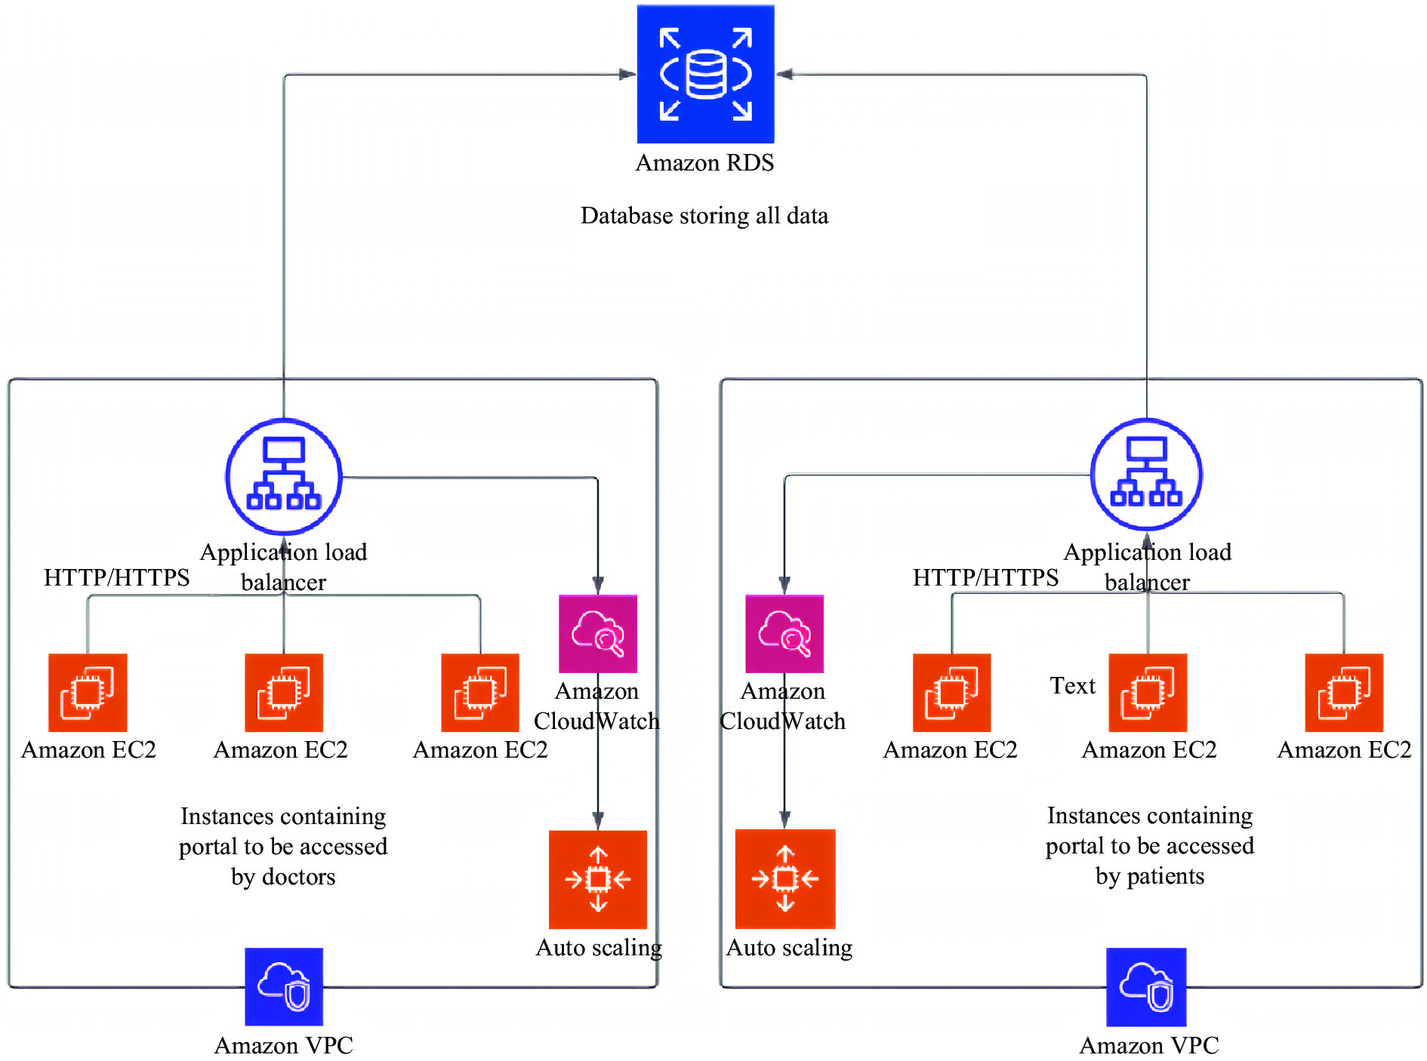
Fig. 3 Architecture illustrating the usage of AWS
4.4 Working of architecture
As shown in Figure 4, the web content built for the portal is firstly migrated to an Amazon EC2 instance. An EC2 instance works to provide IaaS. The instance operating system is Linux and an Apache web server is needed to be installed to migrate the content to the cloud. Then, replicas of instances are created to serve more users as the traffic increases. Every instance comes with a different connection point, which is combined and attached to an ALB shown on the above layer. An ALB provides a single point of contact (link) to the add-on, facilitates the architecture in balancing the load between instances, and helps in maintaining a secure environment as the instances cannot be reached directly, which might lead to several security threats such as denial of service. The traffic is distributed equally in all instances. In the architecture, there are currently three instances serving the user; if the load increases, there may be a scenario where three instances are not enough, and the system might fail. To tackle such a scenario, the ALB is attached to CloudWatch. CloudWatch service constantly checks the health of instances; in case of an overload, the health check will fail, and it will call autoscaling groups connected below to increase the number of instances. Hence, whenever there is a spike in load, more web servers (EC2 instances) will be added to the architecture to address the increased traffic. The upper limit of instances can be virtually indefinite. The entire architecture resides in a secure VPC that will provide the architecture the required isolation instead of sharing the environment with other customers. Whenever data is saved (the doctor/patient signing up and the doctor prescribing a new medicine, etc.), the load balancer from both portals will be updating the content in the relational database service (RDS), which can have multiple tables for storing data.
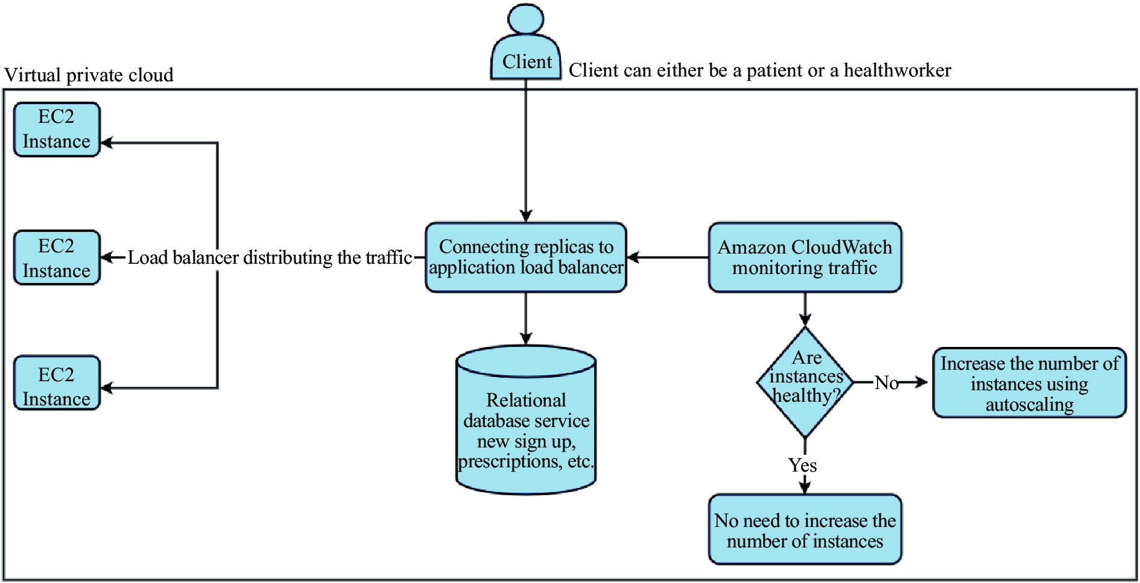
Fig. 4 Flowchart depicting client life cycle
4.5 Security practices intend to follow
Our proposed system provides a backup database following a master-slave architecture. If the master is down or crashes, data will always be live and available. The backup database will reside in another region, as illustrated in Figure 5.
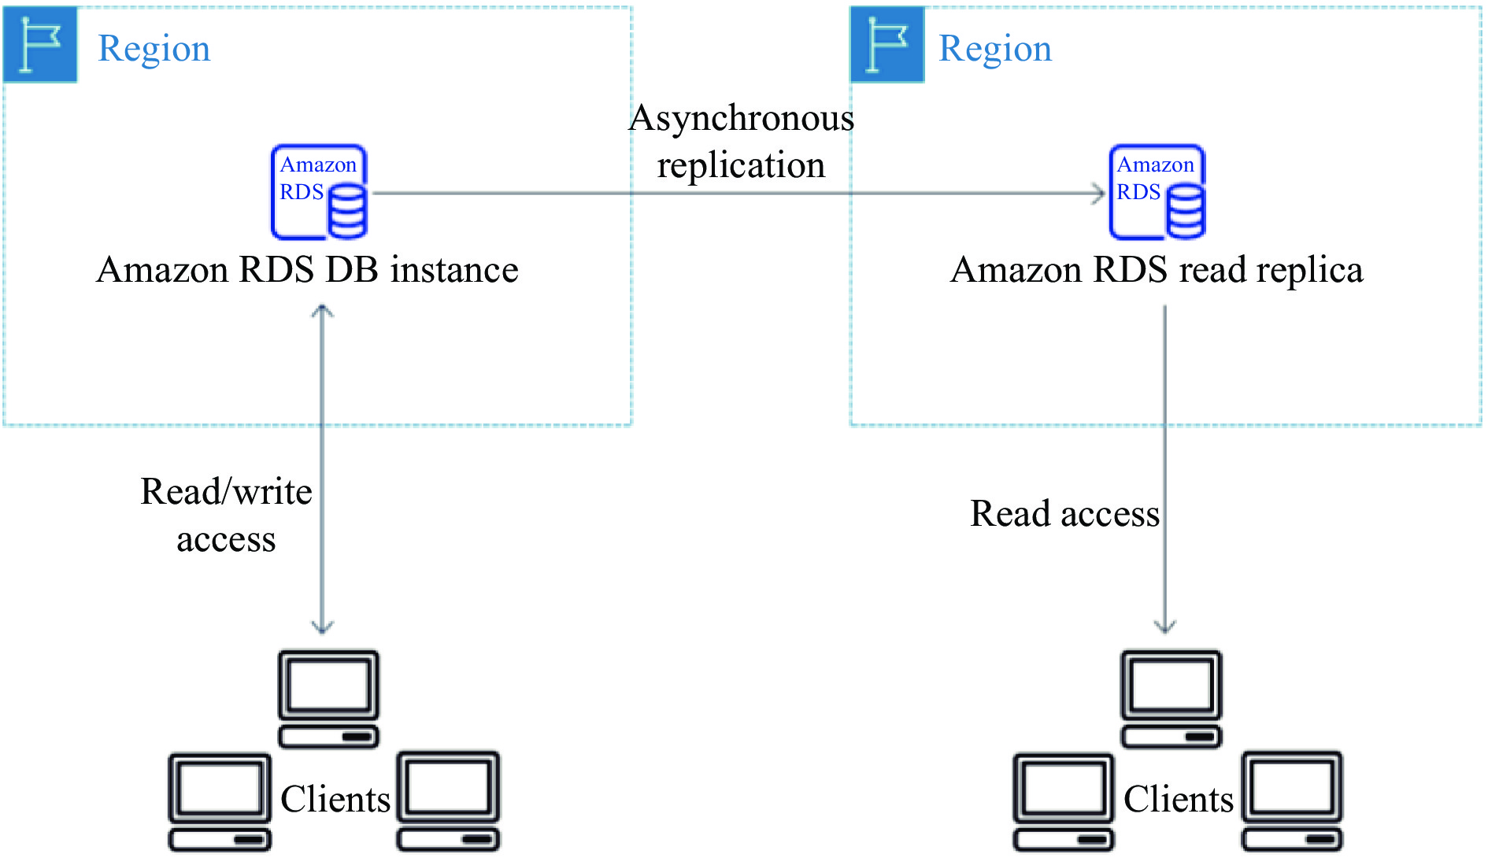
Fig. 5 Multi-region database architecture
Security is one of the most important concerns when people think about managing and providing access to highly sensitive data. Security in the cloud works as a shared responsibility, which is as follows: security of the cloud and security in the cloud. Security of the cloud is managed by renowned providers like AWS, Microsoft Azure, or GCP, depending on the chosen provider. However, as a consumer, data security in the cloud has to be taken care of. Some instances of how security is managed in our system are given below.
(i) Security for data at rest: for this study, AWS has to be considered as the cloud service provider; therefore, for data security, the RDS service from AWS is used. Thus, the data is protected using the industry-standard AES-256 encryption algorithm, which is one of the best security practices.
(ii) Security for data in transit: when data is in transit, it is a challenge to secure it. However, the Web Application Firewall service by AWS is used to protect and filter the requests coming to our databases. This will protect the database from denial-of-service attacks and prevent the server from being overwhelmed with requests, thereby avoiding crashes.
Our system proposes a mechanism for entering user information manually to tackle the problem of incomplete data. Here, the users must fill in all the details to create their profile. If the user is unable to fill in all the details in one go, then his or her progress will be stored and available for completion later.
Health problems are more common among the elderly; based on this, the user interface (UI) will be designed to be as simple as possible so people can use it effortlessly. Moreover, providing toll-free helpline numbers on which users can call and ask for any assistance is planned. Children are usually accompanied by their guardians if any health service is required.
5 Advantages over previous approaches
Compared with other systems like DocOnline, IndiaOPD, Credihealth, and others, our study churned out some existing systems that seem more vulnerable as they are not monitored by authorities and maintained privately. We propose a system to the government that guarantees a reliable infrastructure with health monitoring features while ensuring data safety and maintaining the trust between the user and provider; this is an advantage of our system. During the comparison with other systems, we found that only a few people are availing these online services. Further, as online services are maintained mostly by non-public sector doctors, the cost also has an impact, raising concerns on affordability and awareness for the middle- and lower-class users.
The study proposes a platform that can handle queries from health workers and patients, and maintain the data in the best way possible. It also provides a way to authenticate doctors, and follows an eco-friendly path to benefit the nature.
6 Challenges and future works
Expectations are the thief of joy. Every modern-day technological enhancement brings a lot of expectations to the room along with some challenges. The pandemic led many industries to migrating their entire infrastructure to the cloud and beginning a revolution in digital data. The cloud does provide a highly available and scalable environment but brings along security concerns. Majorly, cloud technologies are divided into two segments: public cloud and private cloud. On the other end, cloud security also consists of two types of security: “of ” the cloud and “in” the cloud. The users can control security in the cloud by investing in people to maintain a secure environment and assure availability simultaneously; however, security of the cloud can be a concern on certain occasions. An average cloud service is available ninety-nine percent of the time, and hence, the availability can differ from the remaining one percent where the resources can face a downtime. A portal like ours might get affected with that one percent as hospital facilities fall under critical services.
Other than the downtime, a security failure is also possible with the large amount of data in the cloud. Medical data is highly personal and sensitive, and if it gets stolen or sold by any entity, there can be major consequences. On the upside, it is well known that digitalization is worth the concerns because security will always keep improving. Cloud computing comes with the best practices and compliances that can be followed when the portal is built. Several encryptions can be conducted regarding the view and edit rights of distinct user types. Many cloud service providers also provide options to conduct security drills on an architecture before deployment, where they suggest loose coupling so that every service is independently secure. All these steps can produce a secure environment in the cloud and ensure data security.
In future works, the portal can be provided with regular security updates to make the system stable. A mobile application can also be developed to make the experience sleek and reach more people. Large amounts of data can be collected and used for various research purposes, for instance, for finding the number of people diagnosed with a particular disease in the state. Via this way, people can be more aware of the types of diseases spreading in their area. Another future application is to build a health dashboard for everyone using the portal; a reminder feature can be added to ensure a patient to remember the date on which a consultation is scheduled. We also observed data ambiguity in a scenario where a health worker consults another health worker; to counter this, a feature can be provided where a health worker is allowed to log in to the portal as a patient.
A major future application can be providing anonymous data to insurance providers to develop better policies for their target groups and provide benefits to people. Data encryption is another future application; as the amount of data increases, the threat is assumed to be going to increase, and thereby a few encryption algorithms are used to ensure that the data is consistent and secure, and manage the read/write privileges of every user efficiently. The pharmaceutical industry can benefit from the data by estimating the quantity of products to be manufactured. With an increase in the number of mono clinics, their authentication can also get tedious; an AI system can be designed to ease this task and decrease the workload of authenticated doctors and health workers. The final goal is to provide more readily available services to everyone using the portal.
7 Conclusion
Modern-day technology is inclined toward making products and services easy to access, and cloud computing can help the current generation access them with a simple click and minimal downtime. Our proposed system ensures the entire medical system remains uniform and contributes toward an eco-friendly future by minimalizing paper use. The study also highlights the disastrous practice of fake clinics in India and provides a solution regarding the authentication of doctors to effectively solve this existing problem. We also presented a practical approach using an AWS-based architecture, in which we described how the system will be highly available and cost-effective. Digitalization always comes with security concerns; however, we believe every problem can be tackled and modern-day security will always be there to address such concerns. When investing in a booming technology like cloud computing, future expectations and benefits are beyond our imagination, and with the given migration of major industries to the cloud, the security of the cloud is only going to become better. In the long run, the benefits of digitalization are much more important than the security concerns. In conclusion, our study successfully develops a way to connect the two ever-improving sectors of healthcare and technology by building a one-stop platform to access medical data and contributes to creating a win-win scenario for patients, doctors, health workers, and governments.

Competing Interests
The authors declare no conflict of interest.

References
- KHATIB A, ALKHATIB MA, TALAEI-KHOEI A, et al. Australasian conference on information systems analysis of research in healthcare data analytics. Australasian Conference on Information Systems, 2015, 1–16.
- ZHU H, HOU M. Research on an electronic medical record system based on the internet. 2018 2nd International Conference on Data Science and Business Analytics (ICDSBA), 2018, 537–540.
- KRAUS S, SCHIAVONE F, PLUZHNIKOVA A, et al. Digital transformation in healthcare: analyzing the current state-of-research. Journal of Business Research, 2021, 123: 557–567.
- ATASOY H, GREENWOOD BN, MCCULLOUGH JS. The digitization of patient care: a review of the effects of electronic health records on health care quality and utilization. Annual Review of Public Health, 2019, 40: 487–500.
- AHMAD I, BAKHT H, MOHAN U. Cloud computing – a comprehensive definition. Journal of Computing and Management Studies, 2017, 1(1): 1–8.
- XUE CTS, XIN FTW. Benefits and challenges of the adoption of cloud computing in business. International Journal on Cloud Computing: Services and Architecture, 2016, 6(6): 1–15.
- AKINOLA KE, ODUMOSU AA. Threat handling and security issues in cloud computing. International Journal of Scientific and Engineering Research, 2015, 6(11): 1371–1385.
- OMETOV A, MOLUA OL, KOMAROV M, et al. A survey of security in cloud, edge, and fog computing. Sensors, 2022, 22(3): 1–27.
- SRIRAM GK. Green cloud computing: an approach towards sustainability. International Research Journal of Modernization in Engineering Technology and Science, 2022, 4(1): 1–5.
- SRIVASTAVA P, KHAN R. A review paper on cloud computing. International Journal of Advanced Research in Computer Science and Software Engineering, 2018, 8(6): 17-20.
- MALASINGHE LP, RAMZAN N, DAHAL K. Remote patient monitoring: a comprehensive study. Journal of Ambient Intelligence and Humanized Computing, 2019, 10(1): 57–76.
- NEELIMA ML, PADMA M. A study on cloud storage. International Journal of Computer Science and Mobile Computing, 2014, 35(5): 966–971.
- ALEXANDER CA, WANG L. Medication errors: preventing untimely deaths. International Journal of Research in Nursing, 2014, 5(2): 52–60.
- KAPOOR A, GUHA S, DAS MK, et al. Digital healthcare: the only solution for better healthcare during COVID-19 pandemic? Indian Heart Journal, 2020, 72(2), 61–64.
- ALHARBI F, ATKINS A, STANIER C, et al. Strategic value of cloud computing in healthcare organisations using the balanced scorecard approach: a case study from a Saudi hospital. Procedia Computer Science, 2016, 58(Icth): 332–339.
- SHARMA DK, BODDU RSK, BHASIN NK, et al. Cloud computing in medicine: current trends and possibilities. 2021 International Conference on Advancements in Electrical, Electronics, Communication, Computing and Automation (ICAECA), 2021, 1–5.
- DEVADASS L, SEKARAN SS, THINAKARAN R. Cloud computing in healthcare. International Journal of Students' Research in Technology & Management, 2017, 5(1): 25–31.
- MEKAWIE N, YEHIA K. Challenges of deploying cloud computing in eHealth. Procedia Computer Science, 2021, 181(1): 1049–1057.
- AHUJA SP, MANI S, ZAMBRANO J. A survey of the state of cloud computing in healthcare. Network and Communication Technologies, 2012, 1(2): 12–19.
- MIRACLE AA, ADAOBI CC. Cloud computing in health care: opportunities, issues, and applications: a systematic evaluation. International Journal of Information Communication Science and Technology, 2021, 1(6): 188–191.
- CAO S, LIN X, HU K, et al. Cloud computing-based medical health monitoring IoT system design. Mobile Information Systems, 2021.
- SIVAN R, ZUKARNAIN ZA. Security and privacy in cloud-based e-Health system. Symmetry, 2021, 13(5): 742.
- MASROM M, RAHIMLI A. Cloud computing adoption in the healthcare sector: a SWOT analysis. Asian Social Science, 2015, 11(10): 12–18.
- RAO VJS, RAI AS. Implementation of cloud computing in NHEI Libraries. International Journal of Science Technology & Engineering, 2015, 3(1), 424–427.
- ALIPOUR J, MEHDIPOUR Y, KARIMI A, et al. Affecting factors of cloud computing adoption in public hospitals affiliated with Zahedan University of Medical Sciences: a cross-sectional study in the Southeast of Iran. Digital Health, 2021, 7: 1–8.
- CHU H, MOON S, PARK J, et al. The use of artificial intelligence in complementary and alternative medicine: a systematic scoping review. Frontiers in Pharmacology, 2022, 13: 826044.
- LEUNG YLA, GUAN BH, CHEN S, et al. Artificial intelligence meets traditional Chinese medicine: a bridge to opening the magic box of sphygmopalpation for pulse pattern recognition. Digital Chinese Medicine, 2021, 4(1): 1–8.
- WANG X, LIU JW, WU CY, et al. Artificial intelligence in tongue diagnosis: using deep convolutional neural network for recognizing unhealthy tongue with tooth-mark. Computational and Structural Biotechnology Journal, 2020, 18: 973–980.
- LI X, ZHANG Y, CUI Q, et al. Tooth-marked tongue recognition using multiple instance learning and CNN features. IEEE Transactions on Cybernetics, 2019, 49(2): 380–387.
- HALEEM A, JAVAID M, SINGH RP, et al. Quality 4.0 technologies to enhance traditional Chinese medicine for overcoming healthcare challenges during COVID-19. Digital Chinese Medcine, 2021, 4(2): 71–80.

