Deep learning-based recognition of stained tongue coating images
ZHONG Liqin^{1, 2}, XIN Guojiang³, PENG Qinghua¹, CUI Ji⁴, ZHU Lei³, LIANG Hao^{1, 2, *}

1. Institute of Traditional Chinese Medicine Diagnostics, Hunan University of Chinese Medicine, Changsha, Hunan 410208, China
2. Hunan Provincial Key Laboratory of Diagnostic Research in Chinese Medicine, Hunan University of Chinese Medicine, Changsha, Hunan 410208, China
3. School of Information Science and Engineering, Hunan University of Chinese Medicine, Changsha, Hunan 410208, China
4. School of Basic Medicine, Shanghai University of Traditional Chinese Medicine, Shanghai 201203, China

*Corresponding author: E-mail: lianghao@hnucm.edu.cn
Manuscript received 2024-1-14; accepted 2024-5-16;
available online 2024-6-25.

[Abstract] [Objective] To build a dataset encompassing a large number of stained tongue coating images and process it using deep learning to automatically recognize stained tongue coating images. [Methods] A total of 1 001 images of stained tongue coating from healthy students at Hunan University of Chinese Medicine and 1 007 images of pathological (non-stained) tongue coating from hospitalized patients at The First Hospital of Hunan University of Chinese Medicine with lung cancer, diabetes, and hypertension were collected. The tongue images were randomized into the training, validation, and testing datasets in a 7 : 2 : 1 ratio. A deep learning model was constructed using the ResNet50 for recognizing stained tongue coating in the training and validation datasets. The training period was 90 epochs. The model’s performance was evaluated by its accuracy, loss curve, recall, F1 score, confusion matrix, receiver operating characteristic (ROC) curve, and precision-recall (PR) curve in the tasks of predicting stained tongue coating images in the testing dataset. The accuracy of the deep learning model was compared with that of attending physicians of traditional Chinese medicine (TCM). [Results] The training results showed that after 90 epochs, the model presented an excellent classification performance. The loss curve and accuracy were stable, showing no signs of overfitting. The model achieved an accuracy, recall, and F1 score of 92%, 91%, and 92%, respectively. The confusion matrix revealed an accuracy of 92% for the model and 69% for TCM practitioners. The areas under the ROC and PR curves were 0.97 and 0.95, respectively. [Conclusion] The deep learning model constructed using ResNet50 can effectively recognize stained coating images with greater accuracy than visual inspection of TCM practitioners. This model has the potential to assist doctors in identifying false tongue coating and preventing misdiagnosis.

[Key words] Deep learning; Tongue coating; Stained coating; Image recognition; Traditional Chinese medicine (TCM); Intelligent diagnosis
[DOI] 10.1016/j.dcmed.2024.09.004

1 Introduction
Traditional Chinese medicine (TCM) predominantly obtains clinical information from “inspection, auscultation and olfaction, inquiry, and palpation”, the four diagnoses, to confirm illnesses ^{[1]}. As part of the “inspection” diagnosis, tongue diagnosis is one of the most unique and widely employed methods in TCM, playing a significant role in syndrome identification and treatment. By observing various changes in tongue texture and coating, tongue diagnosis can be utilized to comprehend the physiological and pathological states within the human body. Tongue texture refers to the muscles and blood vessels in the tongue, while tongue coating is a thin, white, and damp layer of moss-like matter spreading on the tongue surface. Alterations in tongue coating are largely in association with the occurrence and progression of illnesses, with abilities to reflect the depth of illness location, pathogenic nature, and the tendency of illness. Hence, tongue texture and coating have important implications for guiding disease treatment and evaluating its prognosis ^{[2-5]}. Nevertheless, external factors, for example having colored foods or drugs, can result in “stained tongue coating”. This type of stained coating could be easily mixed with pathological coatings, leading to delayed clinical management. Pathological tongue coatings, referred to as non-stained coatings, are categorized into three distinct types: white, yellow, and gray-black. White coatings are indicative of the initial phase of a disease, while yellow coatings suggest the presence of internal heat or a more advanced stage. Gray-black coatings are indicative of a severe condition. Therefore, it is crucial to distinguish them from one another. Inspection with naked eyes is a conventional tongue recognition approach that is susceptible to both subjective factors, for example, dim light, and external factors, for instance, colored food, readily failing to meet the requirements on repeatability in research and clinical use. The application of artificial intelligence (AI) in detecting and classifying tongue images is significant for enhancing the precision of TCM syndrome differentiation and treatment, as well as its utility in clinical settings.
Deep learning, an AI technology, is a branch of machine learning in which neural networks have been employed to automatically analyze vast amounts of training data to proficiently perform tasks such as identifying objects or texts on images. Its application in medical imaging has been prevalent for numerous years, yielding satisfying outcomes ^{[6, 7]}. The application of deep learning in the recognition and analysis of tongue images has emerged as a prominent area in TCM research. For instance, JIANG et al. ^{[8]} demonstrated that deep learning can be used to evaluate the quality of tongue images, with convolutional neural network (CNN) models performing particularly well in the classification of poor-quality images. YAN et al. ^{[9]} proposed an approach for categorizing textures on tongue images based on image inpainting and CNN models, which had classified tongue textures into three categories: tough tongue, tender tongue, and normal tongue. WANG et al. ^{[10]} established a dataset of tooth-marked tongues and employed CNN models to identify the tooth-marked characteristics in the tongue, with an accuracy of 90.5% achieved.
Although previous studies have made significant advancements in the automatic classification of tongue images, there are still some important issues to be resolved. First, there are no openly available datasets of stained tongue coating images. Second, it is unknown whether the AI-based recognition of tongue coating images would take the aforementioned staining factors into consideration while performing tasks. Third, the effects of AI technology on the recognition of stained tongue coating images remain unclear. Therefore, this study aimed to establish a dataset of stained tongue coating images and utilize deep learning for automatic classification of the tongue images into stained tongue coating and non-stained tongue coating categories, as well as train an AI model for automatic recognition of stained tongue coatings to prevent misdiagnosis.
2 Data and methods
The protocol was approved by the Institutional Ethics Committee of Shuguang Hospital Affiliated to Shanghai University of Traditional Chinese Medicine (2018-626-55-01), and all participants signed informed consents. The trial was registered in the Chinese Clinical Trial Registry (ChiCTR1900026008) and adhered to the Standards for Reporting of Diagnostic Accuracy (STARD) guidelines ^{[11]}. The study was conducted from March 1, 2023 to September 1, 2023.
2.1 Study population
Images of stained tongue coatings were collected from healthy students at Hunan University of Chinese Medicine. The inclusion criteria were: (i) age between 18 and 35 years; (ii) no signs of diseases upon routine check-up (blood, urine, and stool routine, liver and kidney function, blood sugars, lipid levels, etc.); (iii) presence of white tongue coating before eating; (iv) no participation in any other clinical studies. The exclusion criteria were: (i) inability to stick out the tongue; (ii) peeled tongue coating; (iii) a history of allergy to foods with stained coating; (iv) pregnant or lactating women.
Images of pathological (non-stained) tongue coatings were acquired from patients admitted to The First Hospital of Hunan University of Chinese Medicine. The inclusion criteria were: (i) no less than 18 years of age; (ii) hospitalized patients with lung cancer, diabetes, and hypertension with color variation in tongue coating; (iii) no other treatment received. The exclusion criteria were: (i) tongue diseases, including tongue tumors and glossitis; (ii) a history of tongue surgery.
2.2 Datasets construction and preprocessing
We collected tongue images using a tongue diagnosis instrument (Shanghai University of Traditional Chinese Medicine, TFDA-1), and a tongue-facial diagnostic information collection system (Shanghai Daosheng Medical Technology Ltd., DS01-B). The stained tongue coating data included tongue images of healthy individuals taken at 5, 10, and 30 min after eating food such as milk, mango, and mulberry for staining tongue coating. Subjects were required to fast for over 6 h before the trial. The pathological tongue coating data consisted of tongue images from hospitalized patients with color variation in tongue coating.
To ensure a relative consistency in the quality of images, those with poor resolution, overexposure, and incomplete information were discarded. As a result, a total of 2 008 images that met the requirements remained, labelled as “stained tongue coating” or “non-stained tongue coating” and stored in different folders. The tongue areas were identified using the target detection algorithm GCYTD ^{[12]}. The DeepLab V3+ method was applied to perform semantic segmentation of the tongue body ^{[13-16]}. The segmented tongue images were employed as the training dataset, including 1001 images of stained tongue coating and 1007 images of non-stained tongue coating. The dataset is currently accessible on ScienceDB (https://doi.org/10.57760/sciencedb.j00001.00822) ^{[17]}. The sample dataset is shown in Figure 1.
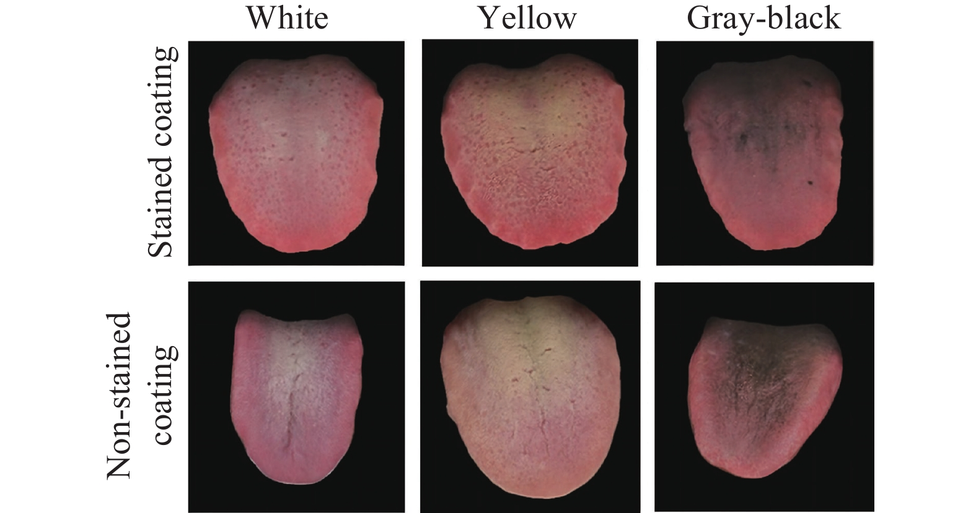
Fig. 1 Samples of tongue images in various color
Moreover, we used the “train_test_split” function to randomly split our dataset into training, validation, and testing datasets in a 7 : 2 : 1 ratio based on data volume. The distribution of training data is shown in Table 1.

Table 1 Statistics of training data in each class
Classification | Training set | Validation set | Testing set
Stained coating | 700 | 200 | 101
Non-stained coating | 704 | 201 | 102

2.3 Model structure
Considering the training advantages of the residual network (ResNet) and the potential decline in testing accuracy when using a high-parameter network model in limited data scenarios, this study selected ResNet50 to recognize tongue images. The structure of the model is shown in Figure 2. The model consists of 49 convolutional layers and 1 fully connected layer. To enhance training stability, a batch normalization (BN) layer is added after each convolutional layer. The classical rectified linear unit (ReLU) is chosen as the activation function of the network ^{[18]}. The ReLU function is defined as follows:
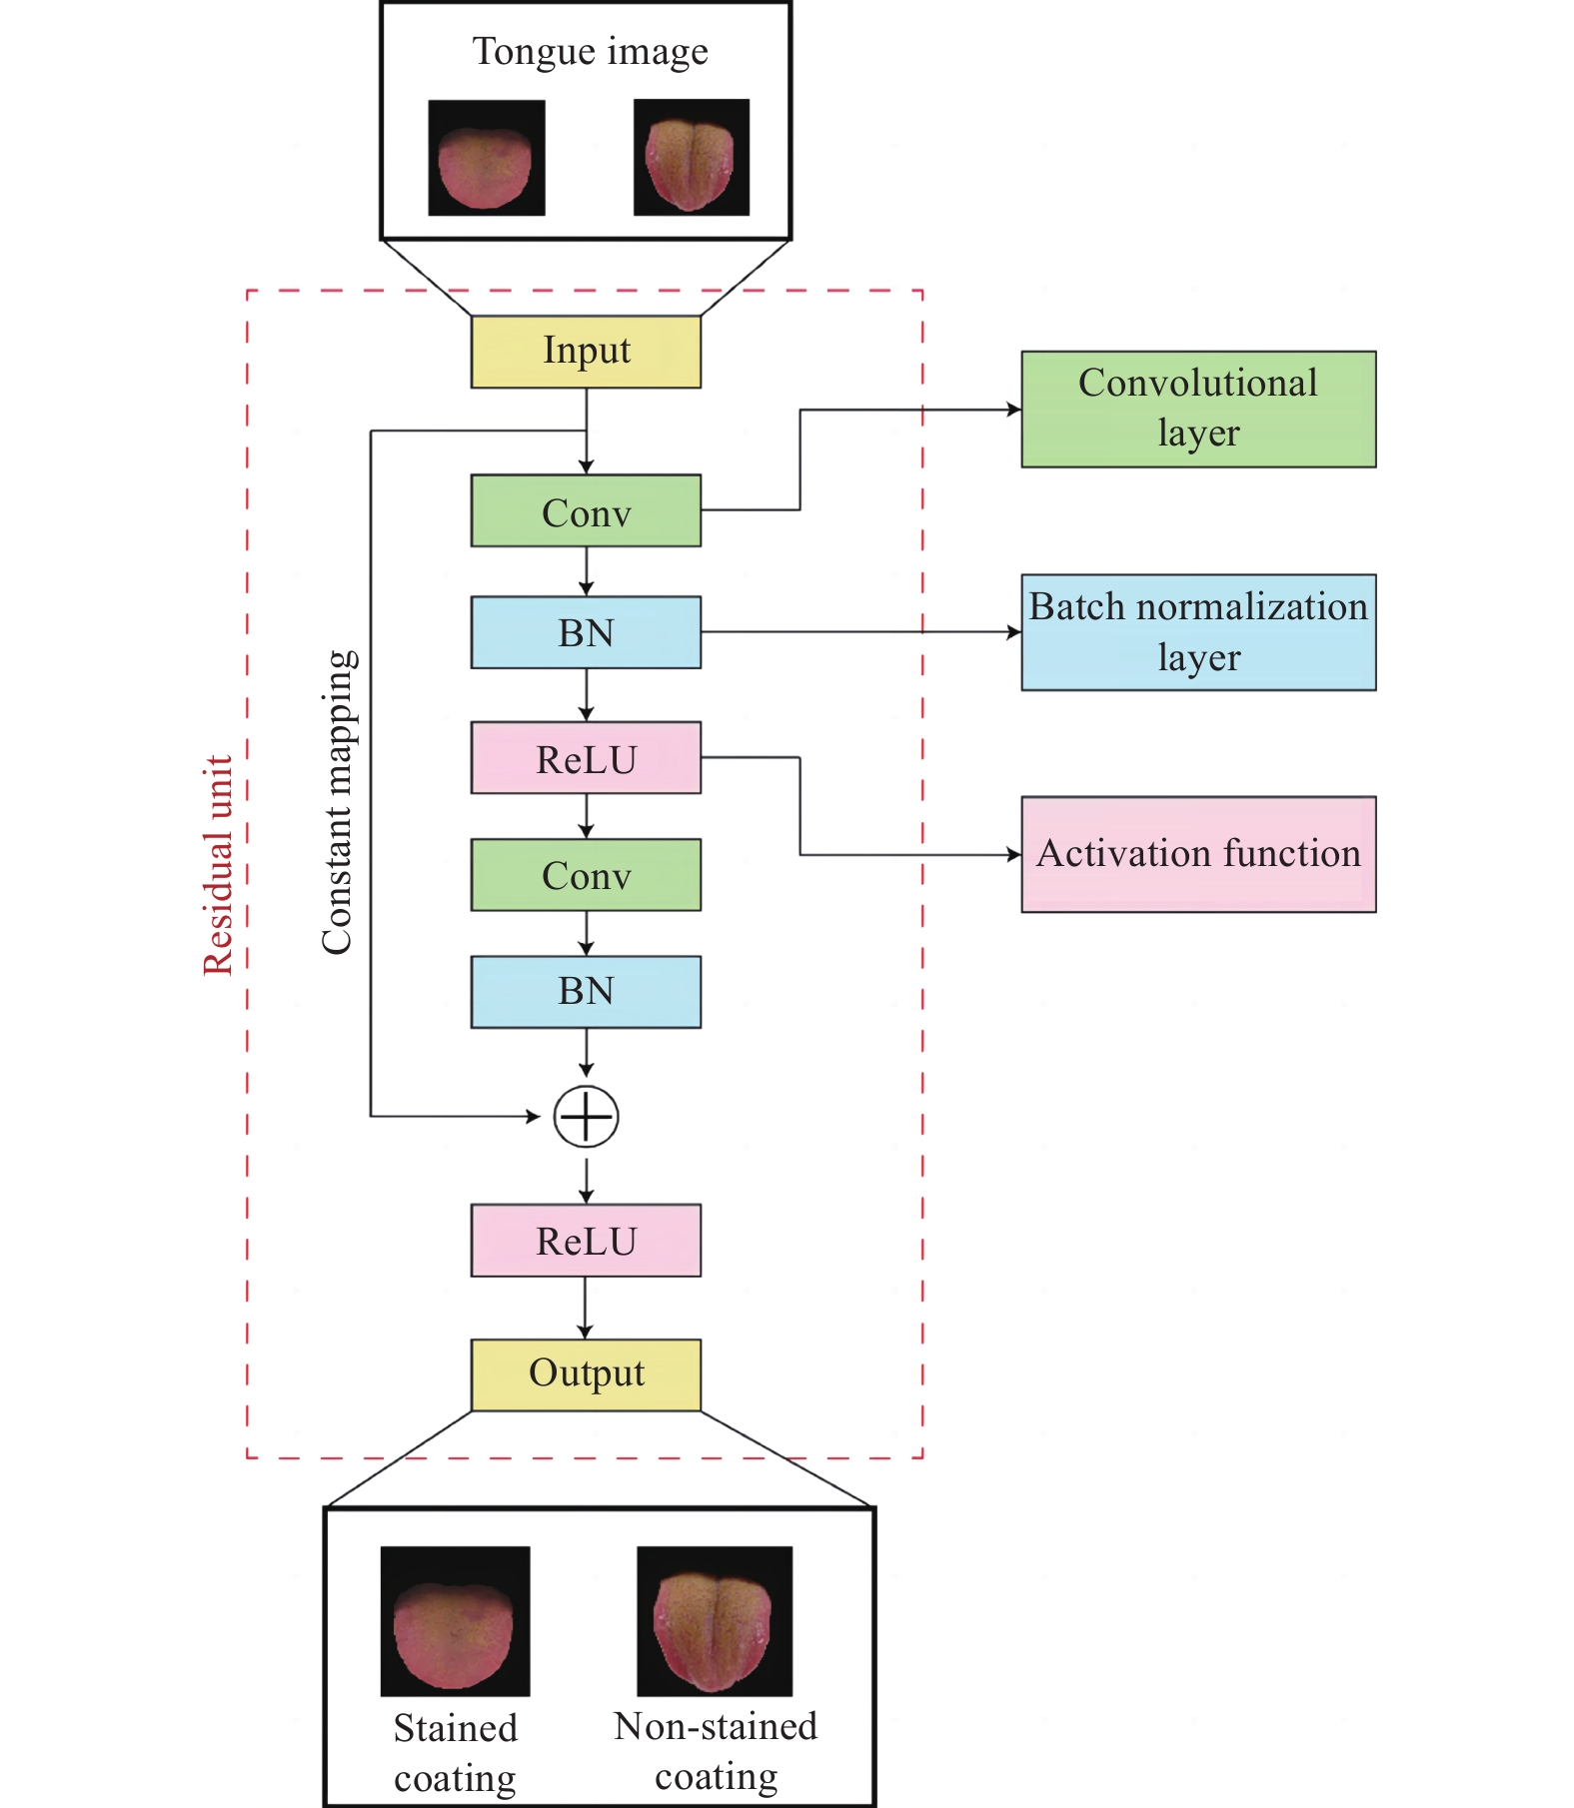
Fig. 2 The network structure of ResNet50
$f\left(x\right)=max\left(0,x\right)=\{\begin{aligned}0,x<0 \\ x,x>0\end{aligned}$ (1)
In Equation (1), x represents any real number. When x > 0, the output remains unchanged; when x < 0, the output is 0. The ReLU function is more straightforward and effective in network training than activation functions such as sigmoid and tanh. It expedites the training process and prevents the vanishing gradient problem.
2.4 Model training and testing
The study used the PyTorch 2.0 deep learning framework to construct network architectures and perform model training. We optimized network training by employing the Adam algorithm and updated network weights and bias parameters using the backpropagation (BP) algorithm. The learning rate and scaling parameters are shown in Table 2. We used pre-trained network pass parameters from the ImageNet dataset as initialization weights for the ResNet architecture, random initialization for the fully connected layer parameters, and the Softmax function for image classification. All training data were randomly resized and cropped to 640 × 640 pixels, and divided into 64 batch sizes for training the network, which finished after 90 consecutive training epochs. The test data were randomly adjusted to 640 × 640 pixels and cropped to 512 × 512 pixels in the center. The hyperparameters were fine-tuned based on the best performance on the validation dataset, and PyTorch was used to save the best model weight parameters from the training dataset (Figure 3).

Table 2 Training parameters of deep learning
Parameter | Parameter value
Image size (pixel) | 640 × 640
Cropped size (pixel) | 512 × 512
Learning rate | 0.01
Momentum | 0.9
Weight decay | 0.001

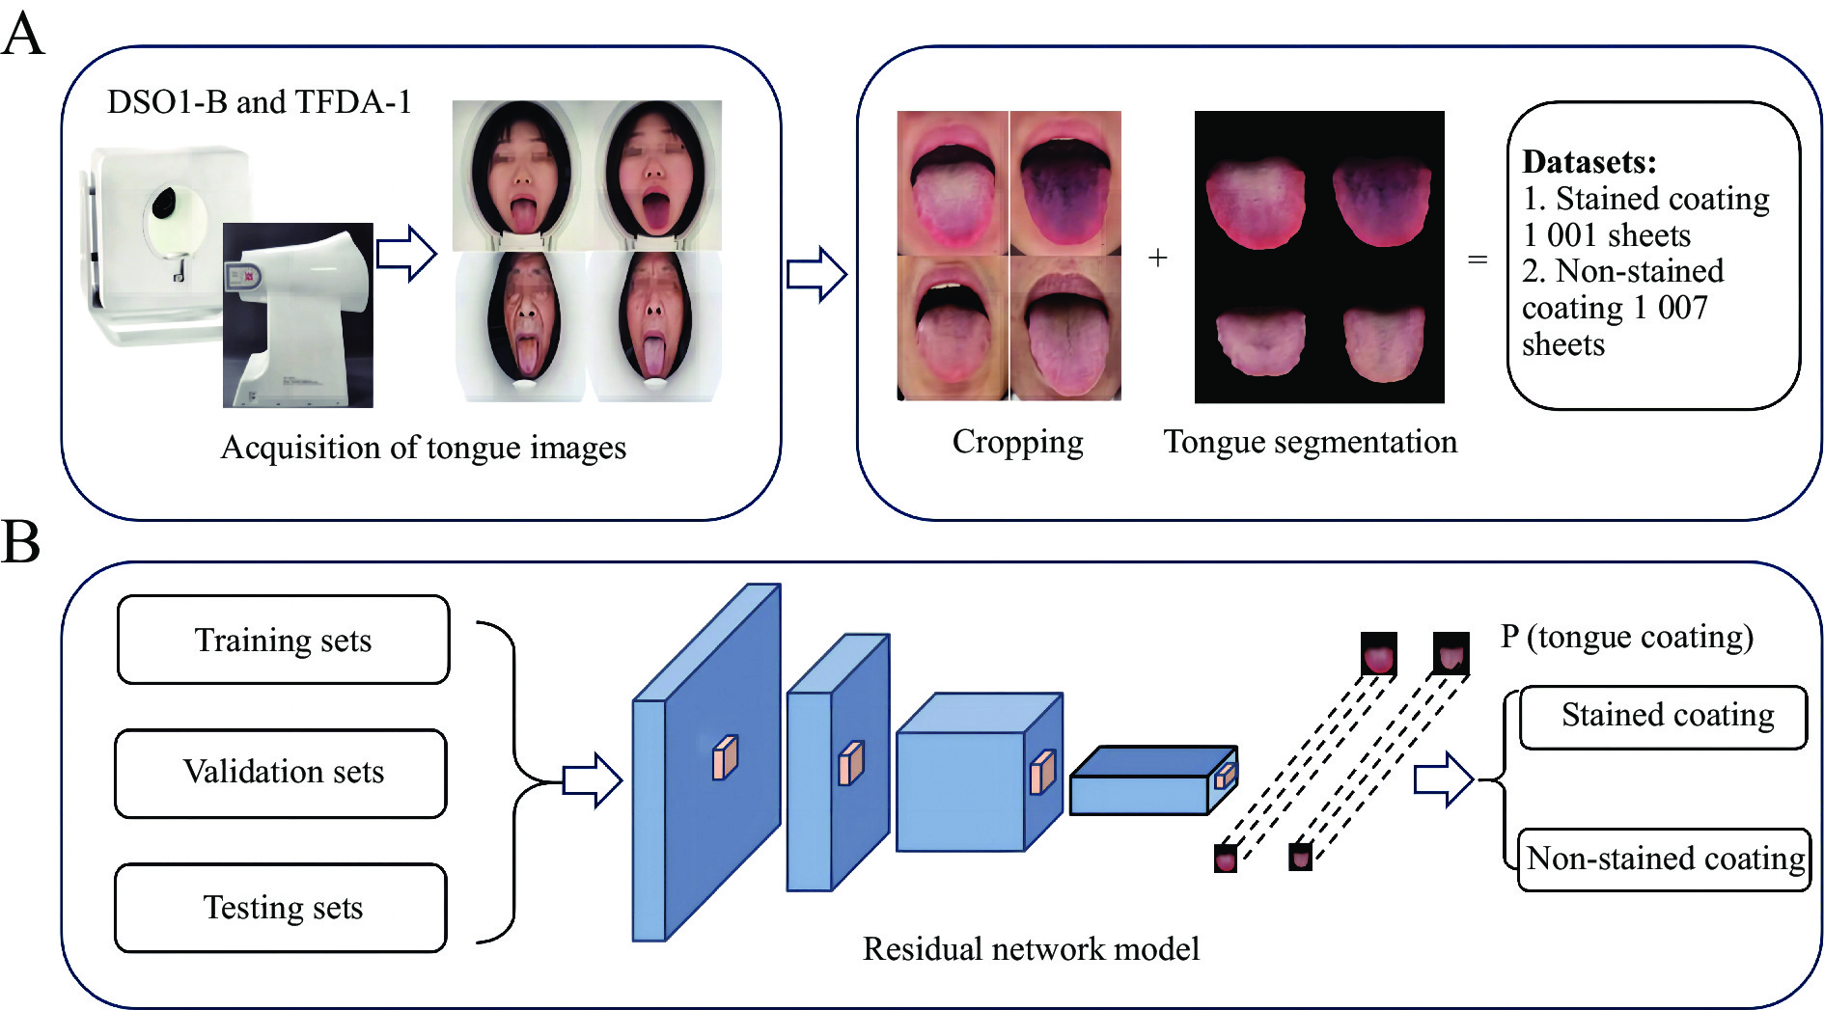
Fig. 3 Overview of the research process
A, acquiring tongue images using a tongue diagnostic instrument and constructing a tongue image dataset after pre-processing such as cropping and tongue segmentation. B, dividing the datasets into training, validation, and testing datasets to recognize tongue images using deep learning models. P, image of target tongue coating.
2.5 Model evaluation
We used seven metrics to evaluate the model's performance: accuracy, recall, F1 score, loss curve, confusion matrix, receiver operating characteristic (ROC) curve, and precision-recall (PR) curve ^{[19-21]}. Each metric’s definition and calculation formula are as follows:
The accuracy represents the ratio of all correctly predicted stained coating samples to the total number of tongue samples. The recall measures the ratio of correctly stained tongue coating samples to all actual stained tongue coating samples. The higher the value of these ratios, the better the results achieved. The Equations are as follows:
$Accuracy=\frac{TP+TN}{TP+TN+FP+FN}$ (2)
$Recall=\frac{TP}{TP+FN}$ (3)
TP denotes true positives, representing the classification of stained tongue coating samples into the stained tongue coating category; TN denotes true negatives, representing the classification of non-stained tongue coating samples into the non-stained tongue coating category; FP indicates false positives, representing the classification of non-stained tongue coating samples into the stained tongue coating category; FN indicates false negatives, representing the classification of stained tongue coating samples into the non-stained tongue coating category.
The F1 score can be used as an overall indicator of the model’s performance. The higher the value, the better the performance is. The Equation is as follows:
$F1=\frac{2×Precision×Recall}{Precision+Recall}$ (4)
The loss curve measures the difference between the predicted value and the true value of the model. The smaller the loss value is, the closer the predicted value is to the true value. The Equation is as follows:
$C_{loss}=−\frac{1}{m}\sum_{j=1}^{m}{}\sum_{i=1}^{n}{}y_{ji}log\left({\overset{}{y}}_{ji}\right)$ (5)
In Equation (5), $m$ is the number of tongue samples input to the network in the current batch, n is the total number of tongue categories, $y_{ji}$ is the true label of the stained image, ${\overset{}{y}}_{ji}$ is the label of the stained image prediction, and $C_{loss}$ is the loss value. The smaller this value is, the better the learning effect is in the model's training process.
The confusion matrix, also known as the error matrix, is represented as an N × N matrix, where N is the number of classification labels. The confusion matrix visualizes the accuracy of the classifier by comparing the number of actual class samples with the number of predicted class samples. By examining the data in the confusion matrix, we can further analyze the classification errors of the model and target the specific areas for optimization.
The ROC curve illustrates how the true positive rate and the false positive rate of a model vary across different classification thresholds, providing insights into its discriminative ability.
The PR curve depicts how the model’s precision and recall change with varying thresholds, emphasizing its effectiveness in capturing positive instances.
To compare the performance of the model and human practitioners, we enlisted three TCM practitioners to identify the same set of tongue images from the testing dataset. This dataset comprised 101 images of stained tongue coatings and 102 images of non-stained tongue coatings. Each practitioner recorded the number of tongue images correctly and incorrectly identified. We calculated the final accuracy rates by averaging the individual accuracy rate of the three TCM practitioners.
2.6 Experimental environment
The computer configuration and testing environment information are presented in Table 3, which consists of two primary components: hardware and software.

Table 3 Computer configuration and test environment information
Computer configuration | Name | Parameter
Hardware | Processor | Intel® Core(TM) i5-12500H
Hardware | Memory | 16 GB
Hardware | Graphics card | NVIDIA Tesla A100
Hardware | Memory capacity | 4 GB
 | Memory interface | 128 Bit
Software | Operating system | Debian
 | Programming languages | Python 3.12
 | Network framework | Torch 2.0

3 Results
3.1 Classification accuracy and loss curve of ResNet50
As shown in Figure 4, after 90 training epochs, ResNet50 achieved excellent classification results. This included a decreased loss curve, increased and stable accuracy, and an overall accuracy of over 90% without signs of overfitting. These results suggested that the model effectively learned stained tongue region features from tongue images, leading to precise prediction outcomes.
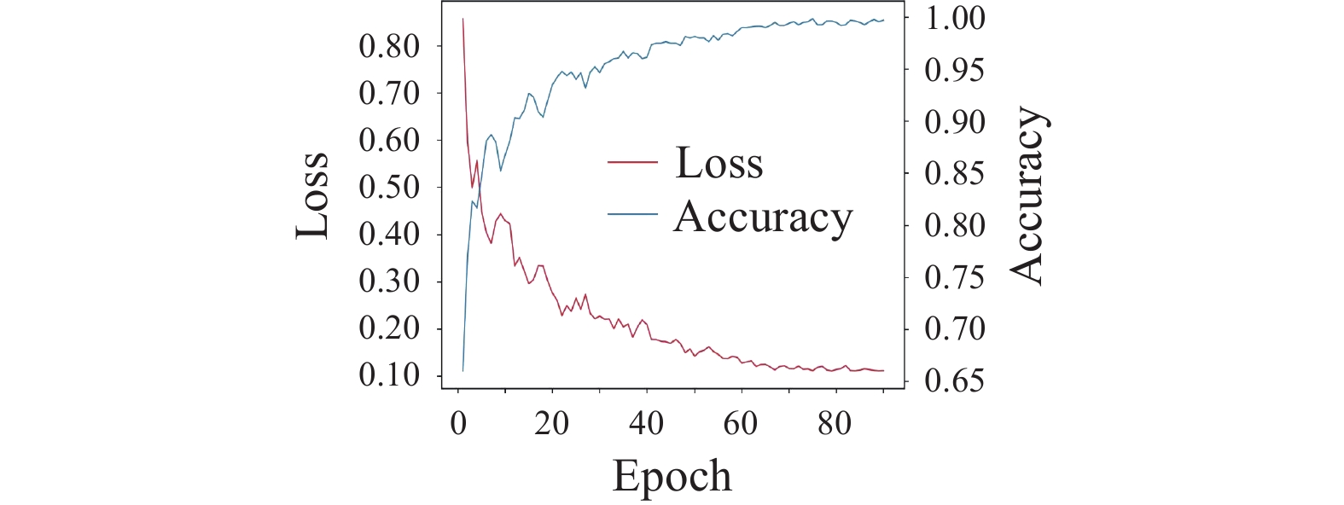
Fig. 4 The training accuracy and loss curves of ResNet50
3.2 Confusion matrix of ResNet50
The confusion matrix of ResNet50 is shown in Figure 5A. The analysis of the confusion matrix data revealed that the accurate prediction rate was 93% for non-stained tongue coating samples and 91% for stained tongue coating samples. In comparison, Figure 5B showed the confusion matrix for the TCM practitioner. The correct prediction rates for the stained tongue coating and non-stained tongue coating samples were 72% and 66%, respectively. The comparison of the two graphs demonstrated that the deep learning model is more accurate than naked eyes in tongue inspection.
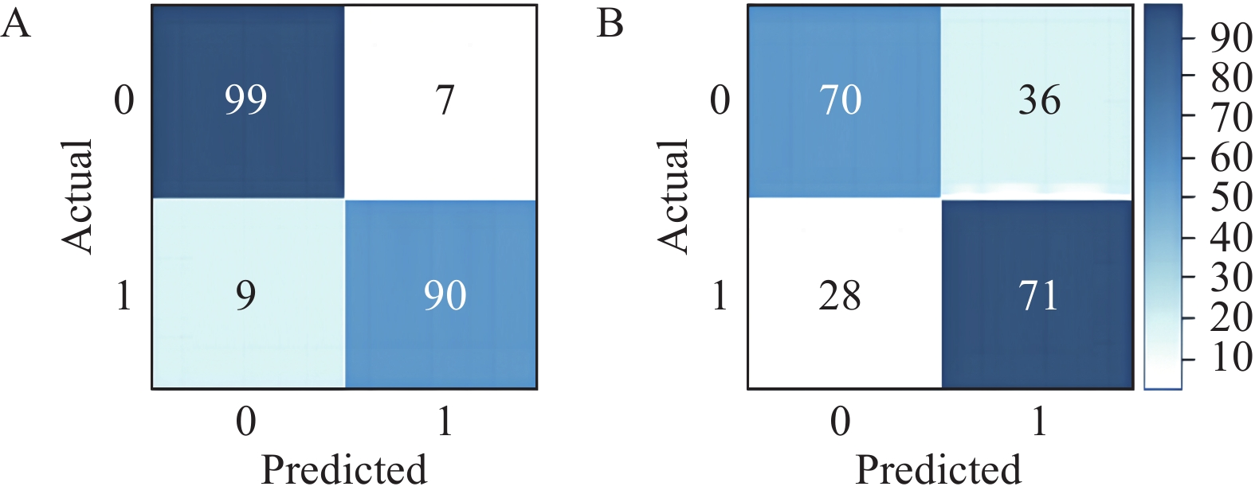
Fig. 5 The confusion matrix of ResNet50
A, the confusion matrix of ResNet50. B, the confusion matrix of the TCM practitioner's naked eyes observation. In this matrix, a darker color corresponds to a higher classification value, indicating a better diagnosis.
3.3 Evaluation of ResNet50
The accuracy, recall, and F1 score of ResNet50 are presented in Table 4. The overall assessment result was that ResNet50 achieved outstanding outcomes in recognizing stained tongue coating images, with an accuracy higher by 23%, a recall higher by 19%, and an F1 score higher by 22% in comparison with that of the process of tongue coating recognition by TCM practitioners’ naked eyes.

Table 4 Performance evaluation for the ResNet50 model and TCM practitioners (%)
Method | Accuracy | Recall | F1 score
ResNet50 | 92 | 91 | 92
TCM practitioners | 69 | 72 | 70

3.4 ROC and PR curves
The areas under the ROC and PR curves of ResNet50 is shown in Figure 6. ResNet50 exhibited excellent classification performance, with the AUC value of the ROC and PR curve reaching 0.97 and 0.95, respectively. This indicated that the model was trained with high prediction accuracy in identifying stained tongue coating images.
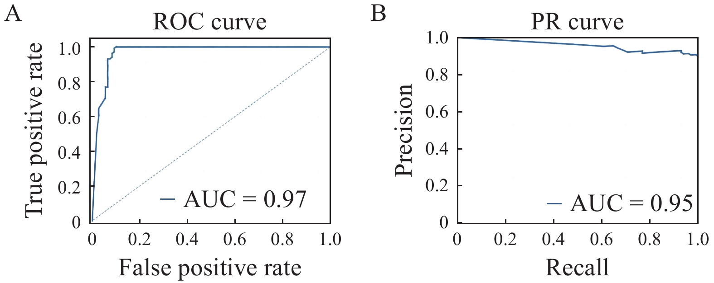
Fig. 6 The ROC and PR curves of ResNet50
A, analysis of the ROC curve. B, analysis of the PR curve.
4 Discussion
TCM holds that rapid and obvious color changes in tongue coating can objectively reflect the progression of disease and effectively guide its treatment and prognosis ^{[22]}. However, food or medication can easily alter the color of the tongue coating, resulting in potential misinterpretation of stained tongue coating. Even experienced practitioners find it challenging to determine whether the tongue coating is stained in specific cases. AI technology, particularly deep learning, offers significant advantages in image recognition ^{[23]}. Neural networks can capture subtle image features and perform intelligent analysis, enhancing the efficiency of objective diagnosis for tongue images.
4.1 Summary and innovation
This study established a dataset of stained tongue coating, and recognized and classified the tongue images using ResNet50. The results demonstrated that the model exhibited an overall accuracy rate of 92%, surpassing the accuracy achieved by the visual assessments of TCM practitioners. The model proposed in this study has a higher accuracy in terms of automatic identification of stained tongue coating images compared with those in previous studies. In addition, our study offers a novel reference for diagnosing diseases based on tongue characteristics. Previous studies documented that using tongue imaging data and precise classification for the diagnosis of diabetic ^{[20]} and fatigued populations ^{[24]} was possible with the employment of machine learning methods ^{[25-29]}. The deep learning model in this study is based on artificial neural networks within the field of machine learning. It employs multi-layer neural networks to automatically extract significant feature information from the images, thereby enhancing computational capabilities and providing an objective and effective computer-aided approach for the recognition of tongue coatings. This model can assist TCM practitioners in distinguishing false tongue coatings, thus preventing misdiagnosis. Currently, significant advancements have been made in the intelligent diagnosis of diseases with tongue features. For example, tongue diagnosis based on computerized tongue image analysis served as a screening tool for nonalcoholic fatty liver disease (NAFLD) ^{[30]}, and played a predictive role in analyzing the risks of diabetes ^{[19]}. Based on this premise, this study examined the impacts of factors in association with the formation of tongue coatings on the intelligent diagnosis of diseases and employed a deep learning model to evaluate the efficacy of AI in recognizing stained tongue coatings.
4.2 The principles, strengths, and limitations of ResNet50
CNN is a class of feedforward neural networks with convolutional computation and a deep structure that has been applied to the recognition of medical images ^{[31]}, such as skin melanoma detection ^{[32]}, pelvic ultrasound images ^{[33]}, and breast cancer image recognition ^{[34]}. However, traditional network layers can affect training accuracy and network convergence. ResNet ^{[35]} is one of the representatives among CNN models that effectively addresses issues relating to degradation and network convergence by introducing residual blocks and BN layers. The ResNet utilized in this study has two significant advantages over other network models: (i) the ResNet structure incorporates cross-layer connections to address the issue of gradient vanishing; (ii) the residuals within the ResNet architecture can effectively preserve feature information, enhancing the model's generalization capability. With these two advantages, the classification accuracy for stained tongue coating images has been improved ^{[36-40]}. Regardless, there are some limitations in this study. First, the number of stained and non-stained tongue coating images was limited, and the generalization ability of deep learning models will significantly improve with the further collection of more tongue image data. Second, although ResNet50 employed in this study is a widely accepted deep learning model with an accuracy of 92% for the detection of stained tongue coatings, there are other deep learning models with an accuracy of 93% or higher. Third, we included diverse populations (students and patients), standardizing the study population could potentially enhance model applicability. Last, we need to further explore the model's interpretability in future studies.
5 Conclusion
The deep learning model constructed with ResNet50 can effectively recognize stained tongue coating images and classify them into two categories: stained and non-stained tongue coatings. Deep learning was found to be superior to human naked eyes in terms of recognizing stained tongue coating images. The proposed model may assist TCM practitioners in identifying fake stained tongue coatings, thus improving the efficiency of clinical diagnosis.

Competing Interests
The authors declare no conflict of interest.

References
- CHIU CC. A novel approach based on computerized image analysis for traditional Chinese medical diagnosis of the tongue. Computer Methods and Programs in Biomedicine, 2000, 61（2）: 77–89.
- NI JH, YAN ZZ, JIANG JH. TongueCaps: an improved capsule network model for multi-classification of tongue color. Diagnostics, 2022, 12（3）: 653.
- LI ZY, YU ZC, LIU WX, et al. Tongue image segmentation via color decomposition and thresholding. 2017 4th International Conference on Information Science and Control Engineering （ICISCE）, 2017: 752–755.
- YUAN L, YANG L, ZHANG SC, et al. Development of a tongue image-based machine learning tool for the diagnosis of gastric cancer: a prospective multicentre clinical cohort study. eClinicalMedicine, 2023, 57: 101834.
- KAINUMA M, FURUSYO N, URITA Y, et al. The association between objective tongue color and endoscopic findings: results from the Kyushu and Okinawa population study （KOPS）. BMC Complementary and Alternative Medicine, 2015, 15: 372.
- CHEN XX, WANG XM, ZHANG K, et al. Recent advances and clinical applications of deep learning in medical image analysis. Medical Image Analysis, 2022, 79: 102444.
- LIN MC, BAO GD, SANG XQ, et al. Recent advanced deep learning architectures for retinal fluid segmentation on optical coherence tomography images. Sensors , 2022, 22（8）: 3055.
- JIANG T, HU XJ, YAO XH, et al. Tongue image quality assessment based on a deep convolutional neural network. BMC Medical Informatics and Decision Making, 2021, 21（1）: 147.
- YAN JJ, CHEN BC, GUO R, et al. Tongue image texture classification based on image inpainting and convolutional neural network. Computational and Mathematical Methods in Medicine, 2022, 2022: 6066640.
- WANG X, LIU JW, WU CY, et al. Artificial intelligence in tongue diagnosis: using deep convolutional neural network for recognizing unhealthy tongue with tooth-mark. Computational and Structural Biotechnology Journal, 2020, 18: 973–980.
- BOSSUYT PM, REITSMA JB, BRUNS DE, et al. STARD 2015: an updated list of essential items for reporting diagnostic accuracy studies. BMJ, 2015, 351: h5527.
- ZHU L, XIN GJ, WANG X, et al. A fast tongue detection and location algorithm in natural environment. Computers, Materials & Continua, 2022, 73（3）: 4727–4742.
- CHEN LC, PAPANDREOU G, KOKKINOS I, et al. DeepLab: semantic image segmentation with deep convolutional nets, atrous convolution, and fully connected CRFs. IEEE Transactions on Pattern Analysis and Machine Intelligence, 2018, 40（4）: 834–848.
- YUAN HB, ZHU JJ, WANG QF, et al. An improved DeepLab V3+ deep learning network applied to the segmentation of grape leaf black rot spots. Frontiers in Plant Science, 2022, 13: 795410.
- ZHANG XF, BIAN HN, CAI YH, et al. An improved tongue image segmentation algorithm based on DeepLabV3+ framework. IET Image Processing, 2022, 16（5）: 1473–1485.
- WANG J, LIU XP. Medical image recognition and segmentation of pathological slices of gastric cancer based on DeepLab V3+ neural network. Computer Methods and Programs in Biomedicine, 2021, 207: 106210.
- ZHONG LQ, JIANG GJ, PENG QH, et al. A dataset of stained tongue fur images of TCM. China Scientific Data, 2023, 8（3）: 1–10.
- DITTMER S, KING EJ, MAASS P. Singular values for ReLU layers. IEEE Transactions on Neural Networks and Learning Systems, 2020, 31（9）: 3594–3605.
- LI J, CHEN QG, HU XJ, et al. Establishment of noninvasive diabetes risk prediction model based on tongue features and machine learning techniques. International Journal of Medical Informatics, 2021, 149: 104429.
- LI J, HUANG JB, JIANG T, et al. A multi-step approach for tongue image classification in patients with diabetes. Computers in Biology and Medicine, 2022, 149: 105935.
- WANG X, WANG XR, LOU YN, et al. Constructing tongue coating recognition model using deep transfer learning to assist syndrome diagnosis and its potential in noninvasive ethnopharmacological evaluation. Journal of Ethnopharmacology, 2022, 285: 114905.
- WANG Y, LI JQ, HU HY, et al. Distinct microbiome of tongue coating and gut in type 2 diabetes with yellow tongue coating. Heliyon, 2024, 10（1）: e22615.
- TIRYAKI B, TORENEK-AGIRMAN K, MILOGLU O, et al. Artificial intelligence in tongue diagnosis: classification of tongue lesions and normal tongue images using deep convolutional neural network. BMC Medical Imaging, 2024, 24（1）: 59.
- SHI YL, YAO XH, XU JT, et al. A new approach of fatigue classification based on data of tongue and pulse with machine learning. Frontiers in Physiology, 2022, 12: 708742.
- DEO RC. Machine learning in medicine. Circulation, 2015, 132（20）: 1920–1930.
- HANDELMAN GS, KOK HK, CHANDRA RV, et al. eDoctor: machine learning and the future of medicine. Journal of Internal Medicine, 2018, 284（6）: 603–619.
- CHOI RY, COYNER AS, KALPATHY-CRAMER J, et al. Introduction to machine learning, neural networks, and deep learning. Translational Vision Science & Technology, 2020, 9（2）: 14.
- SULTAN AS, ELGHARIB MA, TAVARES T, et al. The use of artificial intelligence, machine learning and deep learning in oncologic histopathology. Journal of Oral Pathology & Medicine, 2020, 49（9）: 849–856.
- AROMOLARAN O, AROMOLARAN D, ISEWON I, et al. Machine learning approach to gene essentiality prediction: a review. Briefings in Bioinformatics, 2021, 22（5）: bbab128.
- JIANG T, GUO XJ, TU LP, et al. Application of computer tongue image analysis technology in the diagnosis of NAFLD. Computers in Biology and Medicine, 2021, 135: 104622.
- LECUN Y, BENGIO Y, HINTON G. Deep learning. Nature, 2015, 521（7553）: 436–444.
- HAENSSLE HA, FINK C, SCHNEIDERBAUER R, et al. Man against machine: diagnostic performance of a deep learning convolutional neural network for dermoscopic melanoma recognition in comparison to 58 dermatologists. Annals of Oncology, 2018, 29（8）: 1836–1842.
- GAO Y, ZENG SQ, XU XY, et al. Deep learning-enabled pelvic ultrasound images for accurate diagnosis of ovarian cancer in China: a retrospective, multicentre, diagnostic study. The Lancet Digital Health, 2022, 4（3）: e179–e187.
- ZHOU LQ, WU XL, HUANG SY, et al. Lymph node metastasis prediction from primary breast cancer US images using deep learning. Radiology, 2020, 294（1）: 19–28.
- HE KM, ZHANG XY, REN SQ, et al. Deep residual learning for image recognition. 2016 IEEE Conference on Computer Vision and Pattern Recognition （CVPR）, 2016: 770–778.
- DİKER A. An efficient model of residual based convolutional neural network with Bayesian optimization for the classification of malarial cell images. Computers in Biology and Medicine, 2022, 148: 105635.
- SALEM A, IBRAHEM H, YAGOUB B, et al. End-to-end residual network for light field reconstruction on raw images and view image stacks. Sensors, 2022, 22（9）: 3540.
- TIAN TY, WANG L, LUO M, et al. ResNet-50 based technique for EEG image characterization due to varying environmental stimuli. Computer Methods and Programs in Biomedicine, 2022, 225: 107092.
- ZHANG X, ZHENG LM, TAN ZH, et al. Loop closure detection based on residual network and capsule network for mobile robot. Sensors, 2022, 22（19）: 7137.
- ZHAO TT, SUN ZN, GUO Y, et al. Automatic renal mass segmentation and classification on CT images based on 3D U-Net and ResNet algorithms. Frontiers in Oncology, 2023, 13: 1169922.

